Fundamentals of Data Science - Lab Manual
Question 23
Hypothesis testing and p-value of a new treatment
AIM:
To test whether a new treatment has a statistically significant effect compared to a placebo by calculating the p-value, and to visualise the data and the p-value using Matplotlib.
ALGORITHM:
Step 1: Start the program and import NumPy, scipy.stats and matplotlib.
Step 2: Store the improvement scores of the placebo (control) group and the treatment group (30 patients each).
Step 3: State H0: the mean improvement of both groups is the same. H1: the means are different. Take alpha = 0.05.
Step 4: Calculate the t-statistic and the two-tailed p-value using stats.ttest_ind().
Step 5: Plot the box plots of the two groups.
Step 6: Plot the t-distribution, shade the tail areas beyond +/- t and display the p-value.
Step 7: Reject H0 if p < alpha; display the conclusion and stop.
PROGRAM:
import numpy as np
import matplotlib.pyplot as plt
from scipy import stats

# improvement score of the patients
placebo = [6.7, 5.7, 4.8, -2.0, 6.3, -1.4, 7.7, 6.8, 7.5, 7.5, 5.9, 3.4,
4.1, 9.5, 3.3, 4.3, 2.8, 3.4, 4.1, 5.8, 4.1, 3.9, 3.1, 5.3,
1.0, 5.2, 8.9, 2.7, 4.9, 13.5]
treatment = [5.5, 3.6, 7.2, 13.9, 14.6, 4.9, 10.2, 8.5, 6.7, 2.7, 11.6,
5.9, 9.4, 8.7, 14.1, 12.0, 5.0, 7.7, 11.6, 4.5, 7.3, 9.2,
3.7, 4.8, 3.4, 9.4, 6.8, 11.3, 8.8, 10.2]

t_stat, p_value = stats.ttest_ind(treatment, placebo) # two-tailed t-test
df = len(placebo) + len(treatment) - 2
alpha = 0.05

print(f"Mean (placebo) : {np.mean(placebo):.2f}")
print(f"Mean (treatment) : {np.mean(treatment):.2f}")
print(f"t-statistic : {t_stat:.4f}")
print(f"p-value : {p_value:.6f}")
print("Conclusion :", "Reject H0 - the treatment has a significant effect"
if p_value < alpha else "Fail to reject H0 - no significant effect")

fig, ax = plt.subplots(1, 2, figsize=(11, 4.5))

# left: box plots of the data
ax[0].boxplot([placebo, treatment])
ax[0].set_xticklabels(["Placebo", "Treatment"])
ax[0].set_title("Improvement score of the two groups")
ax[0].set_ylabel("Score")

# right: t-distribution with the p-value area shaded
x = np.linspace(-6, 6, 500)
y = stats.t.pdf(x, df)
ax[1].plot(x, y, color="black")
ax[1].fill_between(x, y, where=(x >= abs(t_stat)), color="red", alpha=0.5)
ax[1].fill_between(x, y, where=(x <= -abs(t_stat)), color="red", alpha=0.5)
ax[1].axvline(t_stat, color="blue", linestyle="--", label=f"t = {t_stat:.2f}")
ax[1].set_title(f"t-distribution (df = {df}), p-value = {p_value:.6f}")
ax[1].set_xlabel("t value")
ax[1].legend()
plt.tight_layout()
plt.show()
INPUT:
Placebo group (n = 30): 6.7, 5.7, 4.8, -2.0, 6.3, -1.4, 7.7, 6.8, 7.5, 7.5, 5.9, 3.4, 4.1, 9.5, 3.3, 4.3, 2.8, 3.4, 4.1, 5.8, 4.1, 3.9, 3.1, 5.3, 1.0, 5.2, 8.9, 2.7, 4.9, 13.5
Treatment group (n = 30): 5.5, 3.6, 7.2, 13.9, 14.6, 4.9, 10.2, 8.5, 6.7, 2.7, 11.6, 5.9, 9.4, 8.7, 14.1, 12.0, 5.0, 7.7, 11.6, 4.5, 7.3, 9.2, 3.7, 4.8, 3.4, 9.4, 6.8, 11.3, 8.8, 10.2
OUTPUT:
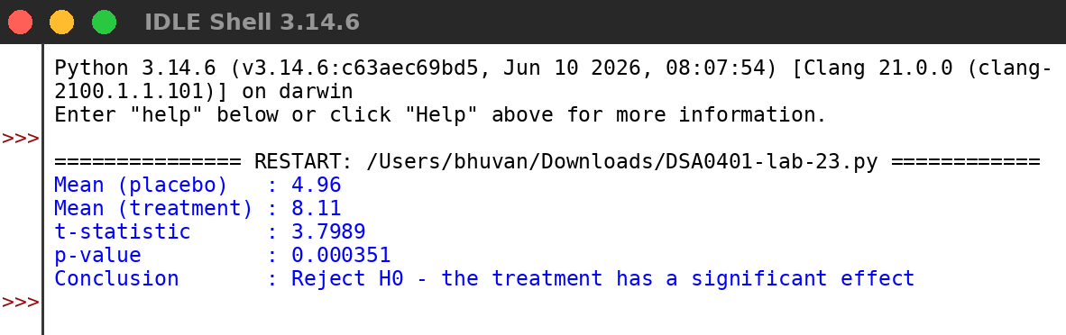
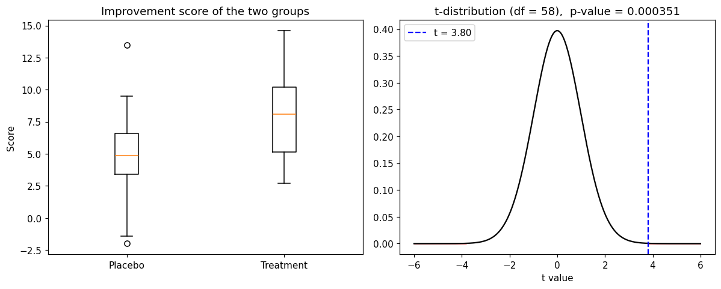
RESULT:
Thus the program was written and executed successfully and the output was verified.

