Fundamentals of Data Science - Lab Manual
Question 24
K-Nearest Neighbors classifier for a medical condition
AIM:
To write a Python program that uses the KNN classifier of scikit-learn to predict whether a patient has a medical condition from the symptom features and the value of k entered by the user.
ALGORITHM:
Step 1: Start the program and import Pandas and scikit-learn.
Step 2: Load patients.csv; separate the features (age, fever, cough, fatigue) and the label (condition: 0 / 1).
Step 3: Standardise the features with StandardScaler so that all features carry equal weight.
Step 4: Read the features of the new patient and the value of k from the user.
Step 5: Train KNeighborsClassifier(n_neighbors=k) on the dataset.
Step 6: Scale the new patient data and predict the class; also display the prediction probability.
Step 7: Display whether the patient has the condition and stop.
PROGRAM:
import pandas as pd
from sklearn.neighbors import KNeighborsClassifier
from sklearn.preprocessing import StandardScaler

df = pd.read_csv("patients.csv")
X = df.drop(columns="condition")
y = df["condition"]

scaler = StandardScaler()
X_scaled = scaler.fit_transform(X)

age = float(input("Enter age: "))
fever = float(input("Enter body temperature (F): "))
cough = float(input("Enter cough severity (0-10): "))
fatigue = float(input("Enter fatigue level (0-10): "))
k = int(input("Enter the value of k: "))

knn = KNeighborsClassifier(n_neighbors=k)
knn.fit(X_scaled, y)

new_patient = pd.DataFrame([[age, fever, cough, fatigue]], columns=X.columns)
new_scaled = scaler.transform(new_patient)

prediction = knn.predict(new_scaled)[0]
probability = knn.predict_proba(new_scaled)[0][prediction]

print(f"\nPredicted class : {prediction}")
if prediction == 1:
print(f"The patient HAS the condition (probability {probability:.2f}).")
else:
print(f"The patient does NOT have the condition (probability {probability:.2f}).")
INPUT:
File: patients.csv (first 12 of 40 rows shown)
age | fever | cough | fatigue | condition
45 | 101.1 | 8 | 7 | 1
36 | 103.3 | 8 | 9 | 1
55 | 101.8 | 9 | 7 | 1
26 | 97.3 | 0 | 5 | 0
37 | 99.2 | 4 | 2 | 0
52 | 97.6 | 3 | 3 | 0
45 | 101.5 | 7 | 8 | 1
38 | 99.6 | 1 | 3 | 0
46 | 99.8 | 6 | 3 | 1
27 | 100.2 | 8 | 7 | 1
47 | 98.0 | 0 | 4 | 0
36 | 99.9 | 3 | 5 | 1

Values entered by the user at run time:
Prompt | Value entered
Enter age | 45
Enter body temperature (F) | 101.2
Enter cough severity (0-10) | 7
Enter fatigue level (0-10) | 6
Enter the value of k | 5

OUTPUT:
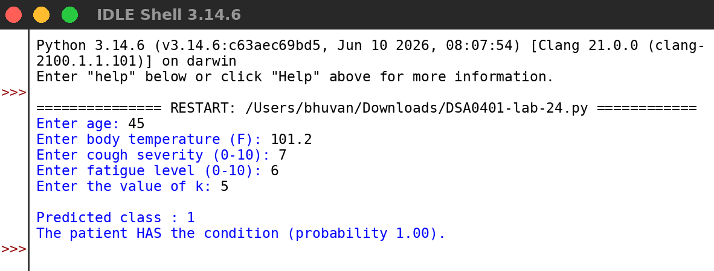
RESULT:
Thus the program was written and executed successfully and the output was verified.

