Fundamentals of Data Science - Lab Manual
Question 25
Decision tree classification of iris flowers
AIM:
To write a Python program that loads the Iris dataset, trains a Decision Tree classifier and predicts the species of a new flower from the sepal and petal dimensions entered by the user.
ALGORITHM:
Step 1: Start the program and import load_iris, DecisionTreeClassifier and train_test_split from scikit-learn.
Step 2: Load the Iris dataset (features: sepal length, sepal width, petal length, petal width).
Step 3: Split the data into training (80%) and testing (20%) sets.
Step 4: Train the DecisionTreeClassifier and display its accuracy on the test set.
Step 5: Read the four measurements of the new flower from the user.
Step 6: Predict the species with model.predict() and display it.
Step 7: Stop the program.
PROGRAM:
from sklearn.datasets import load_iris
from sklearn.tree import DecisionTreeClassifier
from sklearn.model_selection import train_test_split

iris = load_iris()
X, y = iris.data, iris.target

X_train, X_test, y_train, y_test = train_test_split(
X, y, test_size=0.2, random_state=42)

model = DecisionTreeClassifier(random_state=42)
model.fit(X_train, y_train)
print(f"Model accuracy on test data: {model.score(X_test, y_test):.2f}")

sl = float(input("Enter sepal length (cm): "))
sw = float(input("Enter sepal width (cm): "))
pl = float(input("Enter petal length (cm): "))
pw = float(input("Enter petal width (cm): "))

prediction = model.predict([[sl, sw, pl, pw]])[0]
print("\nPredicted species:", iris.target_names[prediction])
INPUT:
Values entered by the user at run time:
Prompt | Value entered
Enter sepal length (cm) | 6.3
Enter sepal width (cm) | 2.9
Enter petal length (cm) | 5.6
Enter petal width (cm) | 1.8

OUTPUT:
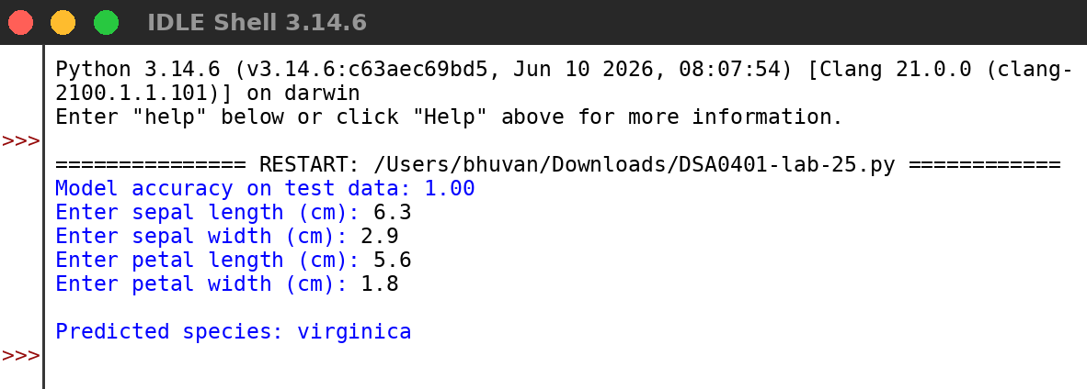
RESULT:
Thus the program was written and executed successfully and the output was verified.

