Fundamentals of Data Science - Lab Manual
Question 26
Linear regression for housing price prediction
AIM:
To write a Python program that uses linear regression of scikit-learn to predict the price of a new house from its area, number of bedrooms and location rating entered by the user.
ALGORITHM:
Step 1: Start the program and import Pandas and LinearRegression.
Step 2: Load houses_price.csv; the features are area, bedrooms and location_rating, the target is price.
Step 3: Train the LinearRegression model on the dataset.
Step 4: Read the area, number of bedrooms and location rating of the new house from the user.
Step 5: Predict the price using model.predict().
Step 6: Display the model coefficients, the R-squared score and the predicted price; stop.
PROGRAM:
import pandas as pd
from sklearn.linear_model import LinearRegression

df = pd.read_csv("houses_price.csv")
X = df[["area", "bedrooms", "location_rating"]]
y = df["price"]

model = LinearRegression()
model.fit(X, y)

for name, coef in zip(X.columns, model.coef_):
print(f"Coefficient of {name:<16}: {coef:.2f}")
print(f"Intercept : {model.intercept_:.2f}")
print("R-squared :", round(model.score(X, y), 4))

area = float(input("\nEnter the area (sq.ft): "))
bedrooms = int(input("Enter the number of bedrooms: "))
location = float(input("Enter the location rating (1-10): "))

new_house = pd.DataFrame([[area, bedrooms, location]], columns=X.columns)
price = model.predict(new_house)[0]
print(f"\nPredicted price of the house: {price:,.2f}")
INPUT:
File: houses_price.csv (first 12 of 30 rows shown)
area | bedrooms | location_rating | price
2868 | 4 | 8 | 613500
1979 | 2 | 5 | 411300
2130 | 1 | 10 | 484200
1362 | 3 | 4 | 355400
1740 | 5 | 10 | 461900
962 | 5 | 1 | 241600
1661 | 2 | 6 | 398200
2510 | 2 | 7 | 542600
2629 | 3 | 10 | 594100
2751 | 5 | 7 | 582200
1973 | 4 | 6 | 491100
2116 | 2 | 9 | 529700

Values entered by the user at run time:
Prompt | Value entered
Enter the area (sq.ft) | 1800
Enter the number of bedrooms | 3
Enter the location rating (1-10) | 7

OUTPUT:
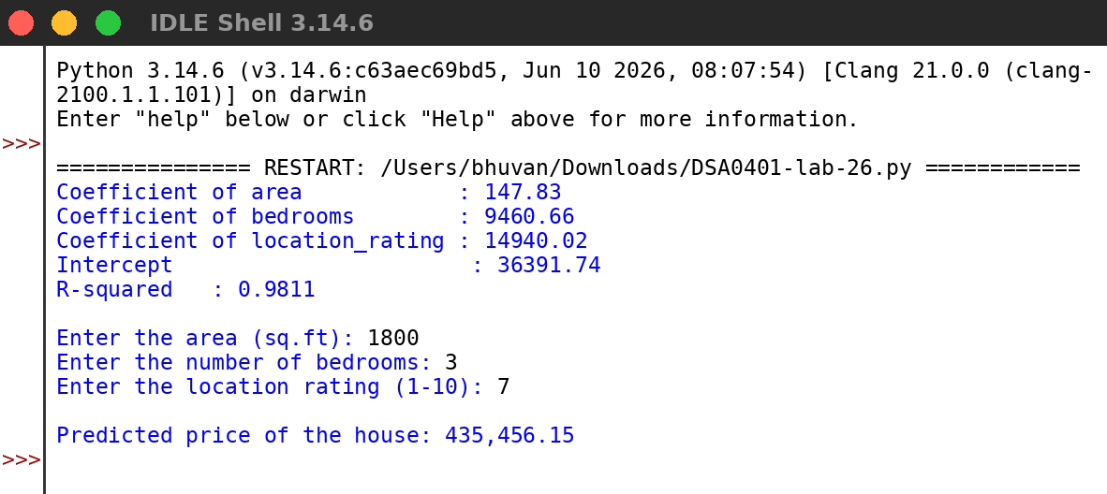
RESULT:
Thus the program was written and executed successfully and the output was verified.

