Fundamentals of Data Science - Lab Manual
Question 27
Logistic regression for customer churn prediction
AIM:
To write a Python program that uses logistic regression of scikit-learn to predict whether a new telecom customer will churn from the usage and demographic features entered by the user.
ALGORITHM:
Step 1: Start the program and import Pandas and scikit-learn.
Step 2: Load customers.csv; features: usage_minutes, contract_months, customer_age, support_calls; target: churn (0 / 1).
Step 3: Build a pipeline of StandardScaler and LogisticRegression and train it.
Step 4: Read the features of the new customer from the user.
Step 5: Predict the churn status and the churn probability.
Step 6: Display whether the customer will churn and stop.
PROGRAM:
import pandas as pd
from sklearn.linear_model import LogisticRegression
from sklearn.preprocessing import StandardScaler
from sklearn.pipeline import make_pipeline

df = pd.read_csv("customers.csv")
X = df.drop(columns="churn")
y = df["churn"]

model = make_pipeline(StandardScaler(), LogisticRegression())
model.fit(X, y)
print(f"Training accuracy: {model.score(X, y):.2f}")

usage = float(input("\nEnter usage minutes per month: "))
contract = float(input("Enter contract duration (months): "))
age = float(input("Enter customer age: "))
calls = float(input("Enter number of support calls: "))

new_customer = pd.DataFrame([[usage, contract, age, calls]], columns=X.columns)
prediction = model.predict(new_customer)[0]
probability = model.predict_proba(new_customer)[0][1]

print(f"\nChurn probability: {probability:.2f}")
print("Prediction: the customer WILL churn." if prediction == 1
else "Prediction: the customer will NOT churn.")
INPUT:
File: customers.csv (first 12 of 50 rows shown)
usage_minutes | contract_months | customer_age | support_calls | churn
498 | 22 | 56 | 1 | 0
413 | 24 | 26 | 1 | 0
25 | 4 | 43 | 5 | 1
206 | 11 | 38 | 6 | 1
427 | 28 | 43 | 1 | 0
296 | 10 | 38 | 1 | 0
170 | 5 | 47 | 3 | 1
296 | 25 | 30 | 1 | 0
168 | 6 | 47 | 6 | 1
318 | 3 | 36 | 4 | 1
306 | 29 | 45 | 1 | 0
198 | 6 | 52 | 2 | 1

Values entered by the user at run time:
Prompt | Value entered
Enter usage minutes per month | 230
Enter contract duration (months) | 4
Enter customer age | 33
Enter number of support calls | 5

OUTPUT:
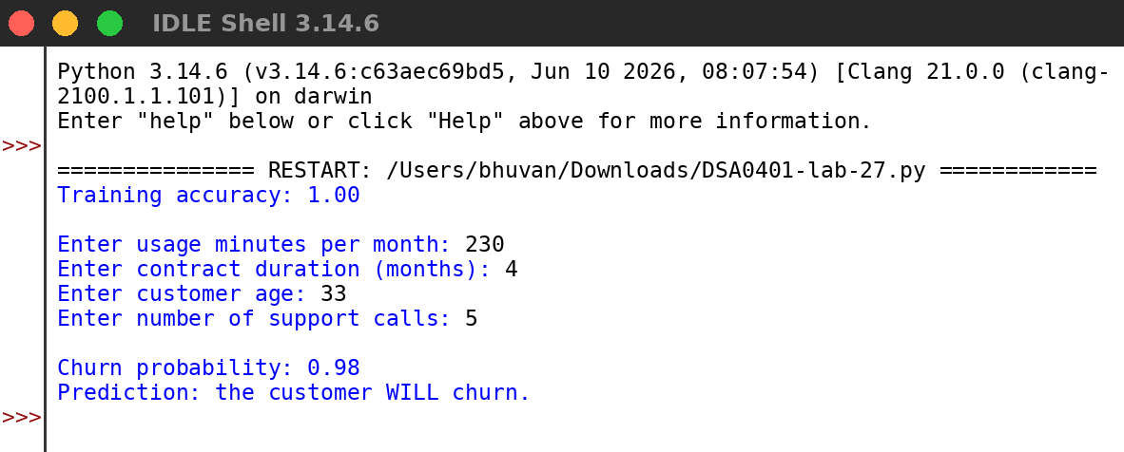
RESULT:
Thus the program was written and executed successfully and the output was verified.

