Fundamentals of Data Science - Lab Manual
Question 28
K-Means clustering to assign a new customer to a segment
AIM:
To write a Python program that groups customers into segments using K-Means clustering of scikit-learn and assigns a new customer to one of the existing segments.
ALGORITHM:
Step 1: Start the program and import Pandas, StandardScaler and KMeans.
Step 2: Load customer_data.csv (annual spend, visits per month, average basket value).
Step 3: Scale the features with StandardScaler.
Step 4: Create KMeans(n_clusters=3) and fit it to the scaled data.
Step 5: Display the centre of every segment in the original units.
Step 6: Read the features of the new customer, scale them and use predict() to find the segment.
Step 7: Display the segment number and stop.
PROGRAM:
import pandas as pd
from sklearn.preprocessing import StandardScaler
from sklearn.cluster import KMeans

df = pd.read_csv("customer_data.csv")

scaler = StandardScaler()
X_scaled = scaler.fit_transform(df)

kmeans = KMeans(n_clusters=3, n_init=10, random_state=42)
kmeans.fit(X_scaled)

centres = pd.DataFrame(scaler.inverse_transform(kmeans.cluster_centers_),
columns=df.columns).round(1)
centres.index.name = "segment"
print("Segment centres:")
print(centres)

spend = float(input("\nEnter annual spend: "))
visits = float(input("Enter visits per month: "))
basket = float(input("Enter average basket value: "))

new_customer = pd.DataFrame([[spend, visits, basket]], columns=df.columns)
segment = kmeans.predict(scaler.transform(new_customer))[0]

print(f"\nThe new customer belongs to segment {segment}.")
INPUT:
File: customer_data.csv (first 12 of 60 rows shown)
annual_spend | visits_per_month | avg_basket_value
42085 | 6 | 920
11804 | 1 | 351
43111 | 6 | 877
81474 | 8 | 2359
84782 | 13 | 1713
10992 | 1 | 324
86861 | 9 | 1933
47431 | 7 | 1232
47293 | 4 | 1014
10618 | 3 | 468
11307 | 3 | 316
41517 | 6 | 571

Values entered by the user at run time:
Prompt | Value entered
Enter annual spend | 50000
Enter visits per month | 7
Enter average basket value | 950

OUTPUT:
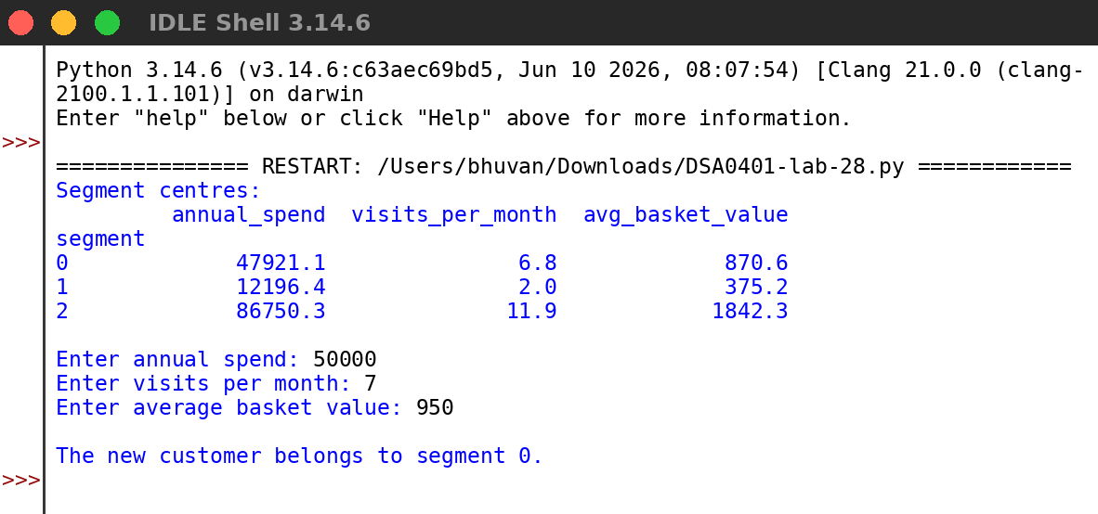
RESULT:
Thus the program was written and executed successfully and the output was verified.

