Fundamentals of Data Science - Lab Manual
Question 29
Evaluation metrics for model performance
AIM:
To write a Python program that trains a model on a scikit-learn dataset using the feature names and target name given by the user and calculates accuracy, precision, recall and F1-score on the test data.
ALGORITHM:
Step 1: Start the program and import the dataset, model and metric functions from scikit-learn.
Step 2: Load the breast cancer dataset as a DataFrame.
Step 3: Read the names of the feature columns and of the target variable from the user.
Step 4: Split the data into training (70%) and test (30%) sets.
Step 5: Train a logistic regression model (with feature scaling) on the training data.
Step 6: Predict the test data and calculate accuracy, precision, recall and F1-score.
Step 7: Display the metrics and stop.
PROGRAM:
import pandas as pd
from sklearn.datasets import load_breast_cancer
from sklearn.model_selection import train_test_split
from sklearn.preprocessing import StandardScaler
from sklearn.pipeline import make_pipeline
from sklearn.linear_model import LogisticRegression
from sklearn.metrics import accuracy_score, precision_score, recall_score, f1_score

data = load_breast_cancer(as_frame=True)
df = data.frame
print("Dataset: breast cancer,", df.shape[0], "rows and", df.shape[1], "columns")
print("Example feature names:", ", ".join(data.feature_names[:4]))
print("Target column name : target\n")

names = input("Enter feature names (comma separated): ")
features = [f.strip() for f in names.split(",")]
target = input("Enter the target variable name: ").strip()

X, y = df[features], df[target]
X_train, X_test, y_train, y_test = train_test_split(
X, y, test_size=0.3, random_state=42, stratify=y)

model = make_pipeline(StandardScaler(), LogisticRegression(max_iter=1000))
model.fit(X_train, y_train)
y_pred = model.predict(X_test)

print("\nEvaluation on the test data")
print(f"Accuracy : {accuracy_score(y_test, y_pred):.4f}")
print(f"Precision : {precision_score(y_test, y_pred):.4f}")
print(f"Recall : {recall_score(y_test, y_pred):.4f}")
print(f"F1-score : {f1_score(y_test, y_pred):.4f}")
INPUT:
Values entered by the user at run time:
Prompt | Value entered
Enter feature names (comma separated) | mean radius,mean texture,mean smoothness,mean area
Enter the target variable name | target

OUTPUT:
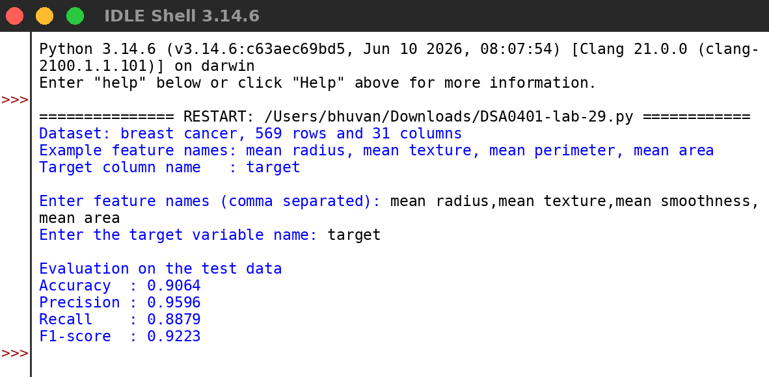
RESULT:
Thus the program was written and executed successfully and the output was verified.

