Fundamentals of Data Science - Lab Manual
Question 30
CART decision tree for used car price prediction
AIM:
To write a Python program that uses the CART algorithm (DecisionTreeRegressor) of scikit-learn to predict the price of a used car and to display the decision path followed for the new car.
ALGORITHM:
Step 1: Start the program and import Pandas and DecisionTreeRegressor.
Step 2: Load cars.csv (mileage, age, brand, engine type, price).
Step 3: Convert the categorical columns brand and engine_type into numbers using one-hot encoding (get_dummies).
Step 4: Train DecisionTreeRegressor(max_depth=3) on the data.
Step 5: Read the details of the new car from the user and encode them in the same way.
Step 6: Predict the price using model.predict().
Step 7: Use model.decision_path() to find the nodes visited and print the condition at every node.
Step 8: Display the predicted price and the decision path; stop.
PROGRAM:
import pandas as pd
from sklearn.tree import DecisionTreeRegressor

cars = pd.read_csv("cars.csv")
X = pd.get_dummies(cars.drop(columns="price"),
columns=["brand", "engine_type"]).astype(float)
y = cars["price"]

model = DecisionTreeRegressor(max_depth=3, random_state=42)
model.fit(X, y)

mileage = float(input("Enter mileage (km): "))
age = float(input("Enter age of the car (years): "))
brand = input("Enter brand (Toyota/Honda/Hyundai/Ford): ")
engine = input("Enter engine type (Petrol/Diesel/Electric): ")

new = pd.DataFrame([{"mileage": mileage, "age": age,
"brand": brand, "engine_type": engine}])
new = pd.get_dummies(new, columns=["brand", "engine_type"]).astype(float)
new = new.reindex(columns=X.columns, fill_value=0)

price = model.predict(new)[0]
print(f"\nPredicted price of the car: {price:,.0f}")

tree = model.tree_
print("\nDecision path:")
for node in model.decision_path(new).indices:
if tree.children_left[node] == tree.children_right[node]: # leaf node
print(f" Leaf node {node}: predicted price = {tree.value[node][0][0]:,.0f}")
else:
feature = X.columns[tree.feature[node]]
value = new.iloc[0][feature]
sign = "<=" if value <= tree.threshold[node] else ">"
threshold = tree.threshold[node]
print(f" Node {node}: {feature} = {value:g} {sign} {threshold:.1f}")
INPUT:
File: cars.csv (first 12 of 60 rows shown)
mileage | age | brand | engine_type | price
17157 | 3 | Toyota | Petrol | 27300
32116 | 3 | Hyundai | Petrol | 24500
91753 | 9 | Toyota | Diesel | 16600
54347 | 5 | Honda | Diesel | 21400
50960 | 3 | Hyundai | Diesel | 26000
15611 | 6 | Ford | Petrol | 21300
78590 | 9 | Honda | Diesel | 15700
73149 | 4 | Ford | Diesel | 20500
32888 | 1 | Hyundai | Diesel | 27900
95010 | 4 | Ford | Petrol | 18300
27154 | 8 | Hyundai | Electric | 24900
104771 | 4 | Honda | Diesel | 20600

Values entered by the user at run time:
Prompt | Value entered
Enter mileage (km) | 45000
Enter age of the car (years) | 4
Enter brand (Toyota/Honda/Hyundai/Ford) | Toyota
Enter engine type (Petrol/Diesel/Electric) | Petrol

OUTPUT:
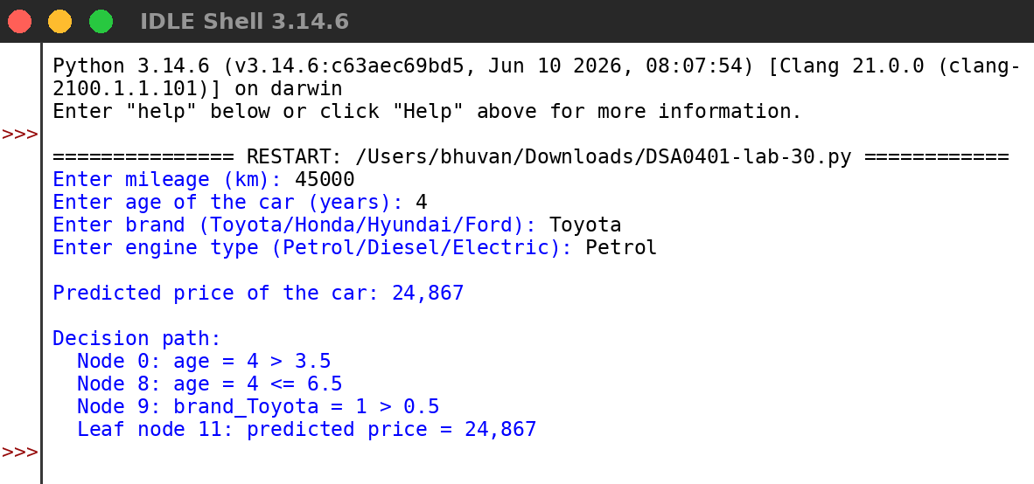
RESULT:
Thus the program was written and executed successfully and the output was verified.

