Fundamentals of Data Science - Lab Manual
Question 31
Customer segmentation using K-Means clustering
AIM:
To segment the customers of an e-commerce company into groups of similar behaviour using K-Means clustering so that the marketing team can target each segment.
ALGORITHM:
Step 1: Start the program and import Pandas, Matplotlib, StandardScaler, KMeans and silhouette_score.
Step 2: Load the customer data (age, annual income, spending score, purchase frequency).
Step 3: Scale the features with StandardScaler.
Step 4: For k = 2 to 8 fit K-Means and record the inertia (elbow method) and the silhouette score.
Step 5: Choose the k with the highest silhouette score and draw the elbow plot.
Step 6: Fit the final K-Means model, assign a segment to every customer and display the profile of each segment.
Step 7: Draw a scatter plot of annual income versus spending score coloured by segment, with the centroids.
Step 8: Stop the program.
PROGRAM:
import pandas as pd
import matplotlib.pyplot as plt
from sklearn.preprocessing import StandardScaler
from sklearn.cluster import KMeans
from sklearn.metrics import silhouette_score

df = pd.read_csv("customers_segmentation.csv")
features = ["age", "annual_income", "spending_score", "purchase_frequency"]
X = StandardScaler().fit_transform(df[features])

inertia, sil = [], {}
for k in range(2, 9):
km = KMeans(n_clusters=k, n_init=10, random_state=42).fit(X)
inertia.append(km.inertia_)
sil[k] = silhouette_score(X, km.labels_)
print(f"k = {k} inertia = {km.inertia_:7.2f} silhouette = {sil[k]:.3f}")

best_k = max(sil, key=sil.get)
print("\nBest number of clusters (highest silhouette):", best_k)

plt.figure(figsize=(6, 4))
plt.plot(range(2, 9), inertia, marker="o")
plt.title("Elbow method")
plt.xlabel("Number of clusters k")
plt.ylabel("Inertia")
plt.show()

kmeans = KMeans(n_clusters=best_k, n_init=10, random_state=42)
df["segment"] = kmeans.fit_predict(X)

print("\nSegment profile (mean values)")
profile = df.groupby("segment")[features].mean().round(1)
profile["customers"] = df["segment"].value_counts().sort_index()
print(profile)

plt.figure(figsize=(7, 5))
plt.scatter(df["annual_income"], df["spending_score"],
c=df["segment"], cmap="viridis")
plt.title("Customer segments")
plt.xlabel("Annual income (thousands)")
plt.ylabel("Spending score")
plt.show()
INPUT:
File: customers_segmentation.csv (first 12 of 100 rows shown)
customer_id | age | annual_income | spending_score | purchase_frequency
1 | 23 | 33 | 86 | 13
2 | 50 | 78 | 18 | 2
3 | 61 | 42 | 13 | 3
4 | 21 | 34 | 75 | 11
5 | 42 | 89 | 72 | 16
6 | 23 | 23 | 69 | 16
7 | 45 | 70 | 28 | 4
8 | 30 | 31 | 70 | 13
9 | 29 | 90 | 58 | 15
10 | 35 | 91 | 87 | 14
11 | 43 | 66 | 24 | 1
12 | 26 | 26 | 75 | 12

OUTPUT:
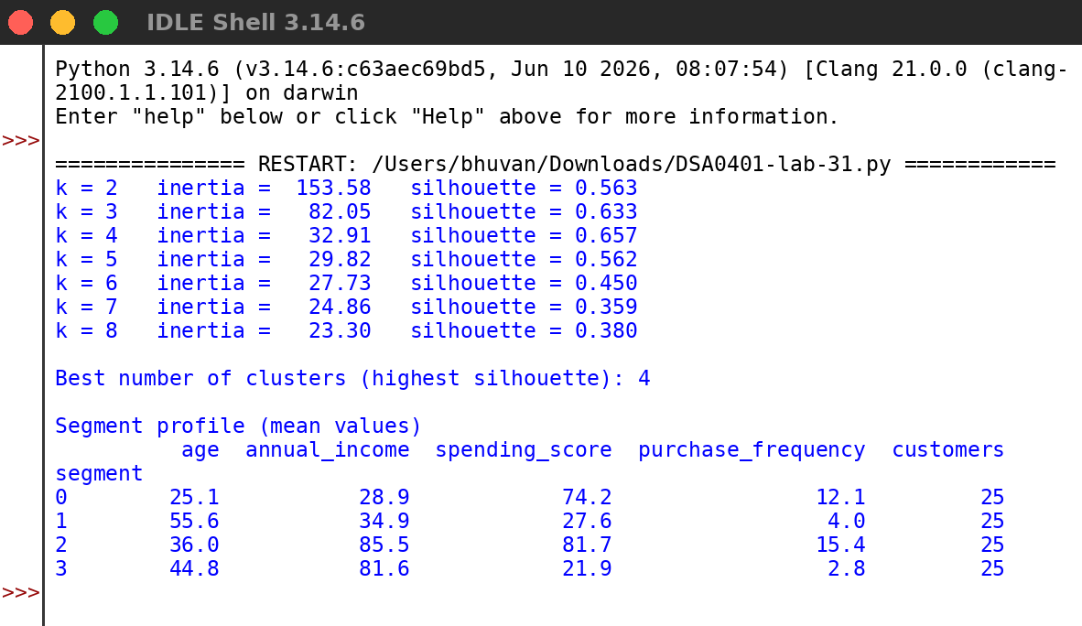
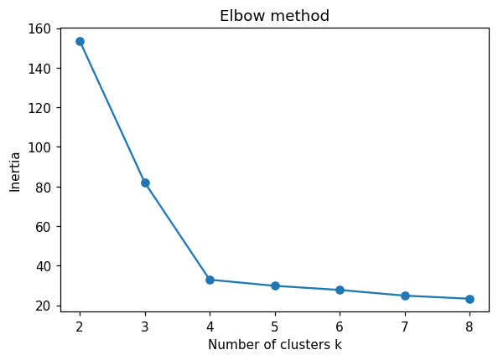
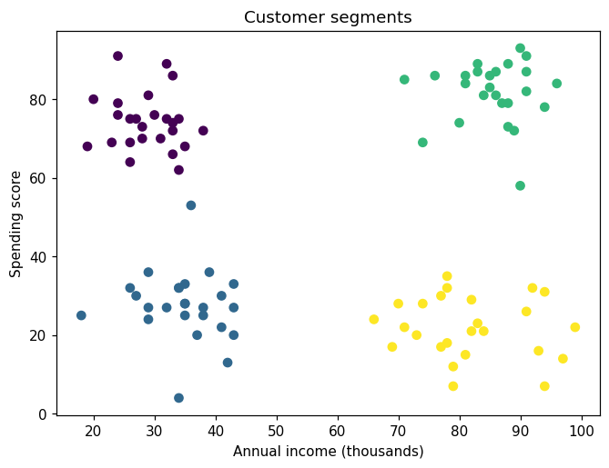
RESULT:
Thus the program was written and executed successfully and the output was verified.

