Fundamentals of Data Science - Lab Manual
Question 32
Bivariate analysis and linear regression of house price
AIM:
To perform bivariate analysis between house size and price and to build and evaluate a simple linear regression model that predicts the house price.
ALGORITHM:
Step 1: Start the program and import Pandas, NumPy, Matplotlib and scikit-learn.
Step 2: Load house_data.csv (size_sqft, price).
Step 3: Bivariate analysis: calculate the correlation coefficient and draw a scatter plot of size versus price.
Step 4: Split the data into training (80%) and testing (20%) sets.
Step 5: Train LinearRegression on the training data and display the slope and the intercept.
Step 6: Evaluate the model on the test data using R-squared, MAE and RMSE.
Step 7: Plot the regression line over the test data and predict the price of a 2000 sq.ft house.
Step 8: Stop the program.
PROGRAM:
import pandas as pd
import numpy as np
import matplotlib.pyplot as plt
from sklearn.model_selection import train_test_split
from sklearn.linear_model import LinearRegression
from sklearn.metrics import r2_score, mean_absolute_error, mean_squared_error

df = pd.read_csv("house_data.csv")

# bivariate analysis
corr = df["size_sqft"].corr(df["price"])
print("Correlation between size and price:", round(corr, 4))
plt.figure(figsize=(6, 4.5))
plt.scatter(df["size_sqft"], df["price"], color="teal")
plt.title("House size vs price")
plt.xlabel("Size (sq.ft)")
plt.ylabel("Price")
plt.show()

X = df[["size_sqft"]]
y = df["price"]
X_train, X_test, y_train, y_test = train_test_split(
X, y, test_size=0.2, random_state=42)

model = LinearRegression().fit(X_train, y_train)
print(f"Slope : {model.coef_[0]:.2f}")
print(f"Intercept : {model.intercept_:.2f}")

y_pred = model.predict(X_test)
print("\nModel evaluation on test data")
print(f"R-squared : {r2_score(y_test, y_pred):.4f}")
print(f"MAE : {mean_absolute_error(y_test, y_pred):.2f}")
print(f"RMSE : {np.sqrt(mean_squared_error(y_test, y_pred)):.2f}")

plt.figure(figsize=(6, 4.5))
plt.scatter(X_test, y_test, color="teal", label="Actual")
plt.plot(X_test, y_pred, color="red", label="Regression line")
plt.title("Linear regression - test data")
plt.xlabel("Size (sq.ft)")
plt.ylabel("Price")
plt.legend()
plt.show()

new_size = pd.DataFrame({"size_sqft": [2000]})
print(f"\nPredicted price of a 2000 sq.ft house: {model.predict(new_size)[0]:,.2f}")
INPUT:
File: house_data.csv (first 12 of 40 rows shown)
size_sqft | price
3146 | 434600
1064 | 144700
3091 | 398900
2259 | 281100
1827 | 230600
1693 | 219300
1420 | 211800
1536 | 239800
2495 | 338000
2591 | 322100
1631 | 290600
3419 | 456300

OUTPUT:
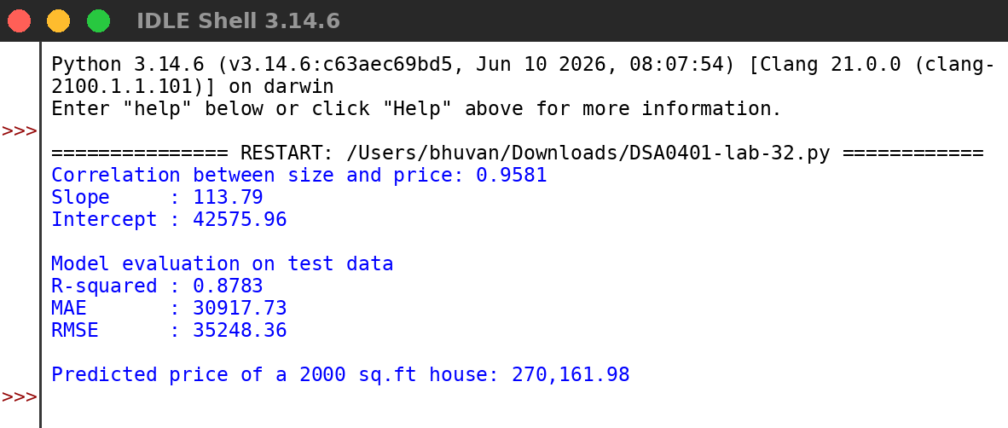
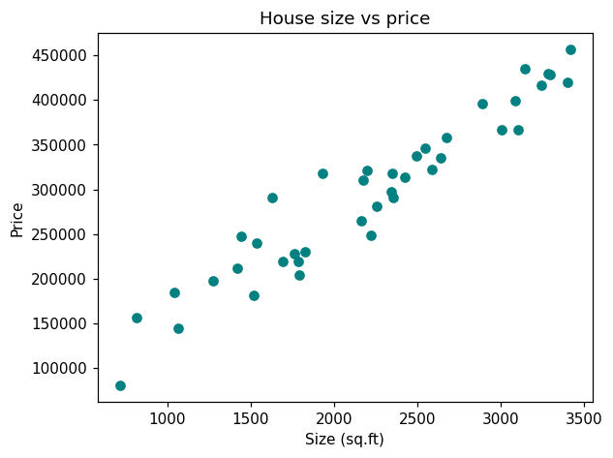
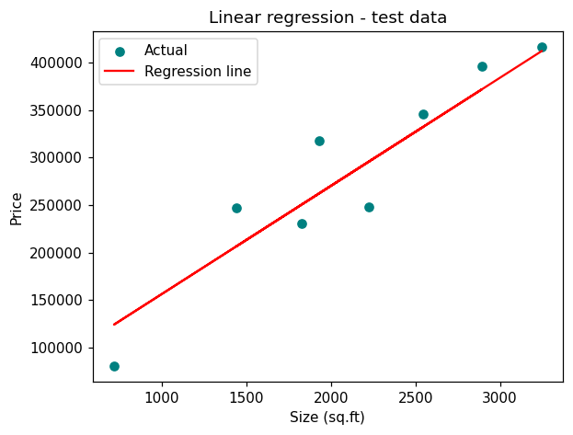
RESULT:
Thus the program was written and executed successfully and the output was verified.

