Fundamentals of Data Science - Lab Manual
Question 33
Multiple linear regression for car price prediction
AIM:
To build a multiple linear regression model that predicts car prices from engine size, horsepower and fuel efficiency, to evaluate it and to find the most influential factor affecting the price.
ALGORITHM:
Step 1: Start the program and import Pandas, NumPy, Matplotlib and scikit-learn.
Step 2: Load cars_features.csv; the features are engine_size, horsepower and fuel_efficiency, the target is price.
Step 3: Split the data into training (80%) and testing (20%) sets and train LinearRegression.
Step 4: Evaluate the model on the test data using R-squared, MAE and RMSE.
Step 5: Standardise the features and fit the model again; the absolute standardised coefficients show the influence of each feature.
Step 6: Display the influence of each feature, name the most influential factor and draw a bar chart.
Step 7: Stop the program.
PROGRAM:
import pandas as pd
import numpy as np
import matplotlib.pyplot as plt
from sklearn.model_selection import train_test_split
from sklearn.linear_model import LinearRegression
from sklearn.preprocessing import StandardScaler
from sklearn.metrics import r2_score, mean_absolute_error, mean_squared_error

df = pd.read_csv("cars_features.csv")
X = df[["engine_size", "horsepower", "fuel_efficiency"]]
y = df["price"]

X_train, X_test, y_train, y_test = train_test_split(
X, y, test_size=0.2, random_state=42)
model = LinearRegression().fit(X_train, y_train)
y_pred = model.predict(X_test)

print("Model evaluation on test data")
print(f"R-squared : {r2_score(y_test, y_pred):.4f}")
print(f"MAE : {mean_absolute_error(y_test, y_pred):.2f}")
print(f"RMSE : {np.sqrt(mean_squared_error(y_test, y_pred)):.2f}")

# influence of each factor: coefficients of standardised features
X_std = StandardScaler().fit_transform(X)
std_model = LinearRegression().fit(X_std, y)
influence = pd.Series(std_model.coef_, index=X.columns)

print("\nStandardised coefficients (influence on price)")
print(influence.round(2))
print("\nMost influential factor:", influence.abs().idxmax())

influence.plot(kind="bar", color="slateblue", figsize=(6, 4))
plt.title("Influence of each feature on car price")
plt.ylabel("Standardised coefficient")
plt.xticks(rotation=0)
plt.show()
INPUT:
File: cars_features.csv (first 12 of 60 rows shown)
engine_size | horsepower | fuel_efficiency | price
2.8 | 156 | 27.7 | 24100
3.3 | 178 | 22.6 | 27400
4.6 | 264 | 18.1 | 43900
2.0 | 124 | 30.6 | 19500
3.4 | 212 | 22.6 | 33500
2.4 | 144 | 24.5 | 22300
4.0 | 224 | 16.0 | 36900
3.2 | 205 | 26.3 | 28900
1.8 | 131 | 36.4 | 15500
3.1 | 167 | 21.4 | 25000
2.0 | 133 | 33.4 | 18700
1.2 | 125 | 38.3 | 11900

OUTPUT:
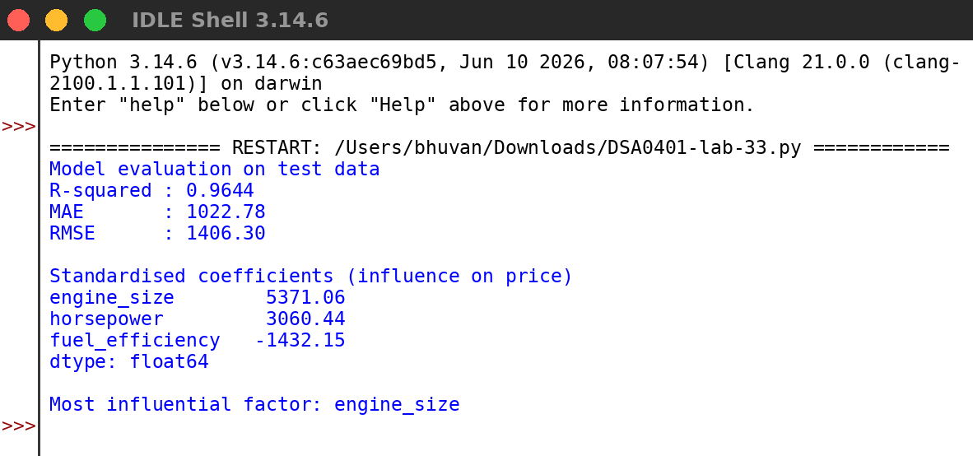
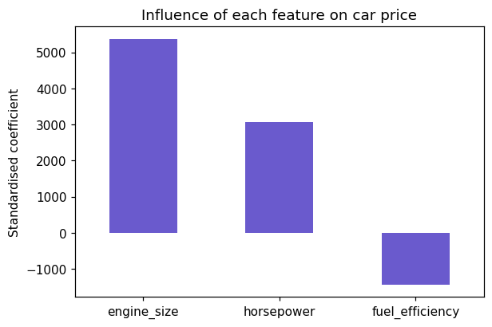
RESULT:
Thus the program was written and executed successfully and the output was verified.

