Fundamentals of Data Science - Lab Manual
Question 34
KNN classification of treatment outcome
AIM:
To build a KNN classification model that predicts the treatment outcome (Good / Bad) of a patient and to evaluate it using accuracy, precision, recall and F1-score.
ALGORITHM:
Step 1: Start the program and import Pandas and scikit-learn.
Step 2: Load treatment.csv; convert gender to numbers (Male = 0, Female = 1).
Step 3: Separate the features (age, gender, blood pressure, cholesterol) and the target (outcome).
Step 4: Split into training (75%) and test (25%) sets and scale the features.
Step 5: Train KNeighborsClassifier(n_neighbors=5) and predict the test set.
Step 6: Calculate accuracy, precision, recall and F1-score (positive class = "Good") and the confusion matrix.
Step 7: Display the actual and predicted outcome of the test patients and stop.
PROGRAM:
import pandas as pd
from sklearn.model_selection import train_test_split
from sklearn.preprocessing import StandardScaler
from sklearn.neighbors import KNeighborsClassifier
from sklearn.metrics import (accuracy_score, precision_score, recall_score,
f1_score, confusion_matrix)

df = pd.read_csv("treatment.csv")
df["gender"] = df["gender"].map({"Male": 0, "Female": 1})

X = df.drop(columns="outcome")
y = df["outcome"]
X_train, X_test, y_train, y_test = train_test_split(
X, y, test_size=0.25, random_state=42, stratify=y)

scaler = StandardScaler()
X_train_s = scaler.fit_transform(X_train)
X_test_s = scaler.transform(X_test)

knn = KNeighborsClassifier(n_neighbors=5)
knn.fit(X_train_s, y_train)
y_pred = knn.predict(X_test_s)

print("Evaluation on the test set")
print(f"Accuracy : {accuracy_score(y_test, y_pred):.4f}")
print(f"Precision : {precision_score(y_test, y_pred, pos_label='Good'):.4f}")
print(f"Recall : {recall_score(y_test, y_pred, pos_label='Good'):.4f}")
print(f"F1-score : {f1_score(y_test, y_pred, pos_label='Good'):.4f}")
print("\nConfusion matrix (rows = actual, columns = predicted; Bad, Good)")
print(confusion_matrix(y_test, y_pred, labels=["Bad", "Good"]))

results = X_test.copy()
results["actual"] = y_test
results["predicted"] = y_pred
print("\nPredictions on the test set")
print(results.to_string())
INPUT:
File: treatment.csv (first 12 of 80 rows shown)
age | gender | blood_pressure | cholesterol | outcome
44 | Male | 129 | 208 | Bad
70 | Male | 136 | 223 | Bad
50 | Male | 130 | 173 | Good
51 | Female | 136 | 179 | Good
30 | Male | 140 | 271 | Bad
58 | Male | 118 | 208 | Bad
52 | Male | 138 | 225 | Bad
45 | Female | 115 | 184 | Good
64 | Male | 118 | 209 | Bad
57 | Male | 108 | 224 | Good
46 | Male | 122 | 210 | Good
35 | Female | 111 | 152 | Good

OUTPUT:
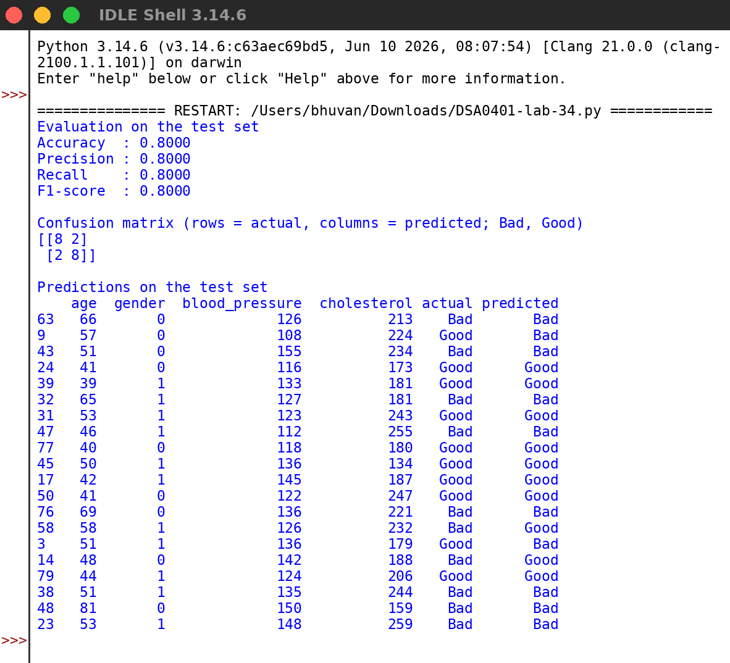
RESULT:
Thus the program was written and executed successfully and the output was verified.

