Fundamentals of Data Science - Lab Manual
Question 35
K-Means clustering of retail customers by spending pattern
AIM:
To group the customers of a retail company into distinct segments based on the total amount spent and the frequency of visits using the K-Means algorithm.
ALGORITHM:
Step 1: Start the program and import Pandas, Matplotlib, StandardScaler and KMeans.
Step 2: Load transactions.csv (customer ID, total amount spent, frequency of visits).
Step 3: Scale the two spending features with StandardScaler.
Step 4: Create KMeans(n_clusters=3) and fit it to the scaled data.
Step 5: Add the cluster label to every customer and display the summary of each segment.
Step 6: Draw a scatter plot of the segments with the centroids.
Step 7: Stop the program.
PROGRAM:
import pandas as pd
import matplotlib.pyplot as plt
from sklearn.preprocessing import StandardScaler
from sklearn.cluster import KMeans

df = pd.read_csv("transactions.csv")
features = ["total_spent", "visit_frequency"]

scaler = StandardScaler()
X = scaler.fit_transform(df[features])

kmeans = KMeans(n_clusters=3, n_init=10, random_state=42)
df["segment"] = kmeans.fit_predict(X)

print(df.head(10))

summary = df.groupby("segment").agg(customers=("customer_id", "count"),
avg_spent=("total_spent", "mean"),
avg_visits=("visit_frequency", "mean")).round(1)
print("\nSegment summary")
print(summary)

centres = scaler.inverse_transform(kmeans.cluster_centers_)
plt.figure(figsize=(7, 5))
plt.scatter(df["total_spent"], df["visit_frequency"], c=df["segment"], cmap="viridis")
plt.scatter(centres[:, 0], centres[:, 1], c="red", marker="X", s=200,
label="Centroids")
plt.title("Customer segments")
plt.xlabel("Total amount spent")
plt.ylabel("Frequency of visits")
plt.legend()
plt.show()
INPUT:
File: transactions.csv (first 12 of 60 rows shown)
customer_id | total_spent | visit_frequency
1 | 4936 | 11
2 | 5203 | 11
3 | 11442 | 35
4 | 17929 | 30
5 | 6310 | 13
6 | 6309 | 11
7 | 10253 | 21
8 | 1477 | 2
9 | 5724 | 8
10 | 7155 | 13
11 | 1757 | 5
12 | 4503 | 14

OUTPUT:
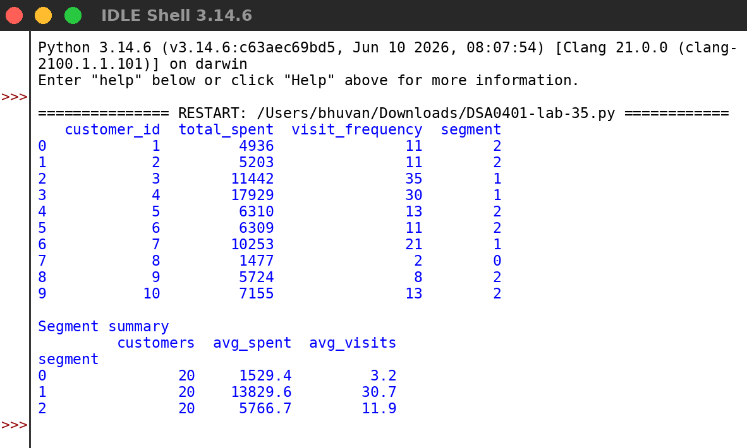
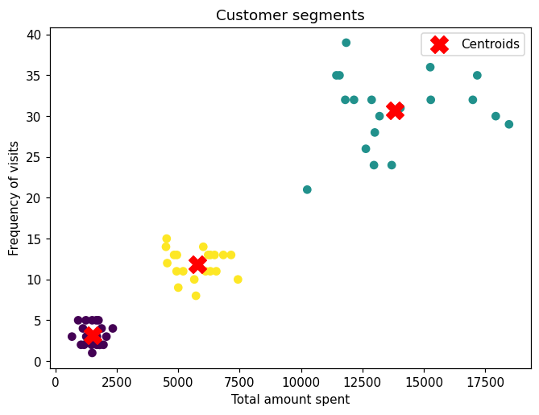
RESULT:
Thus the program was written and executed successfully and the output was verified.

