Fundamentals of Data Science - Lab Manual
Question 36
Variability of stock prices
AIM:
To write a Python program that reads the stock data from a CSV file, calculates the variability of the stock prices and gives insights into the price movements.
ALGORITHM:
Step 1: Start the program and import Pandas and Matplotlib.
Step 2: Read stock_data.csv (date, closing price) into a DataFrame.
Step 3: Calculate the mean, variance, standard deviation, range and coefficient of variation of the closing price.
Step 4: Calculate the daily percentage returns with pct_change() and their standard deviation (volatility).
Step 5: Find the days of the largest daily gain and the largest daily loss.
Step 6: Plot the closing price with the mean line and the +/- 1 standard deviation band, and a histogram of the daily returns.
Step 7: Stop the program.
PROGRAM:
import pandas as pd
import matplotlib.pyplot as plt

df = pd.read_csv("stock_data.csv", parse_dates=["date"])
price = df["close"]
returns = price.pct_change() * 100 # daily return in %

print("Number of trading days :", len(df))
print(f"Mean closing price : {price.mean():.2f}")
print(f"Variance : {price.var():.2f}")
print(f"Standard deviation : {price.std():.2f}")
print(f"Range (max - min) : {price.max() - price.min():.2f}")
print(f"Coefficient of variation : {price.std() / price.mean() * 100:.2f}%")
print(f"Daily volatility (std of returns): {returns.std():.2f}%")

best, worst = returns.idxmax(), returns.idxmin()
print(f"\nLargest daily gain : {returns[best]:.2f}% on {df.loc[best, 'date'].date()}")
print(f"Largest daily loss : {returns[worst]:.2f}% on {df.loc[worst, 'date'].date()}")
print("Overall change :", f"{(price.iloc[-1] / price.iloc[0] - 1) * 100:.2f}%")

fig, ax = plt.subplots(1, 2, figsize=(11, 4))
ax[0].plot(df["date"], price, color="blue", label="Closing price")
ax[0].axhline(price.mean(), color="red", linestyle="--", label="Mean")
ax[0].fill_between(df["date"], price.mean() - price.std(), price.mean() + price.std(),
color="orange", alpha=0.25, label="+/- 1 std")
ax[0].set_title("Closing price")
ax[0].tick_params(axis="x", rotation=30)
ax[0].legend()
ax[1].hist(returns.dropna(), bins=12, color="green", edgecolor="black")
ax[1].set_title("Distribution of daily returns (%)")
plt.tight_layout()
plt.show()
INPUT:
File: stock_data.csv (first 12 of 60 rows shown)
date | close
2026-07-01 | 147.67
2026-07-02 | 147.18
2026-07-03 | 146.75
2026-07-06 | 146.37
2026-07-07 | 149.0
2026-07-08 | 149.45
2026-07-09 | 150.41
2026-07-10 | 150.57
2026-07-13 | 148.7
2026-07-14 | 149.23
2026-07-15 | 151.02
2026-07-16 | 151.44

OUTPUT:
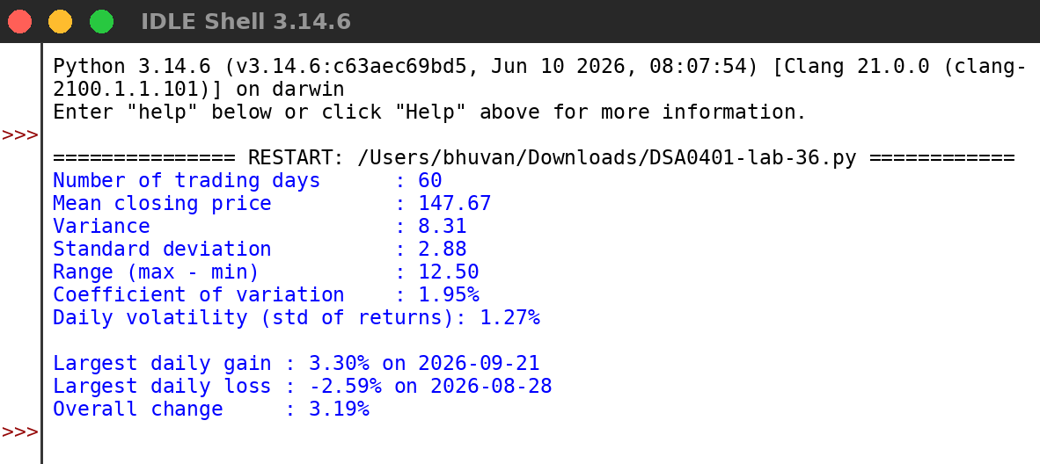
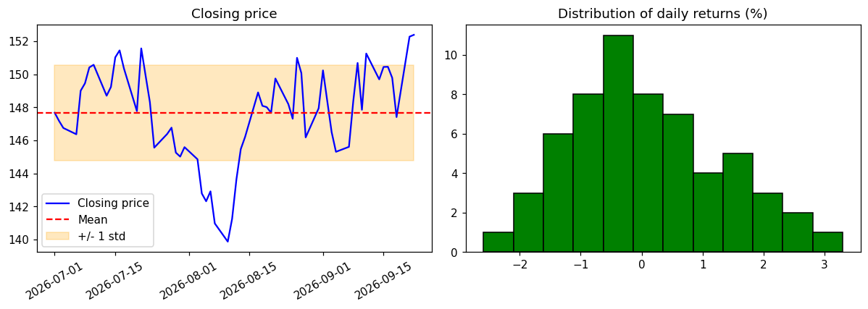
RESULT:
Thus the program was written and executed successfully and the output was verified.

