Fundamentals of Data Science - Lab Manual
Question 37
Correlation between study time and exam scores
AIM:
To identify the correlation between the study time and the exam scores of students and to visualise the relationship using various plotting functions.
ALGORITHM:
Step 1: Start the program and import Pandas, NumPy and Matplotlib.
Step 2: Load study_data.csv (study hours, exam score).
Step 3: Calculate the Pearson and Spearman correlation coefficients and interpret the strength.
Step 4: Fit the best-fit line using np.polyfit().
Step 5: Draw four plots in one figure: scatter plot, scatter plot with the best-fit line, bar chart of the average score for each study-time group and a correlation heat map.
Step 6: Stop the program.
PROGRAM:
import pandas as pd
import numpy as np
import matplotlib.pyplot as plt

df = pd.read_csv("study_data.csv")

pearson = df["hours"].corr(df["score"])
spearman = df["hours"].corr(df["score"], method="spearman")
print(f"Pearson correlation : {pearson:.4f}")
print(f"Spearman correlation : {spearman:.4f}")
r = abs(pearson)
strength = "strong" if r > 0.7 else "moderate" if r > 0.4 else "weak"
direction = "positive" if pearson > 0 else "negative"
print(f"Interpretation: {strength} {direction} correlation")

slope, intercept = np.polyfit(df["hours"], df["score"], 1)
print(f"Best-fit line: score = {slope:.2f} x hours + {intercept:.2f}")

fig, ax = plt.subplots(2, 2, figsize=(10, 8))

ax[0, 0].scatter(df["hours"], df["score"], color="crimson")
ax[0, 0].set_title("Scatter plot")

ax[0, 1].scatter(df["hours"], df["score"], color="crimson")
x = np.linspace(df["hours"].min(), df["hours"].max(), 50)
ax[0, 1].plot(x, slope * x + intercept, color="black")
ax[0, 1].set_title("Scatter plot with best-fit line")

groups = pd.cut(df["hours"], bins=[0, 3, 6, 10], labels=["0-3 h", "3-6 h", "6-10 h"])
avg_score = df.groupby(groups, observed=True)["score"].mean()
avg_score.plot(kind="bar", ax=ax[1, 0], color="teal")
ax[1, 0].set_title("Average score by study time")
ax[1, 0].tick_params(axis="x", rotation=0)

corr = df.corr()
im = ax[1, 1].imshow(corr, cmap="coolwarm", vmin=-1, vmax=1)
ax[1, 1].set_xticks([0, 1]); ax[1, 1].set_xticklabels(corr.columns)
ax[1, 1].set_yticks([0, 1]); ax[1, 1].set_yticklabels(corr.columns)
for i in range(2):
for j in range(2):
ax[1, 1].text(j, i, f"{corr.iloc[i, j]:.2f}", ha="center", va="center")
ax[1, 1].set_title("Correlation heat map")
for a in (ax[0, 0], ax[0, 1]):
a.set_xlabel("Study time (hours)"); a.set_ylabel("Exam score")
plt.tight_layout()
plt.show()
INPUT:
File: study_data.csv (first 12 of 25 rows shown)
hours | score
7.3 | 80
7.0 | 71
1.6 | 50
7.3 | 75
3.9 | 71
5.1 | 69
9.8 | 95
1.6 | 49
2.7 | 49
2.0 | 49
8.6 | 88
7.3 | 85

OUTPUT:
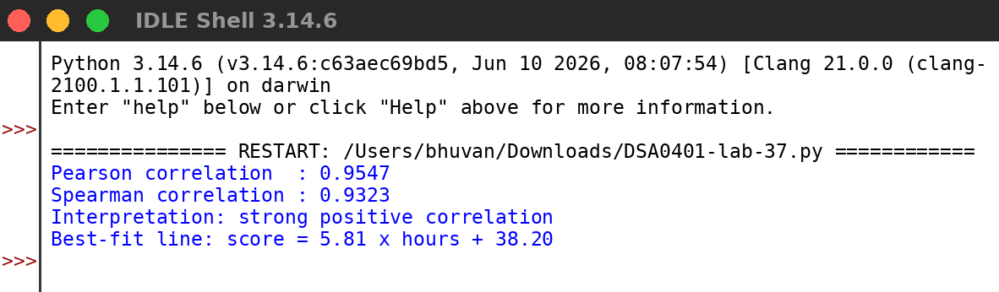
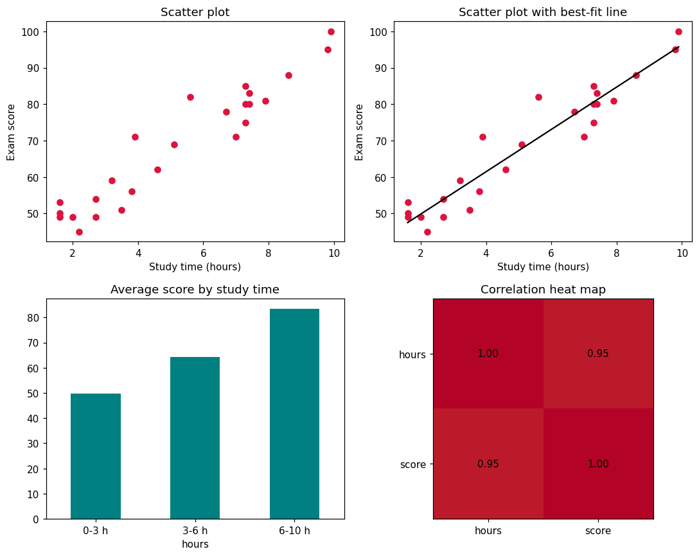
RESULT:
Thus the program was written and executed successfully and the output was verified.

