Fundamentals of Data Science - Lab Manual
Question 38
Temperature variability of different cities
AIM:
To write a Python program that reads the daily temperature readings of several cities for a year and finds the mean, standard deviation, temperature range, the city with the highest range and the city with the most consistent temperature.
ALGORITHM:
Step 1: Start the program and import Pandas.
Step 2: Read temperatures.csv (one column of daily readings for each city).
Step 3: Calculate the mean temperature of each city using mean().
Step 4: Calculate the standard deviation of each city using std().
Step 5: Calculate the temperature range = maximum - minimum for each city.
Step 6: Find the city with the largest range using idxmax() and the city with the smallest standard deviation using idxmin().
Step 7: Display the results and stop.
PROGRAM:
import pandas as pd

df = pd.read_csv("temperatures.csv")
cities = df.columns[1:] # first column is the date

summary = pd.DataFrame({
"Mean": df[cities].mean(),
"Std Dev": df[cities].std(),
"Max": df[cities].max(),
"Min": df[cities].min()})
summary["Range"] = summary["Max"] - summary["Min"]

print(summary.round(2))

print("\n1. Mean temperature of each city")
print(summary["Mean"].round(2).to_string())
print("\n2. Standard deviation of temperature of each city")
print(summary["Std Dev"].round(2).to_string())

hottest_range = summary["Range"].idxmax()
consistent = summary["Std Dev"].idxmin()
print(f"\n3. City with the highest temperature range: {hottest_range} "
f"({summary.loc[hottest_range, 'Range']:.1f} degrees)")
print(f"4. City with the most consistent temperature: {consistent} "
f"(std = {summary.loc[consistent, 'Std Dev']:.2f})")
INPUT:
File: temperatures.csv (first 12 of 365 rows shown)
date | Chennai | Delhi | Mumbai | Bengaluru | Shimla
2026-01-01 | 27.4 | 15.1 | 24.3 | 21.2 | 6.4
2026-01-02 | 25.8 | 13.5 | 26.3 | 22.7 | 6.1
2026-01-03 | 26.0 | 16.9 | 23.8 | 18.8 | 1.6
2026-01-04 | 26.7 | 13.2 | 24.4 | 21.5 | 1.9
2026-01-05 | 26.2 | 11.9 | 26.4 | 20.8 | 3.3
2026-01-06 | 27.4 | 14.1 | 24.6 | 20.4 | 6.7
2026-01-07 | 24.2 | 13.6 | 24.9 | 24.1 | 1.5
2026-01-08 | 26.7 | 11.1 | 24.6 | 18.9 | 7.7
2026-01-09 | 25.7 | 10.4 | 26.6 | 18.7 | 4.8
2026-01-10 | 27.1 | 17.3 | 25.1 | 20.3 | 4.2
2026-01-11 | 27.1 | 11.4 | 25.2 | 23.1 | 7.0
2026-01-12 | 26.6 | 16.8 | 23.9 | 20.7 | 4.3

OUTPUT:
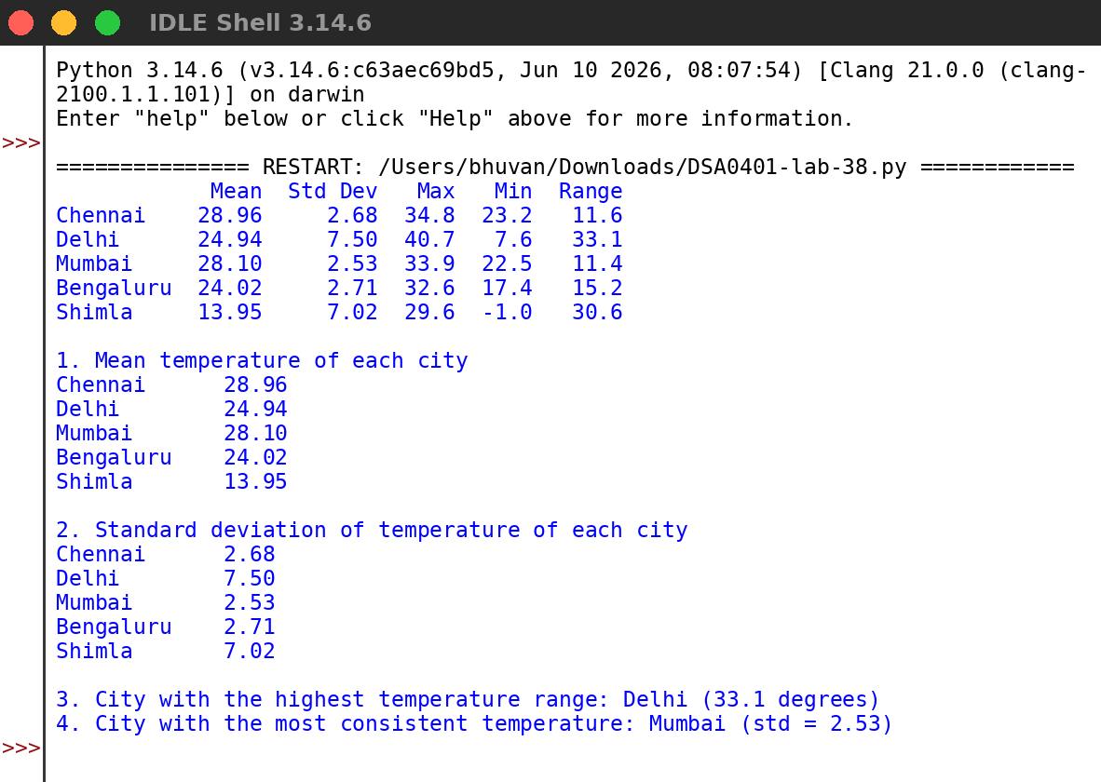
RESULT:
Thus the program was written and executed successfully and the output was verified.

