Fundamentals of Data Science - Lab Manual
Question 39
K-Means clustering and visualisation of spending behaviour
AIM:
To group the customers of an e-commerce company by their spending and purchase behaviour using the K-Means algorithm and to visualise the clusters using a scatter plot.
ALGORITHM:
Step 1: Start the program and import Pandas, Matplotlib, StandardScaler and KMeans.
Step 2: Load purchases.csv (customer ID, total amount spent, number of items purchased).
Step 3: Scale the features with StandardScaler.
Step 4: Fit KMeans(n_clusters=4) and assign a cluster label to each customer.
Step 5: Display the number of customers and the average spend and items of each cluster.
Step 6: Draw a scatter plot with a different colour for each cluster and mark the centroids.
Step 7: Stop the program.
PROGRAM:
import pandas as pd
import matplotlib.pyplot as plt
from sklearn.preprocessing import StandardScaler
from sklearn.cluster import KMeans

df = pd.read_csv("purchases.csv")
features = ["total_amount", "items_purchased"]

scaler = StandardScaler()
X = scaler.fit_transform(df[features])

kmeans = KMeans(n_clusters=4, n_init=10, random_state=42)
df["cluster"] = kmeans.fit_predict(X)

summary = df.groupby("cluster").agg(customers=("customer_id", "count"),
avg_amount=("total_amount", "mean"),
avg_items=("items_purchased", "mean")).round(1)
print("Cluster summary")
print(summary)

centres = scaler.inverse_transform(kmeans.cluster_centers_)
plt.figure(figsize=(7, 5))
plt.scatter(df["total_amount"], df["items_purchased"], c=df["cluster"], cmap="tab10")
plt.scatter(centres[:, 0], centres[:, 1], c="black", marker="X", s=200,
label="Centroids")
plt.title("Customer clusters by spending and purchase behaviour")
plt.xlabel("Total amount spent")
plt.ylabel("Number of items purchased")
plt.legend()
plt.show()
INPUT:
File: purchases.csv (first 12 of 80 rows shown)
customer_id | total_amount | items_purchased
1 | 9248 | 6
2 | 4029 | 13
3 | 2738 | 15
4 | 11774 | 32
5 | 856 | 6
6 | 4306 | 17
7 | 8652 | 9
8 | 9624 | 10
9 | 3465 | 14
10 | 4453 | 17
11 | 4610 | 20
12 | 777 | 4

OUTPUT:
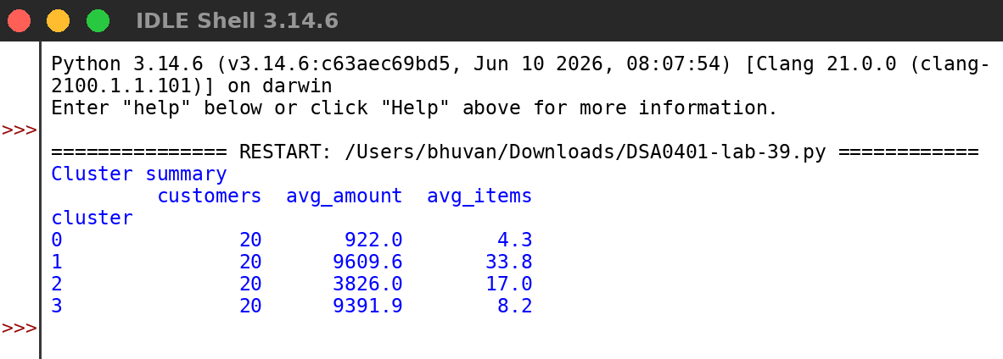
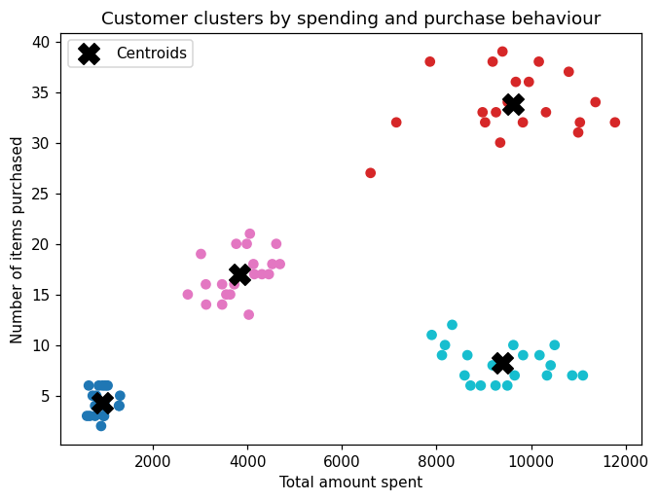
RESULT:
Thus the program was written and executed successfully and the output was verified.

