Fundamentals of Data Science - Lab Manual
Question 40
Soccer players data analysis
AIM:
To read the soccer players data from a CSV file into a Pandas DataFrame and to find the top 5 goal scorers, the top 5 highest paid players, the average age, the players above the average age and to plot the distribution of players by position.
ALGORITHM:
Step 1: Start the program and import Pandas and Matplotlib.
Step 2: Read players.csv into a DataFrame.
Step 3: Find the top 5 players with the most goals using nlargest(5, "goals").
Step 4: Find the top 5 players with the highest weekly salary using nlargest(5, "weekly_salary").
Step 5: Calculate the average age and select the players whose age is above the average.
Step 6: Count the players in each position with value_counts() and draw a bar chart.
Step 7: Stop the program.
PROGRAM:
import pandas as pd
import matplotlib.pyplot as plt

players = pd.read_csv("players.csv")

print("Top 5 players by goals scored")
print(players.nlargest(5, "goals")[["name", "goals"]].to_string(index=False))

print("\nTop 5 players by weekly salary")
top_pay = players.nlargest(5, "weekly_salary")[["name", "weekly_salary"]]
print(top_pay.to_string(index=False))

avg_age = players["age"].mean()
print(f"\nAverage age of the players: {avg_age:.2f}")

print("\nPlayers above the average age")
print(players[players["age"] > avg_age][["name", "age"]].to_string(index=False))

position_count = players["position"].value_counts()
position_count.plot(kind="bar", color="seagreen", figsize=(6, 4))
plt.title("Distribution of players by position")
plt.xlabel("Position")
plt.ylabel("Number of players")
plt.xticks(rotation=0)
plt.show()
INPUT:
File: players.csv (first 12 of 15 rows shown)
name | age | position | goals | weekly_salary
Arjun Mehta | 24 | Forward | 18 | 45000
Rohan Das | 29 | Midfielder | 9 | 32000
Karan Iyer | 31 | Defender | 3 | 28000
Vikram Rao | 22 | Forward | 15 | 38000
Sameer Khan | 27 | Midfielder | 11 | 35000
Dev Patel | 33 | Goalkeeper | 0 | 30000
Nikhil Shah | 25 | Forward | 12 | 36000
Aman Verma | 30 | Defender | 4 | 27000
Rahul Nair | 28 | Midfielder | 7 | 31000
Imran Ali | 21 | Forward | 10 | 33000
Suresh Kumar | 26 | Defender | 2 | 25000
Ajay Singh | 34 | Goalkeeper | 0 | 29000

OUTPUT:
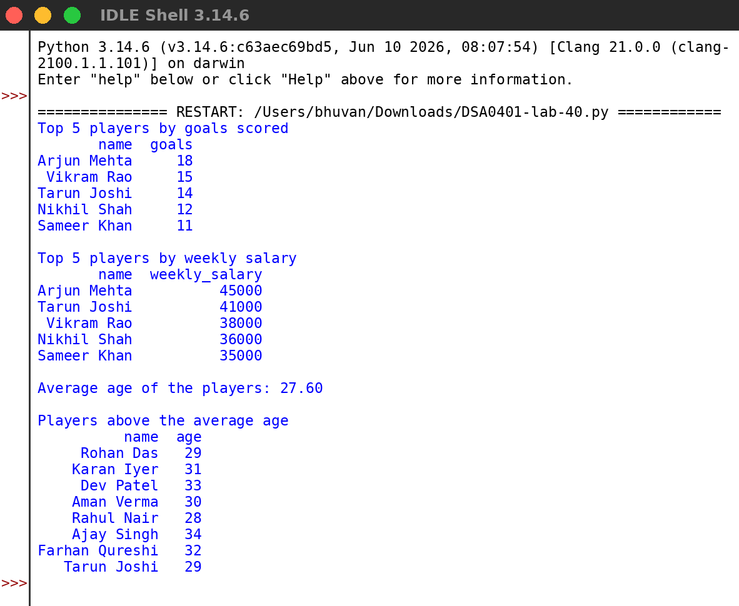
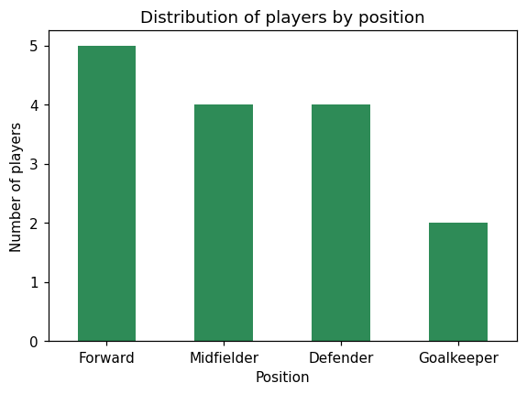
RESULT:
Thus the program was written and executed successfully and the output was verified.

