NAME :Krishnan Gupta M
REG NUM:192524062
COURSE CODE :DSA0103
Q1 – Call by Value, Reference and Pointer (6 Marks)
1. Aim
To implement call by value, call by reference, and call by pointer in C++ and understand how they modify variables.
2. Program 1: Call by Value, Reference and Pointer
#include <iostream>
using namespace std;

void byValue(int fee, int percent) {
fee -= fee * percent / 100;
}

void byReference(int& fee, int percent) {
fee -= fee * percent / 100;
}

void byPointer(int* fee, int percent) {
*fee -= *fee * percent / 100;
}

int main() {
int fee1 = 45000, fee2 = 45000, fee3 = 45000;

byValue(fee1, 10);
byReference(fee2, 10);
byPointer(&fee3, 10);

cout << "Call by value: " << fee1 << endl;
cout << "Call by reference: " << fee2 << endl;
cout << "Call by pointer: " << fee3 << endl;

return 0;
}
3. Predicted Output
Call by value: 45000
Call by reference: 40500
Call by pointer: 40500
4. Actual Output Screenshot
Paste your program execution screenshot here.
5. Predict the Output
Given the program in the question, the predicted output is:
1 12 13
1 100
16 13 6
Explanation:
- a is passed by value, so its original value remains 1. b and c increase by 10.
- bigger(a, c) = 100 changes the larger variable, c, to 100.
- show(1) uses default values 5 and 10, producing 16.
- show(1, 2) uses the default value 10 for z, producing 13.
- show(1, 2, 3) uses all supplied values, producing 6.
6. Complete the Code
#include <iostream>
using namespace std;

void applyByValue(long long fee, int percent) {
fee -= fee * percent / 100;
}

void applyConcession(long long& fee, int percent) {
fee -= fee * percent / 100;
}

int main() {
long long hostelFee = 45000;

applyByValue(hostelFee, 10);
cout << "after call by value : " << hostelFee << '\n';

applyConcession(hostelFee, 10);
cout << "after call by reference: " << hostelFee << '\n';

return 0;
}
7. Expected Output
after call by value : 45000
after call by reference: 40500
Actual Output Screenshot:
8. Explanation
Call by Value: A copy of the variable is passed to the function. Changes affect only the local copy, so the original fee remains unchanged.
Call by Reference: A reference to the original variable is passed. Changes directly affect the original fee.
Call by Pointer: The address of the variable is passed. The dereference operator * is used to modify the original fee.
Const Reference: A const reference allows a function to access a variable without copying it or modifying it. It is useful when passing large objects.
9. Alternative Concept and Complexity Analysis
Instead of modifying the fee through a reference, the function can return the updated fee.
long long applyConcession(long long fee, int percent) {
return fee - fee * percent / 100;
}
The function can be called as follows:
hostelFee = applyConcession(hostelFee, 10);
Time Complexity: O(1) for all three methods because each performs a fixed number of operations.
Space Complexity: Passing a long long by value copies a small, fixed-size value. Passing a large object by value may require copying the entire object. References and pointers avoid copying the object itself.
10. Result
The program successfully demonstrates call by value, call by reference, and call by pointer. Call by reference and call by pointer modify the original variable, whereas call by value modifies only a local copy.

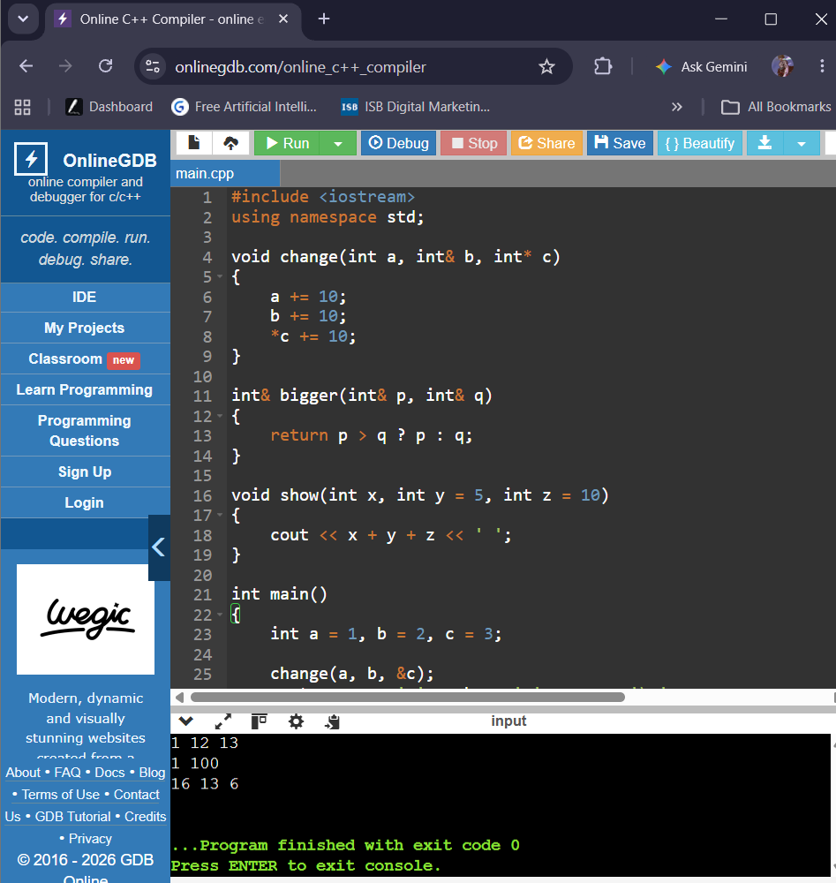

Q2 – Return by Reference and Its Dangers
Aim
To implement return by reference in C++ and understand its advantages and dangers.
Explanation
- Return by reference allows a function to return a reference to an existing variable.
- The highest mark in an array can be returned by reference and modified directly.
- Returning a reference to a local variable is dangerous because the variable is destroyed when the function ends.
- A const reference allows reading without copying but prevents modification through that reference.
- Returning a copy does not modify the original value.
- When a vector grows, its elements may move, invalidating existing references.
C++ Code
#include <iostream>
using namespace std;
int& highestMark(int marks[], int n)
{
int maxIndex = 0;
for (int i = 1; i < n; i++)
{
if (marks[i] > marks[maxIndex])
maxIndex = i;
}

return marks[maxIndex];
}
int main()
{
int marks[] = {75, 90, 85, 80};
int n = 4;
cout << "Highest mark: " << highestMark(marks, n) << endl;

highestMark(marks, n) += 2;

cout << "After moderation: " << highestMark(marks, n) << endl;

return 0;
}
Input
No input required.
Output
Highest mark: 90
After moderation: 92
Complexity Analysis
Time Complexity: O(n)
Space Complexity: O(1)
Result
The program successfully finds the highest mark and increases it by 2 using return by reference.
Screenshot

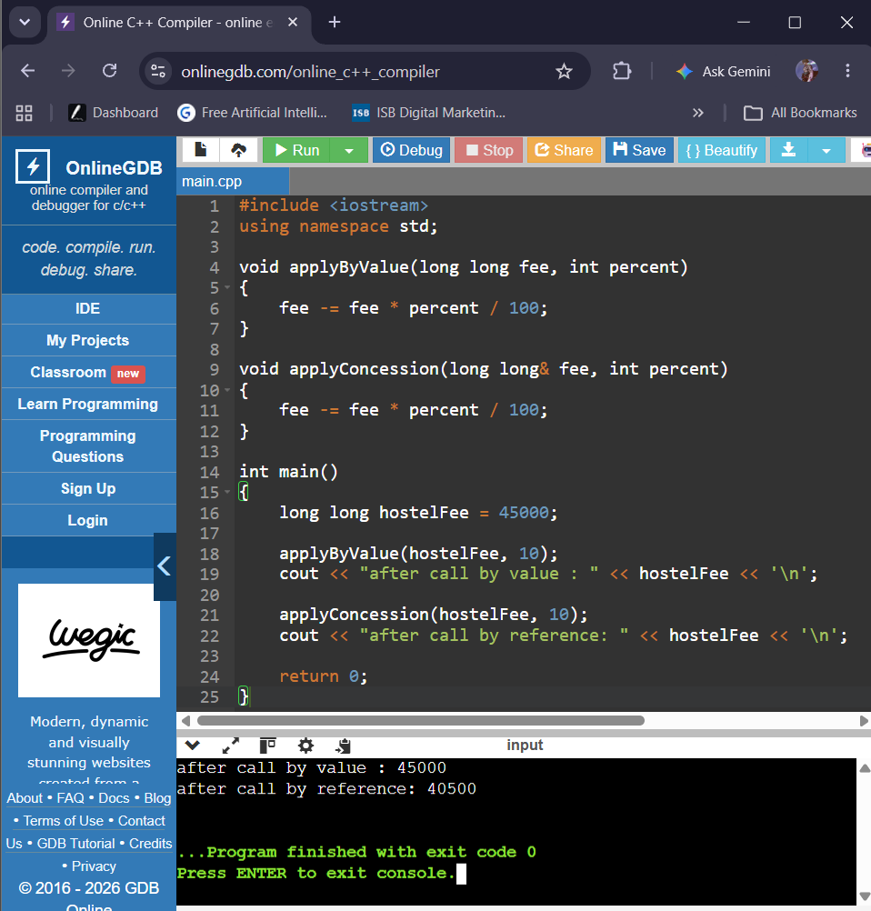
Paste your program output screenshot here.

Q3 – Default Arguments and Function Overloading
Aim
To implement default arguments and function overloading in C++ and avoid ambiguous function calls.
Explanation
- Ambiguous call: When multiple functions match a call equally well, the compiler cannot decide which function to use.
- Default arguments: Allow functions to use predefined values when arguments are not provided.
- Function overloading: Allows multiple functions with the same name but different parameter types.
- Overload resolution: The compiler prefers an exact match, then a promotion, and then a standard conversion.
- Default arguments must be given from the right: Parameters with default values must appear after parameters without default values.
C++ Code
#include <iostream>
using namespace std;
struct Parcel
{
double weight;
bool express;
bool insured;
};
double charge(double weight, bool express = false, bool insured = false)
{
double cost = weight * 50;
if (express)
cost += 100;

if (insured)
cost += 50;

return cost;
}
double charge(int grams)
{
return charge(grams / 1000.0);
}
double charge(Parcel p)
{
return charge(p.weight, p.express, p.insured);
}
int main()
{
Parcel p = {2.0, true, true};
cout << charge(2) << endl;
cout << charge(2.0) << endl;
cout << charge(2.0f) << endl;
cout << charge(2000) << endl;
cout << charge(2.0, true) << endl;
cout << charge(p) << endl;

return 0;
}
Input
No input required.
Output
100
100
100
100
200
250
Explanation of Six Calls
- charge(2) selects the int overload.
- charge(2.0) selects the double overload.
- charge(2.0f) selects the double overload through a conversion.
- charge(2000) selects the int overload.
- charge(2.0, true) selects the double overload with express delivery.
- charge(p) selects the Parcel overload.
Complexity Analysis
Time Complexity: O(1) for each charge calculation.
Space Complexity: O(1) because only a fixed number of variables are used.
Overloading is resolved at compile time and adds no runtime overload-resolution cost. A Parcel structure can make adding new options easier, while overloaded functions provide clear interfaces for different input types.
Result
The program demonstrates function overloading and default arguments without ambiguous calls.

Screenshot
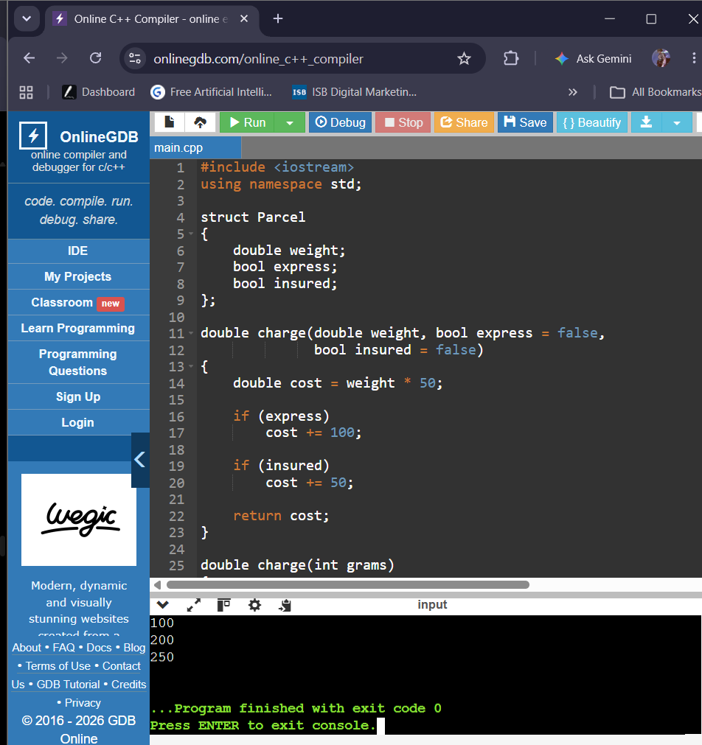

Q4 – Specifying a Class with an Array Inside It
Aim
To create a SavingsAccount class that stores account details and the last 10 transactions.
Explanation
- Class: A class combines data and functions into one unit.
- Private members: Account number, balance, transaction array and count are private to protect the data.
- Public members: deposit(), withdraw() and miniStatement() are used to manage and display transactions.
- 11th transaction: When the array is full, the oldest transaction is removed to store the latest transaction.
- Shifting array: Moving elements takes O(k) time.
- Circular buffer: Uses a start index to overwrite the oldest transaction in O(1) time.
- Last 50 transactions: A circular buffer is a good choice because the capacity can be increased easily.
C++ Code
#include <iostream>
#include <string>
using namespace std;
class SavingsAccount
{
private:
int accountNumber;
double balance;
string transactions[10];
int count;
int start;
void addTransaction(string transaction)
{
if (count < 10)
{
transactions[(start + count) % 10] = transaction;
count++;
}
else
{
transactions[start] = transaction;
start = (start + 1) % 10;
}
}
public:
SavingsAccount(int number, double initialBalance)
{
accountNumber = number;
balance = initialBalance;
count = 0;
start = 0;
}
void deposit(double amount)
{
if (amount > 0)
{
balance += amount;
addTransaction("Deposit: " + to_string(amount));
}
}

void withdraw(double amount)
{
if (amount > 0 && amount <= balance)
{
balance -= amount;
addTransaction
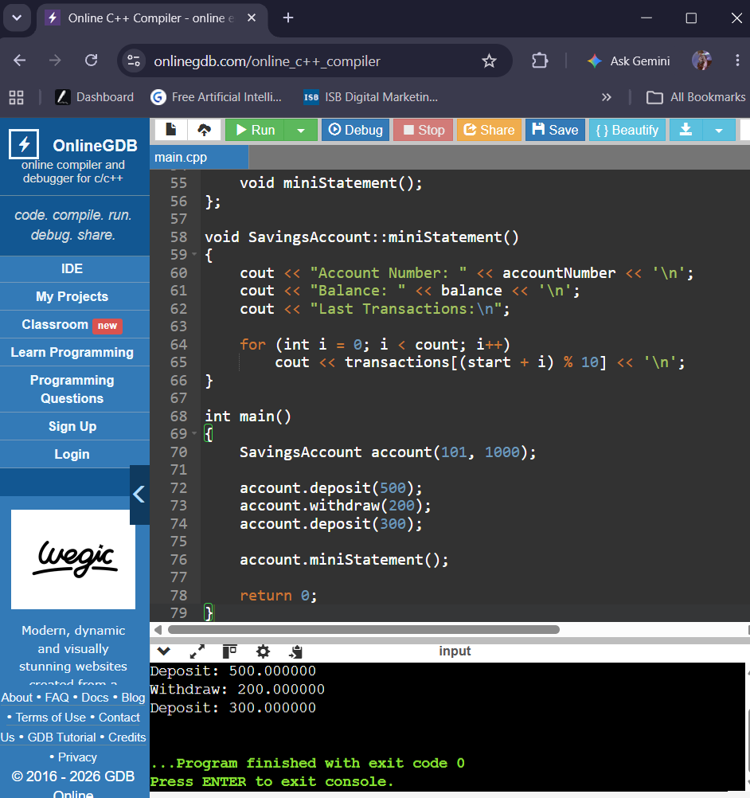

Q5 – Static Members and Arrays of Objects
Aim
To implement static members and an array of objects in C++ for managing college bus tickets.
Explanation
- Static data member: A variable shared by all objects of a class.
- Static member function: Can access static members directly but cannot use this or access non-static members directly.
- Array of objects: Stores multiple objects of the same class.
- Seat allocation: Each ticket receives the next seat number until the bus reaches its capacity.
- Waiting list: Tickets created after all seats are filled are placed on the waiting list.
- Static member definition: The static data member must be defined outside the class.
- Function calls: The static count continues across function calls because it belongs to the class, not to a single object.
C++ Code
#include <iostream>
#include <string>
using namespace std;
class BusTicket
{
static int issued;
static const int CAPACITY = 3;
int seat;
string name;
public:
explicit BusTicket(const string& n) : seat(0), name(n)
{
if (issued < CAPACITY)
{
issued++;
seat = issued;
}
}
static int count()
{
return issued;
}

void print() const
{
cout << name << ": ";

if (seat != 0)
cout << "Seat " << seat;
else
cout << "Waiting";

cout << endl;
}
};
int BusTicket::issued = 0;
int main()
{
BusTicket trip[4] = {
BusTicket("Asha"),
BusTicket("Bala"),
BusTicket("Chitra"),
BusTicket("Dev")
};
for (const BusTicket& t : trip)
t.print();

cout << "Issued: " << BusTicket::count() << endl;

return 0;
}
Input
No input required.
Output
Asha: Seat 1
Bala: Seat 2
Chitra: Seat 3
Dev: Waiting
Issued: 3
Complexity Analysis
- Ticket creation: O(1) per ticket.
- Printing tickets: O(n), where n is the number of tickets.
- Space complexity: O(n) for n ticket objects.
- The shared counter uses O(1) space.
Result
The program successfully allocates seats using static members and places extra tickets on the waiting list.
Screenshot
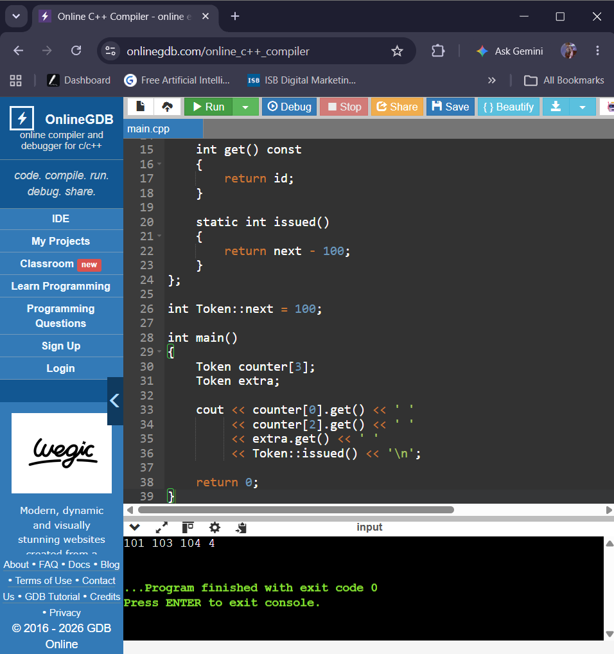

Q6 – Friend Functions and Inline Functions
Aim
To implement friend functions in C++ to calculate the time difference and compare two times.
Explanation
- Friend function: A non-member function that can access the private members of a class.
- Member function: Belongs to a class and is called using an object.
- Inline function: Suggests that the compiler replace a function call with its code when appropriate. The compiler decides whether to inline it.
- Private members: Keep data protected from direct access outside the class.
- Friend functions: Are useful when a function works equally with two objects.
- Efficiency: Inline functions may reduce function-call overhead, but the compiler may ignore the inline request.
C++ Code
#include <iostream>
#include <cstdlib>
using namespace std;
class Time
{
int h, m;
public:
Time(int hh, int mm) : h(hh), m(mm) {}
friend int minutesBetween(const Time& a, const Time& b);
friend bool earlier(const Time& a, const Time& b);
};
inline int minutesBetween(const Time& a, const Time& b)
{
int timeA = a.h * 60 + a.m;
int timeB = b.h * 60 + b.m;
return abs(timeA - timeB);
}
inline bool earlier(const Time& a, const Time& b)
{
if (a.h < b.h)
return true;
if (a.h == b.h && a.m < b.m)
return true;

return false;
}
int main()
{
Time departure(9, 45), arrival(13, 10);
cout << minutesBetween(departure, arrival) << ' '
<< boolalpha << earlier(arrival, departure) << endl;

return 0;
}
Input
No input required.
Output
205 false
Additional Test Cases
- Same time: `Time

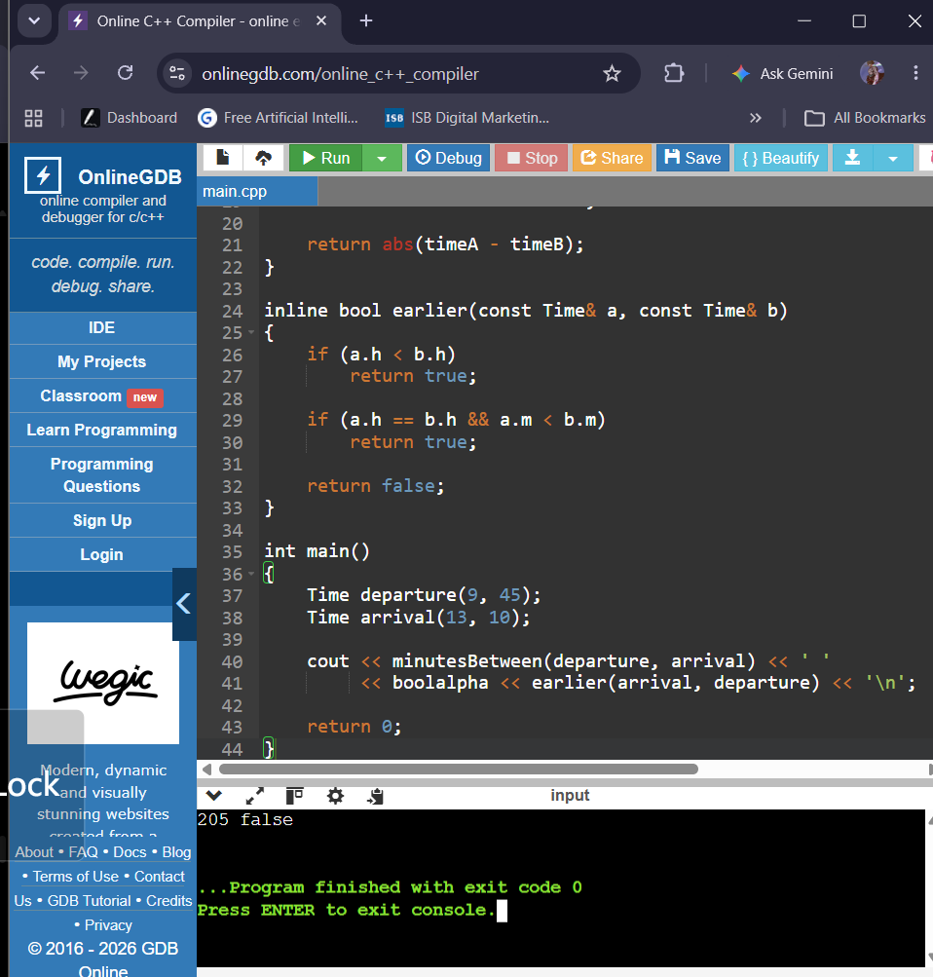

Q7 – Day-4 Design Challenge
Aim
To evaluate an existing C++ program, identify its limitations, and improve its design.
Selected Program
Q4 – Savings Account Mini-Statement
1. Problem Identification
The original program stores only the last 10 transactions. If more than 10 transactions occur, older transactions must be removed to make space for new ones.
2. Objective
To modify the program so that it can store and display the last 50 transactions efficiently.
3. Revised Solution
Increase the transaction array size from 10 to 50 and use a circular buffer. When the array is full, the oldest transaction is replaced by the newest transaction.
Code changes:
Change:
string transactions[10];
To:
string transactions[50];
Change the circular-buffer limit from 10 to 50 in the addTransaction() and miniStatement() functions.
4. Expected Behaviour
- The first 50 transactions are stored normally.
- The 51st transaction replaces the oldest transaction.
- The program displays only the most recent 50 transactions.
- The account balance is updated after valid deposits and withdrawals.
5. Testing
Test Case | Expected Result
Add 3 transactions | All 3 are displayed
Add 50 transactions | All 50 are stored
Add 51 transactions | The oldest transaction is replaced
Withdraw more than the balance | Withdrawal is rejected
Deposit a valid amount | Balance increases
6. Complexity Analysis
- Deposit or withdrawal: O(1), excluding string-handling costs.
- Add a transaction using a circular buffer: O(1), excluding string-handling costs.
- Display the last 50 transactions: O(k), where k is the number of transactions displayed.
- Space complexity: O(1) for a fixed array of 50 transaction entries.
7. Final Recommendation
The circular-buffer design is suitable because it stores only the latest 50 transactions without shifting all existing entries. It uses fixed memory and replaces the oldest transaction when the array becomes full.
Result
The revised design efficiently maintains a mini-statement containing the latest 50 transactions and avoids unnecessary shifting.
Screenshot
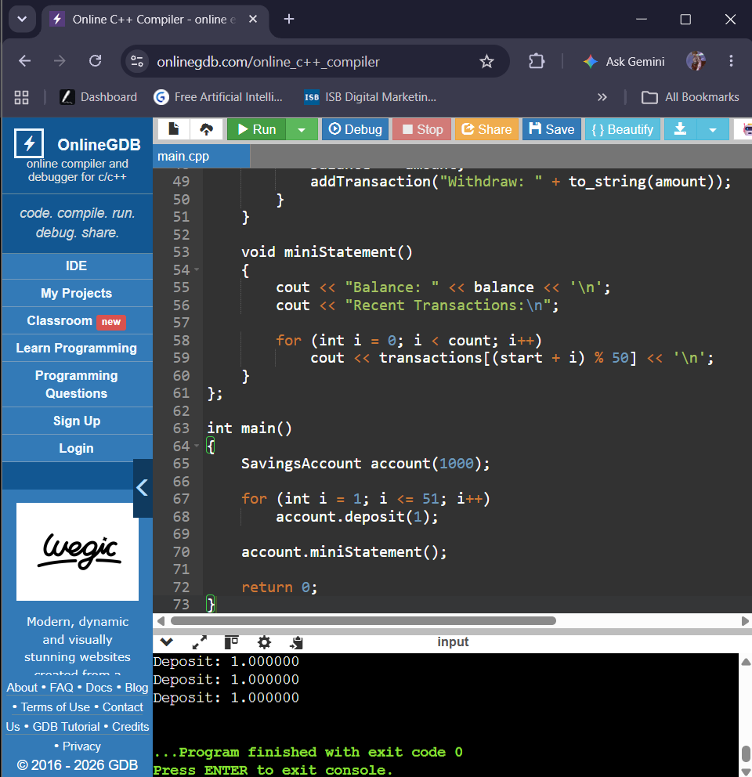
Paste your online compiler output screenshot here.

GitHub Link: https://github.com/192524062simats-ops/DSA0103c-

