Q33: Library System Search using Linear Search
Aim: To implement Linear Search to search Book IDs stored in an unsorted list in a library management system.

Problem Statement
A library stores Book IDs in an unsorted list because books are frequently added and removed. Implement a Linear Search algorithm to search for a given Book ID and analyze its efficiency.

Algorithm
1. Start.
2. Store Book IDs in an unsorted list.
3. Read the Book ID to search.
4. Compare the search key with each element one by one.
5. If a match is found, display 'Book Found' and its position.
6. If no match is found after checking all elements, display 'Book Not Found'.
7. Stop.

Python Source Code
book_ids = [105, 212, 187, 350, 420, 150, 275]
search_id = int(input("Enter the Book ID to search: "))
found = False
for i in range(len(book_ids)):
if book_ids[i] == search_id:
print("Book Found!")
print("Book ID:", search_id)
print("Position:", i)
found = True
break
if not found:
print("Book Not Found!")

Source Code Screenshot
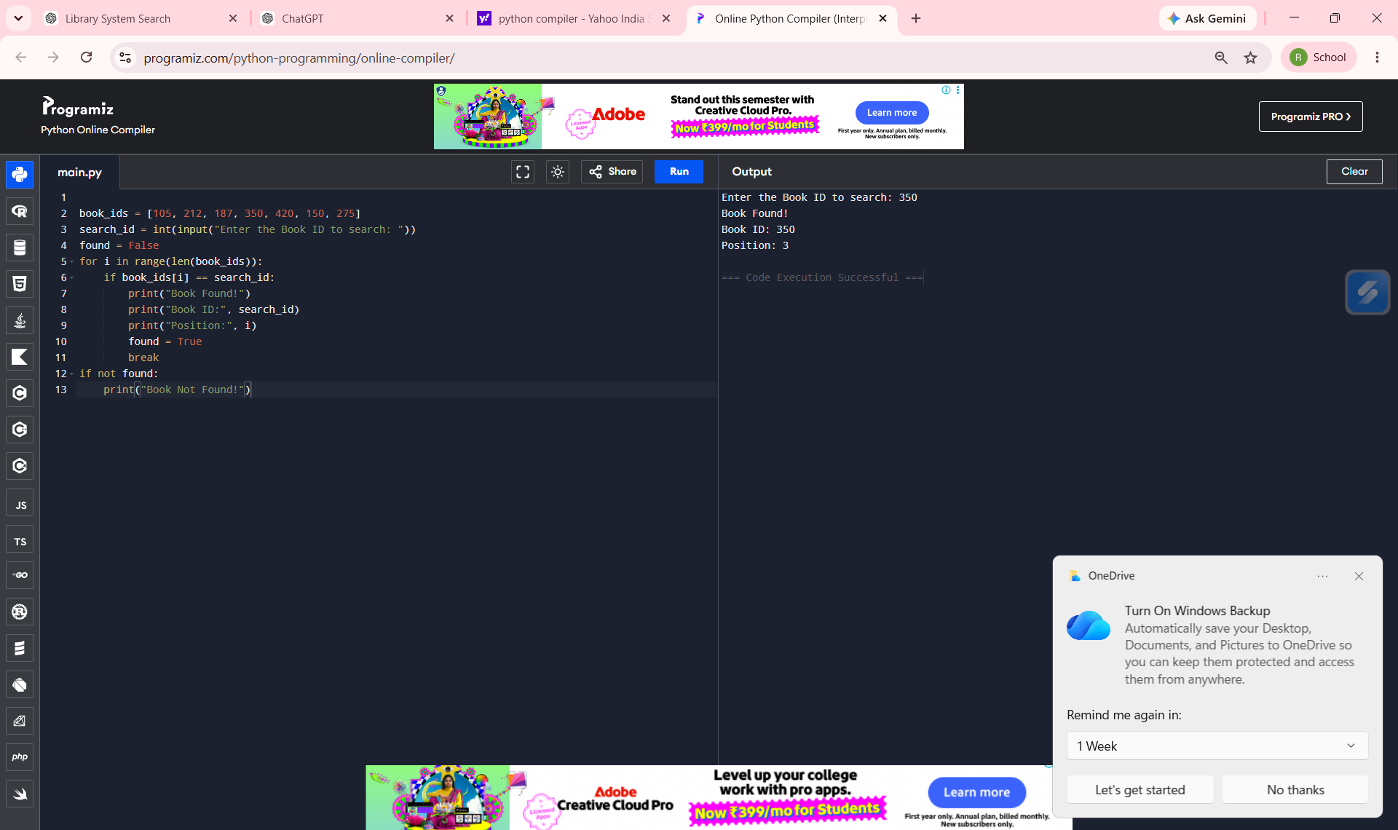

Execution Output - Book Found

Input: 350
Output: Book Found, Book ID = 350, Position = 3

Execution Output - Book Not Found
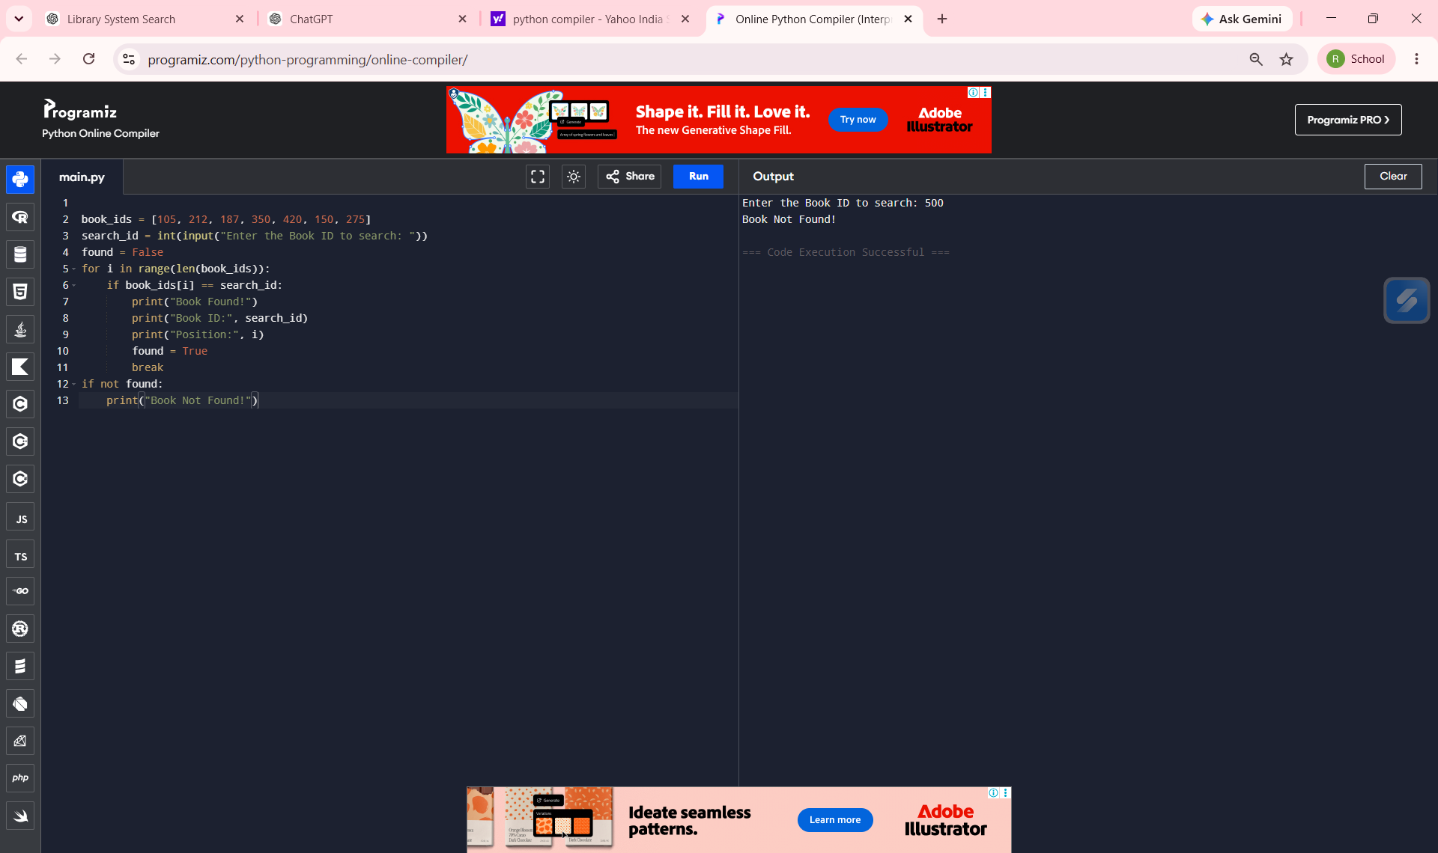
Input: 500
Output: Book Not Found

Implementation
The program stores Book IDs in an unsorted Python list. It accepts a Book ID from the user and compares it sequentially with each element. When a matching ID is found, the search stops immediately using the break statement and displays the position. If the loop completes without finding a match, the program prints 'Book Not Found'.

Analysis
Case | Condition | Time Complexity
Best | Book is the first element | O(1)
Average | Book is around the middle | O(n)
Worst | Book is last or absent | O(n)

Answer to Theory Questions

a) Application of Linear Search
Linear Search is suitable because the library maintains Book IDs in an unsorted list due to frequent insertions and deletions. Each Book ID is checked sequentially until the required ID is found or the list ends.

b) Complexity Analysis
Best Case: O(1), Average Case: O(n), Worst Case: O(n).

c) Justification on Sorting
Sorting enables Binary Search (O(log n)), but maintaining sorted order after every insertion/deletion is expensive. Therefore, for frequently updated data, Linear Search on an unsorted list is a practical and efficient choice.

Advantages
- Simple to implement
- Works on unsorted data
- No preprocessing required
- Suitable for small datasets

Limitations
- Slow for large datasets
- Checks elements sequentially
- Less efficient than Binary Search on sorted data

Conclusion
The Linear Search program successfully searches for Book IDs in an unsorted library list. It is appropriate for systems with frequent additions and deletions, where maintaining sorted order is not efficient.

