Q33. MAXIMUM PRODUCT SUBARRAY
Dynamic Programming
Experiment No. | 33
Experiment Name | Maximum Product Subarray
1. Aim
To find the contiguous subarray having the maximum product from a given array of integers using Dynamic Programming. The algorithm efficiently handles positive numbers, negative numbers, and zero values.
2. Problem Statement
Given an array of integers, determine the maximum possible product obtained from any contiguous subarray. Negative numbers can change the sign of a product, so simply tracking the maximum product is not sufficient. The solution therefore maintains both the maximum and minimum product ending at the current position.
3. Input Format
n = number of elements in the array
arr[] = array elements
4. Sample Input
n = 5
arr = 2 3 -2 4 -1
5. Expected Output
Max Product = 48
6. Theory
The Maximum Product Subarray problem can be solved in O(n) time using Dynamic Programming. At every array position, two values are maintained: maxProd, the maximum product of a subarray ending at the current element, and minProd, the minimum product of a subarray ending at the current element.
The minimum product is important because when the current element is negative, multiplying it by a negative minimum product can produce a large positive value. For example, in the input 2, 3, -2, 4, -1, the product of the contiguous subarray [2, 3, -2, 4, -1] is 48, which is the maximum product.
For each element x, the new maximum and minimum values are obtained by considering x itself, maxProd × x, and minProd × x. If x is negative, maxProd and minProd are swapped before updating because the previous minimum may become the new maximum.
7. Dynamic Programming Logic
Initial values:
maxProd = arr[0]
minProd = arr[0]
result = arr[0]
For every element from index 1 to n−1:
1. Store the current maxProd temporarily.
2. If the current element is negative, swap maxProd and minProd.
3. Update maxProd as the larger of the current element and maxProd × current element.
4. Update minProd as the smaller of the current element and minProd × current element.
5. Update result if maxProd is greater than the current result.
8. Algorithm
• Start.
• Read n and the array elements.
• Initialize maxProd, minProd, and result with the first array element.
• Traverse the array from the second element to the last element.
• If the current element is negative, interchange maxProd and minProd.
• Calculate the new maximum product ending at the current position.
• Calculate the new minimum product ending at the current position.
• Update result with the maximum product found so far.
• Print result.
• Stop.
9. Source Code
#include <stdio.h>
int main() {
int n;
printf("Enter number of elements: ");
scanf("%d", &n);
int arr[n];
printf("Enter array elements: ");
for (int i = 0; i < n; i++) {
scanf("%d", &arr[i]);
}
int maxProd = arr[0];
int minProd = arr[0];
int result = arr[0];
for (int i = 1; i < n; i++) {
int tempMax = maxProd;
if (arr[i] < 0) {
maxProd = minProd;
minProd = tempMax;
}
if (arr[i] > maxProd * arr[i])
maxProd = arr[i];
else
maxProd = maxProd * arr[i];
if (arr[i] < minProd * arr[i])
minProd = arr[i];
else
minProd = minProd * arr[i];
if (maxProd > result)
result = maxProd;
}
printf("Max Product = %d\n", result);
return 0;
}
10. Output
The following screenshot shows the program execution in the C online compiler for the given sample input. The program successfully produces the expected maximum product.
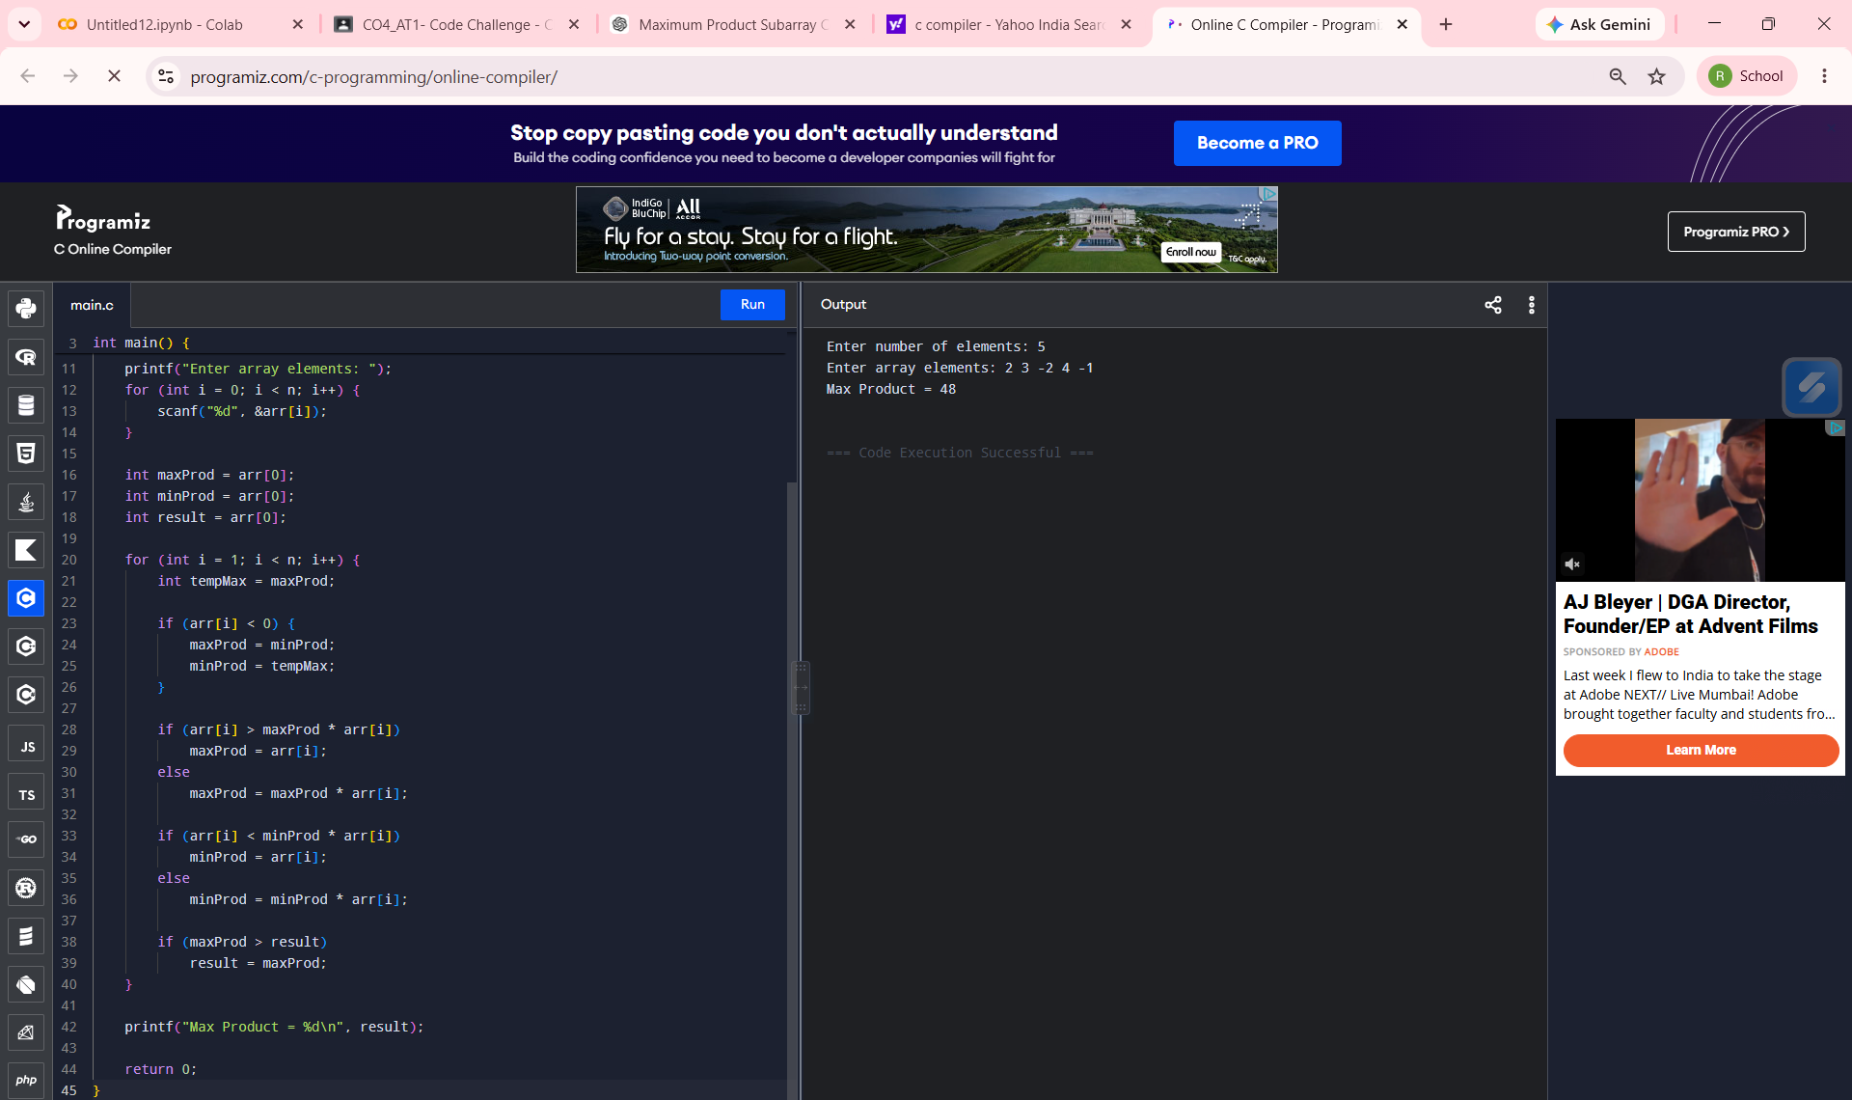
Figure 1: Program execution and output – Max Product = 48
11. Output Explanation
For the input array [2, 3, -2, 4, -1], the complete array forms a contiguous subarray whose product is 2 × 3 × (−2) × 4 × (−1) = 48. Since 48 is greater than the products of the other possible contiguous subarrays, the maximum product is 48.
12. Time Complexity
Time Complexity: O(n)
The array is traversed only once, and each element requires a constant number of operations.
13. Space Complexity
Space Complexity: O(1) auxiliary space.
Only a few variables such as maxProd, minProd, result, and tempMax are used apart from the input array.
14. Result
Thus, the Maximum Product Subarray was successfully found using Dynamic Programming. For the sample input 2 3 -2 4 -1, the maximum product obtained is 48.

