SIMATS ENGINEERING
ASSESSMENT TOOL 2

COURSE CODE: CSA14 COURSE NAME: Compiler Design

COURSE OUTCOME COVERED

CO1: Apply lexical analysis for token specification and recognition using LEX tool (BL3)

Assessment Tool Weightage: 20%

Duration :60 Mins
On class
QUESTIONS: Total Marks:50

Annexure A

ERROR ANALYSIS TASK

Code of Conduct:

I V G ABBIRAMY(192524097) certify that this submission is my original work and that I have adhered to the guidelines specified for this assessment.
I understand that any violation of academic integrity rules will result in disciplinary action.

Signature of the student:
V G ABBIRAMY

Annexure A

ERROR ANALYSIS TASK

Q1. The following C program is intended to perform string processing, function calls, array manipulation, conditional execution, pointer operations, switch-case selection, and loop execution. However, the program contains several errors introduced during different phases of compilation, including lexical, syntax, semantic, logical, and runtime errors.

Given Program
#include <stdio.h>
#include <string.h>

int findLength(char str[])
{
return strlen(str);
}

int main()
{
char name[20] = "Compiler"

int count;

count = findLength();

if(count > 5
{
printf("Length is greater than 5\n");
}

int marks[4] = {85, 90, 75, 80};

printf("%d\n", marks[4]);

int choice = 2;

switch(choice)
{
case 1:
printf("Option 1\n");
break;

case 2
printf("Option 2\n");
break;

default:
printf("Invalid Choice\n");
}

int *ptr;
printf("%d\n", *ptr);

int total = 100;
int students = 0;

float average = total / students;

int i = 1;

while(i <= 5)
{
printf("%d\n", i);
}

return 0;
}

Tasks with answer:

(a) Identify all errors in the program. Mention the line number, error type, and reason for each error

- Line 12: Missing semicolon (;) after char name [20] = "Compiler"
Type: Syntax Error Reason: Every C statement must end with a semicolon.
- Line 16: find Length () is called without an argument.
Type: Semantic Error Reason: The function requires one string argument (name).
- Line 18: Missing closing parenthesis in the if statement.
Type: Syntax Error Reason: The condition is not properly closed.
- Line 25: marks [4] is accessed.
Type: Runtime Error Reason: The array has only 4 elements, so valid indices are 0 to 3.
- Line 34: Missing colon (:) after case 2.
Type: Syntax Error Reason: Every case label must end with a colon.
- Line 43: Uninitialized pointer is dereferenced (*ptr).
Type: Runtime Error Reason: The pointer does not point to a valid memory location.
- Line 48: Division by zero (students = 0).
Type: Runtime Error Reason: Dividing by zero causes undefined behavior.
- Lines 52–55: Infinite loop because i is never incremented.
Type: Logical Error Reason: The loop condition never becomes false.

(b) Classify the identified errors as Lexical, Syntax, Semantic, Logical, or Runtime errors in a suitable table.

- Missing semicolon – Syntax Error
- Function called without argument – Semantic Error
- Missing parenthesis in if – Syntax Error
- Array index out of bounds – Runtime Error
- Missing colon in case – Syntax Error
- Uninitialized pointer – Runtime Error
- Division by zero – Runtime Error
- Infinite loop – Logical Error

(c) Explain at which phase of compilation each category of error is detected. Also mention which errors are detected only during execution.

- Lexical Errors are detected during the Lexical Analysis phase.
- Syntax Errors are detected during the Syntax Analysis (Parsing) phase.
- Semantic Errors are detected during the Semantic Analysis phase.
- Logical Errors are not detected by the compiler and are noticed only after execution.
- Runtime Errors occur during program execution.
Errors detected only during execution:
- Array index out of bounds
- Uninitialized pointer
- Division by zero
- Infinite loop

(d) Rewrite the program after correcting all the errors so that it executes successfully.

#include <stdio.h>
#include <string.h>

int findLength(char str[])
{
return strlen(str);
}

int main()
{
char name[20] = "Compiler";

int count;

count = findLength(name);

if(count > 5)
{
printf("Length is greater than 5\n");
}

int marks[4] = {85, 90, 75, 80};
printf("%d\n", marks[3]);

int choice = 2;

switch(choice)
{
case 1:
printf("Option 1\n");
break;

case 2:
printf("Option 2\n");
break;

default:
printf("Invalid Choice\n");
}

int value = 100;
int *ptr = &value;
printf("%d\n", *ptr);

int total = 100;
int students = 5;

float average = total / (float)students;

int i = 1;

while(i <= 5)
{
printf("%d\n", i);
i++;
}

return 0;
}

OUTPUT

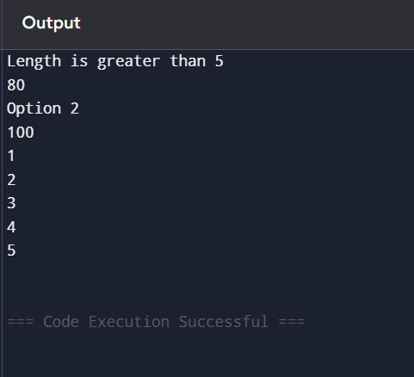
(e) Suggest any three compiler features or warnings that can help detect such programming errors before execution.

- Syntax checking detects missing semicolons, brackets and colons.
- Compiler warnings (-Wall, -Wextra) identify uninitialized variables and suspicious code.
- Static code analysis detects possible runtime errors such as invalid pointers, array bounds violations and division by zero.

Q2. The following C program is intended to perform function calls, array processing, conditional execution, switch-case selection, and loop operations. However, several syntax errors have been intentionally introduced by violating the grammatical rules of the C language. These errors include missing delimiters, unmatched parentheses, incorrect control structures, malformed function definitions, and incomplete statements. Such errors are normally detected during the syntax analysis (parsing) phase of a compiler.

Carefully examine the program and answer the questions that follow.

Given Program
#include <stdio.h>

int maximum(int x, int y
{
if(x > y)
return x;
else
return y;
}

int main()
{
int marks[5] = {70, 80, 90, 85, 95};

int max = maximum(marks[0], marks[1]);

switch(max)
{
case 80:
printf("Maximum is 80\n")
break;

case 90
printf("Maximum is 90\n");
break;

default:
printf("Other Value\n");
}

do
{
printf("%d\n", max);
max--;
while(max > 75);

if(max == 75)
printf("Limit Reached\n"
}

return 0;

Tasks with answer:

(a) Identify all syntax errors in the program. Mention the line number and reason for each error.

- Line 3: Missing closing parenthesis ) in the function definition.
- Line 17: Missing semicolon after printf("Maximum is 80\n").
- Line 20: Missing colon (:) after case 90.
- Line 31: Missing closing brace } before the while statement of the do-while loop.
- Line 35: Missing closing parenthesis ) in printf("Limit Reached\n".
- Line 35: Missing semicolon after the printf statement.
- Line 36: Missing closing brace } for the if statement.
- Line 39: Missing closing brace } for the main() function.

(b) Classify the identified syntax errors under the appropriate categories and present them in a table.

- Missing parenthesis in function definition – Parenthesis Error
- Missing semicolon after printf – Missing Delimiter
- Missing colon after case – Switch-case Syntax Error
- Missing closing brace in do-while – Block Structure Error
- Missing parenthesis in printf – Parenthesis Error
- Missing semicolon – Missing Delimiter
- Missing closing brace for if – Block Structure Error
- Missing closing brace for main – Block Structure Error

(c) Correct the syntax errors and rewrite the complete program.

#include <stdio.h>

int maximum(int x, int y)
{
if(x > y)
return x;
else
return y;
}

int main()
{
int marks[5] = {70, 80, 90, 85, 95};

int max = maximum(marks[0], marks[1]);

switch(max)
{
case 80:
printf("Maximum is 80\n");
break;

case 90:
printf("Maximum is 90\n");
break;

default:
printf("Other Value\n");
}

do
{
printf("%d\n", max);
max--;
}
while(max > 75);

if(max == 75)
{
printf("Limit Reached\n");
}

return 0;
}

OUTPUT:
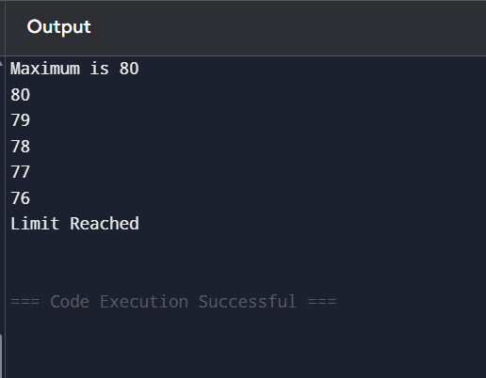

(d) Explain how the parser detects syntax errors and how error recovery enables further parsing.

- The parser checks whether the program follows the grammar rules of C.
- It detects missing semicolons, parentheses, braces and keywords.
- Error recovery allows the parser to skip incorrect statements and continue parsing the remaining program to detect more errors.

(e) Suggest any two improvements that can help a compiler generate better syntax error messages.

- Provide descriptive error messages showing the exact line number and expected symbol.
- Suggest automatic corrections such as missing semicolons, brackets or colons.

Q3. The following C program is intended to perform factorial computation, function calls, array processing, pointer manipulation, conditional execution, switch-case selection, and loop operations. However, the program contains several errors introduced during different phases of compilation and execution, including lexical, syntax, semantic, intermediate code generation, code optimization, and runtime errors.

Carefully examine the program and answer the questions that follow.

Given Program
#include <stdio.h>

int factorial(int n)
{
if(n <= 1)
return 1;

return n * factorial(n - 1);
}

int main()
{
int @num = 5;

int value = 10

int result;

result = factorial();

if(result >= 100)
{
printf("Large Number\n");
}

switch(result)
{
case 24:
printf("Factorial of 4\n");
break;

case 120
printf("Factorial of 5\n");
break;

default:
printf("Other Value\n");
}

int numbers[5] = {2,4,6,8,10};
printf("%d\n", numbers[5]);

int *ptr;
printf("%d\n", *ptr);

int a = 50;
int b = 0;
int c = a / b;

int sum = result + 0 + value;

int i = 1;
while(i <= 5)
{
printf("%d\n", i);
}

return 0;
}
Tasks with answer:

(a) Identify all the errors in the program. Mention the line number, error type, and reason for each error.

- Line 13: Invalid identifier @num.
- Type: Lexical Error
- Reason: @ is not allowed in C identifiers.
- Line 15: Missing semicolon after int value = 10.
- Type: Syntax Error
- Line 19: factorial() called without an argument.
- Type: Semantic Error
- Reason: The function requires one integer parameter.
- Line 30: Missing colon (:) after case 120.
- Type: Syntax Error
- Line 37: numbers[5] accessed.
- Type: Runtime Error
- Reason: Valid indices are 0–4.
- Line 40: Dereferencing an uninitialized pointer.
- Type: Runtime Error
- Line 44: Division by zero (a / b, where b = 0).
- Type: Runtime Error
- Line 46: Expression result + 0.
- Type: Code Optimization Issue
- Reason: Adding zero is redundant and removed during optimization.
- Lines 49–52: Infinite loop because i is never incremented.
- Type: Logical Error

(b) Classify the identified errors according to the appropriate compiler phase (Lexical, Syntax, Semantic, Intermediate Code Generation, Code Optimization, and Runtime) using a suitable table.
- Invalid identifier (@num) – Lexical Analysis
- Missing semicolon – Syntax Analysis
- Function call without argument – Semantic Analysis
- Missing colon in case – Syntax Analysis
- Expression result + 0 – Code Optimization
- Array index out of bounds – Runtime
- Uninitialized pointer – Runtime
- Division by zero – Runtime
- Infinite loop – Runtime / Logical

(c) Explain how the compiler processes the program by identifying the errors detected during each compilation phase and those detected only at runtime.

- Lexical Analysis: Detects invalid characters and identifiers.
- Syntax Analysis: Detects missing semicolons, colons and parentheses.
- Semantic Analysis: Checks function calls, data types and declarations.
- Intermediate Code Generation: Converts the valid program into intermediate code.
- Code Optimization: Removes unnecessary operations such as adding zero.
- Runtime: Detects array index errors, invalid pointers, division by zero and infinite loops.
Errors detected only during execution:
- Array index out of bounds
- Uninitialized pointer
- Division by zero
- Infinite loop

(d) Rewrite the complete corrected program so that it compiles and executes without errors.

#include <stdio.h>

int factorial(int n)
{
if(n <= 1)
return 1;

return n * factorial(n - 1);
}

int main()
{
int num = 5;

int value = 10;

int result;

result = factorial(num);

if(result >= 100)
{
printf("Large Number\n");
}

switch(result)
{
case 24:
printf("Factorial of 4\n");
break;

case 120:
printf("Factorial of 5\n");
break;

default:
printf("Other Value\n");
}

int numbers[5] = {2, 4, 6, 8, 10};
printf("%d\n", numbers[4]);

int temp = 50;
int *ptr = &temp;
printf("%d\n", *ptr);

int a = 50;
int b = 5;
int c = a / b;

int sum = result + 0 + value;

int i = 1;

while(i <= 5)
{
printf("%d\n", i);
i++;
}

return 0;
}

OUTPUT:

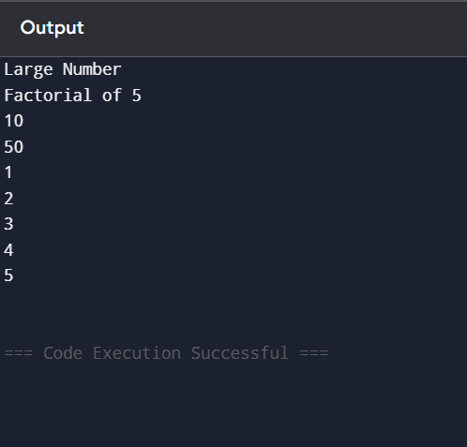

(e) Suggest any two improvements in compiler design or optimization techniques that could detect or prevent such errors before program execution.

- Use advanced static analysis to detect invalid pointers, array bounds violations and division by zero before execution.
- Improve compiler optimization and warning generation to identify redundant expressions, unreachable code and possible runtime errors before the program is executed.

