Activity 6: Website Flow Sankey Design
DSA06 - Data Handling and Visualization
R.No | 11
Reg. No | 192524114
Name | Devamada Hemasree

Scenario: the analytics team of a job portal tracked 8,890 visits last month through four stages: traffic source, landing page, next action and outcome. The Sankey diagram shows the number of visits on every flow. Three flows are hidden and marked "?".

Data read from the diagram
The node totals and the visible flow labels of the diagram are listed below. The three hidden flows are marked (hidden) in the flow table and are found in part (a).
Stage | Nodes (visits)
Traffic source | Referral 3,289 | College placement cell 3,023 | LinkedIn 2,578
Landing page | Resume tips page 3,684 | Company page 2,117 | Home page 3,089
Next action | Search jobs 3,367 | Start application 3,443 | Exit site 2,080
Outcome | Application submitted 2,011 | No application 6,879

Each stage adds up to the same total: 3,289 + 3,023 + 2,578 = 3,684 + 2,117 + 3,089 = 3,367 + 3,443 + 2,080 = 2,011 + 6,879 = 8,890 visits.

(a) Hidden flows by conservation of width [4 marks]
Rule used (conservation of flow): for every node, the total of the flows coming in equals the node value, and equals the total of the flows going out (inflow = outflow = node value). A Sankey does not create or lose visits at a middle node.

Hidden flow 1: Company page → Exit site
- Method: outflow of the Company page = 2,117. Its two visible outflows are Company → Search jobs = 757 and Company → Start application = 788.
- Working: 2,117 − 757 − 788 =
= 572 visits.
Cross-check from the other side: Exit site = 2,080. Inflows are Resume tips → Exit site = 921 and Home page → Exit site = 587, so Company → Exit site = 2,080 − 921 − 587 = 572. Both methods agree.

Hidden flow 2: LinkedIn → Home page
- Method (outflow of LinkedIn): 2,578 − 825 (to Resume tips) − 748 (to Company page) = 1,005.
- Cross-check (inflow of Home page): 3,089 − 724 (Referral) − 1,360 (College placement cell) = 1,005. Same answer.
= 1,005 visits.

Hidden flow 3: Resume tips page → Exit site
- Method: outflow of the Resume tips page = 3,684. Visible outflows: to Search jobs = 1,409 and to Start application = 1,354.
- Working: 3,684 − 1,409 − 1,354 =
= 921 visits.
Cross-check: inflow of the Resume tips page = 1,710 + 1,149 + 825 = 3,684. ✓
Answer: Company page → Exit site = 572; LinkedIn → Home page = 1,005; Resume tips page → Exit site = 921.

Complete flow table (all 23 flows)
From | To | Visits | From | To | Visits
Referral | Resume tips | 1,710 | Resume tips | Search jobs | 1,409
Referral | Company page | 855 | Resume tips | Start application | 1,354
Referral | Home page | 724 | Resume tips | Exit site | 921 (hidden)
College placement cell | Resume tips | 1,149 | Company page | Search jobs | 757
College placement cell | Company page | 514 | Company page | Start application | 788
College placement cell | Home page | 1,360 | Company page | Exit site | 572 (hidden)
LinkedIn | Resume tips | 825 | Home page | Search jobs | 1,201
LinkedIn | Company page | 748 | Home page | Start application | 1,301
LinkedIn | Home page | 1,005 (hidden) | Home page | Exit site | 587
Search jobs | Application submitted | 909 | Start application | Application submitted | 1,102
Search jobs | No application | 2,458 | Start application | No application | 2,341
Exit site | No application | 2,080

Check: the Search jobs, Start application and Exit site columns add up to 3,367, 3,443 and 2,080, and every stage of the table adds up to 8,890 visits.

(b) Calculations [4 marks]

(i) Overall conversion rate
Conversion rate = Application submitted ÷ all visits × 100
= 2,011 ÷ 8,890 × 100 = 22.62%
So only about 1 visit in 4.4 ends with an application. The remaining 6,879 visits (77.38%) end with no application.

(ii) Largest single flow into "No application"
Flow into No application | Visits | Share of all visits
Search jobs → No application | 2,458 | 27.65%
Start application → No application | 2,341 | 26.33%
Exit site → No application | 2,080 | 23.40%
Total | 6,879 | 77.38%

Answer: the largest flow is Search jobs → No application with 2,458 visits (35.7% of the 6,879 visits that end without an application). Visitors who search for jobs but do not apply are the biggest loss.

(iii) Percentage of Company page visits that go on to Search jobs
= Company → Search jobs ÷ Company page total × 100 = 757 ÷ 2,117 × 100 = 35.76%
About 36 of every 100 Company page visits continue to Search jobs. (The rest: 788 ÷ 2,117 = 37.2% start an application and 572 ÷ 2,117 = 27.0% leave the site.)
Part | Calculation | Result
(i) | 2,011 ÷ 8,890 × 100 | 22.62%
(ii) | Largest of 2,458, 2,341, 2,080 | Search jobs → No application (2,458)
(iii) | 757 ÷ 2,117 × 100 | 35.76%

(c) Final Sankey: four design decisions [4 marks]
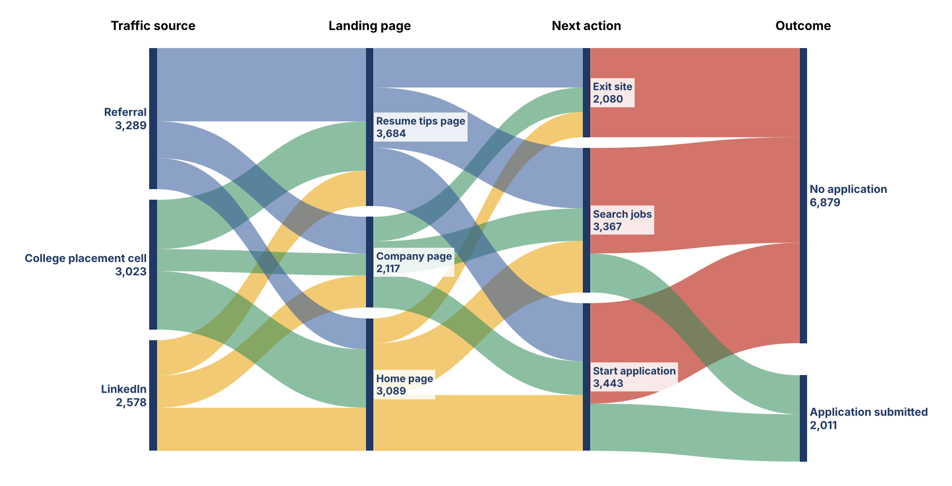
Figure 1: Final Sankey design for the 8,890 visits (drawn from the data above).
Decision | What is done | Justification (one line)
1. Node order | Order the nodes in every stage by the weighted average position of the nodes that feed them (Referral, College placement cell, LinkedIn at the left; Exit site, Search jobs, Start application in the third stage; No application above Application submitted) | This places strongly connected nodes close together, so flows cross less and are easier to follow
2. Colour rule | Colour each flow by where it comes from: blue, green and amber for the three traffic sources and landing pages, then green for flows that end in an application and red for flows that end with no application. No more than four hues | Colour carries the story from source to outcome, so the reader can trace a group without reading labels
3. Labels | Write the node name and its visit count on every node, label the flows of 500 visits or more, and show 22.6% and 77.4% beside the two outcomes. Leave out labels on very thin flows | Exact numbers help the reader, and skipping tiny labels prevents clutter and overlap
4. What to highlight | Draw the drop-off routes (Search jobs → No application, 2,458, and Exit site → No application, 2,080) in strong red, and keep other flows lighter | The key message is that most visits end without an application, so the eye should go there first

(d) Printed node heights [2 marks]
Scale: 1 cm of node height = 400 visits, so height (cm) = visits ÷ 400.
Landing page | Visits | Calculation | Height
Home page | 3,089 | 3,089 ÷ 400 | 7.72 cm
Company page | 2,117 | 2,117 ÷ 400 | 5.29 cm
Resume tips page | 3,684 | 3,684 ÷ 400 | 9.21 cm

Answer: Home page = 7.72 cm, Company page = 5.29 cm, Resume tips page = 9.21 cm. Together they are 22.23 cm (8,890 ÷ 400), plus the small gaps between nodes.

(e) R code with networkD3 [4 marks]
networkD3 needs zero-based node numbers: the first row of the nodes data frame is node 0. The nodes are listed in the order of the diagram, top to bottom within each stage.

Nodes data frame
nodes <- data.frame(name = c(
"Referral", # 0
"College placement cell",# 1
"LinkedIn", # 2
"Resume tips page", # 3
"Company page", # 4
"Home page", # 5
"Search jobs", # 6
"Start application", # 7
"Exit site", # 8
"Application submitted", # 9
"No application")) # 10

Links data frame: first four flows leaving College placement cell and LinkedIn
links_first4 <- data.frame(
source = c(1, 1, 1, 2), # College, College, College, LinkedIn
target = c(3, 4, 5, 3), # Resume, Company, Home, Resume
value = c(1149, 514, 1360, 825))
Meaning: College placement cell → Resume tips (1,149), → Company page (514), → Home page (1,360), and LinkedIn → Resume tips (825).

Links data frame for the whole diagram and the sankeyNetwork() call
links <- data.frame(
source = c(0,0,0, 1,1,1, 2,2,2, 3,3,3, 4,4,4, 5,5,5, 6,6, 7,7, 8),
target = c(3,4,5, 3,4,5, 3,4,5, 6,7,8, 6,7,8, 6,7,8, 9,10, 9,10, 10),
value = c(1710,855,724, 1149,514,1360, 825,748,1005,
1409,1354,921, 757,788,572, 1201,1301,587,
909,2458, 1102,2341, 2080))

library(networkD3)
sankeyNetwork(Links = links, Nodes = nodes,
Source = "source", Target = "target",
Value = "value", NodeID = "name",
units = "visits", fontSize = 12, nodeWidth = 30)
Check done in R: the flows into and out of each middle node equal its node value (3,684, 2,117, 3,089, 3,367, 3,443, 2,080), and each stage adds up to 8,890. Plotly alternative: plot_ly(type = "sankey", node = list(label = nodes$name), link = list(source = links$source, target = links$target, value = links$value)).

(f) When a Sankey misleads [2 marks]
Situation | Why it misleads or becomes unreadable | Alternative chart
1. Too many nodes and flows (for example 30 pages with many crossing links) | The flows cross like a tangle (a hairball), thin flows cannot be followed or labelled, and the reader cannot see which path is which | Heatmap (matrix of source × destination, colour = visits), where every pair has one cell
2. The reader must compare exact values or small differences, or there is no real flow (for example many similar-sized categories, or loops where visitors go back) | People judge the width of curved bands poorly, so a 2,458 and a 2,341 flow look the same. A Sankey also cannot show loops or changes over time well | Bar chart (sorted horizontal bars) for exact comparisons; a line chart if the change over time is the point

Summary of Answers
Part | Answer
(a) | Company → Exit site 572; LinkedIn → Home page 1,005; Resume tips → Exit site 921 (rule: inflow = node value = outflow)
(b) | (i) 22.62%; (ii) Search jobs → No application, 2,458; (iii) 35.76%
(c) | Order by weighted position, colour by origin and outcome, label nodes and big flows, highlight drop-off routes
(d) | Home 7.72 cm, Company 5.29 cm, Resume tips 9.21 cm
(e) | nodes and links data frames (zero-based), sankeyNetwork(Links, Nodes, Source, Target, Value, NodeID)
(f) | Too many nodes → heatmap; exact comparison or loops → bar or line chart

