DSA06 Data Handling and Visualization
Activity 5: Normality Detection using Q-Q Plots
Name | Devamada Hemasree
R.No / Reg. No | 11 / 192524114
Marks | Part A: 16 marks (4 charts × 4) | Part B: 4 marks (2 + 2) | Total: 20 marks
Task | For each Q-Q plot: decide if the data are normal, name the shape, and cite the evidence

Answer Key at a Glance
Chart | Data | Normal? | Shape (from the list) | Key evidence
1 | Plant height (cm), n = 60 | No | Light-tailed | Low end is above the line and high end is below it (S-shape). Data span only about 52 to 75 cm
2 | Battery drain per hour (%), n = 120 | Body yes, but 2 outliers | Normal with outlier(s) | Points follow the line, except 2 high points at about 14.8 and 15.5
3 | Resting pulse (bpm), n = 60 | No | Left-skewed | Low end far below the line (about 41 against 58). Upper end flat at 73 to 74
4 | Resting pulse (bpm), n = 30 | No | Right-skewed | Both ends above the line. Top points about 89 and 96 sit far above it

Part B | Answer
B1 [2] | Chart 2 departs from normality through 2 high outliers (about 14.8 and 15.5). Check these readings first. If they are genuine, use robust methods (median and IQR) before mean-and-SD methods.
B2 [2] | ggplot(df, aes(sample = value)) + stat_qq() + stat_qq_line()

Note: values such as "about 41" are read from the printed axes, so they are approximate (to about ±1 unit). The shape decisions do not depend on that small reading error.

How to Read a Q-Q Plot
- Axes: x = theoretical quantiles (where each value would sit if the data were perfectly normal, in standard deviation units). y = sample quantiles (the real sorted data values).
- Red line: the perfect normal fit (stat_qq_line draws it through the first and third quartiles). If the data are normal, the dots lie on this line.
- Slope and centre of the line: the slope is about the spread (standard deviation) of the data, and the height at x = 0 is about the centre.
- Judge the pattern, not single dots: the middle of the plot should be straight. Look at what the two ends do relative to the line.
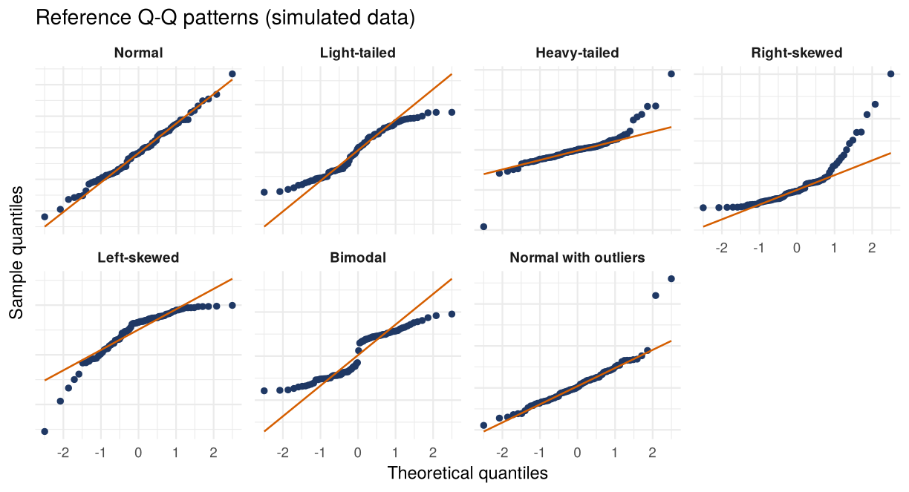
Figure 1: Reference patterns for each shape in the list (simulated data, for comparison only).
Shape | Low end vs line | High end vs line | Meaning
Normal | On the line | On the line | Dots follow the straight line all along
Right-skewed | Above the line | Above the line | Convex curve (bends upward). Values bunched low, long tail upwards
Left-skewed | Below the line | Below the line | Concave curve (bends downward). Values bunched high, long tail downwards
Heavy-tailed | Below the line | Above the line | Reverse S. More extreme values than normal at both ends
Light-tailed | Above the line | Below the line | S-shape. Fewer extreme values than normal (flat ends)
Bimodal | Flat steps with a jump in the middle |  | Two clusters: dots bunch at two levels with a gap between them
Normal with outlier(s) | On the line | 1 to 3 dots far off one end | Straight line except for a few isolated dots

Part A: Chart-by-Chart Answers [16 marks]

Chart 1: plant height (cm), n = 60 [4 marks]
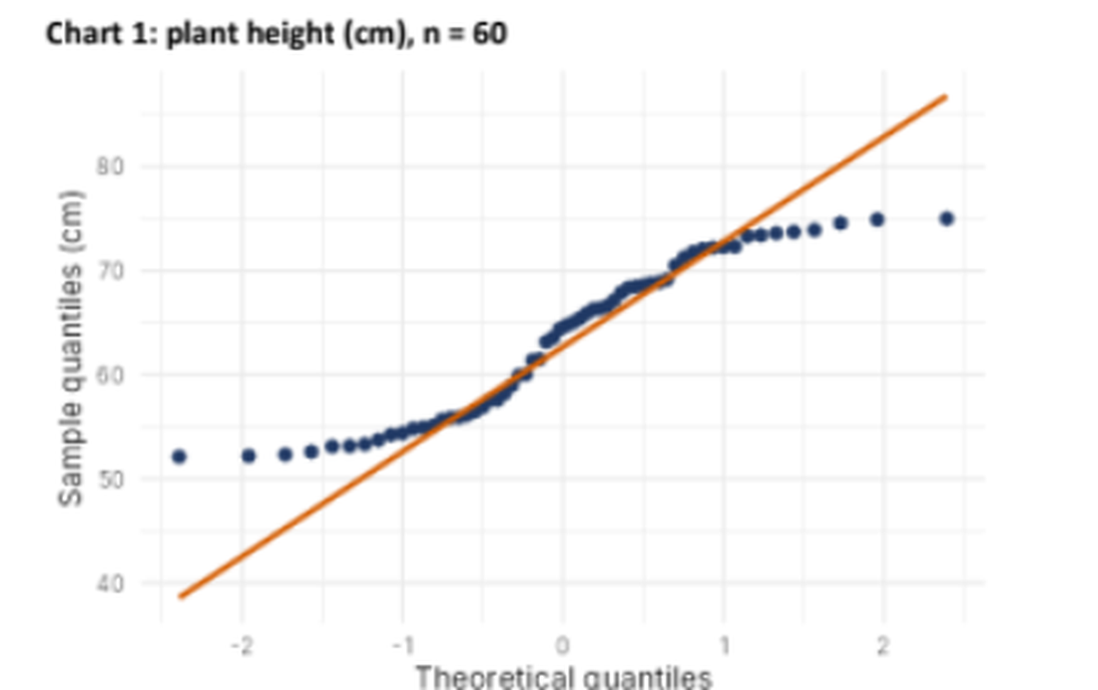
Chart 1: plant height (cm), n = 60 (from the activity sheet)
Normal? (Yes / No) | No
Shape (from the list) | Light-tailed

Evidence in the plot:
- Both ends of the plot flatten away from the red line. The line runs from about 38 cm to 87 cm, but the data only span about 52 to 75 cm.
- Low end: the smallest points (about 52 to 54 cm) lie about 13 cm ABOVE the line.
- High end: the largest points (about 74 to 75 cm) lie about 12 cm BELOW the line.
- Centre (about 55 to 72 cm): the dots are steeper than the line and cross it, giving an S-shape.
- Meaning: the sample has fewer extreme values than a normal distribution would give, so the tails are lighter (shorter) than normal.
Why not the other shapes:
Shape | Reason it does not fit
Heavy-tailed | Would be the reverse: low end below the line and high end above it
Skewed (left or right) | The two ends would bend the same way, not in opposite directions
Bimodal | There is no jump or gap in the middle. The dots rise smoothly
Outliers | There are no isolated dots far from the others

Chart 2: battery drain per hour (percent), n = 120 [4 marks]
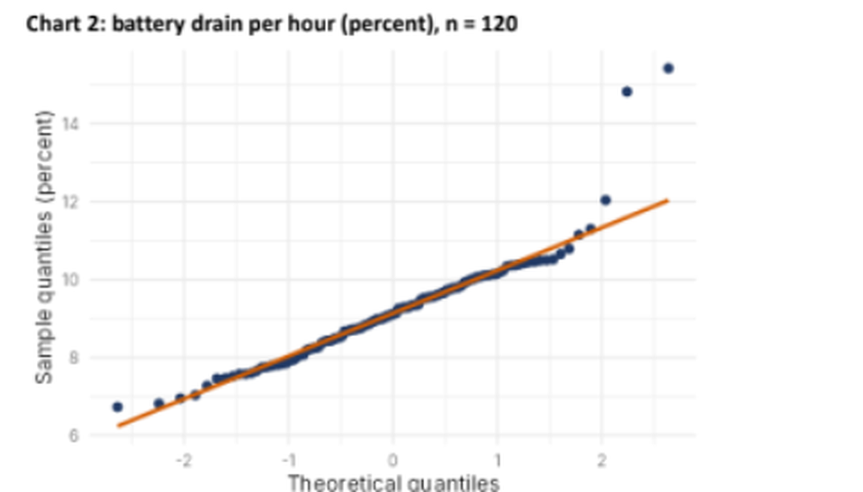
Chart 2: battery drain per hour (percent), n = 120 (from the activity sheet)
Normal? (Yes / No) | Body yes, but not fully normal because of 2 outliers (so strictly: No)
Shape (from the list) | Normal with outlier(s)

Evidence in the plot:
- About 117 of the 120 dots lie right on the red line, from about 6.7 to 11.3 percent. The body of the data is normal (centre about 9.1).
- Two dots at the top right are far above the line: about 14.8 (the line gives about 11.6 there) and about 15.5 (the line gives about 12.0). They are 3.2 and 3.5 above the line.
- These two values are about 5 standard deviations from the centre: (14.8 − 9.1) ÷ 1.1 = 5.2 and (15.5 − 9.1) ÷ 1.1 = 5.8. The largest value expected for n = 120 is only about 2.6 standard deviations (about 12.0).
- A third dot (about 12.0) is only slightly above the line, which is a borderline case.
- The low end is on the line, and the curve does not bend, so there is no skew and no heavy tail.
Why not the other shapes:
Shape | Reason it does not fit
Right-skewed | A skew bends the whole curve upward. Here the line stays straight for 117 dots
Heavy-tailed | The low end would also be below the line. Here only the top has dots away from the line
Light-tailed or bimodal | The ends do not flatten and there is no jump in the middle

Chart 3: resting pulse (beats per minute), n = 60 [4 marks]
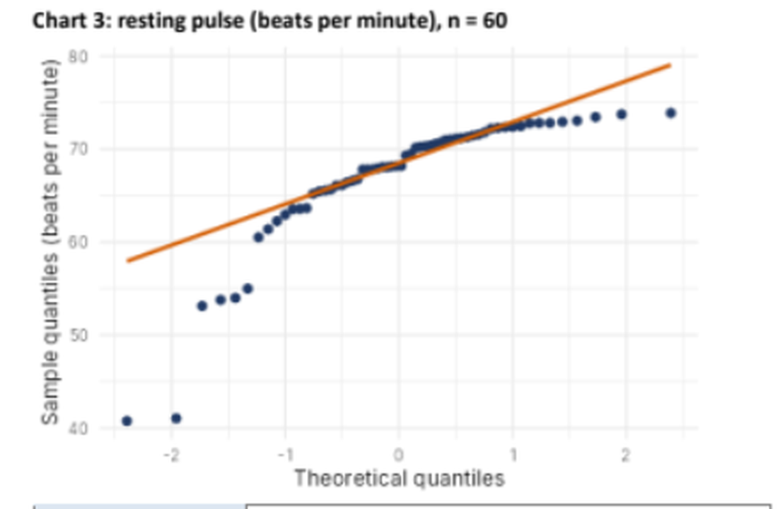
Chart 3: resting pulse (beats per minute), n = 60 (from the activity sheet)
Normal? (Yes / No) | No
Shape (from the list) | Left-skewed

Evidence in the plot:
- The curve bends downward (concave), and the low end lies far BELOW the red line. The line runs from about 58 to 79, with the centre near 68.5.
- Low end: the two lowest dots are about 41 beats per minute, about 17 below the line (about 58). Four more dots at about 53 to 55 are about 7 to 8 below the line, and dots near 60 to 64 are also below it.
- High end: the dots flatten at about 73 to 74, about 5 below the line (about 79). Many values pile up between about 68 and 73.
- Middle (about 65 to 72): the dots follow the line.
- Meaning: a long tail towards low pulse values, with the bulk bunched at the upper end. This is a left (negative) skew.
Why not the other shapes:
Shape | Reason it does not fit
Normal with outliers | Only the two lowest dots (about 41) are extreme, but 6 or more low dots and the flat upper end also leave the line, so the whole curve bends
Right-skewed | Right skew bends upward, with both ends above the line. Here both ends are below it
Heavy-tailed / light-tailed | The ends go the same way (both below), not opposite ways

Chart 4: resting pulse (beats per minute), n = 30 [4 marks]
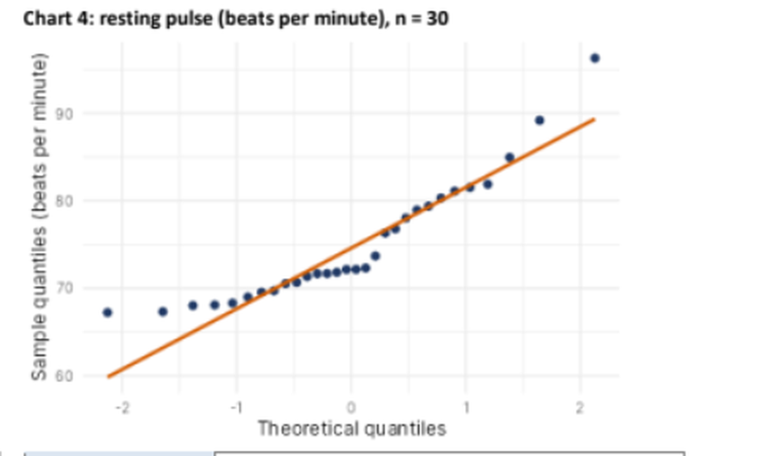
Chart 4: resting pulse (beats per minute), n = 30 (from the activity sheet)
Normal? (Yes / No) | No
Shape (from the list) | Right-skewed

Evidence in the plot:
- The curve bends upward (convex): both ends sit ABOVE the red line. The line runs from about 60 to 89.5, with the centre near 74.8.
- Low end: the lowest dots are about 67 to 68, which is 3 to 7 above the line (about 60 to 66). The lower tail is short and bunched.
- Middle: dots at about 71 to 72 form a flat strip (x from about −0.3 to 0.2), slightly below the line.
- High end: dots at about 89 and 96 are far above the line (the line gives about 86 and 89.5), so the upper tail is long, with the last dot about 7 above the line.
- Meaning: most pulses are bunched at about 67 to 72, with a long tail towards high pulse values. This is a right (positive) skew. The sample is small (n = 30), so the dots wiggle more, but the overall bend is clear.
Why not the other shapes:
Shape | Reason it does not fit
Heavy-tailed | Would have the low end BELOW the line. Here the low end is above it
Normal with outliers | The 89 and 96 dots are extreme, but the low end and middle also deviate systematically, so it is a skewed shape
Left-skewed | Left skew bends downward with both ends below the line, the opposite of this chart

Part B [4 marks]

B1. Chart 2 departs from normality: the departure and the remedy [2 marks]
Chart 2 departs from normality, name the departure and state the remedy you would try before using mean-and-SD methods.
- Departure: two high outliers at the top right (about 14.8 and 15.5 percent), about 5 standard deviations above the centre (about 9.1). The rest of the data are normal.
- Remedy 1: check the two readings. See whether they are recording errors or sensor faults. If so, correct them or remove them with a note.
- Remedy 2: use robust methods. If the values are genuine, use the median and IQR (and a trimmed mean or MAD) instead of the mean and SD, because the mean and SD are pulled by outliers. Report results with and without the two outliers.
Possible remedy | Suitable for | Used here?
Log transform | Right-skewed data | No. The body is already normal, and the transform would distort it
Square transform | Left-skewed data | No. There is no left skew
Split the data | Bimodal data (two groups) | No. There is only one cluster
Robust methods (median, IQR) | Outliers | Yes. This is the fitting remedy

B2. Fill the blanks for the Q-Q plot with its reference line [2 marks]
ggplot(df, aes(sample = value)) + ________ + ________
ggplot(df, aes(sample = value)) + stat_qq() + stat_qq_line()

Part | What it does
aes(sample = value) | Tells ggplot to use the column value as the sample for the Q-Q plot (not x and y)
stat_qq() | Draws the dots: sorted sample values against the theoretical normal quantiles
stat_qq_line() | Draws the red reference line through the first and third quartiles

Equivalent: geom_qq() and geom_qq_line() give the same plot. The line colour in the activity was set with colour = "orange" inside stat_qq_line().
Check: the code was run in R (ggplot2 3.4.4) on example data of 120 values. It produced 2 layers: 120 dots and the reference line.
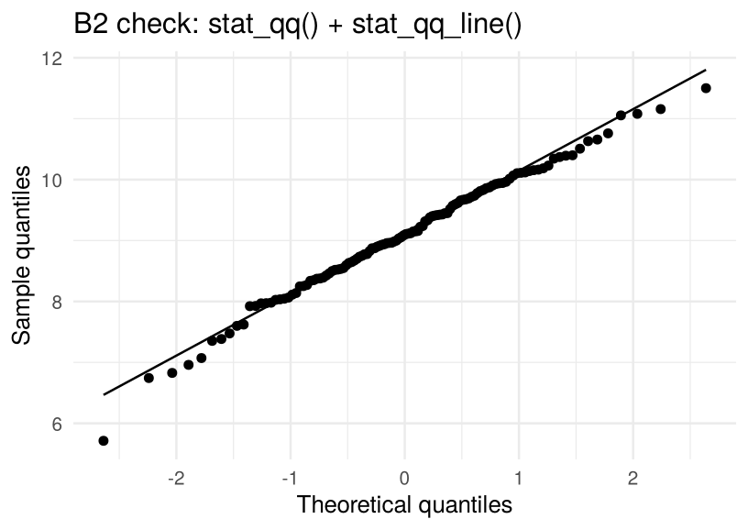
Figure 2: Output of the completed line on example data (simulated).

Quick Revision
Remember
Normal | Dots on the red line
Right-skewed | Curve bends UP: both ends above the line
Left-skewed | Curve bends DOWN: both ends below the line
Light-tailed | S-shape: low end above, high end below (flat ends)
Heavy-tailed | Reverse S: low end below, high end above
Normal with outliers | Straight line with 1 to 3 dots far off an end
Our answers | Chart 1 light-tailed, Chart 2 normal with outliers, Chart 3 left-skewed, Chart 4 right-skewed

