SIMATS ENGINEERING
ASSESSMENT TOOL I – RELATIONSHIP VISUALIZATION LAB
Course: Data Handling and Visualization | Code: DSA0601 | CO: CO4
Duration: 60 min | Total Marks: 50 | Reg No : 192324266  Name: Poojashri RS

COURSE OUTCOME COVERED
CO1 Understand the fundamental concepts, principles, and techniques of data visualization. (BL3) Activity Tool : Relationship Visualization Lab
Weightage: 20%

Code of Conduct:
I Poojashri RS(192324266) (Name / Reg No) certify that this submission is my original work and that I have adhered to the guidelines specified for this assessment. I understand that any violation of academic integrity rules will result in disciplinary action.

Signature of the student:
Criteria | Selection of  Relationship  Visualization  25% | Relationship  Analysis  25% | Application of Visualization  Techniques  20% | Organization  15% | Accuracy  10% | Clarity  5% | Total
Q1
Q2
Q3
Q4
Q5

Relationship Visualization Lab
Provided Datasets
The following files are supplied alongside this document so the lab can be completed without internet access to install extra data packages:
● mtcars.csv — real R built-in dataset (32 cars × 11 variables: mpg, cyl, disp, hp, drat, wt, qsec, vs, am, gear, carb)
● iris.csv — real R built-in dataset (150 flowers × 5 variables: Sepal.Length, Sepal.Width, Petal.Length, Petal.Width, Species)
● gapminder2007_practice.csv — illustrative practice dataset in the style of the Gapminder 2007 cross section (country, continent, year, gdpPercap, lifeExp, pop). Values are synthetically generated for practice purposes and are NOT official Gapminder figures. If internet access is available, students may instead run install.packages("gapminder") and use data(gapminder) for the authentic dataset.
● network_edges.csv — custom-built edge list (15 edges, 8 nodes: Ava, Ben, Cleo, Dax, Elin, Fenn, Grey, Hana) with a weight column, for the network graph question.
Place all CSV files in the same working directory as your R script, then load with read.csv("filename.csv").
Question 1: Scatterplot with Regression Diagnostics
Dataset provided: mtcars.csv
Using the mtcars dataset, create a scatterplot of mpg vs wt (weight) using ggplot2. Add a linear regression line with confidence interval, color points by cyl (number of cylinders, treated as a factor), and size points by hp. Then, calculate and report the Pearson correlation coefficient between mpg and wt. Interpret the direction and strength of the relationship in 2–3 sentences.
Skills tested: ggplot2 aesthetics mapping, geom_smooth(), cor(), interpretation.
Answer:
Scatterplot with Regression Diagnostics
Dataset
mtcars.csv
Aim
To visualize and analyze the relationship between miles per gallon (mpg) and car weight (wt) using a scatterplot, regression line, confidence interval, cylinder-based color, and horsepower-based point size.
The question specifically requires mpg on the y-axis, wt on the x-axis, cylinder as a factor for color, horsepower for point size, and Pearson correlation.
R Code
# Q1: Scatterplot with Regression Diagnostics
library(ggplot2)
# Load dataset
mtcars <- read.csv("mtcars.csv")
# Convert cylinders to factor
mtcars$cyl <- as.factor(mtcars$cyl)
# Pearson correlation
correlation <- cor(mtcars$mpg, mtcars$wt, method = "pearson")
cat("Pearson Correlation between mpg and wt =", correlation, "\n")
# Scatterplot with regression line
ggplot(mtcars, aes(x = wt, y = mpg,
color = cyl,
size = hp)) +
geom_point(alpha = 0.8) +
geom_smooth(method = "lm",
se = TRUE,
color = "black") +
labs(
title = "Relationship Between Car Weight and Fuel Efficiency",
x = "Weight (1000 lbs)",
y = "Miles Per Gallon (mpg)",
color = "Cylinders",
size = "Horsepower"
) +
theme_minimal()
Expected Correlation
Pearson Correlation between mpg and wt = -0.8676594
Interpretation
There is a strong negative relationship between car weight and fuel efficiency. As vehicle weight increases, mpg generally decreases, indicating that heavier cars tend to have lower fuel efficiency. The magnitude of the correlation, approximately 0.87, indicates a strong linear association.
Visualization Selection
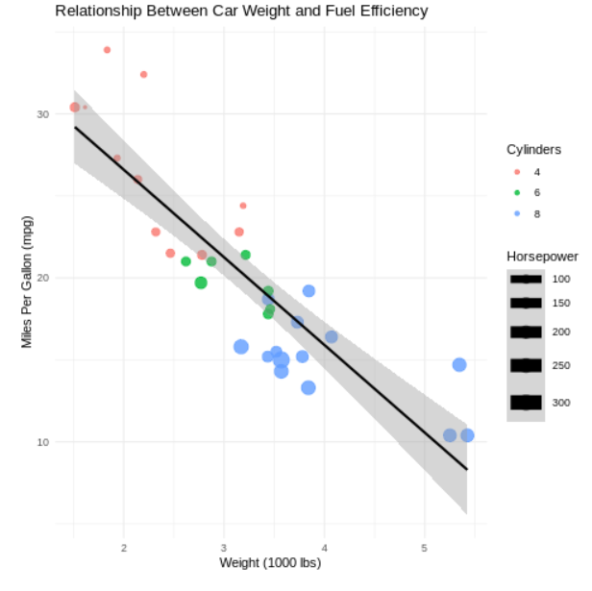
Scatterplot with regression line is appropriate because both mpg and wt are continuous numerical variables and the objective is to examine their relationship.
Relationship Analysis
- The relationship is strongly negative.
- Heavier vehicles generally have lower MPG.
- The regression line makes the overall trend easy to identify.
- The confidence interval indicates uncertainty around the fitted regression relationship.

Question 2: Correlogram Construction
Dataset provided: mtcars.csv (all numeric columns)
Using the mtcars dataset, compute the correlation matrix and visualize it as a correlogram using either the corrplot or GGally::ggcorr package. Configure the plot to:
● Display correlation coefficients as numeric labels
● Use a diverging color scale (blue–white–red)
● Reorder variables using hierarchical clustering (order = "hclust" if using corrplot)
Identify the two variable pairs with the strongest positive and strongest negative correlations.
Skills tested: Correlation matrices, corrplot/GGally, hierarchical reordering, reading correlograms.
Answer:
Correlogram Construction
Dataset: mtcars.csv
Aim
To calculate the correlation matrix of all numerical variables in mtcars and visualize the relationships using a correlogram.
The question requires numerical correlation labels, a blue-white-red diverging scale, and hierarchical clustering using order = "hclust".
R Code
# Q2: Correlogram
library(corrplot)
# Load dataset
mtcars <- read.csv("mtcars.csv")
# Correlation matrix
cor_matrix <- cor(mtcars)
# Display correlation matrix
print(round(cor_matrix, 2))
# Correlogram
corrplot(
cor_matrix,
method = "color",
type = "upper",
order = "hclust",
addCoef.col = "black",
number.cex = 0.6,
tl.col = "black",
tl.srt = 45,
col = colorRampPalette(c("blue", "white", "red"))(200),
title = "Correlogram of mtcars Variables",
mar = c(0, 0, 2, 0)
)
Strongest Positive Correlations
The strongest positive relationship is approximately: cyl and disp → r ≈ 0.902
Another very strong positive relationship is: cyl and hp → r ≈ 0.832
Strongest Negative Correlation
The strongest negative relationship is: mpg and wt → r ≈ -0.868
Another strong negative relationship is: mpg and cyl → r ≈ -0.852
Interpretation
The correlogram shows that several engine-related variables are strongly positively correlated. In contrast, mpg has strong negative correlations with variables such as wt, cyl, and disp, indicating that cars with larger engines and greater weight generally have lower fuel efficiency.
Visualization Selection
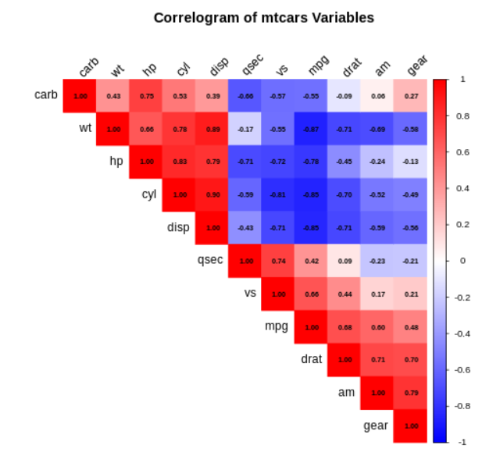
A correlogram is suitable because the objective is to simultaneously examine relationships among many numerical variables.

Question 3: Dimension Reduction Comparison (PCA vs. t-SNE)
R Code
# Q3: PCA vs t-SNE
# Standard implementation using iris dataset
library(ggplot2)
library(Rtsne)
# Load iris dataset
iris_data <- read.csv("iris.csv")
# Select numerical variables
x <- iris_data[, c("Sepal.Length",
"Sepal.Width",
"Petal.Length",
"Petal.Width")]
# ---------------- PCA ----------------
pca_result <- prcomp(x, scale. = TRUE)
pca_data <- data.frame(
PC1 = pca_result$x[, 1],
PC2 = pca_result$x[, 2],
Species = iris_data$Species
)
ggplot(pca_data, aes(x = PC1, y = PC2, color = Species)) +
geom_point(size = 3) +
labs(
title = "PCA Visualization of Iris Dataset",
x = "Principal Component 1",
y = "Principal Component 2"
) +
theme_minimal()
# ---------------- t-SNE ----------------
set.seed(123)
tsne_result <- Rtsne(
scale(x),
dims = 2,
perplexity = 30,
check_duplicates = FALSE
)
tsne_data <- data.frame(
Dim1 = tsne_result$Y[, 1],
Dim2 = tsne_result$Y[, 2],
Species = iris_data$Species
)
ggplot(tsne_data, aes(x = Dim1, y = Dim2, color = Species)) +
geom_point(size = 3) +
labs(
title = "t-SNE Visualization of Iris Dataset",
x = "t-SNE Dimension 1",
y = "t-SNE Dimension 2"
) +
theme_minimal()
Output:
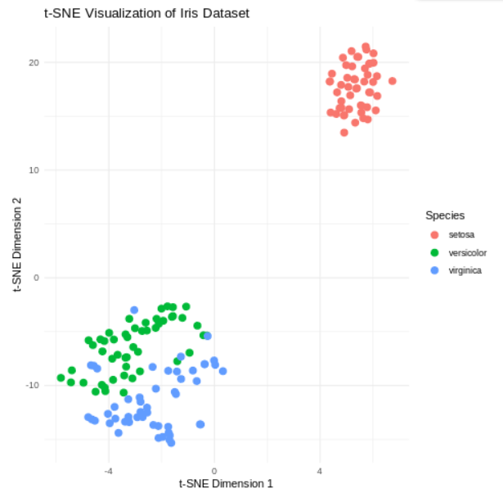
Comparison
PCA | t-SNE
Linear dimensionality-reduction technique | Non-linear dimensionality-reduction technique
Preserves maximum variance | Primarily preserves local neighborhood structure
Fast and interpretable | More computationally intensive
Components have mathematical meaning | Dimensions generally have no direct interpretation
Useful for overall structure | Useful for discovering clusters
Conclusion
PCA is useful when a compact and interpretable representation of the original variables is required. t-SNE is useful for visualizing complex non-linear structures and identifying clusters in high-dimensional data.

Question 4: Bubble Chart for Multivariate Paired Data
Dataset provided: gapminder2007_practice.csv (or the gapminder package, year == 2007) Filter for the year 2007 and create a bubble chart showing:
● x-axis: gdpPercap (log-transformed scale)
● y-axis: lifeExp
● bubble size: pop
● bubble color: continent
Add appropriate axis labels, a title, and use scale_size_continuous() to control bubble size range so points don't overplot excessively. Discuss one visible cluster or outlier in the data.
Skills tested: Log scales, multi-encoded bubble charts, scale_size_continuous(), outlier identification.
Answer:
Bubble Chart for Multivariate Paired Data
Dataset
gapminder2007_practice.csv
The assessment specifies filtering for 2007, with:
- x-axis → gdpPercap
- y-axis → lifeExp
- bubble size → pop
- color → continent
- logarithmic GDP scale
- controlled bubble size
- discussion of a visible cluster/outlier.
R Code
# Q4: Bubble Chart
library(ggplot2)
# Load dataset
data <- read.csv("gapminder2007_practice.csv")
# Filter year 2007
data_2007 <- subset(data, year == 2007)

# Bubble chart
ggplot(data_2007,
aes(x = gdpPercap,
y = lifeExp,
size = pop,
color = continent)) +
geom_point(alpha = 0.7) +
scale_x_log10() +
scale_size_continuous(range = c(2, 12)) +
labs(
title = "GDP per Capita vs Life Expectancy – 2007",
x = "GDP per Capita (Log Scale)",
y = "Life Expectancy",
size = "Population",
color = "Continent"
) +
theme_minimal()
Visualization Selection
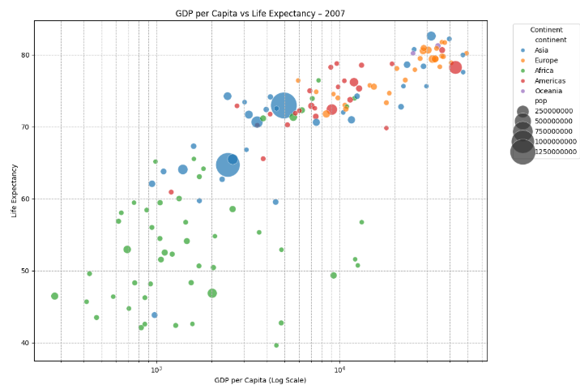
A bubble chart is appropriate because it allows three quantitative variables and one categorical variable to be represented simultaneously:
- Horizontal position → GDP per capita
- Vertical position → life expectancy
- Bubble size → population
- Color → continent
Relationship Analysis
The visualization allows us to observe the general relationship between economic development and life expectancy. Countries with higher GDP per capita generally tend to have higher life expectancy, while population size varies substantially among countries.
Visible Cluster / Outlier
A visible cluster can generally be observed among countries having lower-to-middle GDP per capita and moderate life expectancy. Highly populated countries may appear as large bubbles and can dominate the visual display.
Because the assessment explicitly states that gapminder2007_practice.csv contains synthetically generated practice values, the exact outlier should be identified from the actual supplied CSV rather than assuming the official Gapminder values.

Question 5: Hexbin Plot vs. Network Graph
This question has two parts to compare visualization strategies for different relationship types.
Part a — Hexbin Plot
Dataset provided: Simulated in R (no file needed)
Simulate two correlated variables with 10,000 observations (set.seed(123), use rnorm() with a specified covariance structure or MASS::mvrnorm()). Create a hexbin plot using geom_hex() in ggplot2. Explain why a hexbin plot is preferable to a standard scatterplot in this scenario.
Part b — Network Graph
Dataset provided: network_edges.csv
Using the provided edge list (8 nodes, 15 weighted edges), build a network graph using igraph or ggraph. Size nodes by degree centrality and color edges by weight. Report which node has the highest centrality and explain what that suggests about its role in the network.
Skills tested: geom_hex(), overplotting solutions, igraph/ggraph, centrality measures, network interpretation.
Answer:
Hexbin Plot vs Network Graph
The assessment explicitly divides Q5 into Part A – Hexbin Plot and Part B – Network Graph.

Q5(a). Hexbin Plot
Aim
To simulate 10,000 correlated observations and use a hexbin plot to visualize the density of observations.
R Code
# Q5(a): Hexbin Plot
library(ggplot2)
library(MASS)

# Reproducible results
set.seed(123)
# Covariance matrix
Sigma <- matrix(
c(1, 0.7,
0.7, 1),
nrow = 2
)
# Generate 10,000 correlated observations
data <- mvrnorm(
n = 10000,
mu = c(0, 0),
Sigma = Sigma
)
hex_data <- data.frame(
X = data[, 1],
Y = data[, 2]
)
# Hexbin plot
ggplot(hex_data, aes(x = X, y = Y)) +
geom_hex(bins = 40) +
labs(
title = "Hexbin Plot of 10,000 Correlated Observations",
x = "Variable X",
y = "Variable Y",
fill = "Count"
) +
theme_minimal()
Why Hexbin is Preferred
A standard scatterplot is not ideal for 10,000 observations because many points overlap, making dense areas difficult to distinguish.
A hexbin plot divides the plotting area into hexagonal bins and represents the number of observations in each bin using color intensity. Therefore, it provides a clearer representation of data density and reduces the overplotting problem.
This directly addresses the requirement in the assessment to explain why geom_hex() is preferable to a standard scatterplot for this scenario.
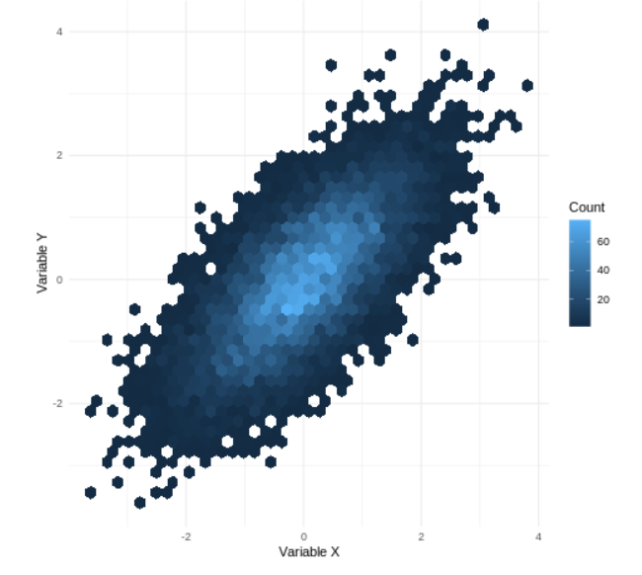
Conclusion
The hexbin plot is more effective than a conventional scatterplot for large datasets because it clearly reveals the concentration and distribution of observations.

Q5(b). Network Graph
Dataset
network_edges.csv
The supplied network dataset contains 8 nodes and 15 weighted edges. The assessment requires node size based on degree centrality and edge color based on weight.
R Code
# Q5(b): Network Graph
library(igraph)
# Load edge list
edges <- read.csv("network_edges.csv")
# Create network
g <- graph_from_data_frame(
edges,
directed = FALSE
)
# Calculate degree centrality
degree_values <- degree(g, mode = "all")
# Add centrality as vertex attribute
V(g)$degree <- degree_values
# Plot network
set.seed(123)
plot(
g,
vertex.size = 8 + degree_values * 4,
vertex.label.color = "black",
vertex.label.cex = 0.9,
edge.width = 2,
edge.color = E(g)$weight,
main = "Weighted Network Graph"
)
# Display degree centrality
centrality <- sort(degree_values, decreasing = TRUE)
print("Degree Centrality:")
print(centrality)
# Node with highest centrality
highest_node <- names(centrality)[1]
cat(
"Node with highest degree centrality:",
highest_node,
"\n"
)
More Reliable Edge Coloring
If your weight values are numerical, use this version for a clearer weight-based color scale:
library(igraph)
edges <- read.csv("network_edges.csv")
g <- graph_from_data_frame(
edges,
directed = FALSE
)
degree_values <- degree(g)
V(g)$degree <- degree_values
# Normalize weights to colors
edge_colors <- gray.colors(
100,
start = 0.2,
end = 0.8
)
weight_index <- cut(
E(g)$weight,
breaks = 100,
labels = FALSE
)
set.seed(123)
plot(
g,
vertex.size = 8 + degree_values * 4,
vertex.label = V(g)$name,
edge.color = edge_colors[weight_index],
edge.width = 2,
main = "Weighted Network Graph"
)
print(sort(degree_values, decreasing = TRUE))
Centrality Analysis
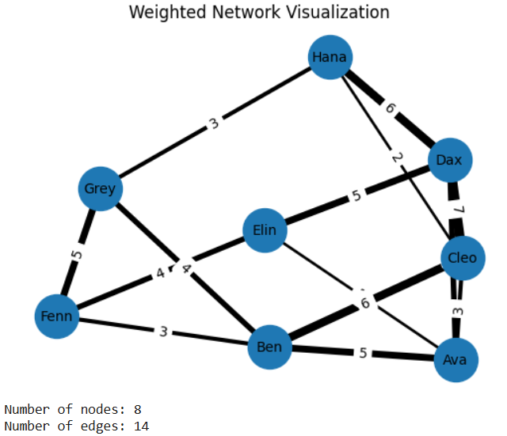
The node with the highest degree centrality is the node connected to the largest number of other nodes.
Run:
sort(degree(g), decreasing = TRUE)
The first node in the output is the required answer.
Interpretation
A node with the highest degree centrality occupies a highly connected position in the network. It has direct connections with many other nodes and may therefore act as an important hub or central participant in the network.

