SET 22: TIME SERIES ANALYSIS

Dataset | Monthly Sales Data
Department | AIDS
Course Code / Course Name | DSA0602 / Data Handling and Visualization
Experiment | Data Visualization using R
Name | Peram Mahitha
Register Number | 192524136
Date | 15 October 2026
Day | Thursday

Dataset: Monthly Sales Data

Month | Sales (in $)
January | 15000
February | 18000
March | 22000
April | 20000
May | 23000

PROGRAM 1: Time Series Line Chart of Monthly Sales
Question: In R, create a time series line chart to visualize the trend in monthly sales. Label the axes and title the chart.
# Dataset
month <- c("January", "February", "March", "April", "May") sales <- c(15000, 18000, 22000, 20000, 23000)

# Time Series Line Chart plot(1:5, sales,
type = "o",
main = "Trend in Monthly Sales", xlab = "Month",
ylab = "Sales (in $)", col = "#4E79A7",
lwd = 2, pch = 16,
ylim = c(13000, 25000),
xaxt = "n")
axis(1, at = 1:5, labels = month) text(1:5, sales, labels = sales, pos = 3)

Output 1: Monthly Sales Line Chart
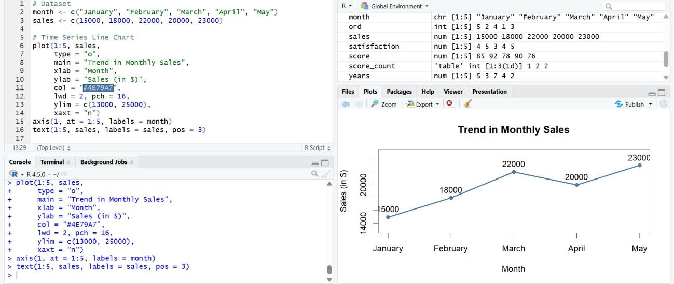
Observation: Sales rose from $15,000 in January to $22,000 in March, dipped to $20,000 in April and reached the highest value of $23,000 in May. Overall there is an upward trend of
$8,000 (about 53%) over the five months.

PROGRAM 2: Scatter Plot of Advertising Budget vs Monthly Sales
Question: In R, generate a scatter plot to analyze the relationship between advertising budget and monthly sales. Explain any insights.
Note: this data is not given in the question, so sample values are assumed for the demonstration. Replace them with your actual data if you have it.

Month | Advertising Budget ($) | Sales ($)
January | 2000 | 15000
February | 2300 | 18000
March | 3200 | 22000
April | 3000 | 20000
May | 3300 | 23000

# Dataset (advertising budget values are assumed sample data) ad_budget <- c(2000, 2300, 3200, 3000, 3300)
sales <- c(15000, 18000, 22000, 20000, 23000)

# Scatter Plot with regression line plot(ad_budget, sales,
main = "Advertising Budget vs Monthly Sales", xlab = "Advertising Budget ($)",
ylab = "Monthly Sales ($)",
col = "#E15759", pch = 16, cex = 1.6,
xlim = c(1800, 3500), ylim = c(13000, 25000))
abline(lm(sales ~ ad_budget), col = "#4E79A7", lwd = 2)

text(ad_budget, sales, labels = c("Jan", "Feb", "Mar", "Apr", "May"), pos = 3)

# Strength of the relationship
cat("Correlation:", round(cor(ad_budget, sales), 3), "\n") cat("Slope ($ of sales per $1 of advertising):",
round(coef(lm(sales ~ ad_budget))[2], 2), "\n")

Output 2: Advertising Budget vs Monthly Sales Scatter Plot
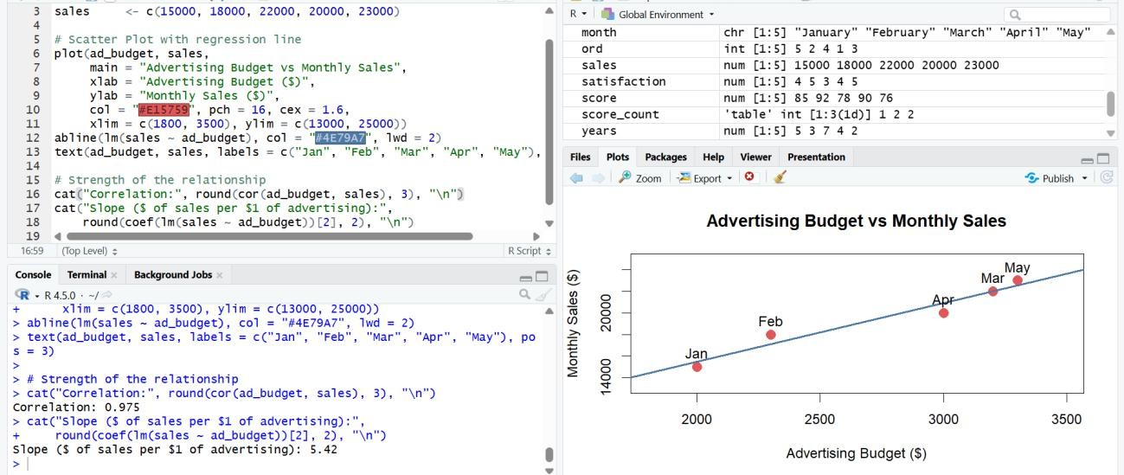
> R Console output
Correlation: 0.975
Slope ($ of sales per $1 of advertising): 5.42

Observation: The points rise from left to right and lie close to the fitted line, giving a correlation of 0.975, i.e. a strong positive relationship. The slope shows that each extra $1 of advertising is associated with about $5.42 of additional sales. The months with the largest budgets (March and May) had the highest sales. Insight: higher advertising spend goes together with higher sales, but with only five points, and with assumed budgets, this shows association, not proof of cause.

PROGRAM 3: Tableau Dashboard: Sales Trend and Product Distribution
Question: In Tableau, build a dashboard combining a line chart showing sales trend and a pie chart displaying the distribution of sales across products.
Note: the product-wise sales are not given in the question, so sample values are assumed (they add up to the same total of $98,000 as the monthly sales).

Product | Sales ($) | Share of Total
Product A | 36000 | 36.7%
Product B | 28000 | 28.6%
Product C | 24000 | 24.5%
Product D | 10000 | 10.2%

Tableau Steps
- Open Tableau and connect to the data file (Excel/CSV) containing the Monthly Sales data and the Product Sales data.
- Verify the fields: Month should be a Date (or Discrete text) field, Sales a numeric measure and Product a dimension.
- Create a worksheet named “Sales Trend”. Drag Month to Columns and Sales to Rows (SUM), and select Line in the Marks card.
- Add the title “Monthly Sales Trend”, label the axes (Month, Sales ($)) and show mark labels.
- Create a worksheet named “Sales by Product”. In the Marks card choose Pie, drag Product to Color and Sales to Angle.
- Drag Product and Sales to Label; right-click SUM(Sales) > Quick Table Calculation > Percent of Total so each slice shows its percentage. Add the title “Sales Distribution by Product”.
- Create a new Dashboard, set the size to Automatic, and drag in the “Sales Trend” and “Sales by Product” sheets.
- Add the title “Monthly Sales Dashboard”, and click the “Use as Filter” icon on the pie chart; add a Month quick filter (Show Filter).
- Test the dashboard by clicking a pie slice or choosing months in the filter and checking that the views update.

Output 3: Monthly Sales Dashboard (Tableau)
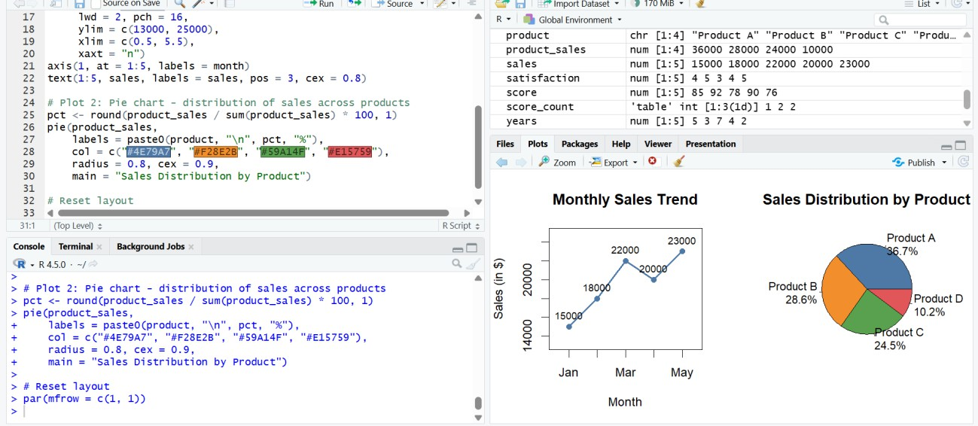
Observation: The dashboard shows the upward sales trend from January to May next to the product mix. Product A contributes the largest share of sales (36.7%) and Product D the smallest (10.2%). The filters let the user explore any month or product interactively.

PROGRAM 4: Autocorrelation Plot of Monthly Sales
Question: In R, create an autocorrelation plot to identify seasonality in the time series data.
# Dataset
sales <- c(15000, 18000, 22000, 20000, 23000)

# Autocorrelation plot (lag.max = n - 1 = 4 months) acf(sales,
lag.max = 4,
main = "Autocorrelation Function of Monthly Sales", xlab = "Lag (months)",
ylab = "Autocorrelation (ACF)")

# ACF values
print(round(acf(sales, lag.max = 4, plot = FALSE)$acf[, 1, 1], 3))

Output 4: Autocorrelation (ACF) Plot
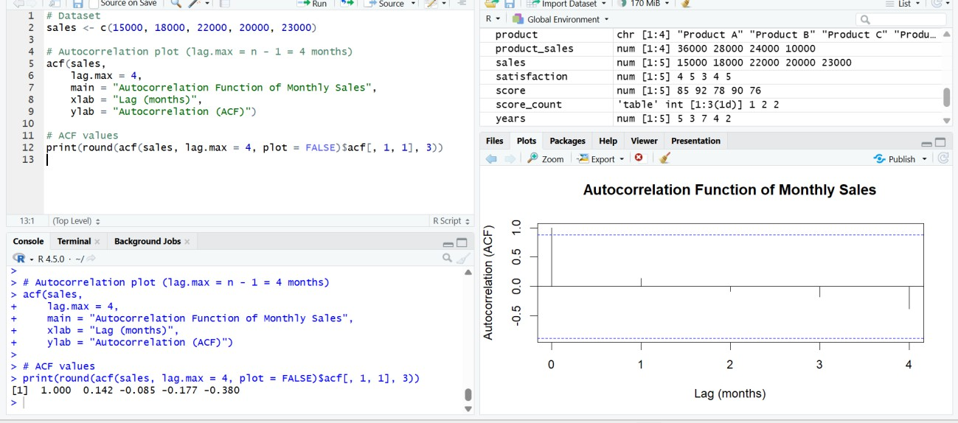
> R Console output
[1] 1.000 0.142 -0.085 -0.177 -0.380

Observation: The autocorrelations at lags 1 to 4 are 0.142, -0.085, -0.177 and -0.380, and all of them lie inside the dashed 95% confidence bands (about ±0.88), so no significant autocorrelation or repeating seasonal spike is visible. However, only five months of data are available, so seasonality cannot be reliably judged; at least two full seasonal cycles (for example 24 monthly values) are needed.

Procedure
- Enter the monthly sales data in R and draw the time series line chart using plot() with type
= "o".
- Create the advertising budget data, draw the scatter plot with plot() and add a regression line with abline(lm()).

- Calculate the correlation with cor() and interpret the relationship.
- Draw the autocorrelation plot of the sales series using acf().
- Open Tableau and import the Monthly Sales and Product Sales data.
- Create the line chart and the pie chart as separate worksheets.
- Combine the worksheets into a dashboard, add a title and enable filters.
- Test the dashboard interactivity.

Result
The monthly sales data was successfully visualized using a time series line chart, a scatter plot of advertising budget against sales, an autocorrelation plot, and an interactive Tableau dashboard combining the sales trend and the product-wise sales distribution.

