SET 24: PRODUCT INVENTORY MANAGEMENT

Dataset | Product Inventory
Department | AIDS
Course Code / Course Name | DSA0602 / Data Handling and Visualization
Experiment | Data Visualization using R
Name | Peram Mahitha
Register Number | 192524136
Date | 15 October 2026
Day | Thursday

Dataset: Product Inventory

Product ID | Product Name | Quantity Available
1 | Product A | 250
2 | Product B | 175
3 | Product C | 300
4 | Product D | 200
5 | Product E | 220

PROGRAM 1: Bar Chart of Quantity by Product
Question: In R, create a bar chart to visualize the quantity of each product in the inventory. Label the axes and title the chart.
# Dataset
product <- c("Product A", "Product B", "Product C", "Product D", "Product E")
quantity <- c(250, 175, 300, 200, 220)

# Bar Chart
bp <- barplot(quantity,
names.arg = product,
main = "Quantity Available by Product", xlab = "Product",
ylab = "Quantity Available", col = "#4E79A7",
ylim = c(0, 350))
text(bp, quantity, labels = quantity, pos = 3)

Output 1: Quantity Available by Product Bar Chart
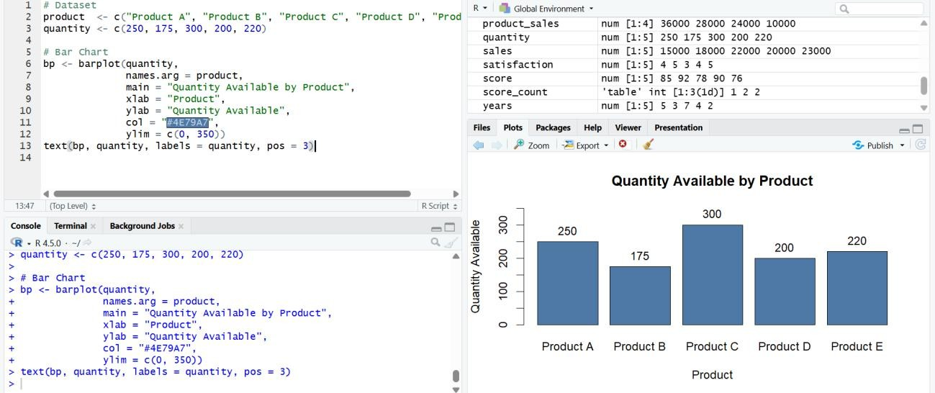
Observation: Product C has the highest stock (300 units) and Product B the lowest (175 units). The total inventory is 1,145 units, an average of 229 units per product.

PROGRAM 2: Stacked Bar Chart by Product Category
Question: In R, generate a stacked bar chart to show the quantity of each product within different product categories.
Note: this data is not given in the question, so sample values are assumed for the demonstration. Replace them with your actual data if you have it.

Product | Category | Quantity Available
Product A | Electronics | 250
Product B | Home | 175
Product C | Electronics | 300
Product D | Home | 200
Product E | Office | 220

# Dataset (categories are assumed sample data) inventory <- data.frame(
Product = c("Product A", "Product B", "Product C", "Product D", "Product E"),
Category = c("Electronics", "Home", "Electronics", "Home", "Office"), Quantity = c(250, 175, 300, 200, 220)
)

# Cross-tabulate: rows = products (stack segments), columns = categories (bars)
stack_data <- xtabs(Quantity ~ Product + Category, data = inventory)

# Stacked Bar Chart barplot(stack_data,
main = "Quantity of Each Product within Product Categories",

xlab = "Product Category", ylab = "Quantity Available",
col = c("#4E79A7", "#F28E2B", "#59A14F", "#E15759", "#B07AA1"),
ylim = c(0, 650),
legend.text = rownames(stack_data),
args.legend = list(x = "topright", title = "Product", cex = 0.8))

Output 2: Stacked Bar Chart of Products within Categories
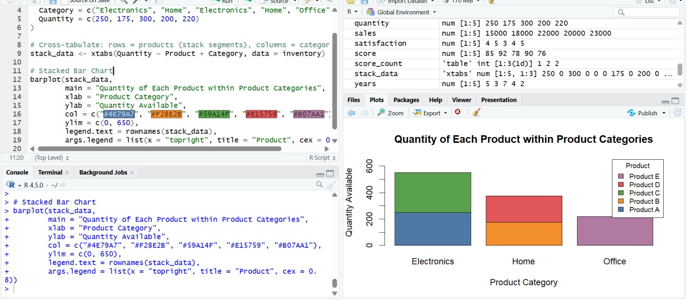
Observation: Electronics holds the most stock (550 units: Product A 250 + Product C 300), which is 48% of the total. Home has 375 units (Product B 175 + Product D 200) and Office has 220 units (Product E only).

PROGRAM 3: Tableau Dashboard: Bar Chart and Stacked Bar Chart
Question: In Tableau, build a dashboard combining the bar chart and stacked bar chart for interactive exploration of inventory data.

Tableau Steps
- Open Tableau and connect to the Product Inventory dataset (Excel/CSV) including the Category field.
- Verify the fields: Product Name and Category are dimensions and Quantity Available is a numeric measure.
- Create a worksheet named “Quantity by Product”. Drag Product Name to Columns and Quantity Available to Rows; select Bar in the Marks card.
- Add the title “Quantity Available by Product”, label the axes and show mark labels.
- Create a worksheet named “Quantity by Category”. Drag Category to Columns, Quantity Available to Rows and Product Name to Color; the bars are stacked automatically.
- Add the title “Quantity of Each Product within Categories”, show the Product Name colour legend and show mark labels.
- Create a new Dashboard, set the size to Automatic, and drag in both worksheets.

- Add the title “Product Inventory Dashboard”, click the “Use as Filter” icon on the stacked bar chart and add a Category quick filter (Show Filter).
- Test the dashboard by selecting a category or a product segment and checking that the other chart updates.

Output 3: Product Inventory Dashboard (Tableau)
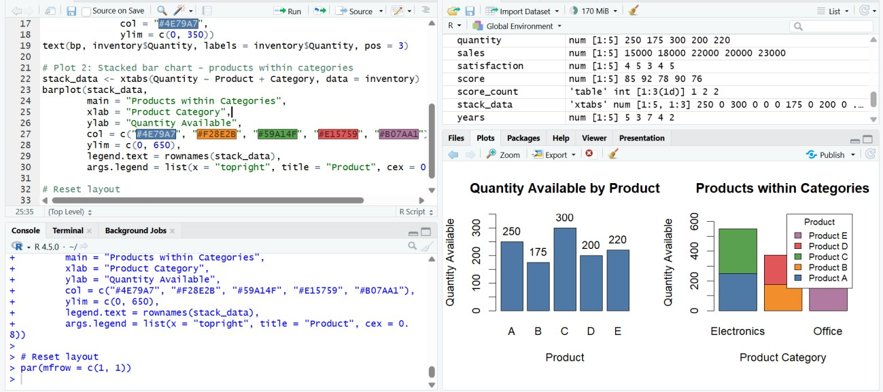
Observation: The dashboard shows stock per product next to the category-wise stacked bars. Selecting a category (for example Electronics) filters the product bar chart to its products, which makes it easy to explore inventory by category and by product.

PROGRAM 4: Scatter Plot of Product Price vs Quantity Available
Question: In R, create a scatter plot to explore the relationship between product price and quantity available. Explain any insights.
Note: product prices are not given in the question, so sample values are assumed for the demonstration.

Product | Price ($) | Quantity Available
Product A | 40 | 250
Product B | 65 | 175
Product C | 30 | 300
Product D | 55 | 200
Product E | 50 | 220

# Dataset (product prices are assumed sample data) price <- c(40, 65, 30, 55, 50)
quantity <- c(250, 175, 300, 200, 220) product <- c("A", "B", "C", "D", "E")

# Scatter Plot with trend line plot(price, quantity,
main = "Product Price vs Quantity Available",

xlab = "Product Price ($)", ylab = "Quantity Available",
col = "#E15759", pch = 16, cex = 1.6, xlim = c(25, 70), ylim = c(150, 330))
abline(lm(quantity ~ price), col = "#4E79A7", lwd = 2)
text(price, quantity, labels = paste("Product", product), pos = 3, cex = 0.8)

# Strength of the relationship
cat("Correlation:", round(cor(price, quantity), 3), "\n")

Output 4: Price vs Quantity Available Scatter Plot
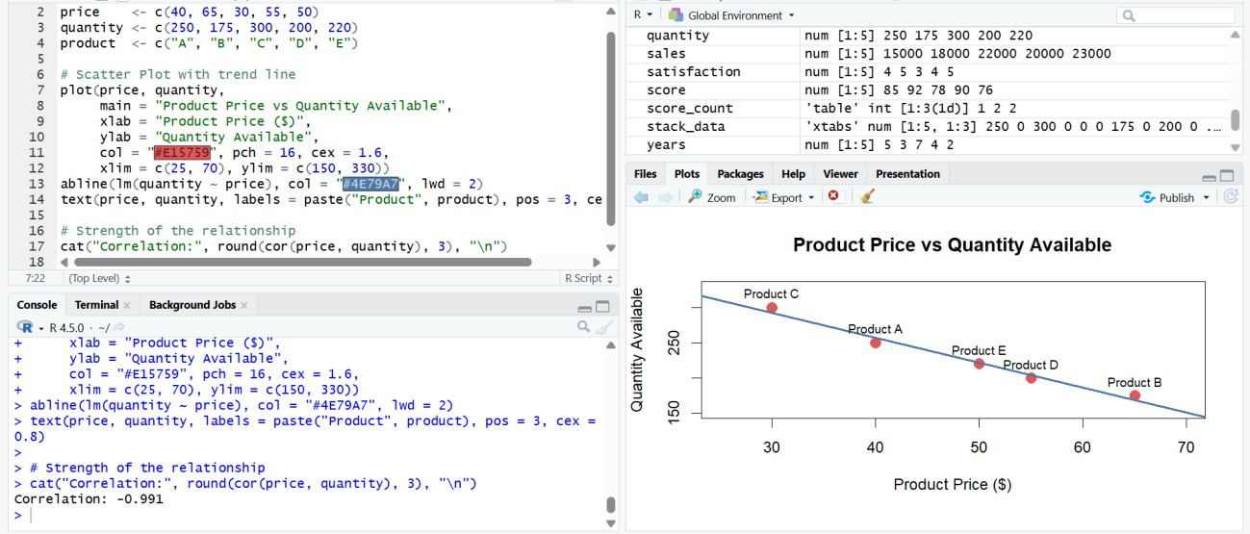
> R Console output
Correlation: -0.991

Observation: The points fall along a downward-sloping line with a correlation of -0.991, a very strong negative relationship. Lower-priced products (Product C at $30: 300 units) are stocked in larger quantities than higher-priced ones (Product B at $65: 175 units). Insight: cheaper products appear to be stocked more heavily, possibly because they sell in greater volume, while expensive items are held in smaller quantities. With five assumed data points this is only an indication, not proof.

Procedure
- Create the product inventory data in R.
- Draw the bar chart of quantity by product using barplot().
- Add the product categories, cross-tabulate with xtabs() and draw the stacked bar chart using barplot().
- Create the price data, draw the scatter plot with plot() and add a trend line using abline(lm()).
- Open Tableau and import the Product Inventory dataset.
- Create the bar chart and the stacked bar chart as separate worksheets.

- Combine the worksheets into a dashboard, add a title, and enable filters.
- Test the dashboard interactivity.

Result
The Product Inventory data was successfully visualized using a bar chart of quantity by product, a stacked bar chart by category, a price versus quantity scatter plot, and an interactive Tableau dashboard.

