SESSION — ACTIVITY (15-20 MIN) • STUDENT HANDOUT • SLOT D
Visualization Matching Game
R.No: 29 | Reg. No: 192524136 | Name: Peram Mahitha
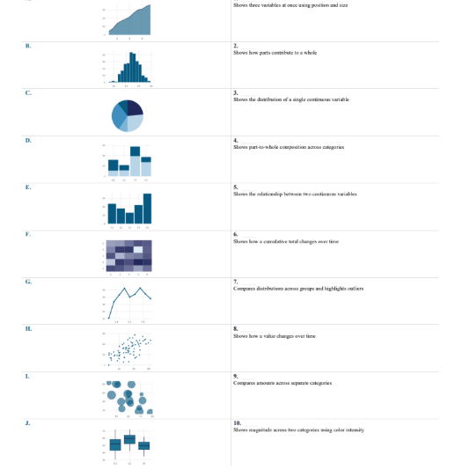

Chart | Chart Name | Matching Option
A | Area Chart | 8
B | Histogram | 1
C | Pie Chart | 3
D | Mosaic Chart | 4
E | Bar Chart | 9
F | Heatmap | 10
G | Line Chart | 8
H | Scatter Plot | 5
I | Bubble Chart | 2
J | Box Plot | 7

