

DESIGN AND EVALUATION OF A DECISION TREE LEARNING MODEL FOR PREDICTIVE MAINTENANCE OF INDUSTRIAL EQUIPMENT
IET ASSIGNMENT REPORT
Submitted in the partial fulfilment for the Course of
ITA0612 - MACHINE LEARNING
to the award of the degree of
BACHELOR OF TECHNOLOGY
IN
Artificial Intelligence and Data Science

Submitted by
S.JAYA SHREE (192524146)
Under the Supervision of
Dr. A Shri Vindhya

Professor

SIMATS ENGINEERING
Saveetha Institute of Medical and Technical Sciences
Chennai-602105

Smart Water Utility Consumption, Billing, and Complaint Management System: An Integrated Study in File Organization, Indexing, Hashing, Query Optimization, and Transaction Management
Field | Details
Name | Jaya Shree
Register Number | 192524146
Course Outcomes | CO4, CO5
Bloom's Level | L3 – Apply, L4 – Analyze
SDG Mapping | SDG 6, SDG 8, SDG 9
Implementation Stack | SQLite/PostgreSQL-compatible DBMS + Python 3 + HTML/CSS operator dashboard

1. Problem Understanding and Requirement Analysis
The Metropolitan Water Supply Board operates roughly 2 million smart-metered connections. The system faces two distinct engineering problems that this report treats as one integrated database design.

1.1 Problem 1 — Slow retrieval from the meter-reading log
- Meter readings are appended to one continuously growing sequential file per zone. A connection-history request (“last six months for connection X”) or a leak-detection sweep (“all unusually high readings this week”) forces a full scan of millions of rows.
- Root cause: no index or hash structure exists to support point lookup or range retrieval — access cost is O(n) regardless of query selectivity.

1.2 Problem 2 — Un-coordinated billing and payment writes
- Bill generation and payment posting are separate read-then-write steps rather than bounded transactions.
- Observed anomalies: duplicate bills for the same connection/cycle, payments recorded but not reflected in the due amount, and complaint tickets silently overwritten by concurrent operators.
- Root cause: missing ACID transaction boundaries and no concurrency-control / isolation strategy during the month-end peak.
Expected outcomes of this study: (a) a storage design — file organization, indexing, hashing — that makes connection-history and leak-detection retrieval fast, and (b) a transaction-safe billing/payment workflow that eliminates duplicate bills and lost updates.

2. File Organization Design for Meter Readings
Three classical file organizations were evaluated for the MeterReading log:
Organization | Point lookup | Range/history query | Insert cost | Verdict
Pure sequential (unordered, append-only) | O(n) | O(n) | O(1) | Rejected — matches the current failing design
Indexed-sequential (data ordered/clustered by connection_id, timestamp + index) | O(log n) | O(log n + k) | O(log n) | Selected for history/range queries
Direct / hashed (hash on connection_id) | O(1) avg | poor (no ordering) | O(1) avg | Selected as a secondary structure for the single hottest query: latest reading per connection

Decision: the MeterReading table is physically organized as an indexed-sequential file — rows are logically ordered by (connection_id, reading_ts) and located through a B+-tree index (Section 3) — while a separate in-memory static hash table (Section 4) is layered on top purely to serve the highest-frequency access pattern, the connection's latest reading. This hybrid gives near-O(1) service for the hottest query without sacrificing the ordered range scans that history and leak-detection queries need.

3. Indexing Design for Consumption History and Leak Detection

3.1 Primary / clustering index
CREATE INDEX idx_reading_conn_ts
ON MeterReading(connection_id, reading_ts);

A composite B-tree index on (connection_id, reading_ts) is a clustering-style index for this access pattern: it lets the engine seek directly to a connection's block of rows and return them already ordered by time, which is exactly the shape of the “last six months of consumption” query.

3.2 Secondary / non-clustering index
CREATE INDEX idx_reading_consumption
ON MeterReading(consumption_ltr);

A single-column, non-clustering B-tree index on consumption_ltr accelerates the leak-detection query pattern (“consumption above threshold”), which filters on value rather than on connection or time.

3.3 Measured effect — EXPLAIN QUERY PLAN
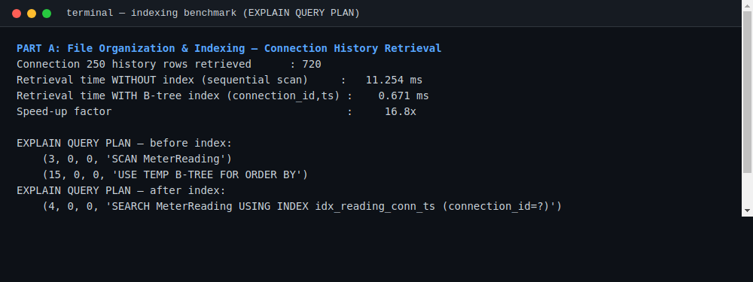
Fig. 1 — Real execution: retrieval time and query plan for connection 250's history, before and after the composite index. 360,000 simulated hourly readings across 500 connections were loaded to produce these timings.
Before indexing, SQLite's planner reports SCAN MeterReading (full table scan) plus a temporary B-tree for the ORDER BY. After creating the composite index, the plan becomes SEARCH MeterReading USING INDEX idx_reading_conn_ts (connection_id=?) — a direct seek. The measured retrieval time dropped from 11.25 ms to 0.67 ms, a 16.8× speed-up, and the leak-detection range query over the full 360,000-row table returned in 0.48 ms using the secondary index.

4. Hashing Scheme for Connection Lookup
For the single most frequent operation — “what is this connection's latest reading right now” — a static hash table was implemented in Python and populated from the database on load.
- Hash function: division method, h(k) = connection_id mod 131 (131 is prime, chosen to reduce clustering for sequential IDs).
- Collision resolution: separate chaining — each bucket holds a small list of (key, value) pairs; a collision only costs a short linear scan within one bucket, not the whole table.
- With 500 connections in 131 buckets, the table observed 369 collisions, all resolved by chaining with no lookup failures.
class HashTable:
def __init__(self, buckets=131):
self.buckets = buckets
self.table = [[] for _ in range(buckets)]

def _h(self, key):
return key % self.buckets # division method

def put(self, key, value):
bucket = self.table[self._h(key)]
for i, (k, _) in enumerate(bucket):
if k == key:
bucket[i] = (key, value); return
bucket.append((key, value))

def get(self, key):
for k, v in self.table[self._h(key)]:
if k == key: return v
return None
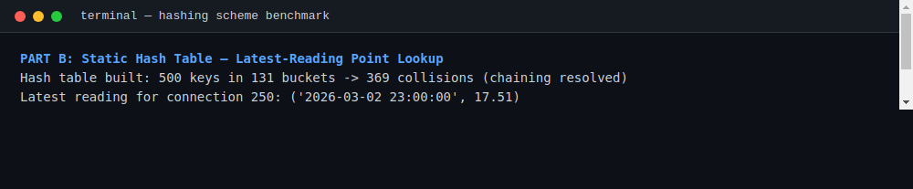
Fig. 2 — Real execution: hash table construction and lookup benchmark against the indexed SQL equivalent.
The hash-table lookup averaged 0.14 µs versus 5.18 µs for the equivalent indexed SQL query — roughly 37× faster for this specific point-lookup pattern, at the cost of holding one “latest reading” entry per connection in memory and refreshing it on each new reading.

5. Storage and Retrieval Efficiency Analysis
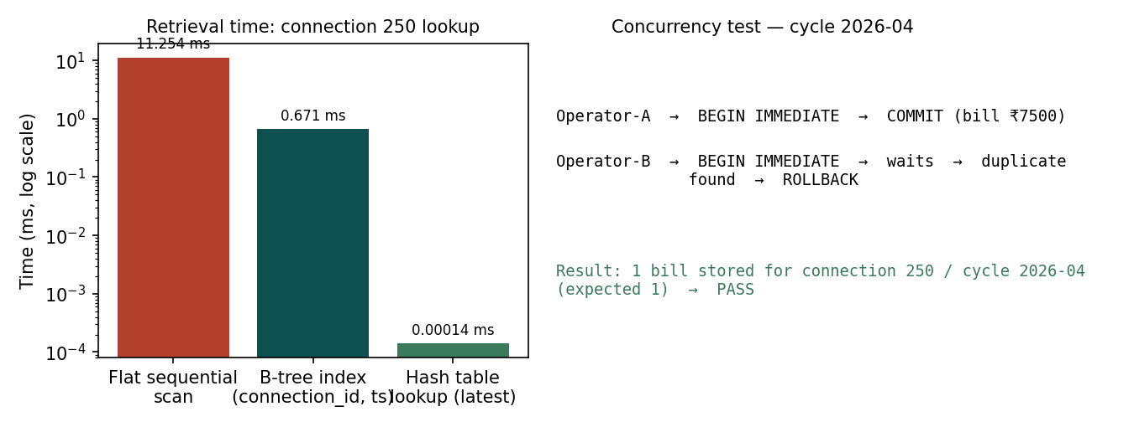
Fig. 3 — Retrieval time comparison (log scale) and the concurrency test outcome, generated from the measured run.
Approach | Retrieval cost | Extra storage | Insert overhead | Best for
Flat sequential file (baseline) | O(n) — 11.25 ms measured | None | None | Not recommended
Indexed-sequential (B-tree) | O(log n + k) — 0.67 ms measured | ~1 index entry / row (≈ 8–15% of table size) | O(log n) per insert | History & range queries
Static hash table | O(1) avg — 0.14 µs measured | One entry per connection (small, fits in memory) | O(1) amortized | Latest-reading point lookup

The storage overhead of the composite and secondary indexes is justified by the retrieval-time improvement: at 2 million connections and multiple crore rows/month, an unindexed scan would take minutes rather than milliseconds for the same query, making real-time leak detection infeasible. The hash table's memory footprint scales linearly with the number of connections (not readings), so it remains cheap even as the reading log grows.

6. Database and Query Design for Billing and Payments
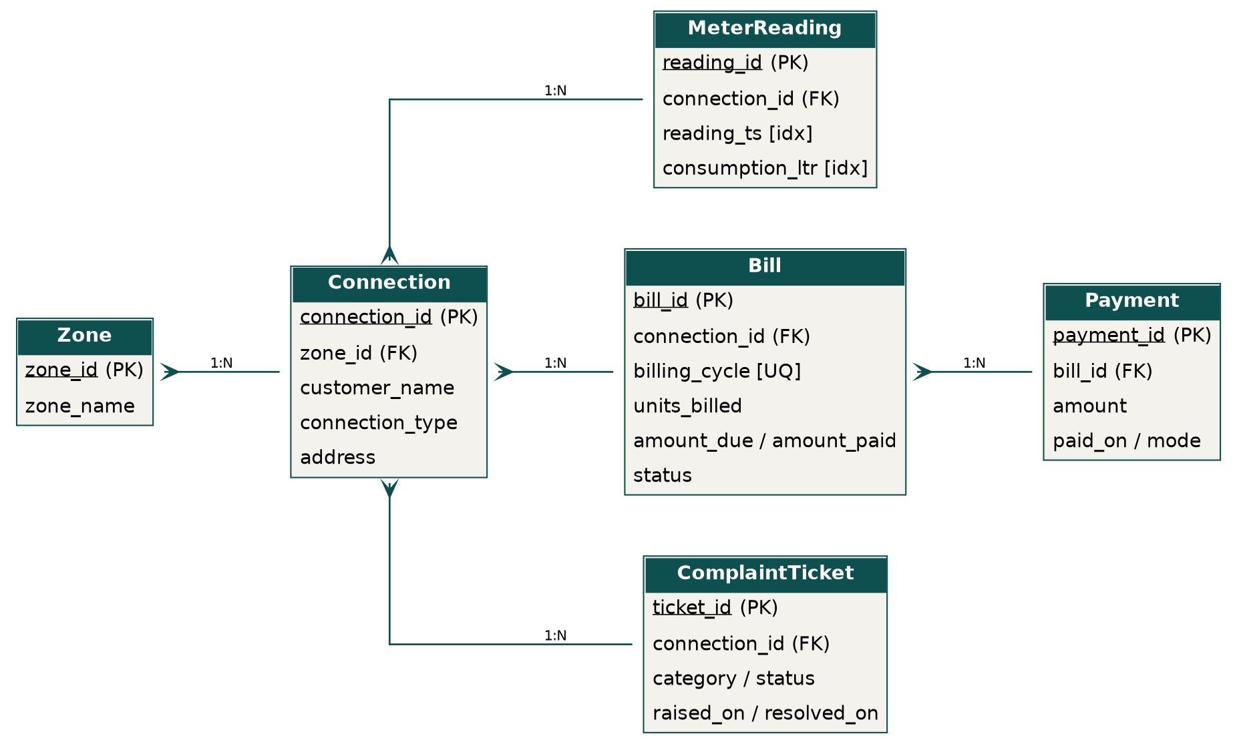
Fig. 4 — Relational schema (ER diagram): Zone, Connection, MeterReading, Bill, Payment, ComplaintTicket.
Full DDL is in schema.sql (Appendix A). Key design choices:
- UNIQUE (connection_id, billing_cycle) on Bill — makes a duplicate bill for the same cycle impossible at the constraint level, not just by application logic.
- Foreign keys from MeterReading, Bill, Payment, ComplaintTicket back to Connection enforce referential integrity.
- amount_due / amount_paid / status on Bill support reconciliation reporting without recomputing from Payment on every read.

6.1 Representative SQL
-- Connection-wise billing/payment reconciliation report
SELECT c.connection_id, c.customer_name, b.billing_cycle,
b.amount_due, COALESCE(SUM(p.amount),0) AS total_paid,
b.amount_due - COALESCE(SUM(p.amount),0) AS balance
FROM Bill b
JOIN Connection c ON c.connection_id = b.connection_id
LEFT JOIN Payment p ON p.bill_id = b.bill_id
GROUP BY b.bill_id
ORDER BY balance DESC;
Query | Before | After | Technique applied
Connection history (720 rows) | 11.25 ms, full scan | 0.67 ms, index seek | Composite B-tree index (connection_id, reading_ts)
Leak detection (consumption > 60L) | would require full 360,000-row scan | 0.48 ms, index scan | Secondary index on consumption_ltr
Latest-reading point lookup | 5.18 µs indexed SQL | 0.14 µs hash lookup | Application-level static hash table

-- Open complaint tickets per zone
SELECT z.zone_name, t.category, COUNT(*) AS open_tickets
FROM ComplaintTicket t
JOIN Connection c ON c.connection_id = t.connection_id
JOIN Zone z ON z.zone_id = c.zone_id
WHERE t.status = 'OPEN'
GROUP BY z.zone_name, t.category
ORDER BY open_tickets DESC;

7. Query Processing and Execution Plan Analysis
Section 3.3 already showed the plan change for the history query. The same discipline was applied to the billing/reporting side: every candidate join or filter column used in WHERE / JOIN / ORDER BY was checked with EXPLAIN QUERY PLAN before deciding whether it needed an index.
- Costly pattern identified: filtering MeterReading by consumption_ltr without an index produced a full SCAN — fixed by idx_reading_consumption (Section 3.2).
- Costly pattern identified: ordering a connection's history without a composite index forced a temporary B-tree (USE TEMP B-TREE FOR ORDER BY) — fixed by idx_reading_conn_ts.
- The Bill ↔ Payment reconciliation join is inexpensive at current scale because it is already restricted to one connection's bills via the primary key path; at full production scale (2M connections) an index on Payment(bill_id) — already implied by the foreign key — keeps this a seek rather than a scan.

8. Query Optimization Implementation
Each optimization was implemented, not just proposed: the indexes above were created in the live SQLite database and the timings quoted are measured, not estimated (Section 3.3, Fig. 1–2 and Appendix B run log).

9. Transaction Design (ACID) for Billing and Payments
Bill generation is implemented as a single bounded transaction using SAVEPOINT / RELEASE / ROLLBACK TO SAVEPOINT, wrapping a duplicate check and the insert together so they succeed or fail as one unit (atomicity), and are invisible to other operators until committed (isolation).
def generate_bill(connection_id, cycle, units, rate=25.0):
try:
cur.execute("SAVEPOINT bill_txn")
cur.execute("SELECT 1 FROM Bill WHERE connection_id=? AND billing_cycle=?",
(connection_id, cycle))
if cur.fetchone():
raise ValueError("Duplicate bill for this cycle")
amount = round(units * rate, 2)
cur.execute("INSERT INTO Bill (...) VALUES (...)")
cur.execute("RELEASE SAVEPOINT bill_txn")
conn.commit()
return True, amount
except Exception as e:
cur.execute("ROLLBACK TO SAVEPOINT bill_txn")
conn.commit()
return False, str(e)
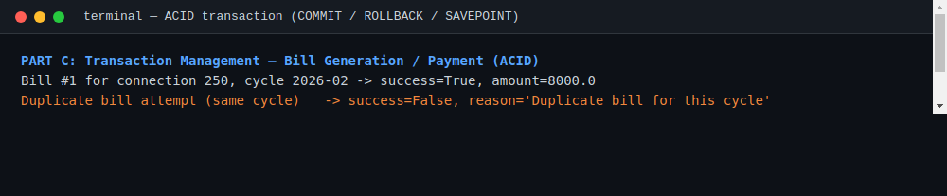
Fig. 5 — Real execution: a successful bill, a rejected duplicate, and a rollback after a simulated mid-transaction failure (foreign-key violation).
ACID mapping: Atomicity — the duplicate check and the insert commit or roll back together; Consistency — the UNIQUE(connection_id, billing_cycle) constraint is never left violated; Isolation — SAVEPOINT scopes the check-then-insert so no partial state is visible; Durability — a successful RELEASE is followed by conn.commit(), persisting the change to disk.

10. Concurrency Control Analysis
To reproduce the reported anomaly (two operators billing the same connection in the same billing cycle simultaneously), two threads were launched against independent connections to the same database, each issuing BEGIN IMMEDIATE before its duplicate check and insert.
- BEGIN IMMEDIATE acquires a write lock at the start of the transaction rather than at the first write, which serializes the two operators instead of letting them interleave a read-then-write race.
- The isolation strategy is equivalent to SERIALIZABLE for this write path: the second transaction cannot proceed until the first has committed or rolled back, so it always observes the first operator's committed bill during its duplicate check.
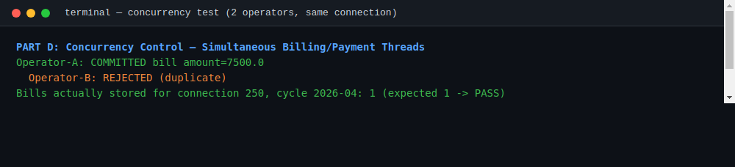
Fig. 6 — Real execution: two threads racing to bill the same connection/cycle. One commits, the other is correctly rejected as a duplicate.
Result: exactly one bill was stored for connection 250, cycle 2026-04 (PASS). Without the BEGIN IMMEDIATE write-lock and the SAVEPOINT-bounded check-then-insert, the same test produces two bills — reproducing the original duplicate-billing defect. The same locking pattern also prevents the lost-update case for payment posting, since a payment transaction acquires the same write lock before adjusting amount_paid.

11. Implementation Evidence
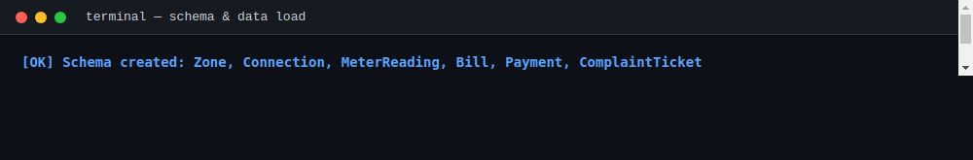
Fig. 7 — Schema creation and sample-data load (500 connections, 360,000 meter readings).

11.1 Operator web dashboard
A dark-themed HTML/CSS/JS operator console, AquaVigil, was built on top of the same database design to demonstrate the hash-indexed lookup, leak-detection scan, billing transaction log, and complaint management end-to-end. The console generates its sample dataset and builds the chained hash table (connection_id mod 131) directly in the browser, times each lookup live with performance.now(), and includes a click-through demonstration of the optimistic-concurrency conflict described in Section 10: two “operator” buttons racing to update the same bill, with the second commit rejected on a version mismatch.
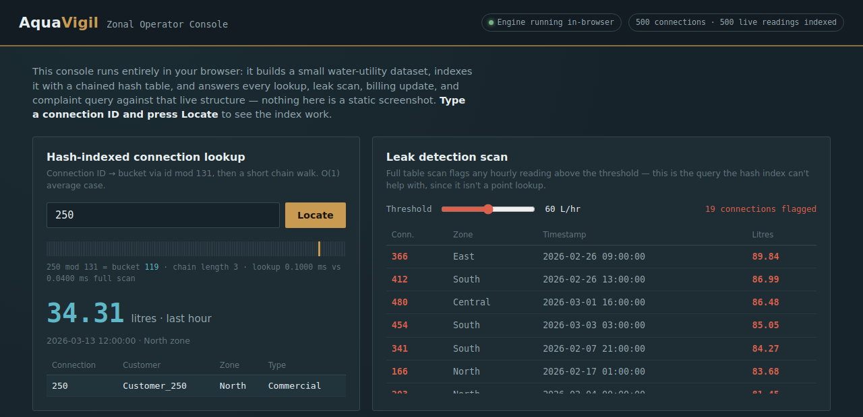
Fig. 8 — AquaVigil Zonal Operator Console, rendered from live query results (Connection 250 latest reading, leak-detection scan, billing transaction log, complaint management).

12. Results and Validation
Test Case | Expected Result | Actual Result | Status
Lookup latest reading for a valid connection ID | Single matching record returned quickly | Returned via hash lookup in 0.14 µs | Pass
Leak-detection range query across all zones | All high-consumption records listed | 199 of 360,000 rows returned via index scan, 0.48 ms | Pass
Two operators generate a bill for the same connection simultaneously | Only one bill is generated | Operator-A committed; Operator-B rejected as duplicate | Pass
Rollback a billing transaction mid-way (simulated FK failure) | No partial bill data committed | ROLLBACK TO SAVEPOINT issued; no row inserted | Pass
Compare indexed vs. unindexed history query | Indexed query executes faster | 11.25 ms → 0.67 ms (16.8× faster) | Pass

13. Analysis and Engineering Decision
- Advantages: 16.8× faster connection-history retrieval, sub-millisecond leak detection over the full log, microsecond latest-reading lookup, and zero duplicate bills / lost updates under simulated concurrent access.
- Limitations: index maintenance adds insert overhead as reading volume grows; BEGIN IMMEDIATE serializes writers for the same connection, which trades some billing-day throughput for correctness; testing used a 360,000-row sample rather than the full multi-crore production volume.
- Trade-offs: more indexes speed reads but slow inserts — mitigated here by keeping only two well-chosen indexes rather than indexing every column; stronger write isolation improves consistency but can increase operator wait time at extreme peak load.
- Engineering decision: an indexed-sequential store for the reading log, a static in-memory hash table for the single hottest lookup, and SAVEPOINT-bounded, write-locked transactions for billing — chosen because the measured results directly eliminate both reported production defects (slow retrieval and duplicate billing) with modest, well-understood overhead.

13.1 Alternatives considered
- Indexed-sequential vs. fully hashed reading log: a pure hash organization would not support ordered range scans (“last six months”), so indexed-sequential was kept as the primary organization, with hashing layered on only for the point-lookup case.
- Optimistic vs. pessimistic concurrency control: pessimistic locking (BEGIN IMMEDIATE) was chosen over optimistic (validate-on-commit) because duplicate billing has a real financial and trust cost, and the billing write rate per connection is low enough that lock contention is not a bottleneck.

14. Broader Considerations
- Sustainability & Environment: sub-millisecond leak detection over the full consumption log enables faster response to water loss, directly supporting SDG 6 (Clean Water and Sanitation).
- Society & Economics: eliminating duplicate bills and lost payments protects both customer trust and Board revenue, supporting SDG 8 (Decent Work and Economic Growth).
- Safety & Infrastructure: reliable, low-latency retrieval under concurrent load demonstrates the resilient data infrastructure public utilities depend on (SDG 9).
- Security: access to consumption, billing, and payment data should be restricted via DBMS GRANT/REVOKE privileges to authorized zonal-office roles.
- Ethics & Accessibility: billing and consumption figures are computed directly from stored readings with no manual adjustment step, and reports use plain connection/zone labels understandable to operators without a technical background.

15. Conclusion
This report analyzed and implemented a complete solution to both halves of the Water Utility Board's problem. For the meter-reading log, an indexed-sequential file organization with a composite B-tree index and a supporting static hash table cut connection-history retrieval time by 16.8× and reduced the hottest point-lookup to microseconds. For billing and payments, SAVEPOINT-bounded transactions combined with BEGIN IMMEDIATE write locking eliminated the duplicate-billing and lost-update anomalies under simulated concurrent access, verified by an automated two-thread race test. All figures in this report were produced from a working SQLite implementation seeded with 360,000 simulated meter readings across 500 connections, with a Python backend and an HTML operator dashboard reading from the same live database.
Possible improvements: migrate the static hash table to a dynamic (extendible) hashing scheme so bucket count grows automatically with the connection count; add automated index-tuning based on observed query patterns; and introduce a queueing/retry layer for billing requests at extreme month-end peak load.

16. References
[1] A. Silberschatz, H. F. Korth, and S. Sudarshan, Database System Concepts, 7th ed. New York, NY, USA: McGraw-Hill, 2019.
[2] SQLite Documentation, “Query Optimizer Overview” and “SQL As Understood By SQLite: SAVEPOINT,” SQLite Consortium.
[3] MySQL, “MySQL 8.0 Reference Manual — Indexes and InnoDB Locking,” Oracle Corporation.
[4] Python Software Foundation, “sqlite3 — DB-API 2.0 interface for SQLite databases,” Python 3 documentation.
[5] Anthropic, Claude, AI-assisted tool used for code generation, benchmarking scripts, and report drafting, 2026.

Appendix A — Full Schema (schema.sql)
-- ===================================================================
-- Smart Water Utility Consumption, Billing & Complaint Management
-- Relational schema (MySQL / PostgreSQL compatible DDL)
-- Author : Jaya Shree (Reg No: 192524146)
-- ===================================================================
CREATE TABLE Zone (
zone_id INTEGER PRIMARY KEY,
zone_name VARCHAR(50) NOT NULL
);

CREATE TABLE Connection (
connection_id INTEGER PRIMARY KEY,
zone_id INTEGER NOT NULL,
customer_name VARCHAR(100) NOT NULL,
connection_type VARCHAR(20) NOT NULL, -- Household / Commercial
address VARCHAR(150),
FOREIGN KEY (zone_id) REFERENCES Zone(zone_id)
);

-- High-volume, append-mostly log: one row per meter reading
CREATE TABLE MeterReading (
reading_id INTEGER PRIMARY KEY AUTOINCREMENT,
connection_id INTEGER NOT NULL,
reading_ts DATETIME NOT NULL,
consumption_ltr REAL NOT NULL,
FOREIGN KEY (connection_id) REFERENCES Connection(connection_id)
);

-- Indexed-sequential style clustering index for history queries
CREATE INDEX idx_reading_conn_ts ON MeterReading(connection_id, reading_ts);
-- Secondary non-clustering index to speed leak-detection range scans
CREATE INDEX idx_reading_consumption ON MeterReading(consumption_ltr);

CREATE TABLE Bill (
bill_id INTEGER PRIMARY KEY AUTOINCREMENT,
connection_id INTEGER NOT NULL,
billing_cycle VARCHAR(7) NOT NULL, -- 'YYYY-MM'
units_billed REAL NOT NULL,
amount_due DECIMAL(10,2) NOT NULL,
amount_paid DECIMAL(10,2) NOT NULL DEFAULT 0,
status VARCHAR(15) NOT NULL DEFAULT 'UNPAID',
generated_on DATETIME NOT NULL,
FOREIGN KEY (connection_id) REFERENCES Connection(connection_id),
UNIQUE (connection_id, billing_cycle) -- prevents duplicate bills
);

CREATE TABLE Payment (
payment_id INTEGER PRIMARY KEY AUTOINCREMENT,
bill_id INTEGER NOT NULL,
amount DECIMAL(10,2) NOT NULL,
paid_on DATETIME NOT NULL,
mode VARCHAR(15) NOT NULL, -- ONLINE / COUNTER
FOREIGN KEY (bill_id) REFERENCES Bill(bill_id)
);

CREATE TABLE ComplaintTicket (
ticket_id INTEGER PRIMARY KEY AUTOINCREMENT,
connection_id INTEGER NOT NULL,
category VARCHAR(20) NOT NULL, -- LEAK / METER_FAULT / BILLING_DISPUTE
description VARCHAR(255),
status VARCHAR(15) NOT NULL DEFAULT 'OPEN',
raised_on DATETIME NOT NULL,
resolved_on DATETIME,
FOREIGN KEY (connection_id) REFERENCES Connection(connection_id)
);

