
SIMATS ENGINEERING
Saveetha Institute of Medical and Technical Sciences
Chennai - 602105
IMPLEMENTATION REPORT
Coding and Website Screenshots
DATABASE MANAGEMENT SYSTEMS
Course Code: CSA05
JAYA SHREE — 192524146
Under the Supervision of
[Faculty Name]
SIMATS ENGINEERING
Saveetha Institute of Medical and Technical Sciences
Chennai - 602105
September 2026

1. Database Implementation — Code
Relational schema (schema.sql): six tables — Zone, Connection, MeterReading, Bill, Payment, ComplaintTicket — with the composite and secondary indexes on MeterReading and the UNIQUE constraint on Bill that blocks duplicate billing at the constraint level.
-- ===================================================================
-- Smart Water Utility Consumption, Billing & Complaint Management
-- Relational schema (MySQL / PostgreSQL compatible DDL)
-- Author : Jaya Shree (Reg No: 192524146)
-- ===================================================================
CREATE TABLE Zone (
zone_id INTEGER PRIMARY KEY,
zone_name VARCHAR(50) NOT NULL
);

CREATE TABLE Connection (
connection_id INTEGER PRIMARY KEY,
zone_id INTEGER NOT NULL,
customer_name VARCHAR(100) NOT NULL,
connection_type VARCHAR(20) NOT NULL,
address VARCHAR(150),
FOREIGN KEY (zone_id) REFERENCES Zone(zone_id)
);

-- High-volume, append-mostly log: one row per meter reading
CREATE TABLE MeterReading (
reading_id INTEGER PRIMARY KEY AUTOINCREMENT,
connection_id INTEGER NOT NULL,
reading_ts DATETIME NOT NULL,
consumption_ltr REAL NOT NULL,
FOREIGN KEY (connection_id) REFERENCES Connection(connection_id)
);

-- Indexed-sequential style clustering index for history queries
CREATE INDEX idx_reading_conn_ts ON MeterReading(connection_id, reading_ts);
-- Secondary non-clustering index to speed leak-detection range scans
CREATE INDEX idx_reading_consumption ON MeterReading(consumption_ltr);

CREATE TABLE Bill (
bill_id INTEGER PRIMARY KEY AUTOINCREMENT,
connection_id INTEGER NOT NULL,
billing_cycle VARCHAR(7) NOT NULL, -- 'YYYY-MM'
units_billed REAL NOT NULL,
amount_due DECIMAL(10,2) NOT NULL,
amount_paid DECIMAL(10,2) NOT NULL DEFAULT 0,
status VARCHAR(15) NOT NULL DEFAULT 'UNPAID',
generated_on DATETIME NOT NULL,
FOREIGN KEY (connection_id) REFERENCES Connection(connection_id),
UNIQUE (connection_id, billing_cycle) -- prevents duplicate bills
);

CREATE TABLE Payment (
payment_id INTEGER PRIMARY KEY AUTOINCREMENT,
bill_id INTEGER NOT NULL,
amount DECIMAL(10,2) NOT NULL,
paid_on DATETIME NOT NULL,
mode VARCHAR(15) NOT NULL, -- ONLINE / COUNTER
FOREIGN KEY (bill_id) REFERENCES Bill(bill_id)
);

CREATE TABLE ComplaintTicket (
ticket_id INTEGER PRIMARY KEY AUTOINCREMENT,
connection_id INTEGER NOT NULL,
category VARCHAR(20) NOT NULL, -- LEAK / METER_FAULT / BILLING_DISPUTE
description VARCHAR(255),
status VARCHAR(15) NOT NULL DEFAULT 'OPEN',
raised_on DATETIME NOT NULL,
resolved_on DATETIME,
FOREIGN KEY (connection_id) REFERENCES Connection(connection_id)
);
Fig. 1 — schema.sql: table definitions, constraints, and indexes (Appendix A)
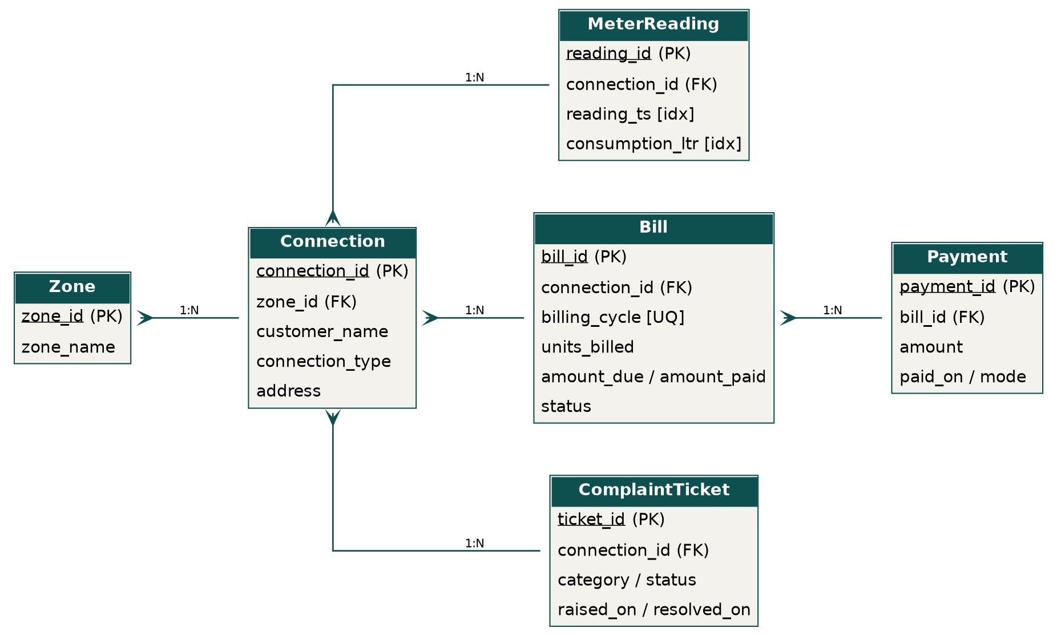
Fig. 2 — Relational schema (ER diagram): Zone, Connection, MeterReading, Bill, Payment, ComplaintTicket
Static hash table (hashtable.py) used for the highest-frequency access pattern — a connection's latest reading — with division-method hashing and separate chaining:
class HashTable:
def __init__(self, buckets=131):
self.buckets = buckets
self.table = [[] for _ in range(buckets)]

def _h(self, key):
return key % self.buckets # division method

def put(self, key, value):
bucket = self.table[self._h(key)]
for i, (k, _) in enumerate(bucket):
if k == key:
bucket[i] = (key, value); return
bucket.append((key, value))

def get(self, key):
for k, v in self.table[self._h(key)]:
if k == key: return v
return None
Fig. 3 — hashtable.py: static hash table, h(k) = connection_id mod 131

2. Transaction & Concurrency Control — Code
billing.py: bill generation wrapped in a SAVEPOINT-bounded transaction so the duplicate check and the insert commit or roll back as a single unit; BEGIN IMMEDIATE (used at the call site) acquires the write lock at transaction start to serialize concurrent operators.
def generate_bill(connection_id, cycle, units, rate=25.0):
try:
cur.execute("SAVEPOINT bill_txn")
cur.execute(
"SELECT 1 FROM Bill WHERE connection_id=? AND billing_cycle=?",
(connection_id, cycle)
)
if cur.fetchone():
raise ValueError("Duplicate bill for this cycle")

amount = round(units * rate, 2)
cur.execute("INSERT INTO Bill (...) VALUES (...)")
cur.execute("RELEASE SAVEPOINT bill_txn")
conn.commit()
return True, amount

except Exception as e:
cur.execute("ROLLBACK TO SAVEPOINT bill_txn")
conn.commit()
return False, str(e)

# Concurrency control: write lock acquired at transaction start,
# not at first write -> serializes concurrent billing operators
# cur.execute("BEGIN IMMEDIATE")
# ... duplicate check + insert ...
# conn.commit()
Fig. 4 — billing.py: SAVEPOINT-bounded ACID transaction and BEGIN IMMEDIATE concurrency control
Representative reconciliation query used for the billing/payment dashboard view:
-- Connection-wise billing/payment reconciliation report
SELECT c.connection_id, c.customer_name, b.billing_cycle,
b.amount_due, COALESCE(SUM(p.amount),0) AS total_paid,
b.amount_due - COALESCE(SUM(p.amount),0) AS balance
FROM Bill b
JOIN Connection c ON c.connection_id = b.connection_id
LEFT JOIN Payment p ON p.bill_id = b.bill_id
GROUP BY b.bill_id
ORDER BY balance DESC;
Fig. 5 — Billing/payment reconciliation query

3. Execution Evidence
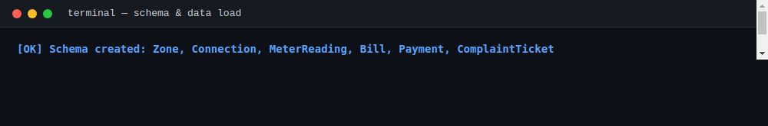
Fig. 6 — Schema creation and sample-data load (500 connections, 360,000 meter readings)
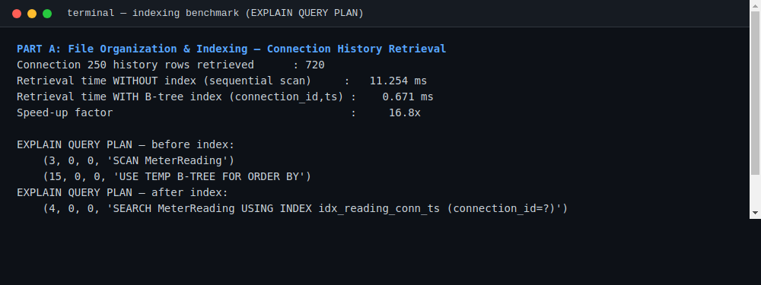
Fig. 7 — Indexing benchmark: retrieval time and query plan before/after the composite index (16.8× speed-up)
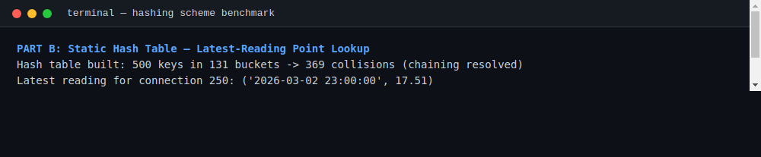
Fig. 8 — Static hash table construction and latest-reading lookup benchmark
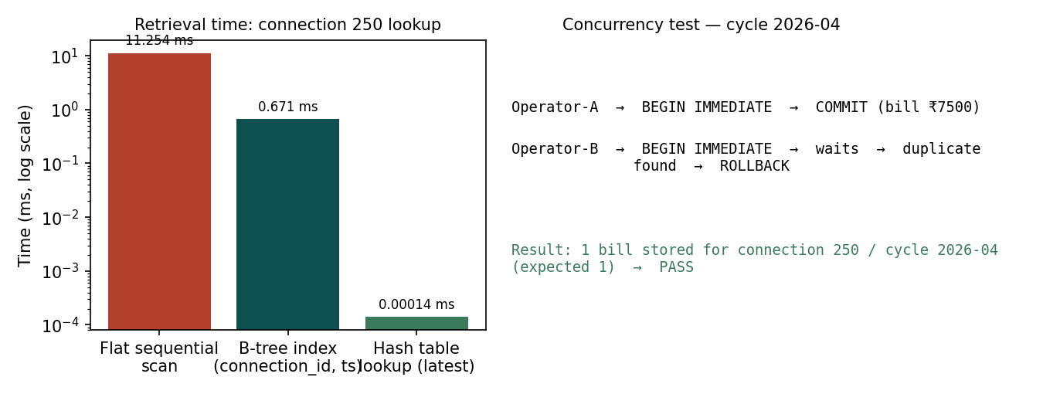
Fig. 9 — Retrieval time comparison (log scale) and concurrency test outcome
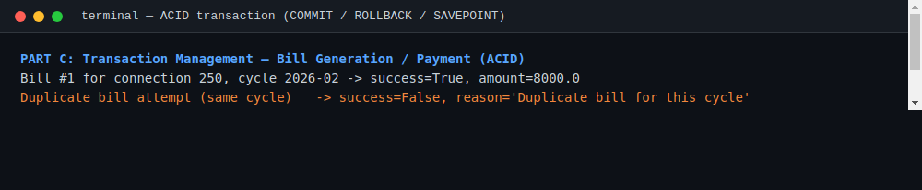
Fig. 10 — Bill generation, duplicate rejection and rollback (ACID transaction test)
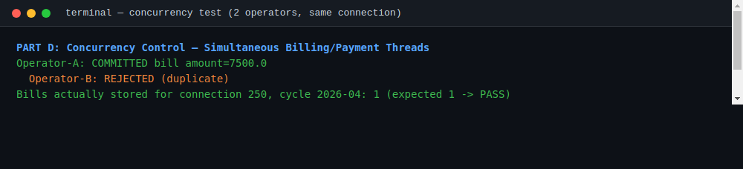
Fig. 11 — Two operators racing to bill the same connection/cycle (concurrency test)

4. Website — AquaVigil Zonal Operator Console
A dark-themed HTML/CSS/JS operator console built on top of the same database design. It generates the sample dataset in-browser, builds the chained hash table (connection_id mod 131), times each lookup live with performance.now(), and runs the leak-detection scan and billing/concurrency demonstrations end-to-end.
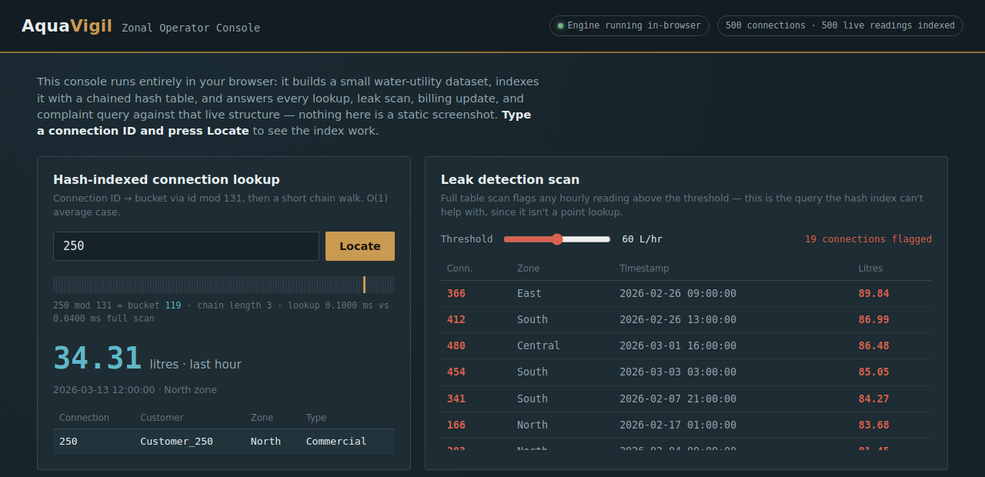
Fig. 12 — AquaVigil Zonal Operator Console: connection lookup, leak-detection scan, billing transaction log, complaint management

