ASSESSMENT TOOL 2
P.ROHINI
192524147

1)Read a fraction&#39;s numerator and denominator. Validate the
denominator and classify the fraction as proper, improper, or equal to one.
Flow chart
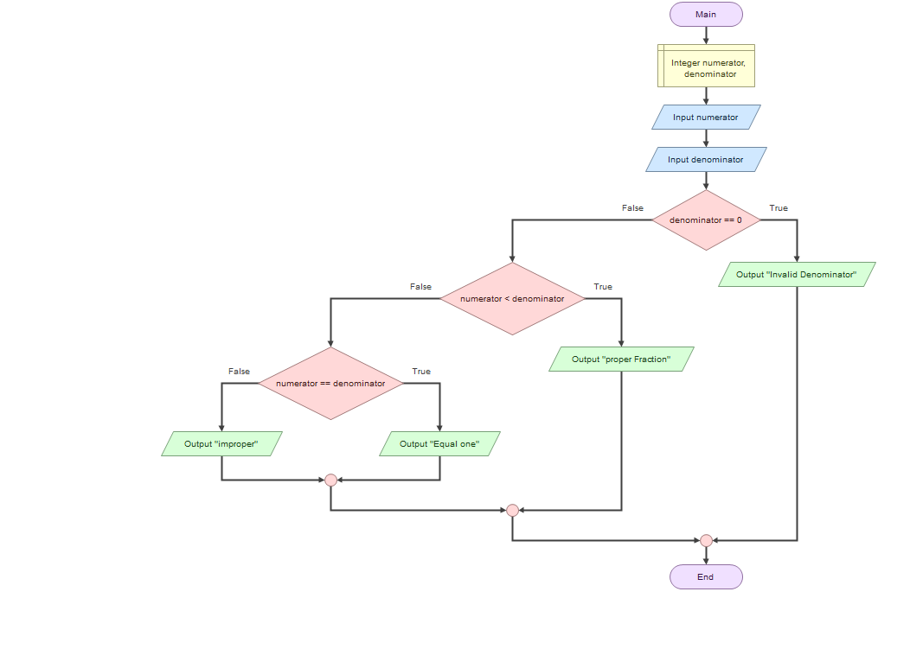
Input :
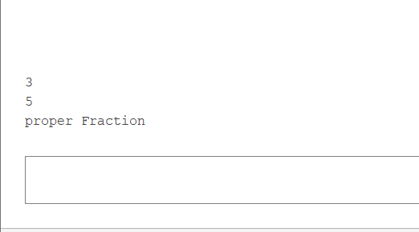
Pseudo Code :
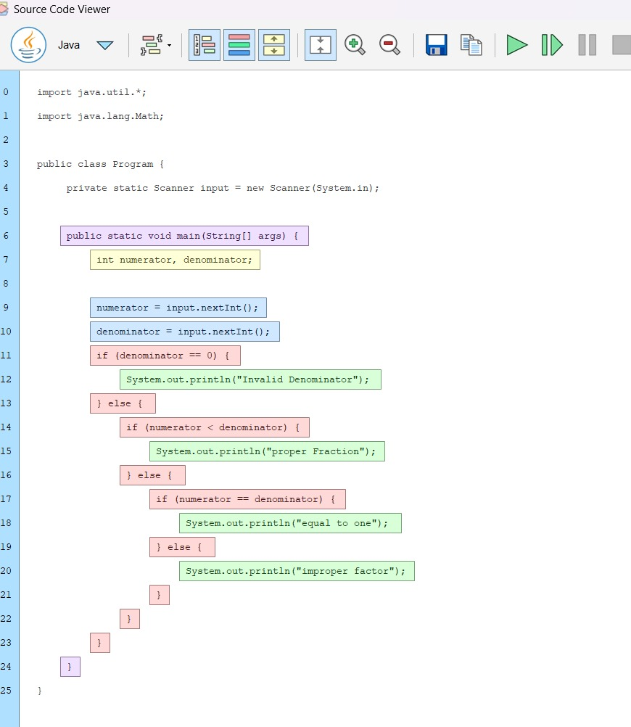
2) Read a positive integer and calculate the digital root by
repeatedly summing its digits until one digit remains.
Flow Chart
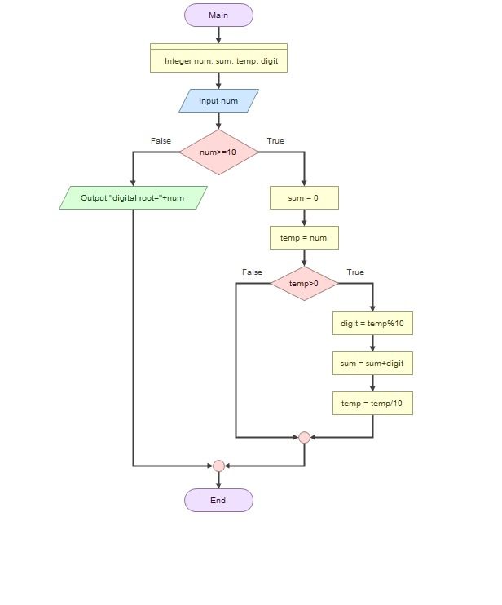
Input :
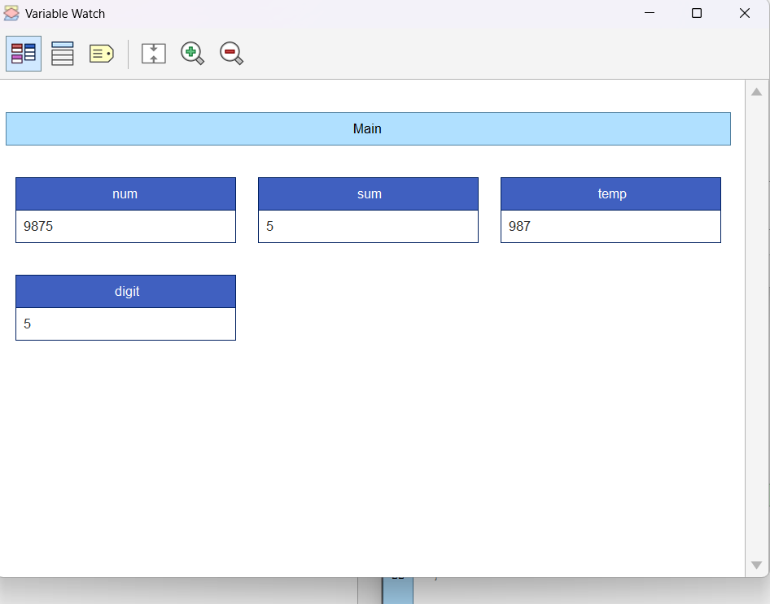

Pseudo Code :
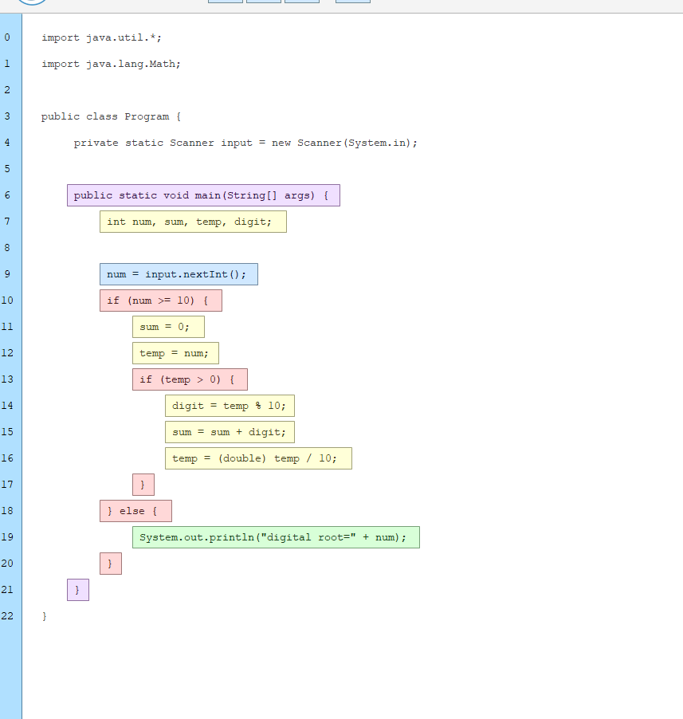

3) Create a function compoundAmount(principal, rate, years)
using a loop and call it for multiple investment options.
Flow Chart

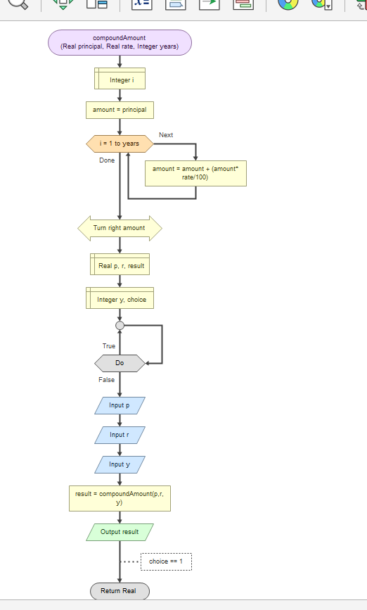
Input :
1000
10
2
0
12100
Pseudo Code :
