Aim:
To write a program to find the factorial of a given number using a loop in RAPTOR.

Algorithm:
- Start the program.
- Read the input number.
- Initialize the required variables.
- Use a loop to calculate the factorial value.
- Update the factorial value for each iteration.
- Continue the loop until the given number is reached.
- Display the factorial value.
- Stop the program.
Input:
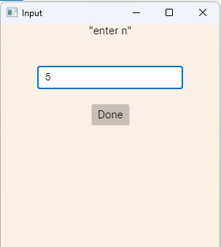
Output:
