AIM:
To check whether a given number is a palindrome or not using RAPTOR flowchart.
Algorithm:
- Start the program.
- Read the input number.
- Initialize the required variables.
- Reverse the given number using a loop.
- Compare the original number with the reversed number.
- If both numbers are equal, the number is a palindrome.
- Otherwise, the number is not a palindrome.
- Display the result.
- Stop the program.
Input:
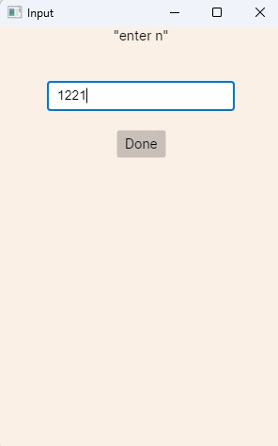

Output:
