AIM:
To find the GCD (Greatest Common Divisor) of two numbers using RAPTOR flowchart.

Algorithm:
- Start the program.
- Read the two input numbers.
- Initialize the required variables.
- Compare the two numbers.
- Find the common divisor of both numbers using a loop.
- Repeat the process until the required condition is satisfied.
- Store the GCD value.
- Display the GCD value.
- Stop the program.
Input:
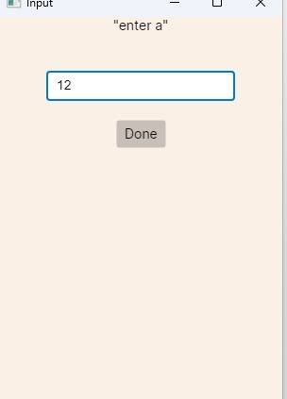
Output:
