C Program to Implement a Shift-Reduce Parser for the Given Grammar.

AIM:
To write a C program to implement a Shift-Reduce Parser and display each SHIFT, REDUCE, and ACCEPT operation while parsing the input string id + id.
PSEUDOCODE:
- Start the program.
- Initialize an empty stack.
- Read the input string id + id.
- Perform SHIFT operation and push input symbols onto the stack.
- Check the stack for matching grammar productions.
- Perform REDUCE operation when a production matches.
- Repeat until the input is completely parsed.
- Display ACCEPT if the input is valid.
- Otherwise, display REJECT.
- Stop the program.

PROGRAM:

#include <stdio.h>
#include <string.h>

int main()
{
char stack[50] = "";
char input[50];
int i = 0;

printf("Enter input string: ");
scanf("%s", input);

while (i < strlen(input))
{
if (strncmp(input + i, "id", 2) == 0)
{
strcat(stack, "id");
printf("SHIFT: %s\n", stack);
i += 2;

if (strcmp(stack, "id") == 0)
{
strcpy(stack, "T");
printf("REDUCE: T -> id\n");
}
else if (strcmp(stack, "E+id") == 0)
{
strcpy(stack, "E+T");
printf("REDUCE: T -> id\n");
strcpy(stack, "E");
printf("REDUCE: E -> E+T\n");
}
}
else if (input[i] == '+')
{
strcat(stack, "+");
printf("SHIFT: %s\n", stack);
i++;
}
else
{
printf("REJECT\n");
return 0;
}

if (strcmp(stack, "T+") == 0)
{
strcpy(stack, "E+");
}
}

if (strcmp(stack, "E") == 0)
printf("ACCEPT\n");
else
printf("REJECT\n");

return 0;
}

OUTPUT:

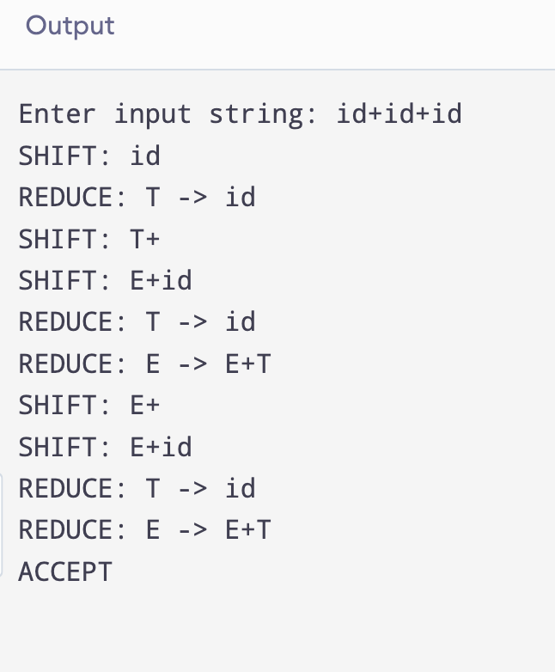

RESULT:
Thus, the C program to implement a Shift-Reduce Parser was executed, and the input string id + id was successfully accepted by the parser.

