C Program to Perform Bottom-Up Evaluation of an S-Attributed Syntax-Directed Definition.
AIM:
To write a C program to perform bottom-up evaluation of an S-attributed syntax-directed definition and calculate the final value of an arithmetic expression.
PSEUDOCODE:
- Start the program.
- Read two numbers from the user.
- Assign the first number to E and the second number to T.
- Apply the production E → E + T.
- Evaluate the semantic attribute using addition.
- Display the final value of E.
- Stop the program.

PROGRAM:

#include <stdio.h>

int main()
{
int E, T, result;

printf("Enter two numbers: ");
scanf("%d %d", &E, &T);

result = E + T;

printf("Value of E = %d\n", result);

return 0;
}

OUTPUT:

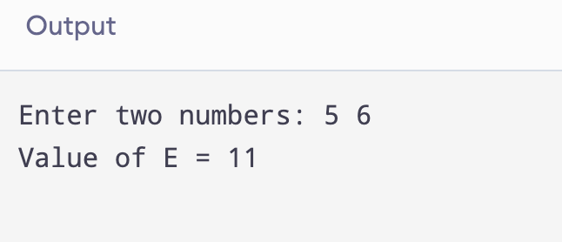

RESULT:
Thus, the C program to perform bottom-up evaluation of an S-attributed syntax-directed definition was successfully executed, and the final value was obtained as 11.

