EXPERIMENT-1
Implementation of Lexical Analyser in C

AIM:
To identify keywords, identifiers, constants, operators, and special symbols in a given C statement.
PSEUDOCODE:
- START
- Read a C statement
- Check each token
- If token is a keyword, print Keyword
- If token is a variable name, print Identifier
- If token is a number, print Constant
- If token is an operator, print Operator
- If token is a special symbol, print Special Symbol
- STOP

Program:

#include <stdio.h>
#include <ctype.h>
#include <string.h>
int main() {
char s[100];
int i = 0;
printf("Enter a statement: ");
fgets(s, sizeof(s), stdin);
while (s[i] != '\0') {
if (isspace(s[i])) {
i++;
}
else if (isalpha(s[i])) {
char word[20];
int j = 0;
while (isalnum(s[i])) {
word[j++] = s[i++];
}
word[j] = '\0';

if (strcmp(word, "int") == 0 ||
strcmp(word, "float") == 0 ||
strcmp(word, "char") == 0)
printf("%s - Keyword\n", word);
else
printf("%s - Identifier\n", word);
}
else if (isdigit(s[i])) {
printf("%c - Constant\n", s[i]);
i++;
}
else if (s[i] == '=' || s[i] == '+' ||
s[i] == '-' || s[i] == '*') {
printf("%c - Operator\n", s[i]);
i++;
}
else {
printf("%c - Special Symbol\n", s[i]);
i++;
}
}
return 0;
}

OUTPUT:
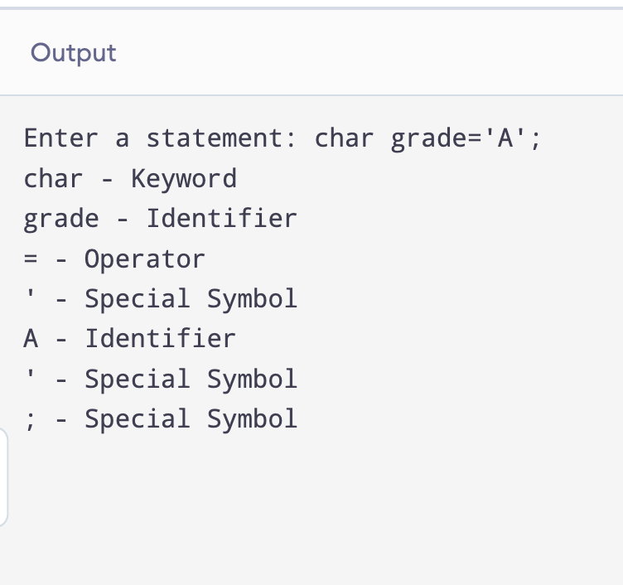

RESULT:
Thus, the Cipher Feedback (CFB) mode was successfully implemented in C, and the original plaintext was correctly recovered after decryption.

