SIMATS ENGINEERING
ASSESSMENT TOOL 2
COURSE NAME: Cryptography and Network Security
COURSE CODE: CSA51
COURSE OUTCOME COVERED
CO1: Apply classical encryption techniques using symmetric and asymmetric ciphers to encrypt and decrypt data for the ensuring data security. (BL3, BL4)
Assessment Tool Weightage: 20%
QUESTIONS: 5 Total Marks:50
Annexure A
CONCEPT MAPPING

Code of Conduct:
I K. Bhavana (192524178) (Name / Reg No) certify that this submission is my original work and that I have adhered to the guidelines specified for this assessment.
I understand that any violation of academic integrity rules will result in disciplinary action.
Signature of the student:

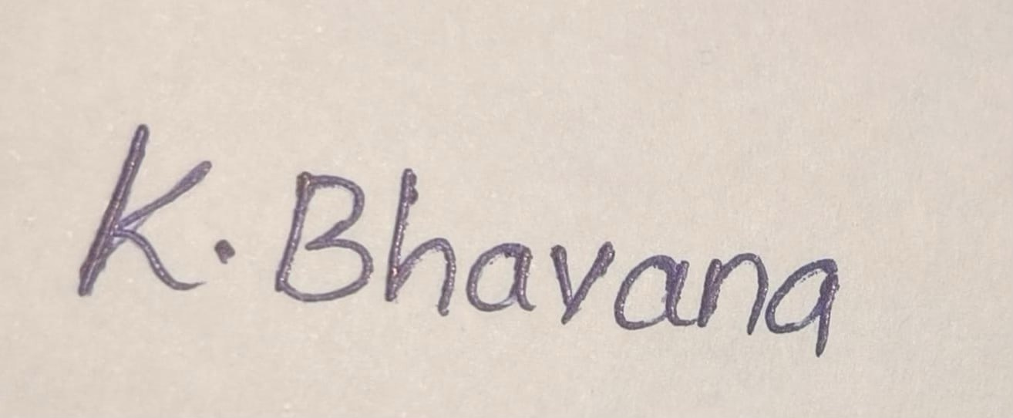
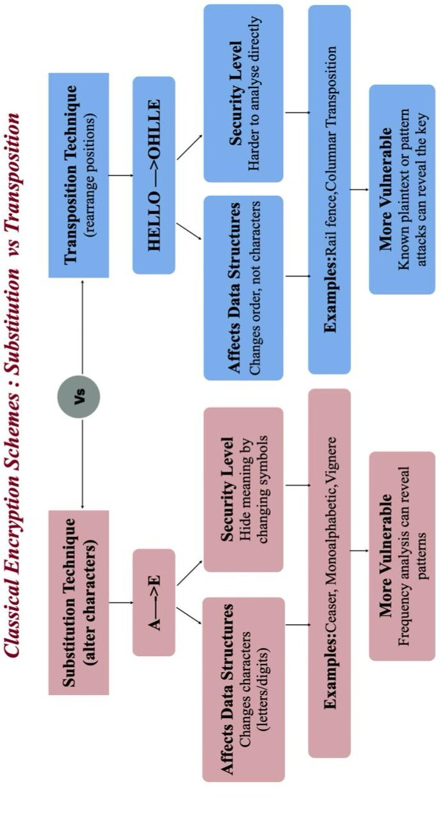

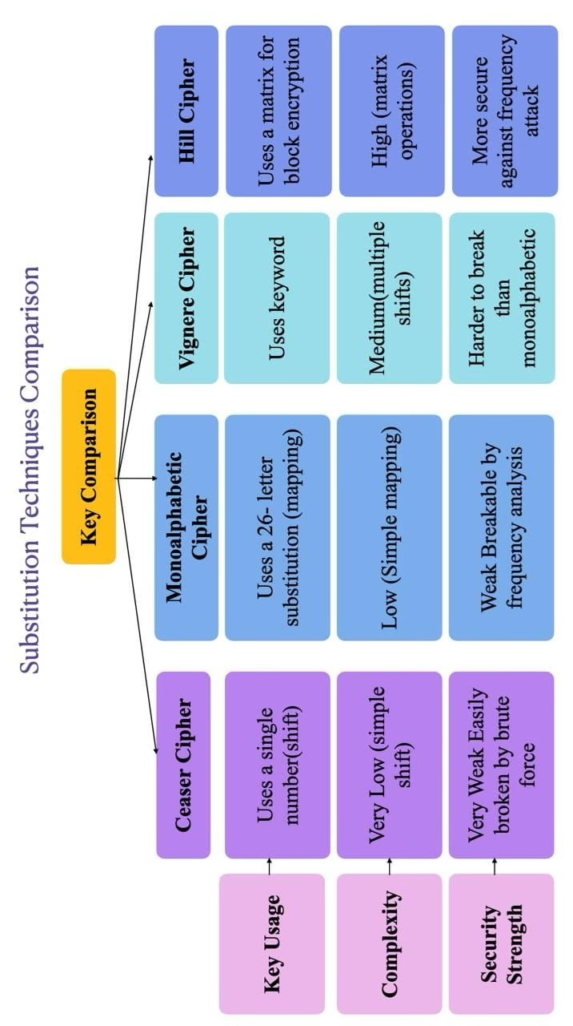

RUBRICS FOR CALCULATION:
Criteria | Weig h ta ge | Level 4 –  Exempla ry | Level 3  – Proficie nt | Level 2 –  Developin g | Level 1  –  Beginni ng
 |  | Demonstrates | Good | Basic | Poor
 |  | thorough | understan | understandi | understandi
Understandi ng of  Concepts | 25 | understandi n g a n d effectively integrates multiple | di ng with proper integratio n of most | n g; limited or partial  integratio  n | n g ; unable to integrate concepts
 |  | concepts/ technolo gies | concepts
 |  | Well-planned, | Correct | Basic | Incorrect or
Experime nt a l  Design | 30 | systematic implementation with optimal solution | implemen  t at ion with minor issues | implement  ati on with errors or  inefficienci  es | incomplet e implement  at i on
 |  | Effective and | Appropria | Limited or | Incorrect
 |  | advanced use of | te use of | inconsistent | o r
Use of Tools | 20 | tools/ technologies with proper | tools with correct | use of tools | minimal u s e o f
 |  | configuration | execution |  | tools
 |  | Insightful | Good | Basic | Poor or
 |  | analysis with | analysis | analysis | incorrect
Analysis of  Results | 15 | accurate interpretation and validation | with reasona  bl  e | with limited insights | analysi s of results
 |  | of results | interpretat

io
n
Document  at i  on | 10 | Clear, wellstructured documentati on  with diagrams, | Organized documenta  ti on with  necessary | Basic document  at io n with missing | Poor or incomplete document  ati o n
 |  | code, and results | details | details

