SIMATS ENGINEERING
ASSESSMENT TOOL 2

COURSE CODE: CSA14 COURSE NAME: Compiler Design

COURSE OUTCOME COVERED

CO1: Apply lexical analysis for token specification and recognition using LEX tool (BL3)

Assessment Tool Weightage: 20%

QUESTIONS: 3 Total Marks:50

Annexure A

ERROR ANALYSIS TASK

Code of Conduct:

I ___K.Bhashitha_________________ (Name / Reg No) certify that this submission is my original work and that I have adhered to the guidelines specified for this assessment.
I understand that any violation of academic integrity rules will result in disciplinary action.

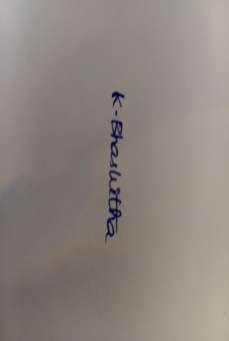
Signature of the student:

Annexure A

ERROR ANALYSIS TASK

Q1. The following program is intended to perform simple arithmetic operations, function calls, array access, and looping constructs. However, the code contains multiple errors introduced at different phases of compilation, including lexical, syntax, semantic, logical, and runtime errors.
Given Program
#include <stdio.h>

int sumArray(int arr[], int n) {
int i, sum = 0;
for(i = 0; i <= n; i++) {
sum = sum + arr[i];
}
return sum;
}

int main() {
int arr[5] = {1,2,3,4,5}
int total;

total = sumArray(arr);

if(total == 15) {
printf("Correct Sum\n")
}

int a = 10, b = 0;
int c = a / b;

int *p;
*p = 20;

return 0;
}
Tasks:
(a) Error Identification (Analysis Level)
- Identify all the errors present in the program. For each error:
- Specify the line number
- Clearly describe the nature of the error
(b) Classification of Errors (Understanding + Analysis)
- Classify each identified error into the appropriate compiler phase:
- Lexical Errors
- Syntax Errors
- Semantic Errors
- Logical Errors
- Runtime Errors
(c) Compilation Behavior (Evaluation Level)
- Analyze which errors will be detected during compilation and which will only appear during execution.
- Explain how early-stage errors (lexical/syntax) may prevent detection of later-stage errors.
(d) Code Correction (Application Level)
- Rewrite the corrected version of the program such that:
- All errors are removed
- The program executes correctly
- Proper syntax and semantics are maintained
(e) Impact Analysis (Evaluation Level)
- Discuss the impact of at least three errors on program execution.
- Explain how incorrect constructs like improper pointer usage, division by zero, and infinite loops affect system behavior.
(f) Advanced Compiler Perspective (Create Level)
- Suggest how a compiler can be improved to:
- Provide better error messages
- Perform early detection of runtime errors
- Propose at least two enhancements in compiler design for efficient debugging.
Answer)
Error Analysis
The program contains errors from different phases of compilation, including lexical, syntax, semantic, logical, and runtime errors.
(a) Error Identification and Classification
Line | Error | Type | Description
28 | i <= n | Logical / Runtime | For an array of size n, the last valid index is n-1. It should be i < n.
34 | Missing ; | Syntax | The array declaration must end with a semicolon.
36 | sumArray(arr) | Semantic | Function requires two arguments: arr and n.
38 | Missing ; | Syntax | printf() statement requires a semicolon.
41 | a / b where b = 0 | Runtime | Division by zero.
43 | *p = 20 | Runtime | p is uninitialized and points to an unknown memory location.
(b) Classification
Lexical Error:
No major lexical error is present in the given program.
Syntax Errors:
- Line 34: Missing semicolon.
- Line 38: Missing semicolon.
Semantic Error:
- Line 36: Incorrect number of arguments in sumArray(arr).
Logical Error:
- Line 28: i <= n should be i < n.
Runtime Errors:
- Line 41: Division by zero.
- Line 43: Invalid pointer dereferencing.
- Line 28: Possible array out-of-bounds access.
(c) Compilation Behavior
Detected during compilation:
- Missing semicolons.
- Incorrect number of function arguments.
- Some compiler warnings related to pointer usage.
Detected during execution:
- Division by zero.
- Array out-of-bounds access.
- Invalid pointer dereferencing.
Early lexical and syntax errors may stop compilation. Therefore, later semantic or runtime problems may not be detected until the earlier errors are corrected.
(d) Corrected Program
#include <stdio.h>

int sumArray(int arr[], int n) {
int i, sum = 0;

for (i = 0; i < n; i++) {
sum = sum + arr[i];
}

return sum;
}

int main() {
int arr[5] = {1, 2, 3, 4, 5};
int total;

total = sumArray(arr, 5);

if (total == 15) {
printf("Correct Sum\n");
}

int a = 10, b = 2;
int c = a / b;

int value = 20;
int *p = &value;

printf("%d\n", *p);

return 0;
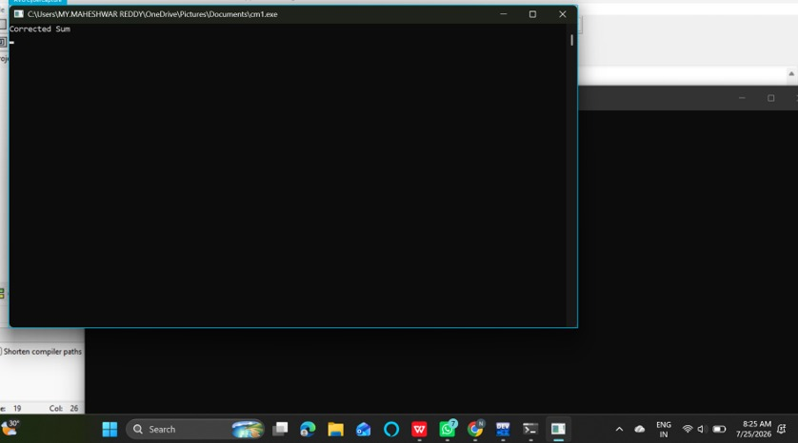
}

(e) Impact Analysis
- Improper pointer usage:
An uninitialized pointer may access an invalid memory location and can crash the program.
- Division by zero:
Division by zero causes a runtime error and the program may terminate unexpectedly.
- Array out-of-bounds:
Accessing an invalid array index may read or modify unwanted memory.
- Incorrect loop condition:
i <= n causes one extra iteration and may access arr[n], which is outside the valid range.
(f) Advanced Compiler Improvements
- Provide the exact line number and error description.
- Give suggestions for correcting the error.
- Use static analysis to detect possible division by zero.
- Use array bounds checking.
- Use pointer analysis to detect uninitialized pointers.
- Provide better debugging information such as variable values and execution flow.

Q2.The following C program contains multiple lexical errors introduced intentionally. These errors occur due to invalid tokens, incorrect identifiers, malformed constants, and illegal symbols, which are typically detected during the lexical analysis phase of a compiler.Carefully examine the program and answer the questions given below.
#include <stdio.h>

int main() {
int 1num = 100;
float rate@ = 25.5;
char ch = 'abc';
int total = 50$20;
int num#1 = 30;
int %count = 40;

printf("Welcome to Compiler Design);

int x = 09;
int y = 0xZ12;
int z = 12.3.4;

char str1[] = "Hello;
char str2[] = "World";

int _valid = 10;
int invalid-id = 20;

float value = 5..6;
int data = 10@5;

char c = 'xy';
int 3value = 60;

printf("Value: %d\n", total);

return 0;
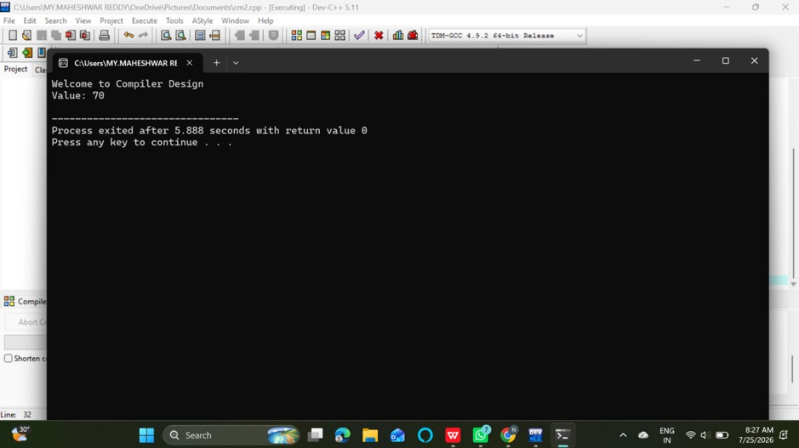
}

Tasks
(a) Error Identification
i) Identify all lexical errors in the program.
ii) List the line number and the invalid token.
(b) Error Classification
i) For each error, explain why it is considered a lexical error.
ii) Specify which rule of token formation is violated:
iii) Identifier rules
iv) Constant formation
v) String/character literal rules
vi) Operator/symbol rules
(c) Token Correction
i)Rewrite each invalid token into a valid token.
ii)Example: 2value → value2
(d) Compiler Behavior Analysis
i) Explain how a lexical analyzer (scanner) processes such errors.
ii)Discuss whether the compiler:
iii)Stops immediately
iv)Continues scanning using error recovery
(e) Advanced Thinking
i) Design a simple rule (or DFA idea) to detect invalid identifiers starting with digits.
ii) Suggest how error messages can be improved for beginners.
Answer)
Lexical Error Analysis
focuses on invalid tokens, identifiers, constants, symbols, and string/character literals detected during lexical analysis.
(a) Error Identification
Line | Invalid Code | Error
84 | 1num | Identifier cannot start with a digit
85 | rate@ | @ is not allowed in an identifier
86 | 'abc' | Character literal must contain one character
87 | 50$20 | $ is an invalid symbol in this expression
88 | num#1 | # is not allowed in an identifier
89 | %count | % cannot start an identifier
90 | "Welcome to Compiler Design); | Missing closing quotation mark
91 | 09 | Invalid octal constant
92 | 0xZ12 | Z is not a valid hexadecimal digit
93 | 12.3.4 | Invalid floating-point constant
94 | "Hello; | Missing closing quotation mark
97 | invalid-id | - is interpreted as an operator
98 | 5..6 | Invalid floating-point constant
99 | 10@5 | @ is an invalid symbol
100 | 'xy' | Character literal contains more than one character
101 | 3value | Identifier cannot start with a digit
Valid Examples
- _valid is a valid identifier.
- "World" is a valid string literal.
- 30, 40, and 60 are valid integer constants.
(b) Error Classification
Identifier Rules
Identifiers:
- Cannot start with a digit.
- Can contain letters, digits, and underscore.
- Cannot contain symbols such as @, #, %, or -.
Constant Formation
- 09 is invalid as an octal constant.
- 0xZ12 contains an invalid hexadecimal digit.
- 12.3.4 and 5..6 are invalid floating-point constants.
String and Character Literals
- A character literal must contain one character, such as 'A'.
- A string must have matching double quotation marks.
Operator and Symbol Rules
Symbols such as @, $, and % cannot be used in these positions as part of identifiers or numeric values.
(c) Token Correction
Invalid Token | Correct Token
1num | num1
rate@ | rate
'abc' | 'a'
50$20 | 50 + 20
num#1 | num1
%count | count
"Welcome to Compiler Design); | "Welcome to Compiler Design"
09 | 9
0xZ12 | 0x12
12.3.4 | 12.34
"Hello; | "Hello"
invalid-id | invalid_id
5..6 | 5.6
10@5 | 10 + 5
'xy' | 'x'
3value | value3
(d) Compiler Behavior
The lexical analyzer reads the source code character by character and groups characters into tokens.
When an invalid token is found, the compiler may:
- Stop immediately and report the lexical error, or
- Use error recovery and continue scanning the remaining source code.
Error recovery allows the compiler to report multiple errors in one compilation.
(e) Advanced Thinking
DFA Idea for Invalid Identifiers Starting with Digits
Start
|
| Digit
v
Invalid Identifier State
|
| Letter / Digit
v
Continue Invalid Token
A valid identifier should begin with:
Letter or _
Then it may contain:
Letter, Digit, or _
Improved Error Message
Instead of:
Invalid identifier
The compiler can display:
Error: Identifier '1num' cannot begin with a digit.
Suggestion: Use 'num1'.

Q3. The following C program is designed to perform arithmetic operations, function calls, conditional checks, pointer usage, and looping. However, the program contains multiple errors distributed across different phases of a compiler, including:
- Lexical Errors
- Syntax Errors
- Semantic Errors
- Intermediate Code Generation Issues (logic/precedence)
- Code Optimization Issues (redundancy/inefficiency)
- Runtime / Target Code Errors
Carefully analyze the program and answer the questions below.

#include <stdio.h>

int divide(int a, int b) {
return a / b
}

int main() {
int #value = 20;
float num = 15.5
int result;

result = divide(10);

if(result = 5) {
printf("Result is 5\n")
}

int x = 10;
int y = 0;
int z = x / y;

int arr[4] = {1,2,3,4};
printf("%d\n", arr[4]);

int *ptr;
*ptr = 25;

int total;
total = x + y * result + 0;

while(x < 20) {
printf("%d\n", x);
}

return 0;
}
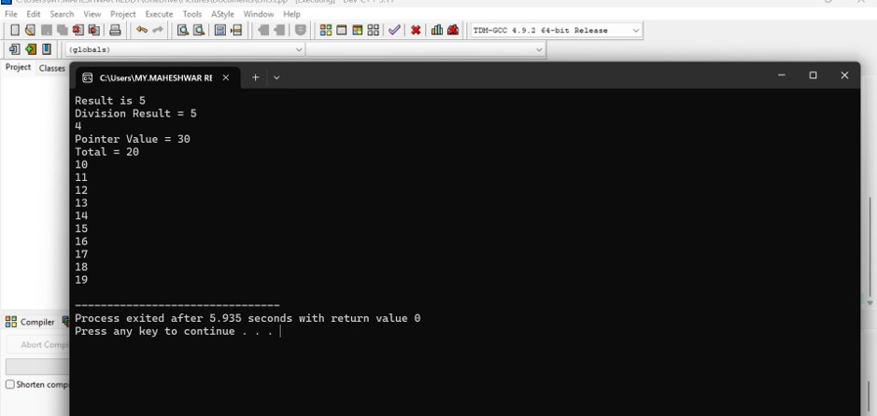
Do the following Tasks
(a) Identify Errors (Analysis Level)
- Identify all errors in the program.
- Mention line number + error description.

(b) Classify by Compiler Phase
Classify each error into:
- Lexical (invalid symbols like @num)
- Syntax (missing semicolon, brackets)
- Semantic (function argument mismatch)
- Intermediate Code Issues (wrong expression handling/precedence)
- Optimization Issues (redundant + 0)
- Runtime Errors (division by zero, invalid pointer access)

(c) Compilation vs Execution (Evaluation)
- Which errors are detected at compile time?
- Which errors appear only during execution?
- Explain why some errors prevent further compilation.

(d) Correct the Program (Application)
- Rewrite the fully corrected program.
- Ensure:
  - Proper syntax
  - Correct semantics
  - Safe execution

(e) Deep Analysis (Evaluation)
- Explain how incorrect pointer usage affects runtime.
- Analyze how array bounds violation impacts memory.
- Discuss how operator precedence errors affect intermediate code.

(f) Advanced Task (Create Level)
- Suggest 2 improvements in compiler design to:
  - Detect runtime errors earlier
  - Improve debugging messages
- Propose how optimization phase can remove redundant expressions.
Answer)

Multi-Phase Error Analysis
Q3 includes lexical, syntax, semantic, intermediate-code, optimization, and runtime errors.
(a) Identify Errors
Line | Error | Description
141 | Missing ; | Syntax error after return a / b
144 | #value | Invalid identifier
145 | Missing ; | Syntax error
147 | divide(10) | Missing second argument
148 | result = 5 | Assignment used instead of comparison
149 | Missing ; | Syntax error after printf()
153 | x / y where y = 0 | Division by zero
156 | arr[4] | Array index out of bounds
158 | *ptr = 25 | Uninitialized pointer
160 | + 0 | Redundant expression
161–163 | No increment of x | Infinite loop
(b) Classification by Compiler Phase
Lexical Error
- Line 144: #value
- # is not valid in an identifier.
Syntax Errors
- Line 141: Missing semicolon.
- Line 145: Missing semicolon.
- Line 149: Missing semicolon.
Semantic Error
- Line 147: divide(10) provides only one argument, but the function requires two.
Intermediate Code / Logic Issue
- Line 148: result = 5 assigns 5 to result.
- Correct comparison:
if (result == 5)
Optimization Issue
- Line 160: + 0 is redundant.
- The compiler can simplify the expression.
Runtime Errors
- Line 153: Division by zero.
- Line 156: Invalid array access.
- Line 158: Invalid pointer access.
- Lines 161–163: Infinite loop.
(c) Compilation vs Execution
Compile-Time Errors
- Invalid identifier.
- Missing semicolons.
- Incorrect function arguments.
- Some logical errors may generate warnings.
Runtime Errors
- Division by zero.
- Array out-of-bounds access.
- Invalid pointer dereferencing.
- Infinite loop.
Early lexical and syntax errors can prevent the compiler from continuing to later compilation phases.
(d) Fully Corrected Program
#include <stdio.h>

int divide(int a, int b) {
return a / b;
}

int main() {
int value = 20;
float num = 15.5;
int result;

result = divide(10, 2);

if (result == 5) {
printf("Result is 5\n");
}

int x = 10;
int y = 2;
int z = x / y;

int arr[4] = {1, 2, 3, 4};
printf("%d\n", arr[3]);

int data = 25;
int *ptr = &data;
printf("%d\n", *ptr);

int total;
total = x + y * result;

while (x < 20) {
printf("%d\n", x);
x++;
}

return 0;
}

(e) Deep Analysis
1. Incorrect Pointer Usage
An uninitialized pointer does not point to a valid memory location. Dereferencing it may cause a program crash or memory corruption.
2. Array Bounds Violation
For:
int arr[4];
the valid indexes are:
arr[0], arr[1], arr[2], arr[3]
Therefore, arr[4] is invalid and may access unwanted memory.
3. Operator Precedence
In:
x + y * result
multiplication has higher precedence than addition:
x + (y * result)
The intermediate code must preserve this order. Incorrect precedence handling can produce an incorrect result.
(f) Advanced Compiler Improvements
1. Early Runtime Error Detection
- Static analysis for division by zero.
- Array bounds checking.
- Pointer initialization analysis.
2. Better Debugging Messages
Example:
Error at line 153:
Possible division by zero.
Variable 'y' has value 0.
Suggestion: Check the denominator before division.
3. Optimization
The compiler can remove redundant expressions:
x + 0
can be optimized to:
x
This reduces unnecessary operations and improves program efficiency.
This completes all three questions of your Compiler Design Error Analysis Lab Task.

RUBRICS FOR CALCULATION:

Criteria | Weightage | Level 4 (Exemplary) | Level 3 (Proficient) | Level 2 (Developing) | Level 1 (Beginning)
Error Identification | 20% | Accurately identifies all errors with clear understanding of issues | Identifies most errors with minor omissions | Identifies limited errors; some are missed | Fails to identify key errors
Root Cause Analysis | 30% | Clearly explains underlying causes with strong technical reasoning | Explains causes with moderate clarity | Partial explanation; weak reasoning | Unable to identify causes of errors
Correction & Justification | 25% | Provides correct solutions with strong justification and logic | Provides correct corrections with some justification | Corrections are partially correct or weakly justified | Incorrect or no corrections provided
Application of Concepts | 15% | Effectively applies relevant concepts to analyze and resolve errors | Applies concepts with minor errors | Limited application; requires guidance | Unable to apply concepts
Clarity & Presentation | 10% | Presents analysis clearly, logically, and systematically | Generally clear with minor issues | Lacks clarity or proper structure | Poor presentation and difficult to understand

