SIMATS ENGINEERING
ASSESSMENT TOOL 3

COURSE CODE: CSA14 COURSE NAME: Compiler Design

COURSE OUTCOME COVERED

CO1: Apply lexical analysis for token specification and recognition using LEX tool. (BL3)

Assessment Tool Weightage: 10%

QUESTIONS: Total Marks:50

Annexure A

TECHNICAL PRESENTATION

Code of Conduct:

I ___K BHASHITHA_________________ (Name / Reg No) certify that this submission is my original work and that I have adhered to the guidelines specified for this assessment.
I understand that any violation of academic integrity rules will result in disciplinary action.

Signature of the student:

Annexure A

TECHNICAL PRESENTATION
1. Introduction to Compilers
- A compiler translates high-level language into machine code.
- It improves execution efficiency.
- Performs syntax and semantic checks.
- Produces optimized output code.
- Essential in software development.

2. Language Processors Overview
- Includes compiler, interpreter, and assembler.
- Each processes source code differently.
- Compilers generate executable files.
- Interpreters execute line by line.
- Assemblers convert assembly to machine code.

3. Compiler vs Interpreter
- Compiler translates entire program at once.
- Interpreter processes line-by-line.
- Compiled code runs faster.
- Interpreted code is easier to debug.
- Used in different programming scenarios.

4. Phases of a Compiler
- Compiler has multiple phases.
- Each phase performs a specific task.
- Includes lexical, syntax, semantic analysis.
- Also includes optimization and code generation.
- Works sequentially.

5. Lexical Analysis Phase
- First phase of compilation.
- Converts input into tokens.
- Removes whitespace and comments.
- Uses finite automata.
- Reports lexical errors.

6. Syntax Analysis (Parsing)
- Checks grammatical structure.
- Builds parse tree.
- Uses CFG rules.
- Detects syntax errors.
- Uses parsers like LL and LR.

7. Semantic Analysis
- Ensures meaning correctness.
- Checks types and scope.
- Uses symbol table.
- Detects semantic errors.
- Prepares for intermediate code.

8. Intermediate Code Generation
- Generates machine-independent code.
- Example: three-address code.
- Simplifies optimization.
- Bridges front-end and back-end.
- Improves portability.

9. Code Optimization
- Improves code efficiency.
- Reduces execution time.
- Eliminates redundancy.
- Uses techniques like loop optimization.
- Makes code faster.

10. Code Generation
- Produces target machine code.
- Uses registers and memory.
- Considers architecture.
- Final phase of compiler.
- Outputs executable program.

11. Symbol Table Management
- Stores variable information.
- Tracks scope and type.
- Used across all phases.
- Supports error checking.
- Efficient access is important.

12. Error Handling in Compilers
- Detects and reports errors.
- Types: lexical, syntax, semantic.
- Uses recovery techniques.
- Improves debugging.
- Important for user-friendly compilers.

13. Grouping of Compiler Phases
- Front-end and back-end division.
- Front-end handles analysis.
- Back-end handles synthesis.
- Improves modular design.
- Simplifies implementation.

14. Front-End of Compiler
- Includes lexical, syntax, semantic phases.
- Generates intermediate code.
- Machine-independent.
- Focuses on correctness.
- Easier to modify.

15. Back-End of Compiler
- Includes optimization and code generation.
- Machine-dependent.
- Produces final output code.
- Focuses on performance.
- Works on intermediate code.

16. Compiler Construction Tools
- Tools to build compilers easily.
- Examples: LEX, YACC.
- Automates phases.
- Saves development time.
- Widely used in industry.

17. Introduction to LEX Tool
- LEX is a lexical analyzer generator.
- Converts patterns into code.
- Uses regular expressions.
- Generates C code.
- Simplifies token recognition.

18. Structure of a LEX Program
- Divided into three parts.
- Definitions section.
- Rules section.
- User code section.
- Each has specific purpose.

19. Role of Lexical Analyzer
- Scans source code.
- Converts into tokens.
- Removes unnecessary characters.
- Passes tokens to parser.
- Handles lexical errors.

20. Tokens and Lexemes
- Token: category of symbols.
- Lexeme: actual string.
- Example: id, number.
- Essential in parsing.
- Defined using patterns.

21. Specification of Tokens
- Uses regular expressions.
- Defines valid patterns.
- Helps lexical analysis.
- Ensures correctness.
- Easy to implement.

22. Regular Expressions in Compilers
- Describe token patterns.
- Used in lexical analysis.
- Simple and powerful.
- Converted to automata.
- Widely used.

23. Finite Automata in Lexical Analysis
- Used for token recognition.
- DFA and NFA types.
- Efficient processing.
- Converts regex to automata.
- Foundation of lexical analyzers.

24. NFA vs DFA
- NFA has multiple transitions.
- DFA has single transition.
- DFA is faster.
- NFA is easier to design.
- Conversion is possible.

25. Transition Diagrams
- Graphical representation.
- Shows state transitions.
- Used in lexical analysis.
- Helps understanding automata.
- Easy visualization.

26. Input Buffering Techniques
- Improves reading efficiency.
- Uses buffers.
- Handles large input.
- Reduces I/O operations.
- Important for performance.

27. Lexical Errors
- Occur in token formation.
- Example: invalid symbols.
- Detected in first phase.
- Error recovery needed.
- Improves program correctness.

28. Bootstrapping in Compilers
- Compiler written in same language.
- Self-hosting concept.
- Improves portability.
- Used in advanced compilers.
- Complex but powerful.

29. Cross Compiler
- Runs on one machine.
- Generates code for another.
- Used in embedded systems.
- Supports portability.
- Widely used in development.

30. One-Pass vs Multi-Pass Compiler
- One-pass: faster, less memory.
- Multi-pass: more accurate.
- Used for complex languages.
- Trade-off exists.
- Depends on requirements.

31. Syntax-Directed Translation
- Combines parsing and translation.
- Uses attributes.
- Generates intermediate code.
- Based on grammar rules.
- Important in compilers.

32. Attribute Grammars
- Extends CFG.
- Adds semantic information.
- Uses synthesized attributes.
- Used in semantic analysis.
- Improves translation.

33. Parsing Techniques Overview
- Top-down and bottom-up.
- LL and LR parsing.
- Used in syntax analysis.
- Each has advantages.
- Widely used methods.

34. Top-Down Parsing
- Starts from root.
- Builds parse tree.
- Uses LL parser.
- Simple implementation.
- May require backtracking.

35. Bottom-Up Parsing
- Starts from input.
- Builds parse tree upward.
- Uses shift-reduce method.
- More powerful.
- Handles complex grammars.

36. Role of YACC Tool
- Parser generator tool.
- Works with LEX.
- Generates syntax analyzer.
- Uses grammar rules.
- Simplifies parser design.

37. Compiler Design Challenges
- Handling errors.
- Optimization complexity.
- Memory management.
- Machine dependency.
- Efficiency concerns.

38. Applications of Compilers
- Software development.
- Embedded systems.
- Game engines.
- AI programming.
- System software.

39. Evolution of Compilers
- From simple translators.
- To modern optimizing compilers.
- Supports multiple languages.
- Improves performance.
- Continues evolving.

40. Future Trends in Compiler Design
- AI-based optimization.
- Just-in-time compilation.
- Parallel compilation.
- Cloud-based compilers.
- Increasing automation.

GEOTAG:
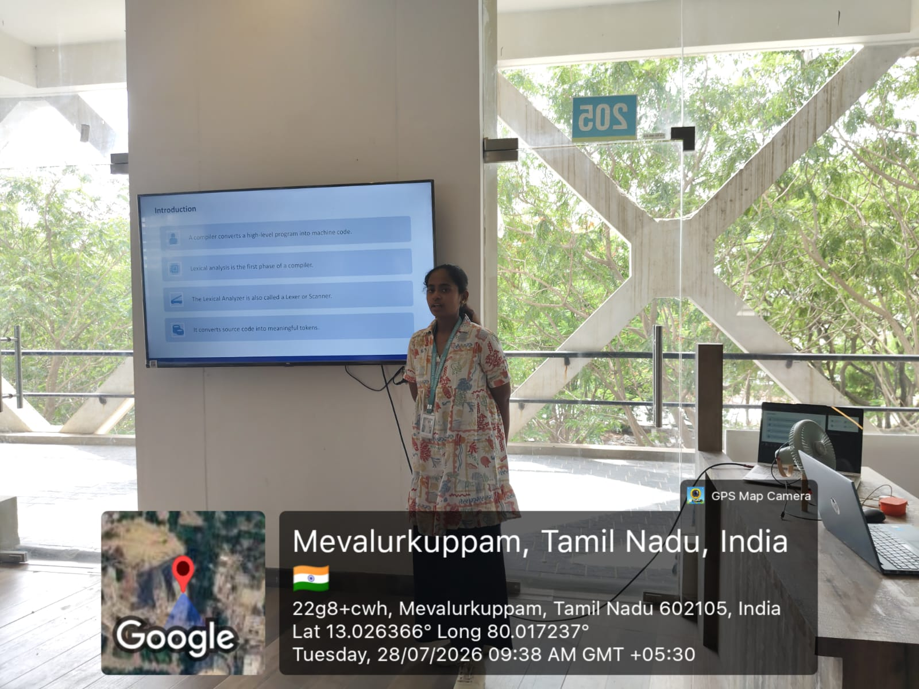

RUBRICS FOR CALCULATION:

Criteria | Weightage | Level 4 – Exemplary | Level 3 – Proficient | Level 2 – Developing | Level 1 – Beginning
Understanding of Case | 25 | Thorough understanding; clearly identifies all key issues | Good understanding with most issues identified | Basic understanding; some issues missed | Poor understanding; problem not identified correctly
Application of Concepts | 25 | Effectively applies relevant concepts to analyze the case deeply | Applies appropriate concepts with minor gaps | Limited application of concepts | Fails to apply relevant concepts
Analysis | 20 | In-depth analysis with strong reasoning and insights | Good analysis with logical reasoning | Basic analysis with limited depth | Weak or no analysis; lacks reasoning
Solution Design | 20 | Innovative, feasible solutions with strong justification | Logical solutions with adequate justification | Basic solutions with weak justification | Incorrect or no solution provided
Clarity | 10 | Clear, well-structured, and easy to understand | Organized and understandable presentation | Limited clarity and structure | Poor clarity; difficult to understand

