Campus Smart Parking System
Assignment 1 Answers and Implementation Guide
Student name: Dharanidharan.M
Register number: 192524229
Course: Java Fundamentals and Object-Oriented Programming
GitHub repository: https://github.com/192524229simats-pixel/CSA0910-JAVA-
Java target: Java 17 or later

Task 1 — Problem analysis and candidate objects
The system receives a vehicle registration and category, the user and pass status, entry and exit times, and charging usage where relevant. It returns a suitable slot and ticket at entry, and a fee and released slot at exit. It must report full capacity, duplicate active registrations, unknown categories, invalid times and invalid slot operations.
Candidate classes: ParkingFacility owns the floor/slot structure and active tickets; ParkingSlot stores floor, number, charging capability and occupancy; Vehicle stores registration and category; ParkingTicket stores ticket ID, vehicle, user, slot and entry time; ParkingUser stores student/staff/visitor and pass status; PricingRule calculates the fee; Chargeable models the charging capability. Each class owns a coherent piece of state or behaviour, so validation and future changes stay localized.
Rules: a slot has at most one vehicle; active registrations are unique; ticket IDs are unique; a vehicle can use a charging slot only when capable; an exit requires an active ticket; negative durations and energy use are invalid; monthly passes are free for students/staff and a visitor one-day pass is free for its date. Assumptions: started-hour billing, Rs 10/hour for two-wheelers and Rs 30/hour for cars, Rs 12/kWh charging, Rs 25 flat e-bike fee for a nonzero stay, delivery vans pay double the car rate when the stay overlaps 9 AM–5 PM, and a Rs 300 daily cap applies to hourly categories.
Parallel-array alternative: registration/type/time would be held in matching arrays. Finding a registration is O(n), just as scanning an object collection without an index. Both use O(n) space, but adding an attribute requires another synchronized array and increases index-alignment risk. Vehicle objects group state and can own behaviour.

Task 2 — Data representation
Use int for floor and slot indexes, String for registration/ticket IDs, LocalDateTime for timestamps, long for duration minutes, and BigDecimal for money to avoid binary floating-point rounding. Store floors as a jagged ParkingSlot[][] because floors may have different capacities. Use Scanner for interactive entry or command-line arguments for repeatable tests.
For 130 minutes, integer division 130/60 yields 2 and undercharges when every started hour is billed. Use (minutes + 59) / 60 after rejecting negative minutes; 130 then yields 3. A fixed one-dimensional array with index=floor*slotsPerFloor+slot assumes equal floor sizes. Jagged arrays and ArrayList<ParkingSlot[]> naturally support unequal floors. Locating a slot is O(S) by scanning, and each representation stores O(S) slots.

Task 3 — Control logic and completed code
Allocation scans floors then slots, skips occupied or unsuitable slots, stores the registration in the first valid slot and returns immediately. If no slot is found, it returns a no-space result. Fee logic first validates duration, checks pass eligibility, rounds minutes upward to billable hours, applies the category rule and daily cap.

ALLOCATE(vehicle): for each floor and each slot: if free and suitable, occupy it and return its coordinates; otherwise continue. Return no-slot.
FEE(vehicle,user,in,out): reject out < in; if eligible pass applies return 0; hours=(minutes+59)/60; apply category rate/rule; cap if needed; return fee.

The completed ParkingFacility program is in SmartParkingAssignment1/Task03/ParkingFacility.java. It implements both TODOs and preserves the provided main method. Expected output: [0, 0], [0, 1], [1, 0], null, true false false, [0, 1].
The supplied implementation scans in O(S) worst-case time with O(1) auxiliary space. Maintaining a stack of free slots per floor uses O(S) extra references and makes allocate/release O(1) average, subject to keeping the stack consistent.

Task 4 — Classes, objects and constructors
Parameterized constructors establish valid Vehicle, ParkingSlot and ParkingTicket objects. Use this(...) to chain overloaded constructors and avoid repeating validation; use super(...) to initialize Vehicle state from a subclass. A copy constructor is not suitable for re-issuing a ticket because every new ticket must have a fresh ID. A reference variable refers to a heap object; after exit, a ticket is collectible when no reachable object references it. Constructors, setters and factory methods all create n tickets in O(n) total time and O(n) total storage, but constructors/factories can prevent invalid intermediate state.

Task 5 — Static members and lifecycle
A static ticket sequence provides IDs unique across facilities in one application. Occupancy belongs to each ParkingFacility instance, not to the class. Static utility methods suit validation that uses no instance state; a static initializer is appropriate for one-time setup. On exit, remove the ticket from the active map and clear its slot. With an instance ticket counter, k facilities use O(k) counter storage and can collide unless IDs include a facility prefix; one static counter uses O(1) counter storage.

Task 6 — Inheritance hierarchy and UML
Vehicle is the base type; TwoWheeler and Car extend it; ElectricCar extends Car and implements Chargeable. E-bike and DeliveryVan are categories in the runnable model and use pricing rules. This is hierarchical inheritance, with one multilevel branch through Car. Shared registration state belongs to Vehicle; subclasses or pricing rules provide category behaviour. For new ElectricCar("TN03C3"), constructors execute ElectricCar → Car → Vehicle, then return Vehicle → Car → ElectricCar.
The UML relationship diagram is supplied in SmartParkingAssignment1/UML.md. Composition alternative: Vehicle would hold a VehicleType/rate strategy. Adding a type adds a strategy rather than a subclass. Fee calculation remains O(1); a strategy reference adds O(1) space per vehicle.

Task 7 — Overriding and Object methods
Subclasses override ratePerHour() or use a PricingRule when the entire pricing policy differs. @Override catches signature errors. Overridden methods must retain the same signature, return a compatible type and not narrow access. Use final for immutable registration/ticket fields; make a method final only when subclasses must not change its invariant. equals() and hashCode() must use the same normalized registration key. A switch on k vehicle categories needs up to O(k) checks and changes when categories grow; virtual dispatch is O(1) for a method call and keeps category-specific behaviour local.

Task 8 — Polymorphism and completed code
Overloading is compile-time polymorphism: calculateFee(int minutes) and calculateFee(LocalDateTime in, LocalDateTime out) are selected from argument types. Runtime polymorphism occurs when Vehicle references hold different subclass objects and a rate method is overridden. The completed FeeDemo source is in SmartParkingAssignment1/Task08/FeeDemo.java. Expected output: TwoWheeler TN01A1 -> Rs 30.0; Car TN02B2 -> Rs 90.0; ElectricCar TN03C3 -> Rs 210.0; true.
The last true follows because the given equals() compares registration number only. It is suitable only if registration alone defines vehicle identity; otherwise include facility or category in equality.

Task 9 — Abstraction
Vehicle is abstract because shared state and common operations exist, but the generic type has no single correct hourly rate. Chargeable is an interface because charging is a capability independent of the class hierarchy and a type can implement multiple interfaces. Interface defaults suit optional shared behaviour; static methods suit interface-related utilities. If Vehicle became an interface, constructors and shared instance fields would be lost; if Chargeable became an abstract class, Java single inheritance would prevent a class from extending another base class too. Method dispatch remains O(1), with O(1) object storage beyond fields.

Task 10 — Packages and encapsulation
A multi-file version can use parking.model for Vehicle, ParkingSlot and ParkingTicket; parking.pricing for PricingRule; parking.service for ParkingFacility; parking.user for pass/user types; and parking.app for Main. Fields should be private, public methods limited to required operations, protected methods reserved for subclass extension points, and package-private members limited to package internals. Constructors/setters reject invalid values. Wrapper classes may be used in collections; compare Integer values with equals() or unbox after null checks, not ==.
Public fields would force callers to repeat validation and could allow invalid state. Validation costs O(1) per update, and encapsulation ensures it is consistently applied in one place.

Task 11 — Implementation, tests and evaluation
The runnable system is SmartParkingAssignment1/Task11_12/SmartParkingSystem.java. It includes five unequal floors, charging-slot preference for electric vehicles, active-ticket lookup by HashMap, fee rules, passes, duplicate rejection and self-checks. The system tests include capacity, duplicate registration, zero duration, a 60-minute boundary, delivery-van daytime pricing, e-bike flat fee, EV energy fee, visitor one-day pass, staff monthly pass, invalid slot release and unknown vehicle type.
Test case | Expected result encoded in check | Observed result
Unequal five-floor capacity | Accepted; floor 4 capacity is 3 | Not run: JDK unavailable in authoring environment
Duplicate active registration | Rejected | Not run
Car exactly 60 minutes | Rs 30.00 | Not run
Two-wheeler zero minutes | Rs 0.00 | Not run
Delivery van 10 AM–12 PM | Rs 120.00 | Not run
E-bike, nonzero stay | Rs 25.00 | Not run
EV, 60 min plus 10 kWh | Rs 150.00 | Not run
Visitor one-day pass valid that day | Rs 0.00 | Not run
Staff monthly pass | Rs 0.00 | Not run
Invalid slot release | false | Not run
Unknown vehicle type | Rejected | Not run
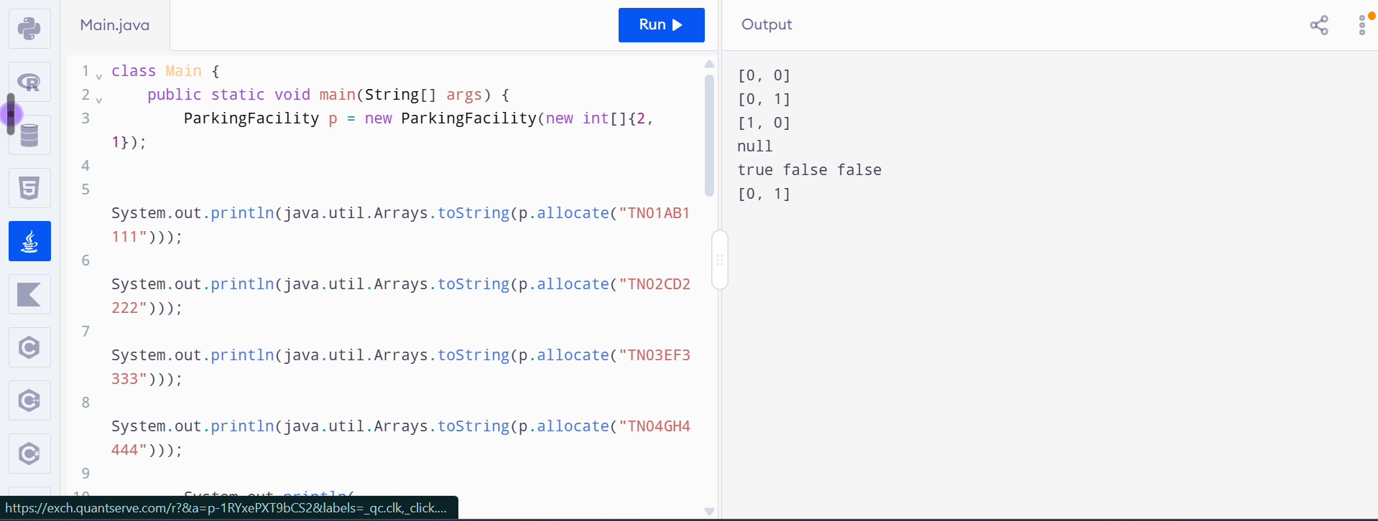

Task 12 — Design challenge
The changed requirements add e-bikes, delivery vans with a time-window rate, visitor day passes and five unequal floors. The jagged floor model already supports varying capacities. Retain the facility, ticket and vehicle concepts, but modify pricing to use PricingRule and pass eligibility to use explicit user/pass state. E-bikes receive a flat fee; vans use twice the car rate when parking overlaps 9 AM–5 PM; a valid visitor day pass makes the date free. The runnable code implements these assumptions.
This is a modify decision rather than a full redesign: new rate cases are localized in StandardPricing, the facility uses a jagged array, and the new pass rule lives with the user. . A further vehicle category should require a new vehicle type and pricing rule, not changes to slot management. Trade-off: the teaching implementation centralizes rules in a switch for simplicity; a production version should split each category into separate PricingRule implementations to reduce modification risk.

