ASSIGNMENT – 2
C++ FUNCTIONS AND OBJECT-ORIENTED PROGRAMMING
OUTPUTS

Q1 – Execution evidence
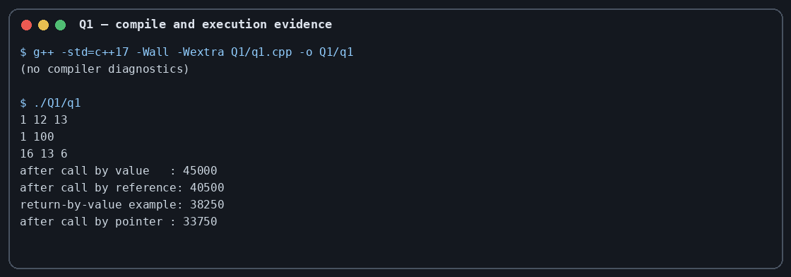

Q2 – Execution evidence
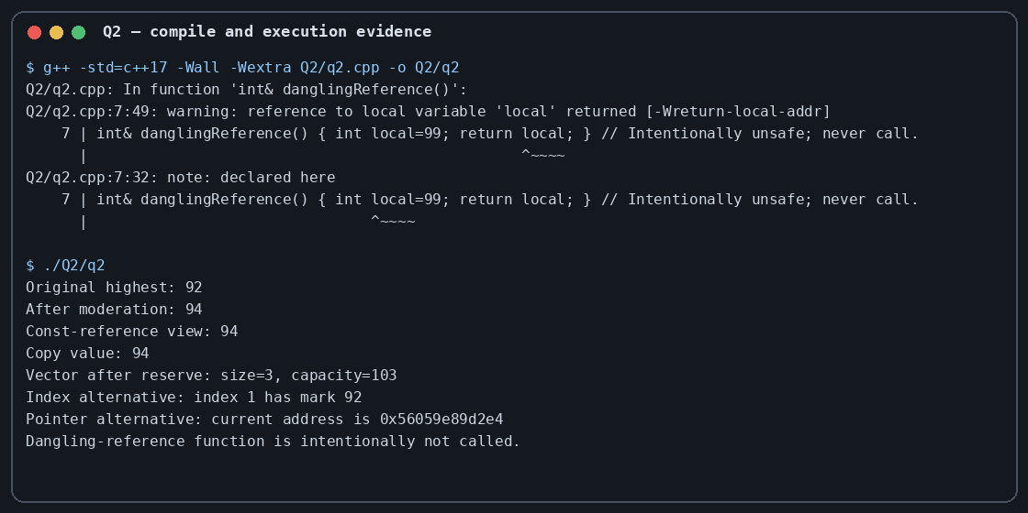

Q3 – Execution evidence
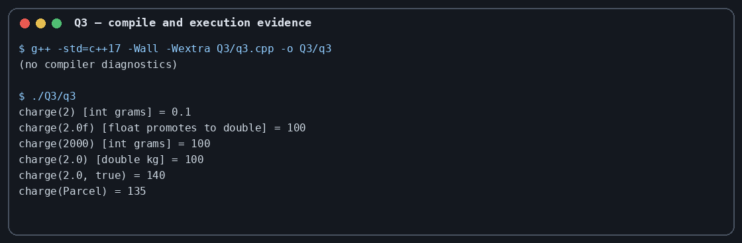

Q4 – Execution evidence
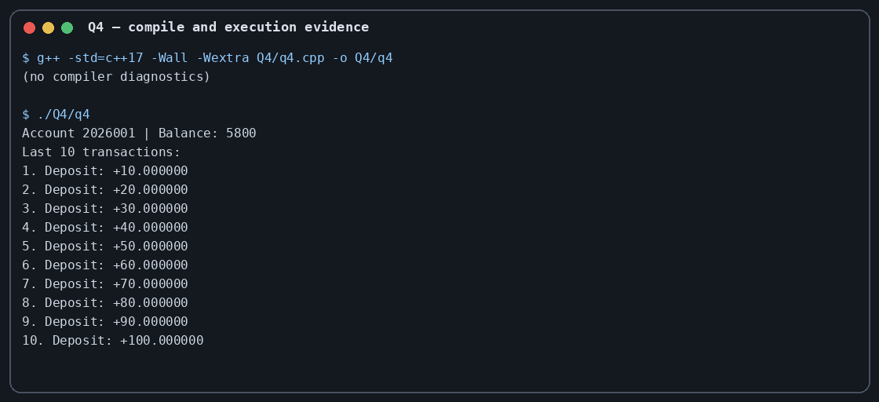

Q5 – Execution evidence
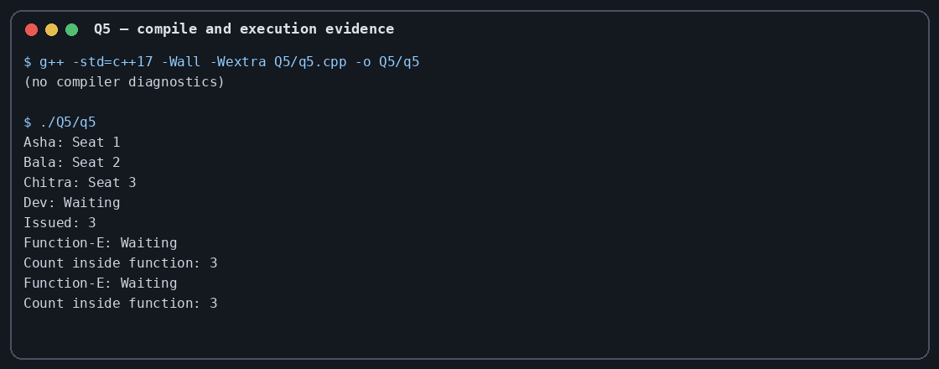

Q6 – Execution evidence
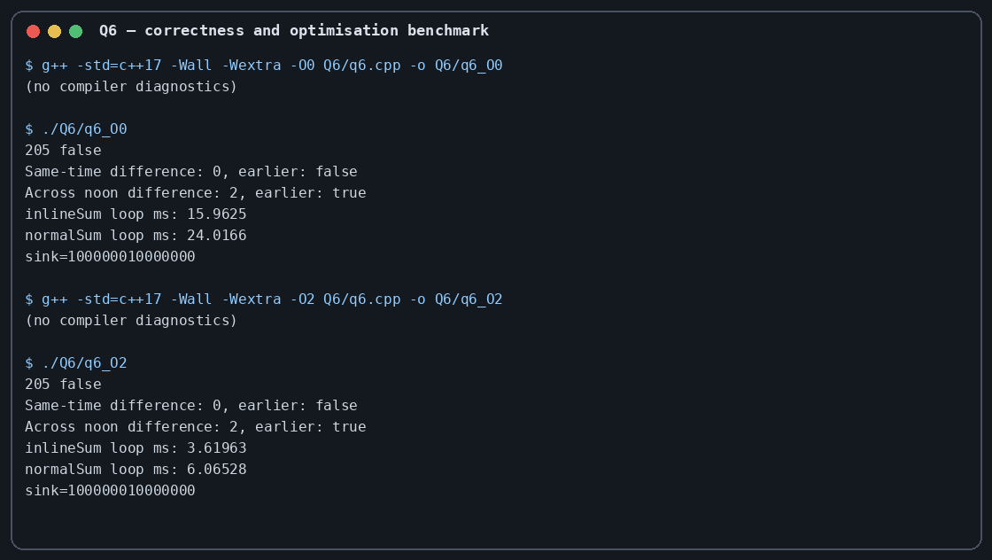

Q7 – Execution evidence


