13 Construct a C program for implementation of the various memory allocation
Strategies.
#include <stdio.h>

void firstFit(int block[], int b, int process[], int p)
{
int allocation[p], i, j;

for(i = 0; i < p; i++)
allocation[i] = -1;

for(i = 0; i < p; i++)
{
for(j = 0; j < b; j++)
{
if(block[j] >= process[i])
{
allocation[i] = j;
block[j] -= process[i];
break;
}
}
}

printf("\nFirst Fit:\n");
for(i = 0; i < p; i++)
printf("Process %d -> Block %d\n", i + 1,
allocation[i] == -1 ? 0 : allocation[i] + 1);
}

void bestFit(int block[], int b, int process[], int p)
{
int allocation[p], i, j, best;

for(i = 0; i < p; i++)
allocation[i] = -1;

for(i = 0; i < p; i++)
{
best = -1;

for(j = 0; j < b; j++)
{
if(block[j] >= process[i])
{
if(best == -1 || block[j] < block[best])
best = j;
}
}

if(best != -1)
{
allocation[i] = best;
block[best] -= process[i];
}
}

printf("\nBest Fit:\n");
for(i = 0; i < p; i++)
printf("Process %d -> Block %d\n", i + 1,
allocation[i] == -1 ? 0 : allocation[i] + 1);
}

void worstFit(int block[], int b, int process[], int p)
{
int allocation[p], i, j, worst;

for(i = 0; i < p; i++)
allocation[i] = -1;

for(i = 0; i < p; i++)
{
worst = -1;

for(j = 0; j < b; j++)
{
if(block[j] >= process[i])
{
if(worst == -1 || block[j] > block[worst])
worst = j;
}
}

if(worst != -1)
{
allocation[i] = worst;
block[worst] -= process[i];
}
}

printf("\nWorst Fit:\n");
for(i = 0; i < p; i++)
printf("Process %d -> Block %d\n", i + 1,
allocation[i] == -1 ? 0 : allocation[i] + 1);
}

int main()
{
int block1[] = {100, 500, 200, 300, 600};
int block2[] = {100, 500, 200, 300, 600};
int block3[] = {100, 500, 200, 300, 600};
int process[] = {212, 417, 112, 426};

int b = 5, p = 4;

firstFit(block1, b, process, p);
bestFit(block2, b, process, p);
worstFit(block3, b, process, p);

return 0;
}

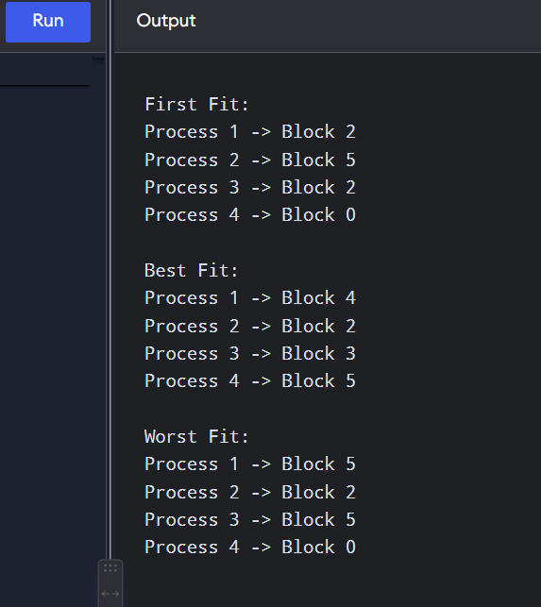

14 Construct a C program to organise the file using a single level directory.
#include <stdio.h>
#include <string.h>
int main()
{
char files[20][30];
int n = 0, choice, i;
char name[30];
while(1)
{
printf("\n1. Create File");
printf("\n2. Delete File");
printf("\n3. Display Files");
printf("\n4. Exit");
printf("\nEnter your choice: ");
scanf("%d", &choice);
if(choice == 1)
{
printf("Enter file name: ");
scanf("%s", name);

strcpy(files[n], name);
n++;
printf("File created successfully.\n");
}
else if(choice == 2)
{
printf("Enter file name to delete: ");
scanf("%s", name);

for(i = 0; i < n; i++)
{
if(strcmp(files[i], name) == 0)
{
strcpy(files[i], files[n - 1]);
n--;
printf("File deleted successfully.\n");
break;
}
}

if(i == n)
printf("File not found.\n");
}
else if(choice == 3)
{
printf("\nFiles in Directory:\n");

for(i = 0; i < n; i++)
printf("%s\n", files[i]);
}
else if(choice == 4)
break;
else
printf("Invalid choice.\n");
}
return 0;
}

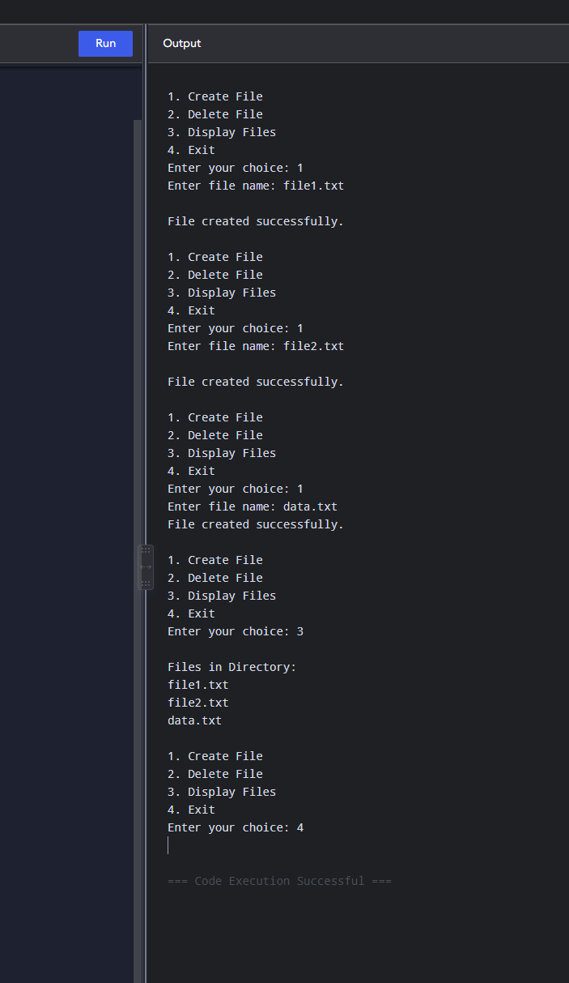

15 Design a C program to organise the file using a two level directory structure.
#include <stdio.h>
#include <string.h>

struct User {
char username[20];
char files[10][20];
int fileCount;
};

int main() {
struct User users[10];
int userCount = 0;
int choice, i, j;
char username[20], filename[20];
int found;

while (1) {
printf("\n--- TWO LEVEL DIRECTORY ---\n");
printf("1. Create User\n");
printf("2. Create File\n");
printf("3. Display Directory\n");
printf("4. Exit\n");
printf("Enter choice: ");
scanf("%d", &choice);

switch (choice) {

case 1:
printf("Enter username: ");
scanf("%s", username);

strcpy(users[userCount].username, username);
users[userCount].fileCount = 0;
userCount++;

printf("User created successfully.\n");
break;

case 2:
printf("Enter username: ");
scanf("%s", username);

found = -1;

for (i = 0; i < userCount; i++) {
if (strcmp(users[i].username, username) == 0) {
found = i;
break;
}
}

if (found == -1) {
printf("User not found.\n");
} else {
printf("Enter file name: ");
scanf("%s", filename);

strcpy(users[found].files[users[found].fileCount],
filename);

users[found].fileCount++;

printf("File created successfully.\n");
}
break;

case 3:
printf("\nDirectory Structure:\n");

for (i = 0; i < userCount; i++) {
printf("\nUser: %s\n", users[i].username);

for (j = 0; j < users[i].fileCount; j++) {
printf(" File: %s\n", users[i].files[j]);
}
}
break;

case 4:
return 0;
default:
printf("Invalid choice.\n");
}
}
return 0;
}
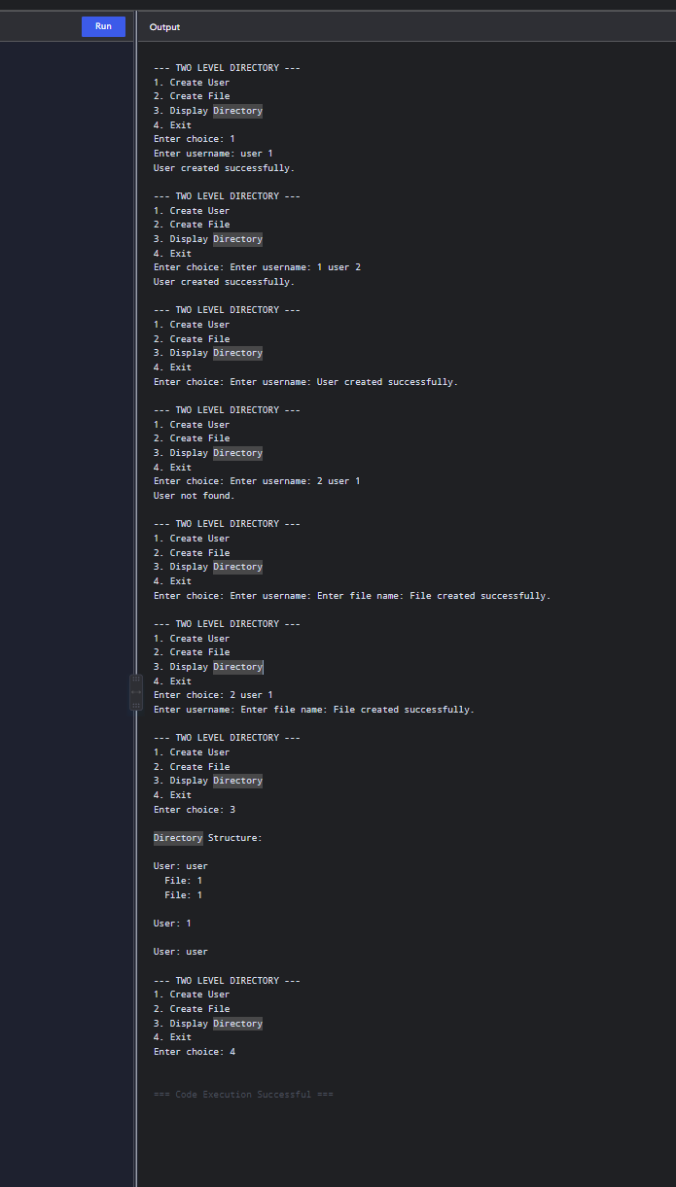
16 Develop a C program for implementing random access file for processing the
employee details.
#include <stdio.h>

struct Employee {
int id;
char name[30];
float salary;
};

int main() {
struct Employee emp[20];
int n, i, record;

printf("Enter number of employees: ");
scanf("%d", &n);

/* Store employee details */
for (i = 0; i < n; i++) {
printf("\nEnter Employee ID: ");
scanf("%d", &emp[i].id);

printf("Enter Employee Name: ");
scanf("%s", emp[i].name);

printf("Enter Salary: ");
scanf("%f", &emp[i].salary);
}

/* Random access */
printf("\nEnter record number to access: ");
scanf("%d", &record);

if (record >= 1 && record <= n) {
i = record - 1;

printf("\nEmployee Details\n");
printf("--------------------\n");
printf("Employee ID : %d\n", emp[i].id);
printf("Name : %s\n", emp[i].name);
printf("Salary : %.2f\n", emp[i].salary);
}
else {
printf("Invalid record number.\n");
}

return 0;
}

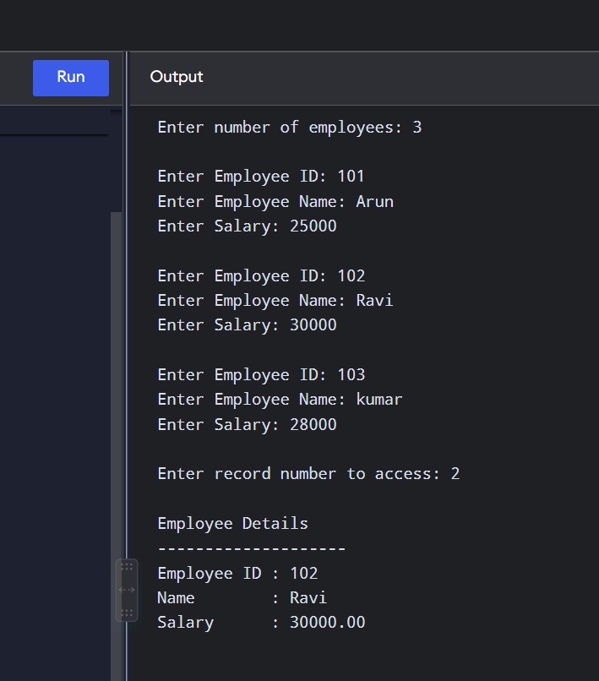

21 Develop a C program to implement the worst fit algorithm of memory management
#include <stdio.h>
int main() {
int block[20], process[20];
int b, p, i, j, worst;
printf("Enter number of memory blocks: ");
scanf("%d", &b);
printf("Enter size of memory blocks:\n");
for (i = 0; i < b; i++)
scanf("%d", &block[i]);
printf("Enter number of processes: ");
scanf("%d", &p);

printf("Enter size of processes:\n");
for (i = 0; i < p; i++)
scanf("%d", &process[i]);

printf("\nWorst Fit Allocation:\n");

for (i = 0; i < p; i++) {
worst = -1;
for (j = 0; j < b; j++) {
if (block[j] >= process[i]) {
if (worst == -1 || block[j] > block[worst])
worst = j;
}
}

if (worst != -1) {
printf("Process %d (%d KB) -> Block %d\n",
i + 1, process[i], worst + 1);

block[worst] -= process[i];
} else {
printf("Process %d (%d KB) -> Not Allocated\n",
i + 1, process[i]);
}
}

return 0;
}
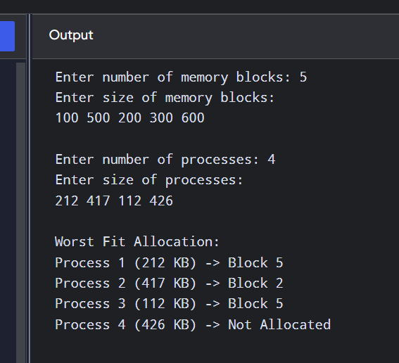

22 Construct a C program to implement the best fit algorithm of memory management.
#include <stdio.h>
int main() {
int block[20], process[20];
int b, p, i, j, best;
printf("Enter number of memory blocks: ");
scanf("%d", &b);
printf("Enter size of memory blocks:\n");
for (i = 0; i < b; i++)
scanf("%d", &block[i]);
printf("Enter number of processes: ");
scanf("%d", &p);
printf("Enter size of processes:\n");
for (i = 0; i < p; i++)
scanf("%d", &process[i]);
printf("\nBest Fit Allocation:\n");
for (i = 0; i < p; i++) {
best = -1;
for (j = 0; j < b; j++) {
if (block[j] >= process[i]) {
if (best == -1 || block[j] < block[best])
best = j;
}
}
if (best != -1) {
printf("Process %d (%d KB) -> Block %d\n",
i + 1, process[i], best + 1);
block[best] -= process[i];
} else {
printf("Process %d (%d KB) -> Not Allocated\n",
i + 1, process[i]);
}
}
return 0;
}
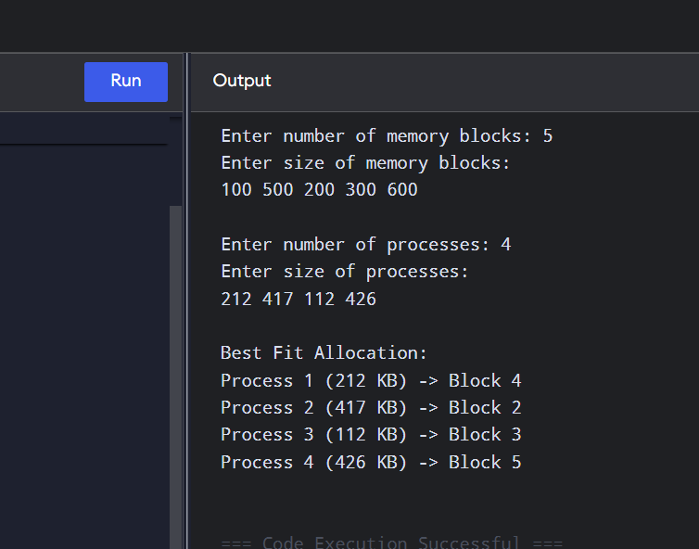

23 Construct a C program to implement the first fit algorithm of memory management
#include <stdio.h>

int main() {
int block[20], process[20];
int b, p, i, j;

printf("Enter number of memory blocks: ");
scanf("%d", &b);

printf("Enter size of memory blocks:\n");
for (i = 0; i < b; i++)
scanf("%d", &block[i]);

printf("Enter number of processes: ");
scanf("%d", &p);

printf("Enter size of processes:\n");
for (i = 0; i < p; i++)
scanf("%d", &process[i]);

printf("\nFirst Fit Allocation:\n");

for (i = 0; i < p; i++) {
int allocated = 0;

for (j = 0; j < b; j++) {
if (block[j] >= process[i]) {
printf("Process %d (%d KB) -> Block %d\n",
i + 1, process[i], j + 1);

block[j] -= process[i];
allocated = 1;
break;
}
}

if (!allocated) {
printf("Process %d (%d KB) -> Not Allocated\n",
i + 1, process[i]);
}
}

return 0;
}
