SIMATS ENGINEERING
Department of Computer Science & Engineering
ASSESSMENT TOOL 2- DEBUGGING & OPTIMISATION TASK

Course Code: | CSA1205 | Course Title: | Computer Architecture for Multicore Systems
CO Assessed: | CO2 | Assessment: | ASSESSMENT TOOL2- DEBUGGING & OPTIMISATION TASK
Weightage: | 20% | Total Marks: | 25
CO2 Statement: | Apply integer and floating-point arithmetic algorithms including Booth's multiplication, restoring/non-restoring division, and IEEE 754 standard operations to solve fixed-point and floating-point computational problems. (BL3)
Student Name: |  | Reg.No.:
Department: |  | Date:

ANNEXURE A
- A program performing signed integer addition using 2’s complement produces incorrect results when adding large values (e.g., +120 and +50 in 8-bit representation). Debug the issue by analyzing the binary computation and identifying whether overflow has occurred. Propose a solution to correctly detect and handle overflow in such cases.

- A processor using a ripple carry adder shows significant delay in executing arithmetic operations in a real-time system. Debug the performance bottleneck by examining how carry propagates through each bit. Suggest an optimized solution using a carry look-ahead adder, and explain how it reduces delay.

- A multiplication unit implementing Booth’s algorithm gives incorrect results for certain negative operands. Debug the step-by-step execution of the algorithm, focusing on bit-pair checking, arithmetic shifts, and sign extension. Identify the possible source of error and suggest corrections to ensure accurate signed multiplication.

- An embedded system using the restoring division algorithm experiences inefficiency due to repeated restoration steps, leading to increased execution time. Debug the algorithm’s workflow and identify where unnecessary operations occur. Propose an optimized approach using the non-restoring division method, explaining how it improves performance.

- A scientific application using IEEE 754 single precision floating-point representation produces inaccurate results when adding very small and very large numbers. Debug the issue by analyzing exponent alignment, normalization, and rounding errors. Suggest optimization techniques, such as using double precision or algorithmic adjustments, to improve accuracy.

Code of Conduct:

I Mohamed FasilHak.M/192524304 (Name / Reg No) certify that this submission is my original work and that I have adhered to the guidelines specified for this assessment.I understand that any violation of academic integrity rules will result in disciplinary action.

Signature of the student:
Mohamed FasilHak.M

MARKS ALLOCATION
 | Identification of Errors / Bugs (20%) | Debugging Approach & Analysis (20%) | Correctness of Debugged Solution (25%) | Optimization Techniques Applied (20%) | Testing and Documentation (15%)
Q1
Q2
Q3
Q4
Q5

RUBRICS FOR CALCULATION:

Criteria | Weightage | Level 4 – Exemplary | Level 3 – Proficient | Level 2 – Developing | Level 1 – Beginning
Identification of Errors / Bugs | 20% | Accurately identifies all errors and issues with complete understanding of the problem | Identifies most errors with minor omissions | Identifies limited errors; misses key issues | Unable to identify errors or misunderstands the problem
Debugging Approach & Analysis | 20% | Uses effective debugging techniques with clear analysis and root cause identification | Applies suitable debugging methods with minor gaps | Uses basic debugging methods with limited analysis | No systematic debugging approach followed
Correctness of Debugged Solution | 25% | Provides completely corrected solution with accurate functionality and expected output | Provides working solution with minor errors | Partially correct solution with limited functionality | Incorrect solution or fails to resolve errors
Optimization Techniques Applied | 20% | Applies efficient optimization methods to improve performance, memory usage and quality | Performs optimization with noticeable improvements | Limited optimization with minimal improvements | No optimization applied or inefficient implementation
Testing and Documentation | 15% | Performs complete testing with proper validation and clear documentation | Provides adequate testing and documentation with minor issues | Limited testing and incomplete documentation | No proper testing or documentation provided

1)
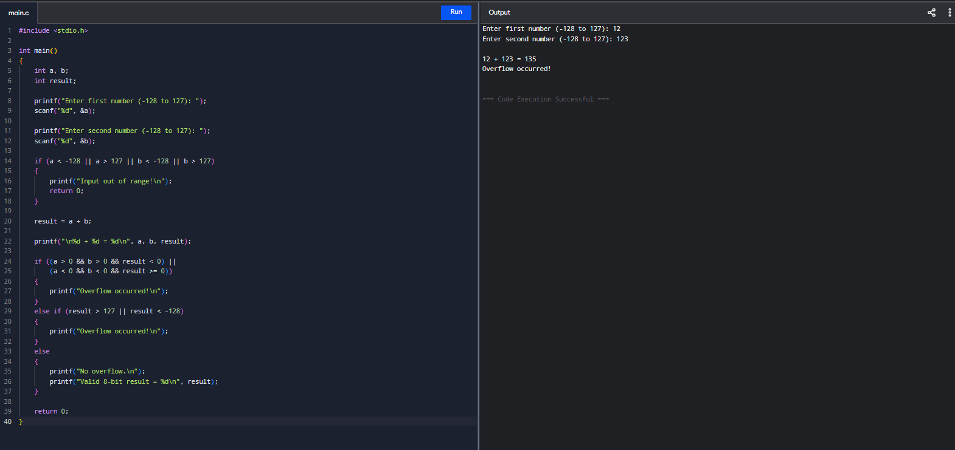

2)
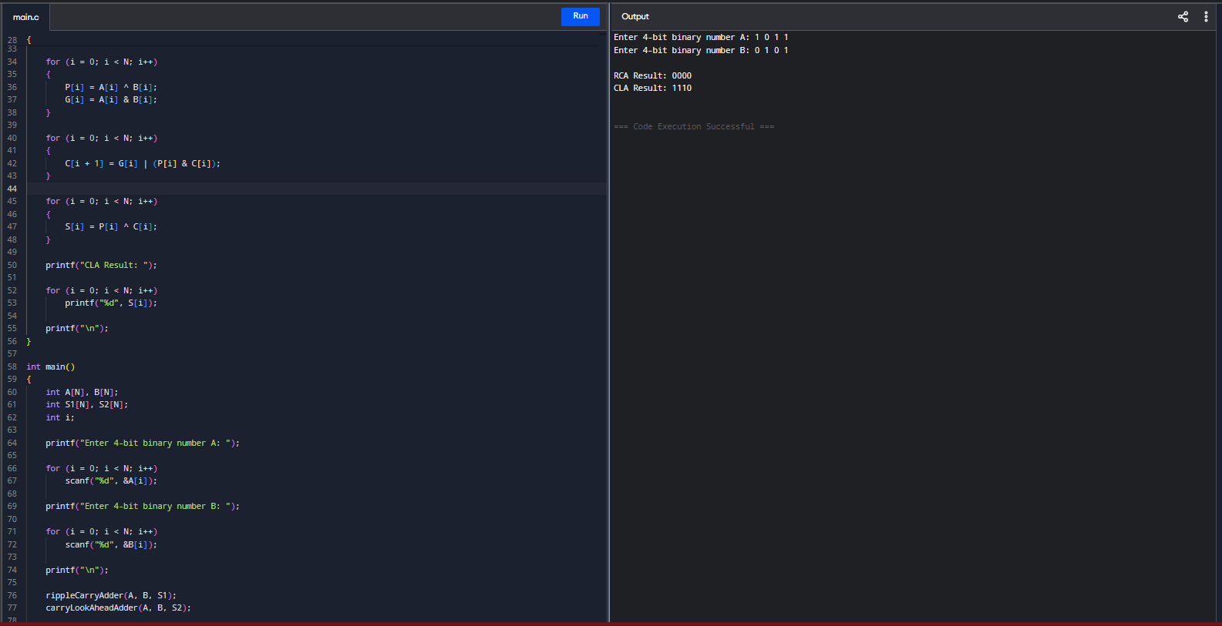

3)
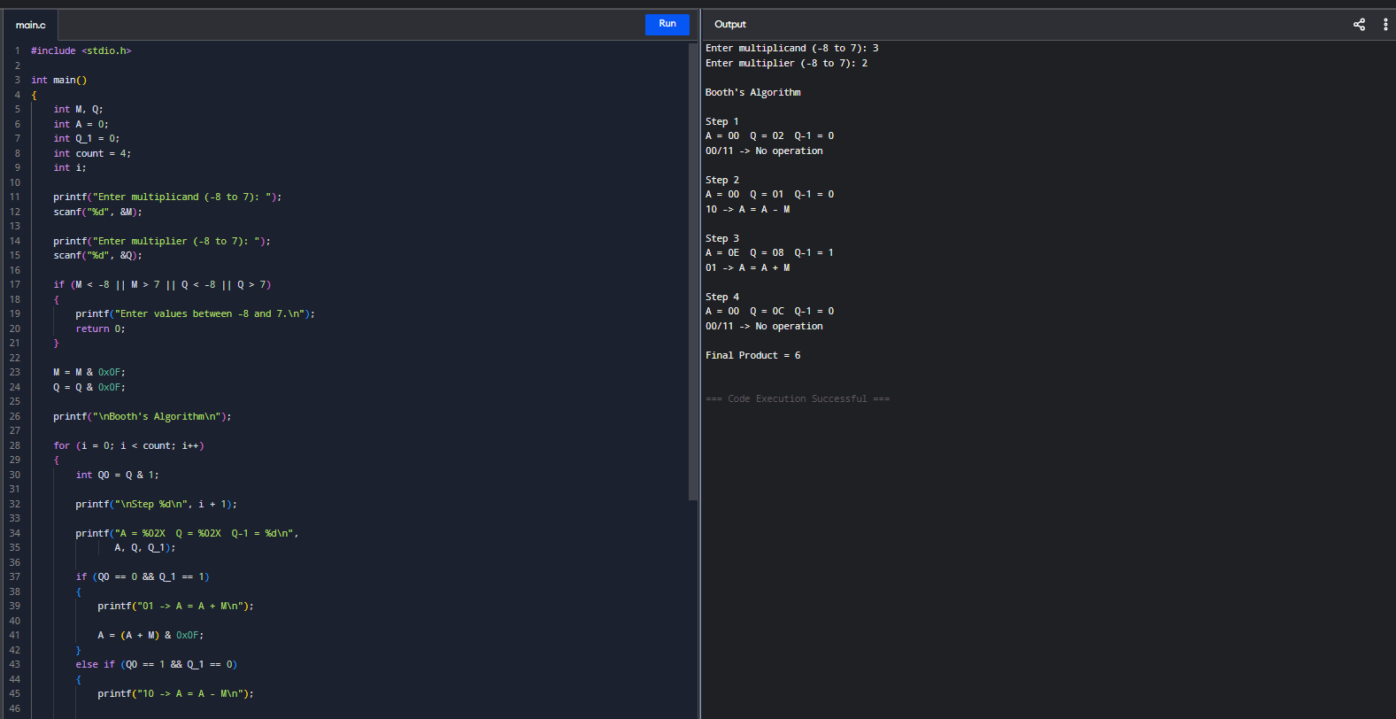

4)
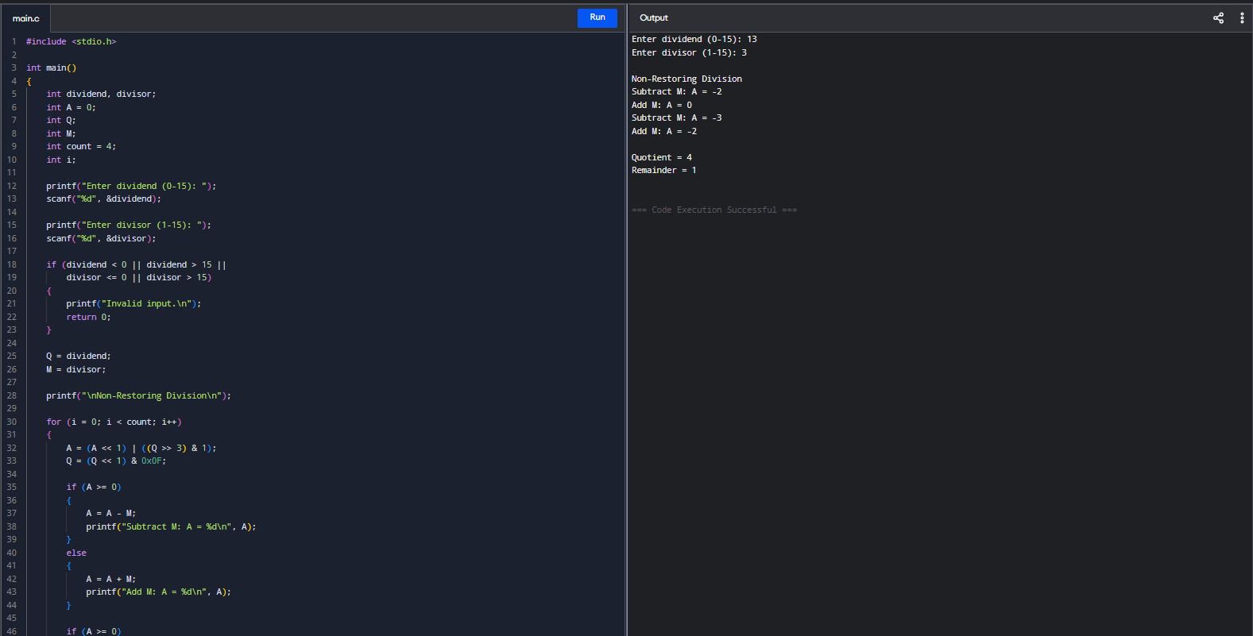

5)
