SIMATS ENGINEERING
ASSESSMENT TOOL 1

COURSE NAME: OBJECT ORIENTED ANALYSIS AND DESIGN
COURSE CODE: CSA11

COURSE OUTCOME COVERED

CO1: Apply object-oriented concepts and software development life cycle models to design structured and modular software systems. (BL2, BL3)

Assessment Tool Weightage: 60%

Dr Ramamoorthy

QUESTIONS: 12 Total Marks:60

Annexure A

CONCEPT MAPPING

Code of Conduct:

I Mohamed Fasil Hak.M/192524304 (Name / Reg No) certify that this submission is my original work and that I have adhered to the guidelines specified for this assessment.
I understand that any violation of academic integrity rules will result in disciplinary action.

Signature of the student:

Mohamed Fasil Hak.M

Annexure A

CONCEPT MAPPING

1. Construct a Concept Map
Given:
Requirement Analysis → ______ → Coding → Testing → ______ → Maintenance
Answer:
The missing concepts are:
- Design
- Deployment
Explanation:
- Design converts requirements into system architecture.
- Deployment releases the software to end users.
Analysis:
- Ensures systematic software development.
- Reduces project risks.
- Improves software quality and maintainability.
Diagram:
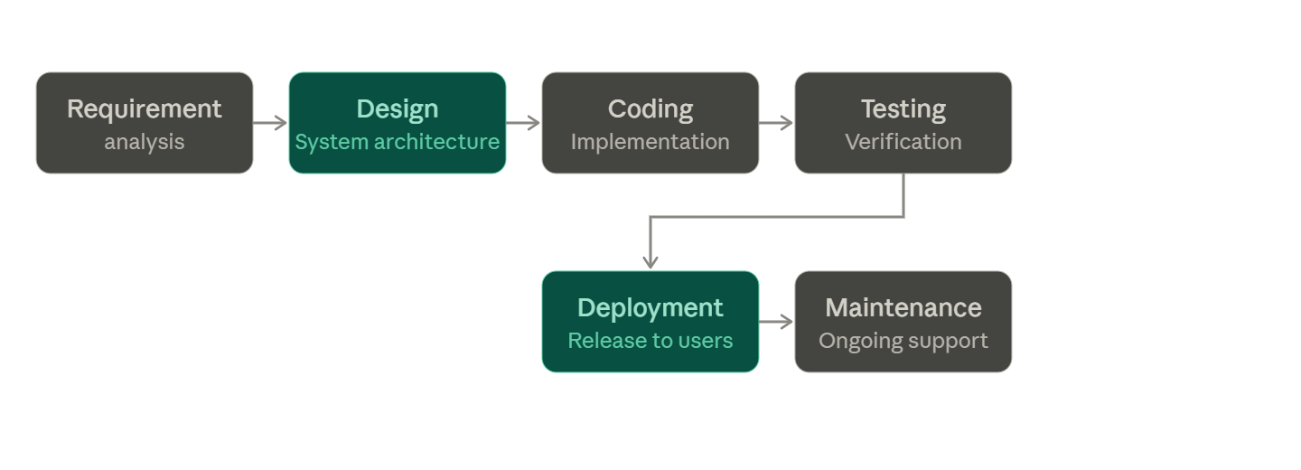

2. Construct a Concept Map
Given:
Object-Oriented Principles
→ Abstraction
→ ______
→ Inheritance
→ ______
Answer:
The missing concepts are:
- Encapsulation
- Polymorphism
Explanation:
- Encapsulation protects data from unauthorized access.
- Polymorphism allows one interface to support multiple behaviors.
Analysis:
- Improves security and flexibility.
- Enhances code reusability.
- Supports efficient software design.
Diagram:
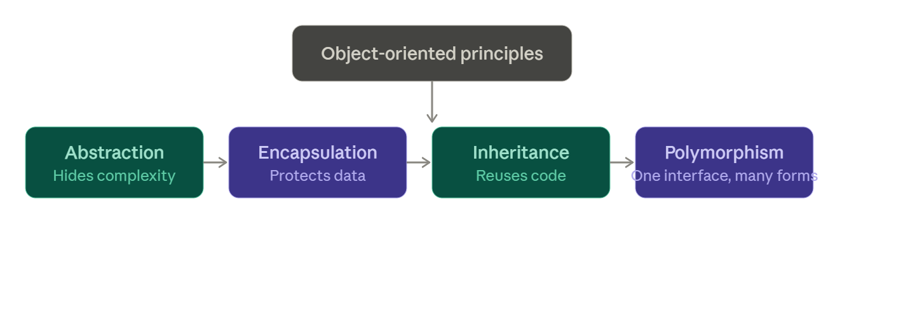

3. Construct a Concept Map
Given:
Class → Blueprint
Object → Instance
Method → ______
Attribute → ______
Answer:
The missing concepts are:
- Behavior
- State
Explanation:
- Methods define the behavior of objects.
- Attributes represent the state of objects.
Analysis:
- Helps model real-world entities.
- Defines object characteristics and actions.
- Improves system organization.
Diagram:
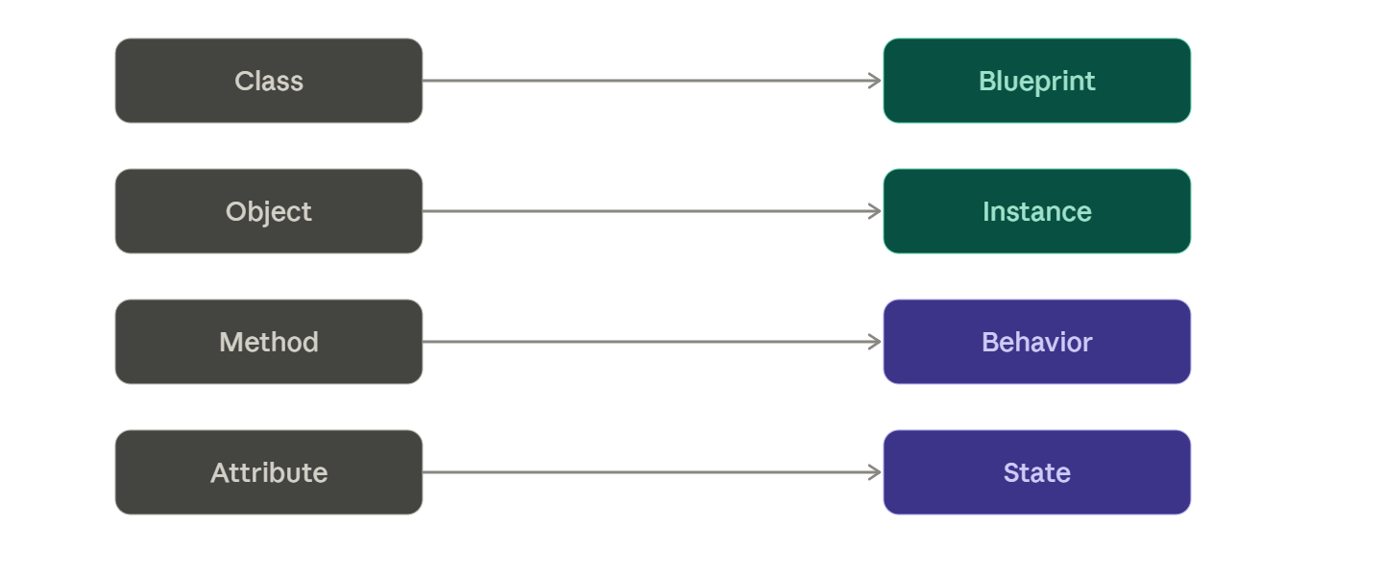

4. A Concept Map Shows
Given:
Software Quality
→ Reliability
→ ______
→ Maintainability
Answer:
The missing concept is:
- Usability
Explanation:
- Usability measures how easily users interact with software.
- Reliable software performs consistently.
- Maintainable software is easy to update.
Analysis:
- Improves user satisfaction.
- Enhances product acceptance.
- Contributes to software success.
Diagram:
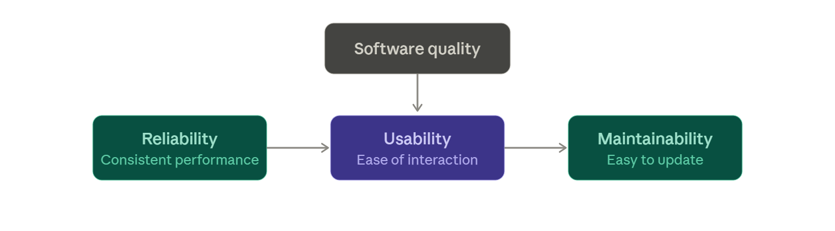

5. UML Concept Map
Given:
UML
→ Structural Diagrams → ______
→ Behavioral Diagrams → Activity Diagram
→ Interaction Diagrams → ______
Answer:
The missing concepts are:
- Object Diagram
- Communication Diagram
Explanation:
- Object diagrams represent object instances and relationships.
- Communication diagrams show message exchange among objects.
Analysis:
- Improves system visualization.
- Supports object-oriented analysis.
- Facilitates stakeholder communication.
Diagram:
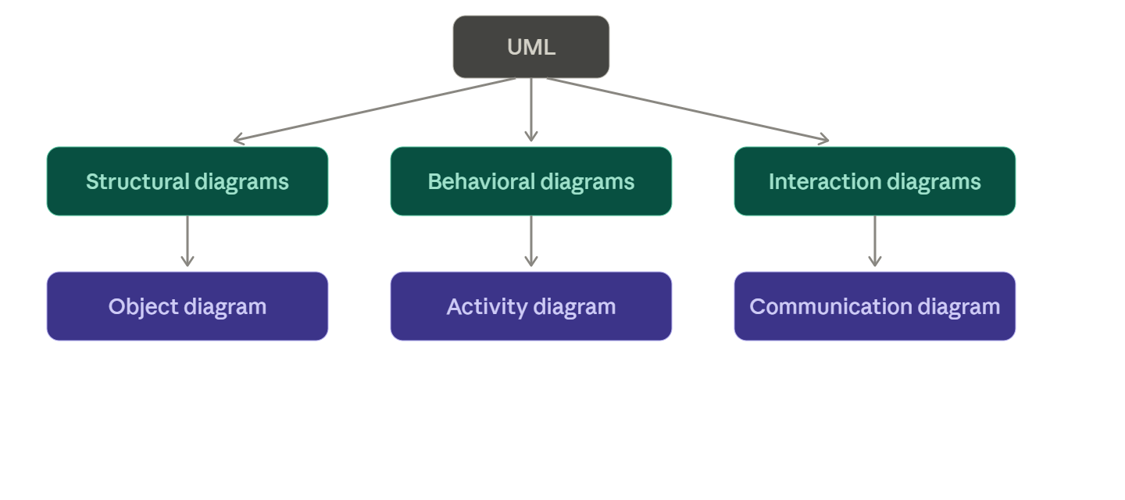

6. Given:
Requirements ✔ → Design ✔ → Coding ✖ → Testing ✖ → Deployment ✖
Explanation:
- Failure occurs during the Coding phase.
- Program logic contains implementation errors.
Analysis:
- Errors affect subsequent phases.
- Testing cannot proceed effectively.
- Software quality decreases.
Solution:
- Review source code.
- Apply coding standards.
- Conduct code inspections before testing.
Diagram:
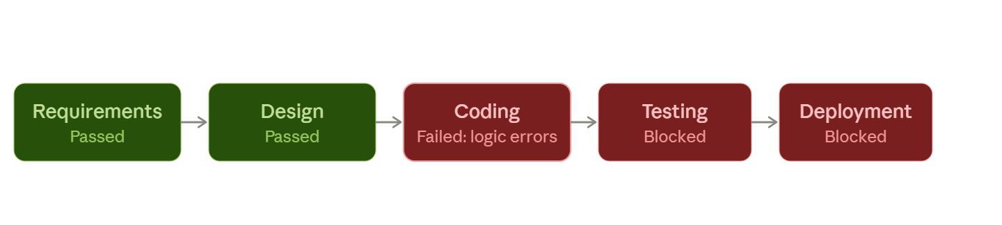

7. Construct a Concept Map
Given:
Problem Identification → ______ → Design → Implementation → ______
Answer:
The missing concepts are:
- Requirement Analysis
- Testing
Explanation:
- Requirement Analysis identifies user needs and system requirements.
- Testing verifies whether the implemented system meets the specified requirements.
Analysis:
- Improves software quality.
- Reduces development errors.
- Ensures successful project completion.
Diagram:
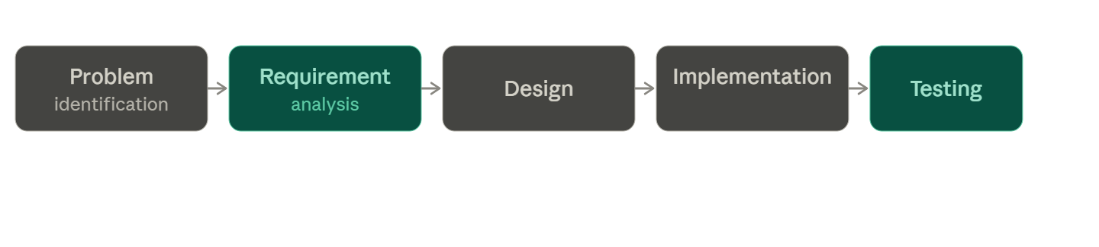

8. Construct a Concept Map
Given:
Object-Oriented Features
→ Class
→ ______
→ Message Passing
→ ______
Answer:
The missing concepts are:
- Object
- Dynamic Binding
Explanation:
- Objects are instances of classes.
- Dynamic binding allows method calls to be resolved at runtime.
Analysis:
- Supports flexibility in software design.
- Improves code maintainability.
- Enables runtime polymorphism.
Diagram:
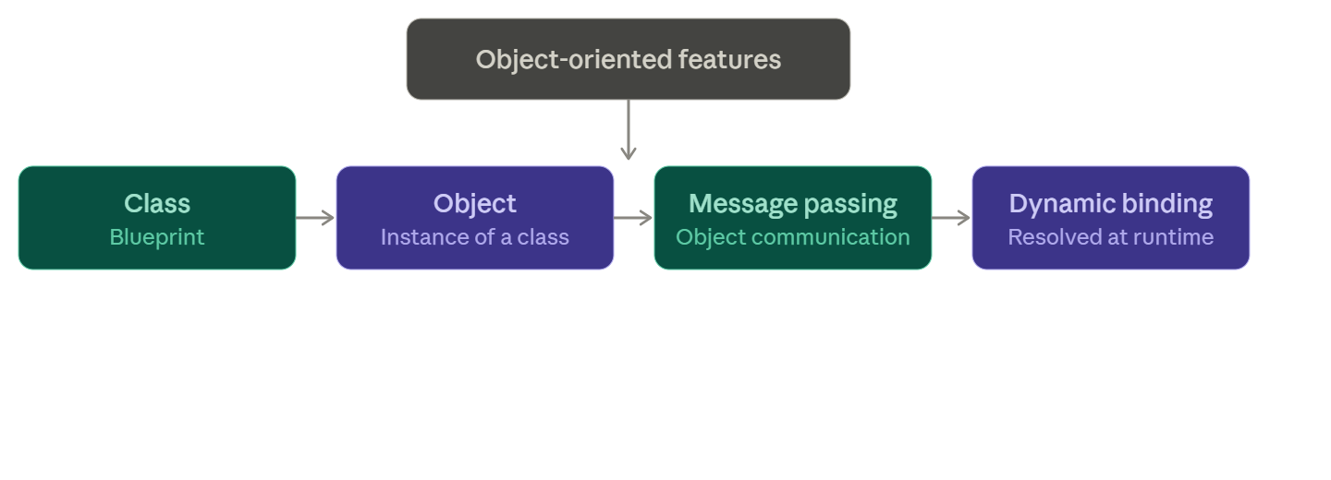

9. Construct a Concept Map
Given:
Software Development Models
→ Waterfall
→ ______
→ Spiral
→ ______
Answer:
The missing concepts are:
- Incremental Model
- Agile Model
Explanation:
- Incremental development delivers software in stages.
- Agile supports iterative development with continuous customer feedback.
Analysis:
- Enhances adaptability.
- Reduces project risks.
- Improves customer satisfaction.
Diagram:
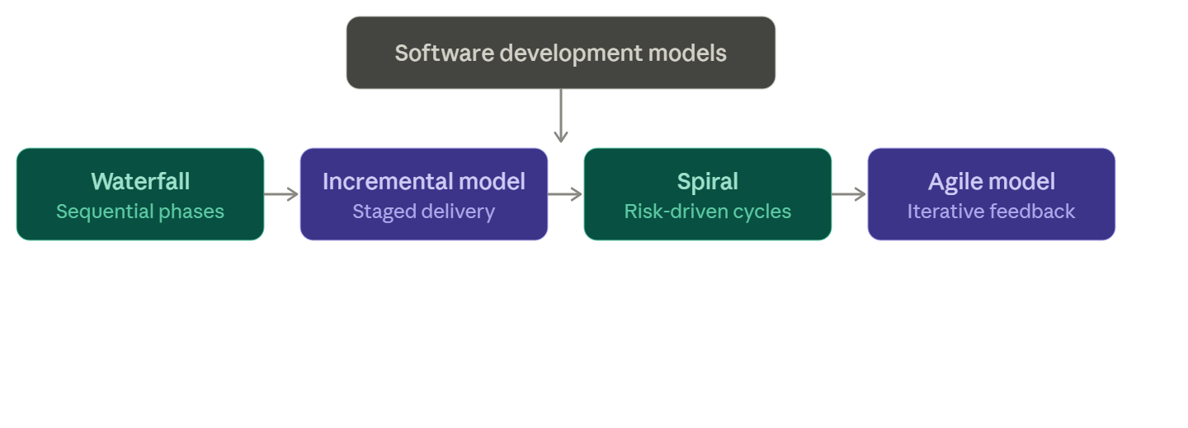

10. Construct a Concept Map
Given:
Class Diagram
→ Class
→ ______
→ Association
→ ______
Answer:
The missing concepts are:
- Attribute
- Method
Explanation:
- Attributes define the properties of a class.
- Methods define the operations performed by a class.
Analysis:
- Represents object structure effectively.
- Improves software documentation.
- Supports object-oriented design.
Diagram:
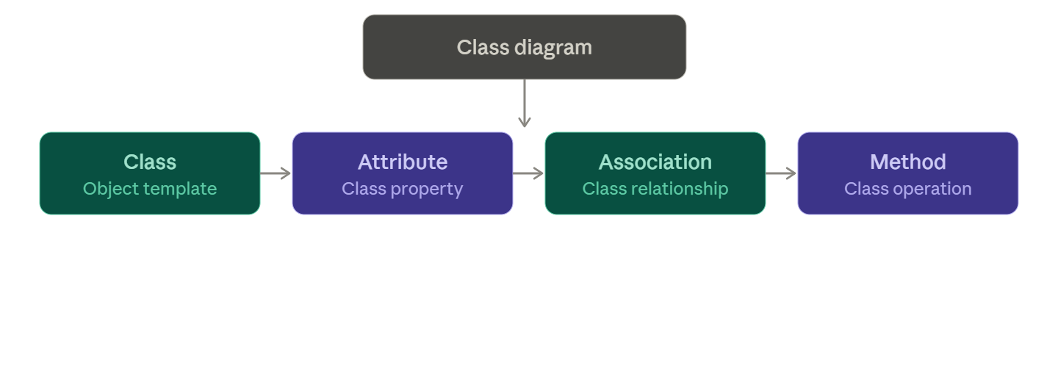

11. Construct a Concept Map
Given:
Software Engineering Principles
→ Modularity
→ ______
→ Reusability
→ ______
Answer:
The missing concepts are:
- Maintainability
- Scalability
Explanation:
- Maintainability simplifies software updates.
- Scalability enables systems to handle increased workload efficiently.
Analysis:
- Improves software performance.
- Reduces maintenance effort.
- Supports long-term software evolution.

Diagram:
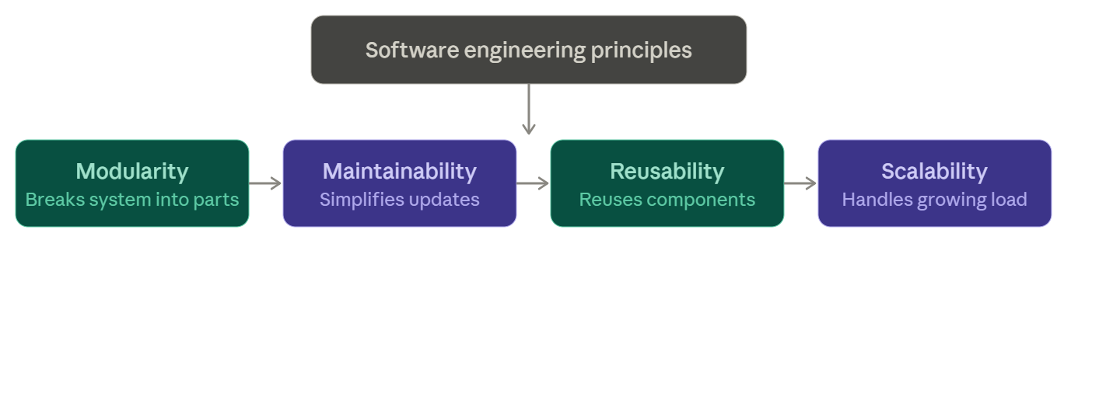

12. Given:
Requirement Analysis ✔ → System Design ✔ → Coding ✔ → Integration ✖ → Deployment ✖
Explanation:
- Failure occurs during the Integration phase.
- Individual modules fail to communicate correctly.
Analysis:
- Causes functional inconsistencies.
- Delays software deployment.
- Increases debugging effort.
Solution:
- Perform integration testing.
- Verify module interfaces.
- Resolve compatibility issues before deployment.
Diagram:
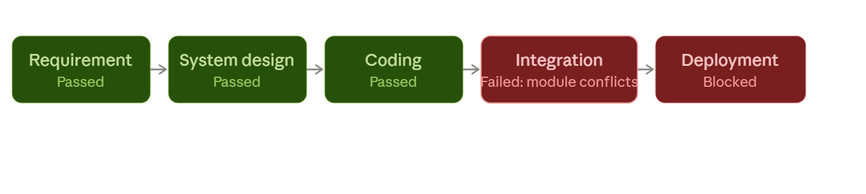

CONCEPT MAPPING

RUBRICS FOR CALCULATION

CONCEPT MAPPING

Criteria | Weightage | Level 4 (Exemplary) | Level 3 (Proficient) | Level 2 (Developing) | Level 1 (Beginning)
Concept Identification | 25% | Identifies all key concepts from literature accurately and comprehensively | Identifies most key concepts with minor omissions | Identifies limited concepts; some are irrelevant or missing | Fails to identify essential concepts
Linkages | 25% | Establishes clear, meaningful, and accurate relationships between concepts | Shows correct relationships with minor gaps | Relationships are weak, unclear, or partially incorrect | No meaningful relationships established
Organization | 20% | Concepts are well-structured hierarchically with logical flow and grouping | Mostly organized with minor structural issues | Some organization but lacks clear hierarchy | No logical organization or structure
Integration of Literature | 20% | Integrates multiple studies effectively to show connections and comparisons | Shows some integration of literature | Limited integration; mostly isolated concepts | No integration of literature evidence
Clarity | 10% | Concept map is clear, neat, visually structured, and easy to interpret | Generally clear with minor readability issues | Clarity is reduced; difficult to interpret in parts | Poorly presented and hard to understand

