SIMATS ENGINEERING
CSA_CO2_ASSIGNMENT TOOL 3

NAME:MOHAMED FASIL HAK.M
REG NO: 192524304
Scenario-Based Answers

1. Use Case Diagram – Smart Pharmacy Management System (5 Marks)
(a) Actors
- Customer
- Pharmacist
- Administrator
- Payment Gateway (External System)
(b) Use Cases
Customer
- Register/Login
- Search Medicines
- Upload Prescription
- Place Medicine Order
- Make Online Payment
- Track Order
Pharmacist
- Verify Prescription
- Dispense Medicine
- Update Order Status
Administrator
- Manage Inventory
- Manage User Accounts
- Generate Reports
Payment Gateway
- Process Payment
(c) Relationships
<>
- Place Order → Search Medicines
- Place Order → Upload Prescription (if prescription medicine)
- Place Order → Make Online Payment
- Make Online Payment → Process Payment
<>
- Verify Prescription → Place Order (only for prescription medicines)
- Track Order → Place Order
Generalization
- User
  - Customer
  - Pharmacist
  - Administrator
Use Case Diagram (Text Representation)
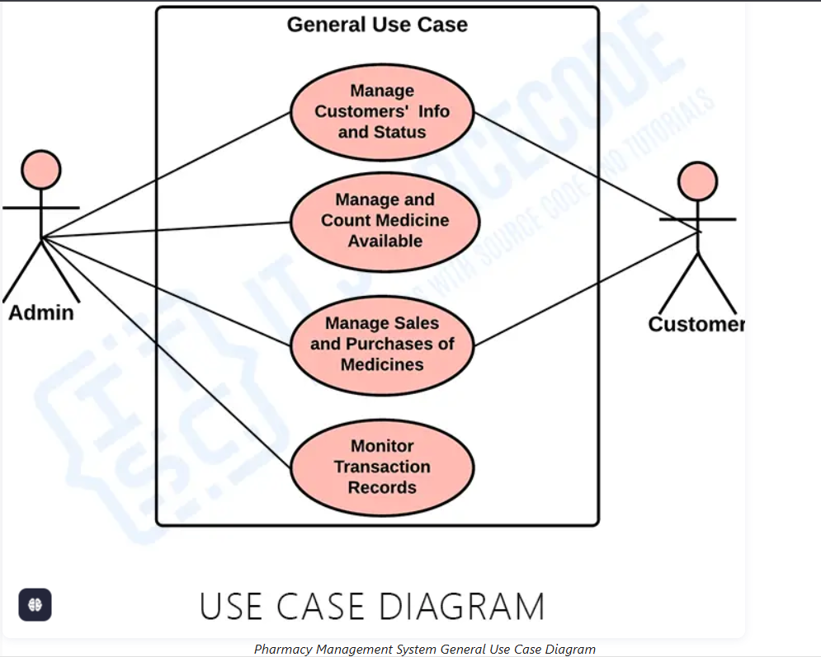

2. Class Diagram – Smart Hotel Management System
Classes
Guest
Attributes
- guestID
- name
- phone
- email
Methods
- bookRoom()
- cancelReservation()

Room
Attributes
- roomNo
- roomType
- price
- status
Methods
- checkAvailability()
- updateStatus()

Reservation
Attributes
- reservationID
- checkInDate
- checkOutDate
- status
Methods
- confirmReservation()
- cancelReservation()

Payment
Attributes
- paymentID
- amount
- paymentMethod
- paymentStatus
Methods
- makePayment()
- generateReceipt()

Receptionist
Attributes
- employeeID
- name
Methods
- assignRoom()
- checkInGuest()
- checkOutGuest()

Relationships
Relationship | Description
Guest — Reservation | Association (1 Guest → 0..* Reservations)
Reservation — Room | Association (1 Reservation → 1 Room)
Reservation ♦— Payment | Composition (Payment belongs to Reservation)
Hotel ◇— Room | Aggregation (Hotel contains Rooms)
Employee → Receptionist | Inheritance
Multiplicity
Guest 1 -------- 0..* Reservation

Reservation 1 -------- 1 Room

Reservation 1 ♦--------1 Payment

Hotel 1 ◇--------0..* Room

Employee
▲
Receptionist
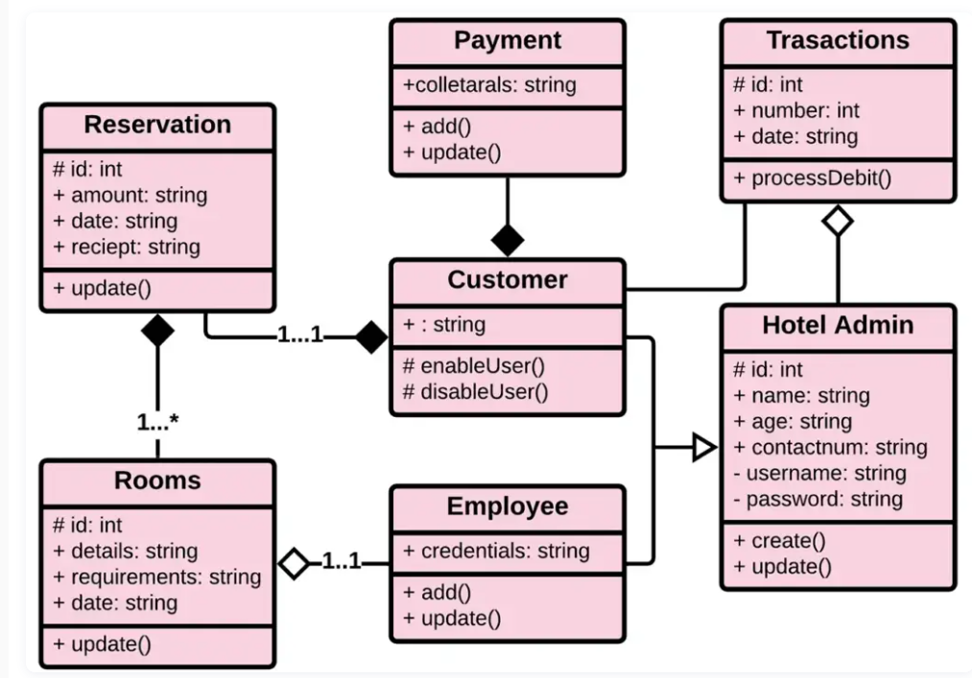

3. Sequence Diagram – Online Banking
Objects
- Customer
- Login Screen
- Authentication Service
- Banking Server
- Database
- OTP Service
Sequence
Customer
|
Login(username,password)
|
Login Screen
|
Authenticate()
|
Authentication Service
|
Check Credentials
|
Database
|
Credentials Valid
|
Authentication Service
|
Login Success
|
Customer
|
Transfer Funds
|
Banking Server
|
Generate OTP
|
OTP Service
|
Send OTP
|
Customer
|
Enter OTP
|
OTP Service
|
Verify OTP
|
Banking Server
|
Update Account
|
Database
|
Transaction Successful
|
Banking Server
|
Send Confirmation
|
Customer
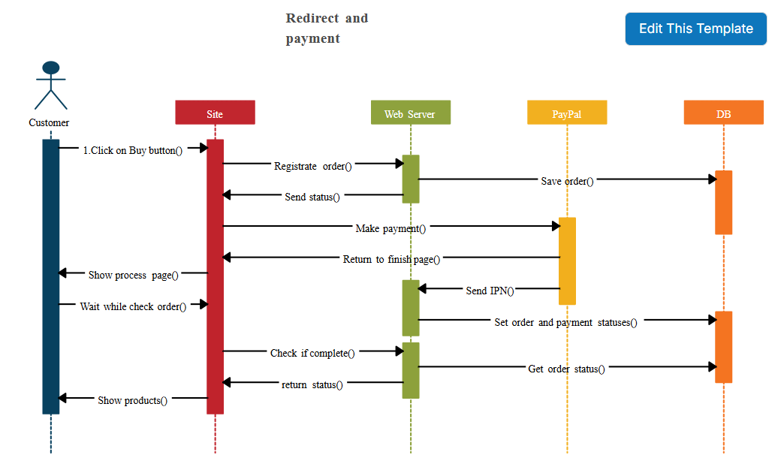

4. Activity Diagram – Passport Application System
Activity Flow
Start
|
Submit Application
|
Upload Documents
|
Fork
/ \
Identity Verification
Fee Payment
\ /
Join
|
Decision
Documents Valid?
/ \
Yes No
| |
Application Approved
| |
Passport Printed
| Notify Rejection
Passport Delivered
|
End
Decision Nodes
- Documents valid?
- Identity verified?
- Payment successful?
Parallel Activities
- Identity Verification
- Fee Payment

5. State Diagram – Smart Elevator Control System
States
- Idle
- Door Open
- Door Closed
- Moving Up
- Moving Down
- Emergency Stop
- Maintenance Mode
State Transitions
Start
|
Idle
|
Call Elevator
|
Door Open
|
Close Door
|
Door Closed

Door Closed
| |
Up Call Down Call
| |
Moving Up Moving Down

Moving Up
|
Destination Reached
|
Door Open

Moving Down
|
Destination Reached
|
Door Open

Any State
|
Emergency Button
|
Emergency Stop

Emergency Stop
|
Reset
|
Idle

Idle
|
Maintenance Request
|
Maintenance Mode
|
Maintenance Complete
|
Idle

6. Deployment Diagram – Smart Home Automation System
Hardware Nodes
- Smart Sensors
- IoT Controller
- Home Gateway
- Cloud Server
- Mobile Device
Software Artifacts
Smart Sensors
- Sensor Firmware
IoT Controller
- Device Control Software
Home Gateway
- Gateway Application
Cloud Server
- Cloud API
- Database
- Authentication Service
Mobile Device
- Smart Home Mobile App
Communication Links
+--------------------+
| Smart Sensors |
| Sensor Firmware |
+--------------------+
|
Wi-Fi/ZigBee
|
+--------------------+
| IoT Controller |
| Device Controller |
+--------------------+
|
Ethernet/Wi-Fi
|
+--------------------+
| Home Gateway |
| Gateway Software |
+--------------------+
|
Internet
|
+-------------------------------+
| Cloud Server |
| Cloud API |
| Database |
| Authentication Service |
+-------------------------------+
|
HTTPS
|
+--------------------+
| Mobile Application |
| Android/iOS App |
+--------------------+
Communication Channels
- Sensors ↔ IoT Controller (ZigBee/Wi-Fi/Bluetooth)
- IoT Controller ↔ Home Gateway (Wi-Fi/Ethernet)
- Home Gateway ↔ Cloud Server (Internet/HTTPS)
- Mobile App ↔ Cloud Server (HTTPS)
These diagrams satisfy the required UML concepts, including actors, classes, relationships, multiplicities, message flows, activity control, state transitions, and deployment architecture, making them suitable for 5-mark exam answers.

