SIMATS ENGINEERING
ASSESSMENT TOOL 2
Case study

COURSE NAME: OBJECT ORIENTED ANALYSIS AND DESIGN
COURSE CODE: CSA11

COURSE OUTCOME COVERED

CO3: Analyze system requirements using object-oriented techniques to identify classes, attributes, and relationships and develop use case models. (BL4)

Assessment Tool Weightage: 40%

Code of Conduct:

I Mohamed Fasil Hak.M/192524304 (Name / Reg No) certify that this submission is my original work and that I have adhered to the guidelines specified for this assessment.
I understand that any violation of academic integrity rules will result in disciplinary action.

Signature of the student:
Mohamed Fasil Hak.M

Case study

QUESTIONS: Any 4 Total Marks:40

1. Online Hotel Reservation System
A travel company plans to develop an online hotel reservation platform where customers can search hotels, book rooms, make payments, and provide reviews. Hotel managers can update room availability and pricing, while administrators manage users and transactions.
Question:
Analyze the system and explain how object-oriented principles (encapsulation, inheritance, polymorphism) can be applied. Also, suggest a suitable SDLC model and justify your choice for this system.

Answer:

Online Hotel Reservation System
System overview
The platform has four main actors: Customer (searches hotels, books rooms, pays, reviews), Hotel Manager (updates room availability and pricing), and Administrator (manages users and transactions). Core entities include Hotel, Room, Booking, Payment, and Review.

Applying object-oriented principles
Encapsulation
Each class hides its internal data and exposes only the operations needed by other parts of the system.
- A Room class keeps attributes like roomNumber, price, and availabilityStatus private, exposing only controlled methods such as checkAvailability() and updatePrice() — no external class can directly modify a room's price without going through validated logic.
- A Payment class encapsulates sensitive data (card number, transaction ID, billing details) behind a method like processPayment(), so payment details are never exposed to or manipulated by unrelated classes such as Review or Booking.
- This protects data integrity — e.g., a Customer object cannot directly set Room.price; only HotelManager.updatePricing() can.
Inheritance
A general User base class holds shared attributes and behavior (userId, name, email, login(), logout()). Specific roles inherit from it and extend it with their own responsibilities:
- Customer (inherits User) → adds searchHotel(), bookRoom(), makePayment(), writeReview()
- HotelManager (inherits User) → adds updateAvailability(), updatePricing()
- Administrator (inherits User) → adds manageUsers(), monitorTransactions()
This avoids duplicating common authentication and profile logic across three separate classes.
Polymorphism
A method like generateReport() or processRequest() can be called on any User object but produce role-specific behavior — calling it on a Customer object might generate a booking receipt, while calling it on a HotelManager object generates an occupancy/revenue report (method overriding). Similarly, a Payment base class could have subtypes CreditCardPayment, WalletPayment, and NetBankingPayment, each overriding a common pay() method with its own transaction logic — the booking module simply calls payment.pay() without needing to know which subtype it's dealing with.

Suggested SDLC model: Incremental/Iterative model
Justification:
- The system naturally decomposes into independent, deliverable modules — hotel search, room booking, payment processing, reviews, and admin management — which fits incremental delivery well: the core search-and-booking module can go live first while payment gateway integrations, the review system, and admin dashboards are added in subsequent increments.
- Requirements are likely to evolve (new payment providers, loyalty/discount schemes, additional filters for search) — the incremental model accommodates this without requiring a full redesign, unlike Waterfall.
- Early, working increments let the travel company gather real user feedback (e.g., from actual bookings) and adjust priorities before building out later features — valuable for a customer-facing commercial product where market fit matters.
- Compared to a full Spiral model, the risk profile here is moderate (no safety-critical or heavily regulated data), so the lighter overhead of Incremental/Agile-style delivery is more efficient than Spiral's formal risk-analysis cycles.

(10 Marks)

2. University Management System
A university intends to automate its operations including student admissions, course registration, examination management, and result processing. Different users such as students, faculty members, examination staff, and administrators interact with the system.
Question:
Design a structured approach using object-oriented concepts to model this system. Identify key classes and relationships, and recommend an SDLC model for efficient development with reasoning.

Answer: University Management System
System overview
Four user roles interact with the system: Student (admissions, course registration, results), Faculty (course management, grading), Examination Staff (exam scheduling, result processing), and Administrator (overall management). Core academic entities include Course, Registration, Examination, and Result.

Structured object-oriented design
Key classes:
Class | Attributes | Methods
Person (abstract base) | personId, name, contactInfo, email | login(), logout(), updateProfile()
Student (inherits Person) | admissionId, department, semester, admissionStatus | applyForAdmission(), registerCourse(), viewResults()
Faculty (inherits Person) | employeeId, department, designation | assignGrades(), manageCourseContent()
ExaminationStaff (inherits Person) | staffId | scheduleExam(), processResults(), publishResults()
Administrator (inherits Person) | adminId | manageAdmissions(), manageUsers(), generateReports()
Course | courseId, title, credits, department | getCourseDetails()
Registration | registrationId, studentId, courseId, semester, status | createRegistration(), cancelRegistration()
Examination | examId, courseId, date, venue | scheduleExam(), getExamDetails()
Result | resultId, studentId, examId, marks, grade | calculateGrade(), publishResult()
Key relationships:
- Student, Faculty, ExaminationStaff, and Administrator all inherit from Person (generalization) — shared login/profile behavior lives in one place.
- Registration is an association class connecting Student and Course (many-to-many: a student registers for many courses, a course has many students).
- Course has many Examinations (one course can have multiple exams — midterm, final, etc.).
- Result associates a Student with an Examination (each result record links one student's performance on one exam).
- Faculty is associated with Course (a faculty member teaches one or more courses).
Here's the structural view:
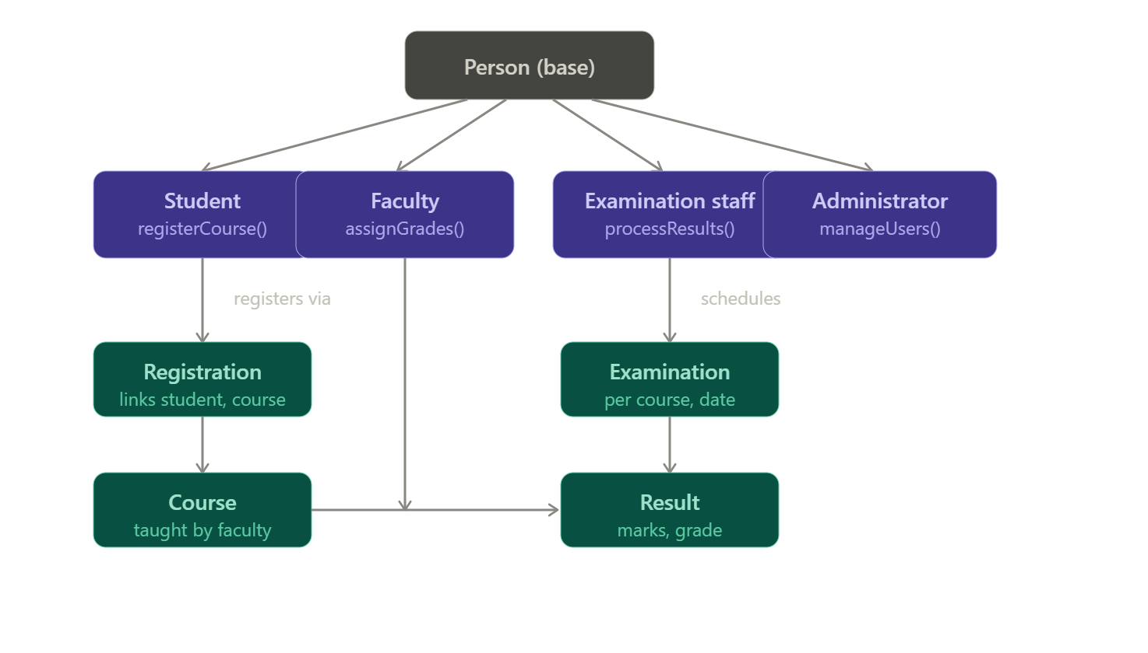

Recommended SDLC model: Spiral model
Justification:
- The university system spans several independent but interdependent modules — admissions, course registration, examination scheduling, and result processing — each carrying real risk if built incorrectly (e.g., incorrect grade calculation, duplicate registrations, exam scheduling conflicts).
- The spiral model's repeated risk analysis → prototype → build → evaluate cycles let the team tackle each module in turn (e.g., admissions first, then registration, then exams, then results), validating correctness and gathering stakeholder feedback before committing to the next phase — important since result-processing errors have direct academic and legal consequences.
- Requirements across departments (each with slightly different admission or grading rules) are likely to be refined as the system is prototyped and reviewed by faculty and administration, which spiral's iterative risk-driven approach accommodates better than a rigid Waterfall sequence.
(10 Marks)

3. Online Retail Shopping Platform
A retail company wants to develop an e-commerce platform where customers can browse products, place orders, track deliveries, and make online payments. Vendors manage product catalogs, while administrators monitor transactions and inventory.
Question:
Discuss how modular software design can be achieved using object-oriented techniques. Evaluate different SDLC models and select the most appropriate one for this scenario with justification.
Answer:

Online Retail Shopping Platform
System overview
Three actors: Customer (browses products, places orders, tracks deliveries, pays), Vendor (manages product catalogs), and Administrator (monitors transactions and inventory). Core entities: Product, Order, Payment, Delivery, Inventory.

Achieving modular design through object-oriented techniques
1. Encapsulation isolates modules Each functional area is wrapped into its own class with a clean, minimal interface — ShoppingCart exposes addItem()/removeItem(), Order exposes placeOrder()/cancelOrder(), Payment exposes processPayment(), Delivery exposes trackShipment(). Internal data (cart contents, payment credentials, shipment coordinates) stays hidden from unrelated modules. This means the payment module can be changed, upgraded, or replaced (e.g., adding a new gateway) without touching the ordering or delivery modules, since they only interact through defined method calls.
2. Inheritance reduces duplication across similar roles/entities A User base class holds shared behavior (login(), logout(), updateProfile()); Customer, Vendor, and Administrator inherit from it and add role-specific methods — Customer.trackDelivery(), Vendor.manageCatalog(), Administrator.monitorTransactions(). Similarly, a Product base class can be extended into Electronics, Clothing, Groceries, each adding category-specific attributes (warranty period, size chart, expiry date) while sharing common ones (productId, price, stockCount).
3. Polymorphism enables uniform handling of varied behavior The checkout module can call product.calculateShippingCost() or product.displayDetails() on any Product object without knowing its exact subtype — each subclass overrides the method with its own logic (e.g., groceries may have temperature-controlled shipping costs, electronics may have insurance costs). This lets the ordering and cart logic stay generic and category-agnostic even as new product types are added.
4. Composition/aggregation supports independent module evolution An Order is composed of multiple OrderItem objects (each referencing a Product and quantity), so the order-processing module doesn't need direct knowledge of catalog internals. Inventory aggregates Product stock records separately from the catalog-display logic, so stock management can scale or change independently of how products are presented to customers.
Together, these techniques mean each module — catalog, cart, checkout, payment, delivery tracking, inventory, admin dashboard — can be developed, tested, deployed, and modified largely independently, which is the essence of modular design.

Evaluating SDLC models
Model | Fit for this scenario
Waterfall | Poor — rigid sequential phases can't accommodate the fast-changing nature of e-commerce (new promotions, seasonal features, payment methods); no room for iteration once a phase closes.
Spiral | Reasonable for risk-heavy components (payment security) but adds process overhead not needed across the whole platform.
Incremental | Good — modules can be delivered in stages (catalog → cart → payment → delivery tracking → admin dashboard).
Agile (Scrum) | Best fit — see justification below.

Recommended SDLC model: Agile (Scrum)
Justification:
- E-commerce platforms face constantly evolving requirements — new product categories, seasonal promotions, changing payment providers, UI/UX experiments — which Agile's short sprints and continuous backlog reprioritization handle far better than a fixed upfront plan.
- Frequent releases let the company respond quickly to market feedback (e.g., adjusting checkout flow based on cart-abandonment data) and to vendor/administrator needs as they emerge.
- Different modules (catalog, checkout, delivery tracking, admin monitoring) can be assigned to separate sprint teams and developed in parallel, aligning naturally with the object-oriented modular design described above — each sprint can deliver a working increment of one module.
- Continuous stakeholder involvement (retail company, vendors) throughout sprints ensures the evolving product catalog and transaction-monitoring needs are captured early rather than discovered late, reducing costly rework.
- Compared to Spiral, Agile's lighter-weight iteration suits a commercial platform prioritizing speed-to-market and continuous feature delivery over formal risk-analysis documentation at every cycle.

(10 Marks)

4. Smart Waste Management System
A municipality introduces a smart waste management system where IoT-enabled bins monitor waste levels and automatically notify collection vehicles when bins are full. Citizens can also report waste-related issues through a mobile application.
Question:
Apply object-oriented system development principles to design this system. Identify the life cycle model best suited for handling real-time data, sensor integration, and evolving requirements, and explain why.

Answer: Smart Waste Management System
System overview
Key participants: IoT-enabled bins (monitor waste levels via sensors), Collection vehicles (receive notifications, collect waste), Citizens (report issues via mobile app), and Municipal administrators (oversee the system).

Applying object-oriented system development principles
Key classes:
Class | Attributes | Methods
Bin | binId, location, currentLevel, capacity | checkLevel(), sendAlert(), isFull()
Sensor (base) | sensorId, reading, calibrationDate | captureData(), calibrate()
WeightSensor (inherits Sensor) | maxWeight | captureData() (overridden)
UltrasonicLevelSensor (inherits Sensor) | distanceReading | captureData() (overridden)
CollectionVehicle | vehicleId, route, capacity | receiveNotification(), updateRoute(), collectWaste()
Citizen | citizenId, name, contact | reportIssue(), viewReportStatus()
MunicipalAdmin | adminId | monitorSystem(), assignVehicle(), generateReports()
IssueReport | reportId, citizenId, binId, description, status, timestamp | submitReport(), updateStatus()
Applying OOP concepts:
- Encapsulation: Bin hides raw sensor data and internal thresholds — external systems (vehicles, admin dashboards) only see high-level status through methods like isFull() or getFillLevel(), never raw voltage/distance readings. This protects the integrity of sensor calibration logic from being tampered with by unrelated modules.
- Inheritance: A general Sensor base class defines a common interface (captureData(), calibrate()), while WeightSensor, UltrasonicLevelSensor, and potentially OdorSensor extend it — each implementing its own data-capture logic while sharing common calibration and reporting behavior. Similarly, MunicipalAdmin and other system users can inherit from a common SystemUser base class for shared authentication logic.
- Polymorphism: A single notify() call behaves differently depending on the calling object — a Bin reaching capacity calls notify() to alert the nearest CollectionVehicle (triggering a route update), while a Citizen's IssueReport calls notify() to alert MunicipalAdmin (triggering a maintenance ticket). The system code that dispatches notifications doesn't need to know which specific type of notification it's handling.
- Association/composition: Bin "has-a" Sensor (composition — the sensor is integral to the bin and doesn't exist independently of it); CollectionVehicle is associated with multiple Bins along its assigned route; Citizen submits many IssueReports, each optionally linked to a specific Bin.
Here's how these pieces fit together structurally:
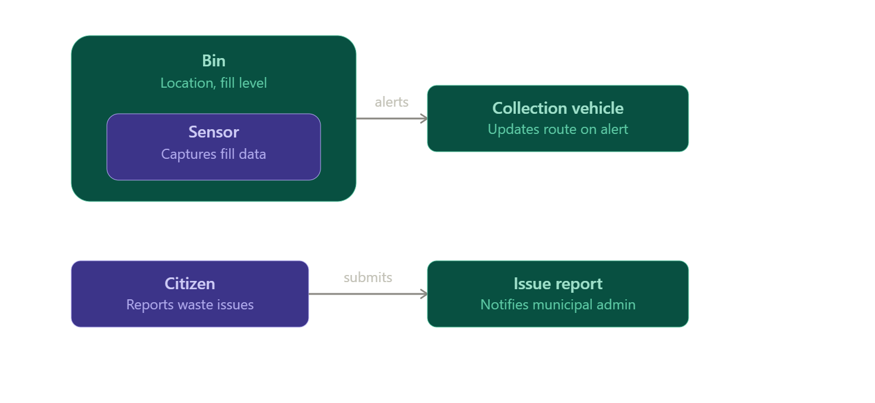
Justification:
This system involves three sources of significant uncertainty and risk, which the spiral model is specifically designed to manage through repeated risk-analysis cycles:
- Real-time data handling: Sensor readings must be processed continuously and reliably; the reliability, accuracy, and latency of this pipeline are technically risky and need to be prototyped and validated before full deployment — exactly what spiral's "identify and resolve risk" phase supports.
- Hardware/sensor integration: IoT sensors (weight, ultrasonic level) involve physical hardware testing in real field conditions (weather, bin damage, connectivity gaps) — issues that only surface through iterative prototyping and testing cycles, not through upfront design alone.
- Evolving requirements: As the system is piloted (e.g., in one neighborhood first), municipal administrators and citizens will likely request changes — different alert thresholds, new issue categories in the reporting app, additional sensor types — which spiral's incremental, risk-reviewed iterations can absorb without derailing the whole project.
(10 Marks)

RUBRICS FOR CALCULATION:

Case study

Criteria | Weightage | Level 4 – Exemplary | Level 3 – Proficient | Level 2 – Developing | Level 1 – Beginning
Understanding of Case | 25 | Thorough understanding; clearly identifies all key issues | Good understanding with most issues identified | Basic understanding; some issues missed | Poor understanding; problem not identified correctly
Application of Concepts | 25 | Effectively applies relevant concepts to analyze the case deeply | Applies appropriate concepts with minor gaps | Limited application of concepts | Fails to apply relevant concepts
Analysis | 20 | In-depth analysis with strong reasoning and insights | Good analysis with logical reasoning | Basic analysis with limited depth | Weak or no analysis; lacks reasoning
Solution Design | 20 | Innovative, feasible solutions with strong justification | Logical solutions with adequate justification | Basic solutions with weak justification | Incorrect or no solution provided
Clarity | 10 | Clear, well-structured, and easy to understand | Organized and understandable presentation | Limited clarity and structure | Poor clarity; difficult to understand

