SIMATS ENGINEERING
ASSESSMENT TOOL 1
Experiments

COURSE NAME: OBJECT ORIENTED ANALYSIS AND DESIGN
COURSE CODE: CSA11

COURSE OUTCOME COVERED

CO3: Analyze system requirements using object-oriented techniques to identify classes, attributes, and relationships and develop use case models. (BL4)

Assessment Tool Weightage: 40%

QUESTIONS:4 Total Marks:40

- Develop a system using UML for implementing the Book Bank process. It should verify the details of the student by the central computer. The details regarding the student will be provided to the central computer through the administrator in the book bank and the computer will verify the details of the student and provide approval to the office. Then the books that are needed by the student will issue from the office to him.

Book Bank Management System – UML Design
The Book Bank process involves four participants: the Student (submits details, receives books), the Administrator (collects student details, forwards them to the system, and later issues books), the Central Computer (verifies student eligibility), and the Office (approves and physically issues books). Below are the four standard UML views for this system.

1. Use Case Diagram
Actors: Student, Administrator, Central Computer, Office Staff
Use Cases:
- Submit Student Details (Student → Administrator)
- Forward Details for Verification (Administrator → Central Computer)
- Verify Student Details (Central Computer)
- Send Approval Status (Central Computer → Office)
- Request Books (Student → Office)
- Issue Books (Office → Student)
- Update Book Bank Records (Office/Central Computer)

2. Class Diagram
Class | Attributes | Methods
Student | studentId, name, department, semester | submitDetails(), requestBooks()
Administrator | AdminId, name | collectDetails(), forwardToCentralComputer()
CentralComputer | recordDatabase | verifyDetails(), sendApproval()
Office | officeId, staffName | receiveApproval(), issueBooks(), maintainStock()
Book | bookId, title, author, isbn, status | checkAvailability()
BookBankRecord | recordId, studentId, bookId, issueDate, dueDate | createRecord(), closeRecord()

3. Sequence Diagram (message flow)
- Student → Administrator : submitDetails()
- Administrator → CentralComputer : forwardDetails(studentInfo)
- CentralComputer → CentralComputer : verifyDetails()
- CentralComputer → Administrator : verificationResult()
- Administrator → Office : forwardApproval()
- Student → Office : requestBooks(bookList)
- Office → Office : checkAvailability()
- Office → Student : issueBooks()
- Office → CentralComputer : updateRecord()
4. Activity Diagram (process flow)
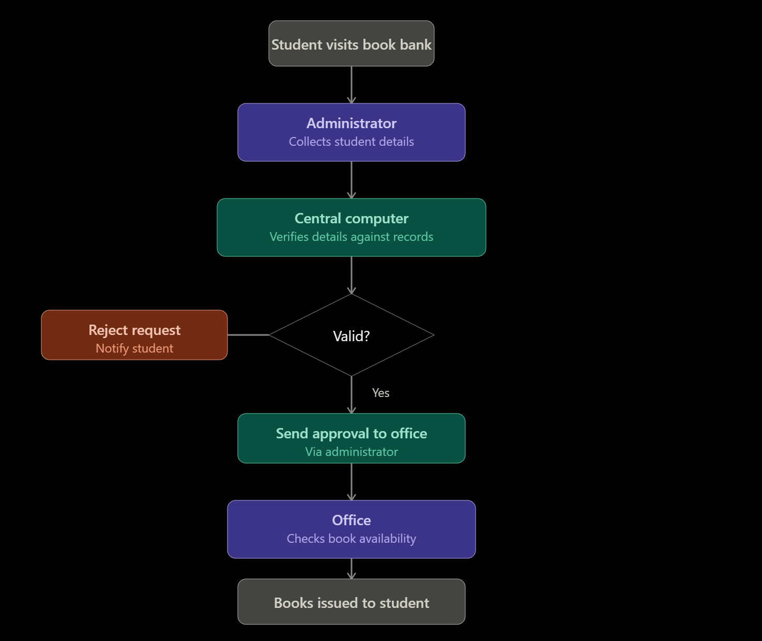

Summary of the workflow:
- The student visits the book bank and provides their details to the administrator.
- The administrator forwards these details to the central computer.
- The central computer verifies the details against its database — if invalid, the request is rejected and the student is notified; if valid, it approves the request.
- Approval is sent to the office.
- The office checks availability and issues the requested books to the student, and a record is created linking the student, books, and issue date.

- Develop a system using UML for implementing the Exam Registration Portal. It should verify the details of the candidate by the central computer. The details regarding the candidate will be provided to the central computer through the administrator and the computer will verify the details of the candidate and provide approval. Then the hall ticket will be issued from the office to the candidate.

Exam Registration Portal – UML Design
This system follows the same verification-and-approval pattern as the book bank, but here the outcome is a hall ticket rather than books. Participants: Candidate (submits details), Administrator (relays details), Central Computer (verifies eligibility), Office (issues the hall ticket).

1. Use Case Diagram
Actors: Candidate, Administrator, Central Computer, Office Staff
Use Cases:
- Submit Candidate Details (Candidate → Administrator)
- Forward Details for Verification (Administrator → Central Computer)
- Verify Candidate Eligibility (Central Computer) — checks fee payment, attendance/eligibility criteria, exam registration status
- Send Approval Status (Central Computer → Office)
- Generate Hall Ticket (Office)
- Issue Hall Ticket (Office → Candidate)
- Reject/Notify Ineligible Candidate (Central Computer → Administrator → Candidate)

2. Class Diagram
Class | Attributes | Methods
Candidate | candidateId, name, course, semester, examsRegistered | submitDetails(), collectHallTicket()
Administrator | adminId, name | collectDetails(), forwardToCentralComputer()
CentralComputer | eligibilityDatabase | verifyEligibility(), checkFeeStatus(), sendApproval()
Office | officeId, staffName | receiveApproval(), generateHallTicket(), issueHallTicket()
Exam | examId, subject, date, venue | getExamDetails()
HallTicket | ticketId, candidateId, examId, seatNumber, issueDate | printTicket()

3. Sequence Diagram (message flow)
- Candidate → Administrator : submitDetails()
- Administrator → CentralComputer : forwardDetails(candidateInfo)
- CentralComputer → CentralComputer : verifyEligibility()
- CentralComputer → Administrator : verificationResult()
- Administrator → Office : forwardApproval()
- Office → Office : generateHallTicket(candidateId, examId)
- Office → Candidate : issueHallTicket()
- Office → CentralComputer : updateRegistrationStatus()
4. Activity Diagram (process flow)
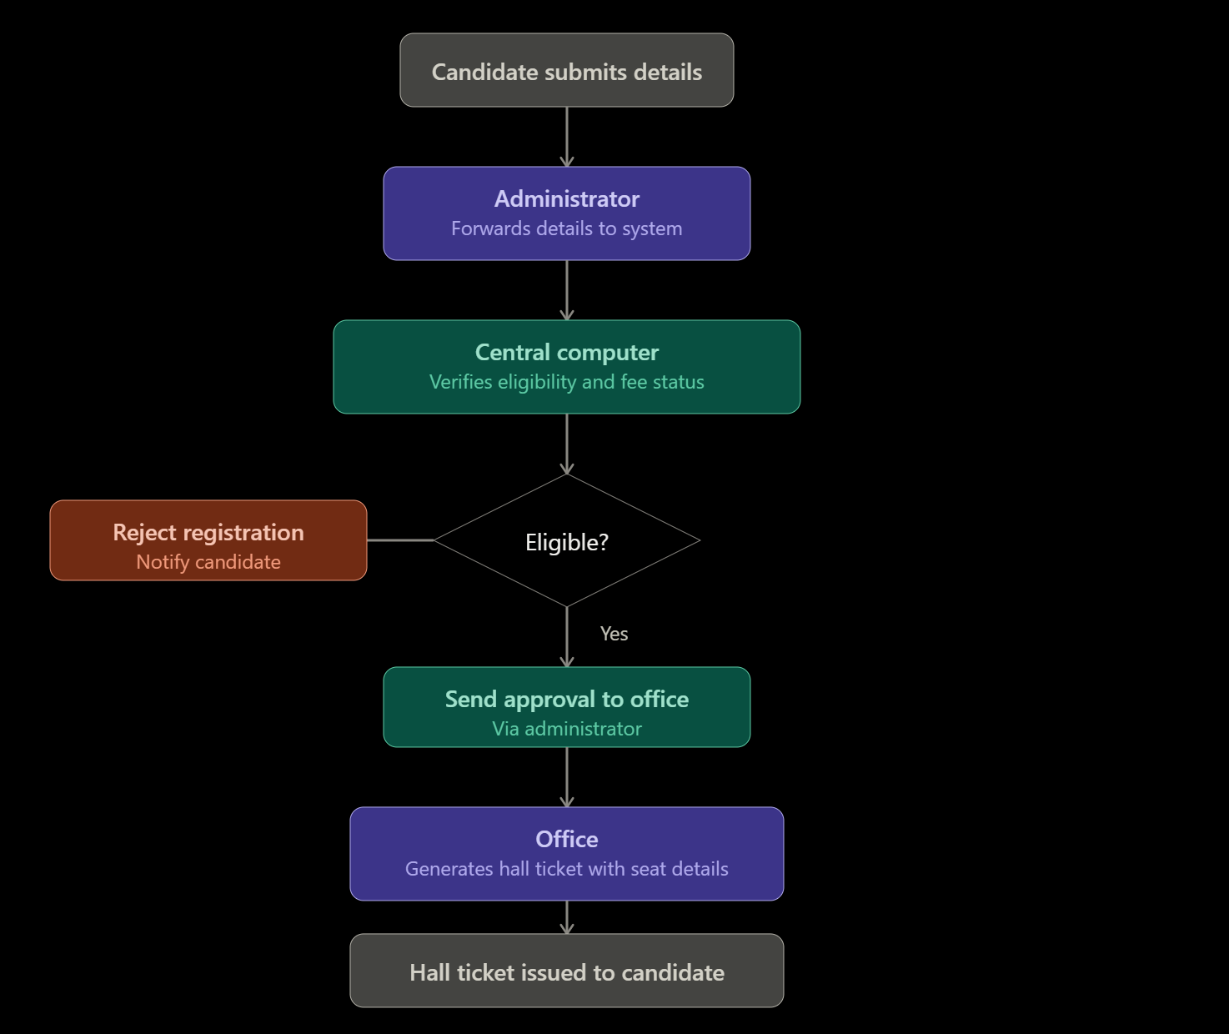
Summary of the workflow:
- The candidate submits registration details to the administrator.
- The administrator forwards them to the central computer.
- The central computer checks eligibility (fee payment, attendance, prerequisite criteria) — if ineligible, it rejects and notifies the candidate; if eligible, it approves.
- Approval reaches the office.
- The office generates a hall ticket (with seat number, exam date, and venue) and issues it to the candidate.

- Develop a system using UML for implementing Stock Maintenance System. In this system, the customer can place orders and purchase items with the aid of the stock dealer and central stock system. These orders are verified and the items are delivered to the customer. Then the stock details are to be updated accordingly.

Stock Maintenance System – UML Design
This system differs slightly from the previous two: here there's a feedback loop — after delivery, stock levels must be updated, which affects future order verification. Participants: Customer (places orders), Stock Dealer (intermediary who takes orders and coordinates delivery), Central Stock System (verifies stock availability and maintains inventory).

1. Use Case Diagram
Actors: Customer, Stock Dealer, Central Stock System
Use Cases:
- Place Order (Customer → Stock Dealer)
- Forward Order for Verification (Stock Dealer → Central Stock System)
- Verify Stock Availability (Central Stock System)
- Approve/Reject Order (Central Stock System → Stock Dealer)
- Deliver Items (Stock Dealer → Customer)
- Update Stock Details (Central Stock System)
- Generate Stock Report (Central Stock System)

2. Class Diagram
Class | Attributes | Methods
Customer | customerId, name, address, contactNo | placeOrder(), receiveItems()
StockDealer | dealerId, name | takeOrder(), forwardOrder(), deliverItems()
CentralStockSystem | stockDatabase | verifyAvailability(), approveOrder(), updateStock()
Order | orderId, customerId, itemList, orderDate, status | calculateTotal(), checkStatus()
Item | itemId, itemName, price, quantityInStock | checkStock(), reduceStock()
StockRecord | recordId, itemId, quantityChanged, date, type(in/out) | logTransaction()

3. Sequence Diagram (message flow)
- Customer → StockDealer : placeOrder(itemList)
- StockDealer → CentralStockSystem : forwardOrder(orderDetails)
- CentralStockSystem → CentralStockSystem : verifyStockAvailability()
- CentralStockSystem → StockDealer : approvalStatus()
- StockDealer → Customer : deliverItems()
- StockDealer → CentralStockSystem : confirmDelivery()
- CentralStockSystem → CentralStockSystem : updateStockDetails()
- CentralStockSystem → StockDealer : updatedStockConfirmation()
4.Activity Diagram (process flow, including the update loop)
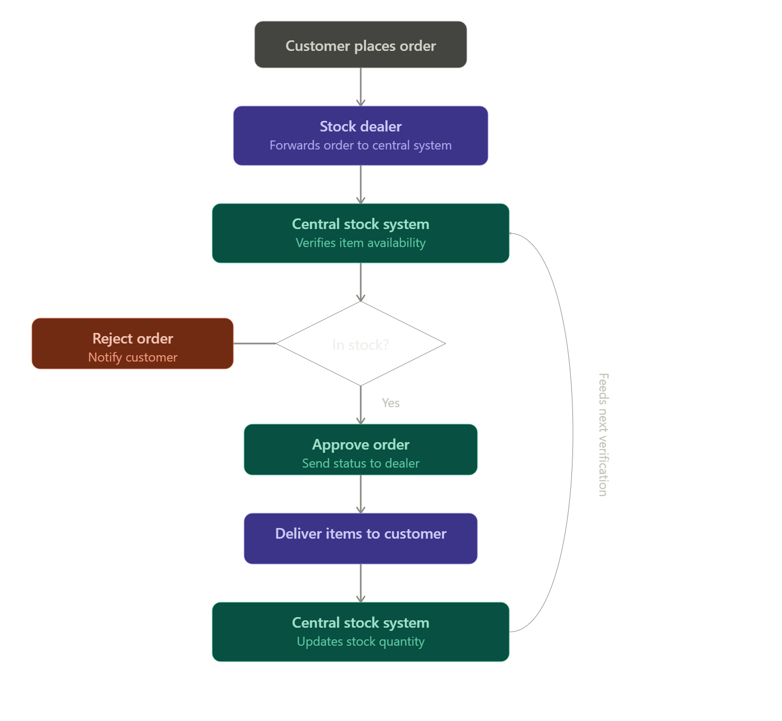

- Develop a system using UML for implementing Online Course Reservation System. This system is organized by the central management system. The student first browses and selects the desired course of their choice. The university then checks the availability of the seat if it is available the student is enrolled for the course.

Online Course Reservation System – UML Design
Participants here: Student (browses and selects courses), Central Management System (the platform that organizes course listings and coordinates the process), and University (checks seat availability and confirms enrollment).

1. Use Case Diagram
Actors: Student, Central Management System, University
Use Cases:
- Browse Courses (Student)
- Select Course (Student)
- Submit Reservation Request (Student → Central Management System)
- Check Seat Availability (Central Management System → University)
- Confirm/Reject Enrollment (University)
- Enroll Student in Course (Central Management System)
- View Enrollment Status (Student)
- Update Course Seat Count (University)

2. Class Diagram
Class | Attributes | Methods
Student | studentId, name, department, semester | browseCourses(), selectCourse(), viewStatus()
CentralManagementSystem | courseDatabase | listCourses(), submitRequest(), notifyStudent()
University | universityId, name | checkSeatAvailability(), confirmEnrollment(), updateSeatCount()
Course | courseId, title, instructor, credits, totalSeats, seatsAvailable | checkAvailability(), reduceSeat()
Reservation | reservationId, studentId, courseId, requestDate, status | createReservation(), updateStatus()
Relationships: Student (1) — browses → Course (many); Student (1) — makes → Reservation (many); Reservation — references → Course; CentralManagementSystem — coordinates between Student and University; University — manages → Course (updates seat counts).

3. Sequence Diagram (message flow)
- Student → CentralManagementSystem : browseCourses()
- Student → CentralManagementSystem : selectCourse(courseId)
- CentralManagementSystem → University : checkSeatAvailability(courseId)
- University → University : checkSeatAvailability()
- University → CentralManagementSystem : availabilityResult()
- CentralManagementSystem → University : enrollStudent(studentId, courseId) (if available)
- University → University : updateSeatCount()
- University → CentralManagementSystem : enrollmentConfirmed()
- CentralManagementSystem → Student : notifyEnrollmentStatus()

4. Activity Diagram (process flow)
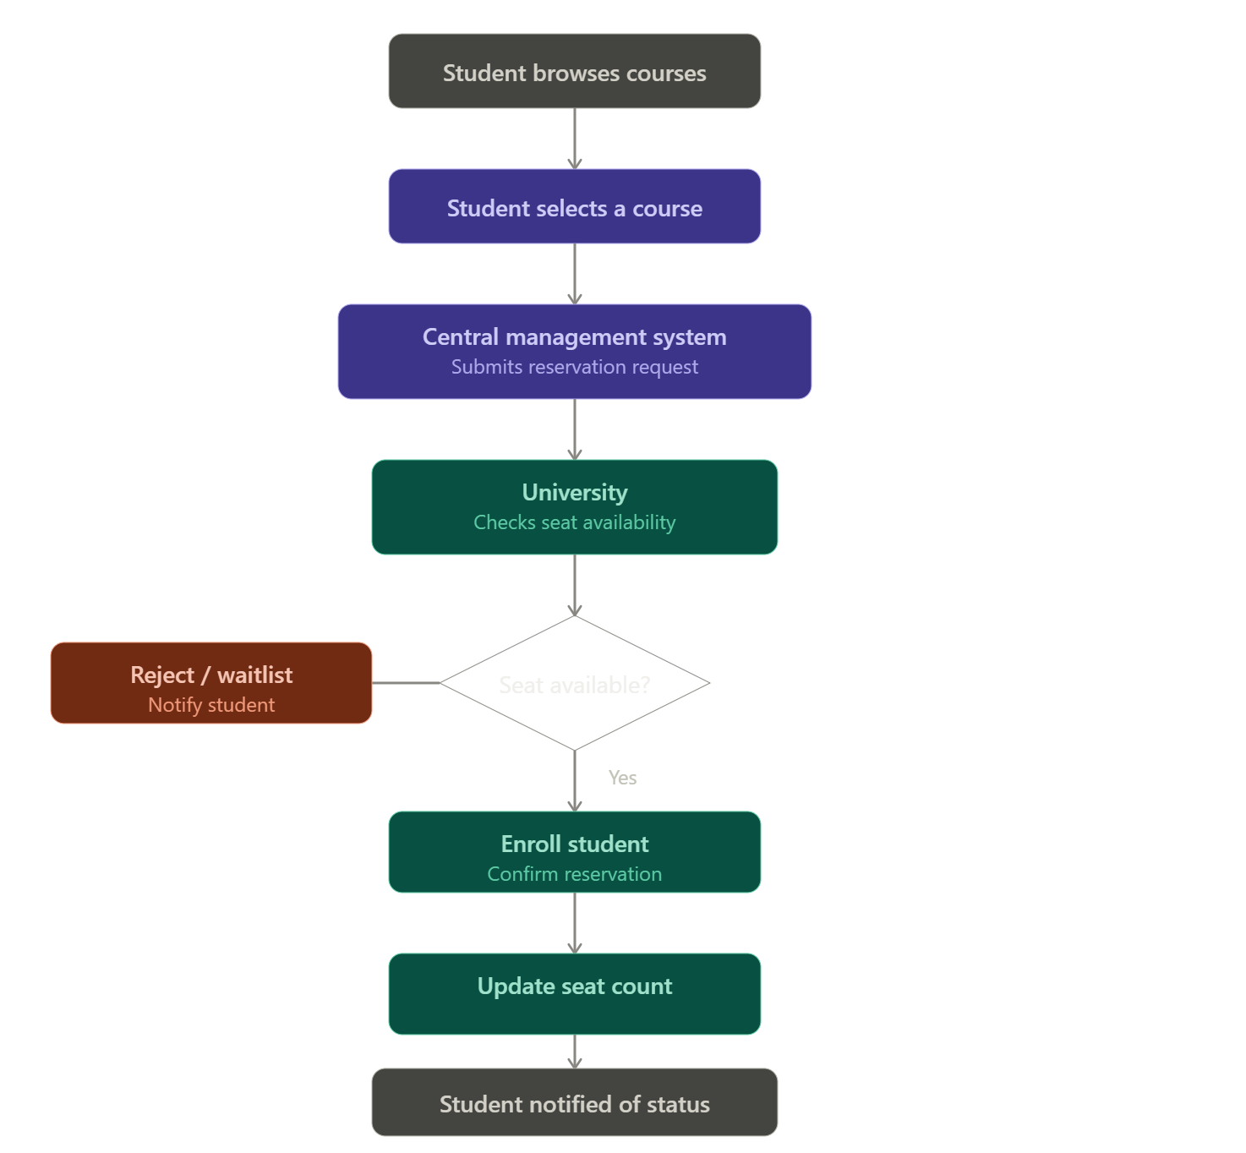

Code of Conduct:
I Mohamed Fasil Hak.M/192524304 (Name / Reg No) certify that this submission is my original work and that I have adhered to the guidelines specified for this assessment.
I understand that any violation of academic integrity rules will result in disciplinary action.
Signature of the student:
Mohamed Fasil Hak.M

RUBRICS FOR CALCULATION:

Experiments

Criteria | Weightage | Level 4 – Exemplary | Level 3 – Proficient | Level 2 – Developing | Level 1 – Beginning
Understanding of Concepts | 25 | Demonstrates thorough understanding and effectively integrates multiple concepts/technologies | Good understanding with proper integration of most concepts | Basic understanding; limited or partial integration | Poor understanding; unable to integrate concepts
Experimental Design | 30 | Well-planned, systematic implementation with optimal solution | Correct implementation with minor issues | Basic implementation with errors or inefficiencies | Incorrect or incomplete implementation
Use of Tools | 20 | Effective and advanced use of tools/technologies with proper configuration | Appropriate use of tools with correct execution | Limited or inconsistent use of tools | Incorrect or minimal use of tools
Analysis of Results | 15 | Insightful analysis with accurate interpretation and validation of results | Good analysis with reasonable interpretation | Basic analysis with limited insights | Poor or incorrect analysis of results
Documentation | 10 | Clear, well-structured documentation with diagrams, code, and results | Organized documentation with necessary details | Basic documentation with missing details | Poor or incomplete documentation

