SIMATS ENGINEERING
ASSESSMENT TOOL 1

COURSE CODE: CSA14 COURSE NAME: COMPILER DESIGN

COURSE OUTCOME COVERED

CO3: Analyze syntax-directed translation method using synthesized and inherited attributes to generate a Parser Tree. (BL4)

Assessment Tool Weightage: 40%

QUESTIONS:5 Total Marks:100

Annexure A

EXPERIMENTS

Code of Conduct:

I Sabith .K(192524308)_ (Name / Reg No) certify that this submission is my original work and that I have adhered to the guidelines specified for this assessment.
I understand that any violation of academic integrity rules will result in disciplinary action.

Signature of the student:

Annexure A

EXPERIMENTS

Q1.You are developing a compiler-based desk calculator that evaluates arithmetic expressions using syntax-directed definitions (SDD).
The system should:
(i) Accept an arithmetic expression with operators +, -, *, / and parentheses
(ii) Use syntax-directed evaluation to compute values based on operator precedence
(iii) Optimize evaluation by reducing unnecessary temporary computations
(iv) Display the final result of the expression
Demonstrate how SDD rules (synthesized attributes) are used for expression evaluation.
SDD
Grammar with semantic rules:
E → E + T { E.val = E1.val + T.val }
E → E - T { E.val = E1.val - T.val }
E → T { E.val = T.val }
T → T * F { T.val = T1.val * F.val }
T → T / F { T.val = T1.val / F.val }
T → F { T.val = F.val }
F → (E) { F.val = E.val }
F → digit { F.val = digit }

Q2. In a compiler, postfix expressions are evaluated during code generation using stack-based bottom-up evaluation.
Write a C program that:
(i) Evaluates a postfix expression
(ii) Demonstrates S-attributed definition evaluation
(iii) Shows how intermediate results are computed

Q3.You are designing a parser that uses L-attributed definitions, where inherited attributes are passed from parent to child.
Write a C program that:
(i).Evaluates a simple expression like a + b * c
(ii) Uses function parameters to simulate inherited attributes
(iii). Ensures correct precedence handling
(iv). Demonstrates top-down evaluation logic
Explain how inherited attributes influence computation.

Q4.In a compiler, it is important to check whether two type expressions are equivalent.
Write a C program that:
(i).Accepts two type expressions (e.g., int, float, int*)
(ii).Compares them for type equivalence
(iii).Displays whether they are:
(a).Equivalent
(b).Not equivalent
Extend the logic to handle pointer types (int*, float*).

Q5.You are building a semantic analyzer that detects type errors in arithmetic expressions.
Write a C program that:
(i). Accepts two operands and their types
(ii). Checks whether the operation (e.g., +, *) is valid
(iii). Reports:
(a).Valid expression
(b).Type error (e.g., int + char*)
Demonstrate how compilers detect semantic errors during type checking

CODE AND OUTPUT
#include <stdio.h>
#include <ctype.h>

char expr[100];
int pos = 0;

/* E -> T { (+|-) T } */
double E();

/* T -> F { (*|/) F } */
double T();

/* F -> (E) | digit */
double F()
{
double value;

if (expr[pos] == '(')
{
pos++;
value = E();

if (expr[pos] == ')')
pos++;
}
else
{
value = expr[pos] - '0';
pos++;
}

return value;
}

double T()
{
double value = F();

while (expr[pos] == '*' || expr[pos] == '/')
{
char op = expr[pos++];
double right = F();

if (op == '*')
value = value * right;
else
value = value / right;
}

return value;
}

double E()
{
double value = T();

while (expr[pos] == '+' || expr[pos] == '-')
{
char op = expr[pos++];
double right = T();

if (op == '+')
value = value + right;
else
value = value - right;
}

return value;
}

int main()
{
printf("Enter arithmetic expression: ");
scanf("%s", expr);

printf("Final Result = %.2lf\n", E());

return 0;
}
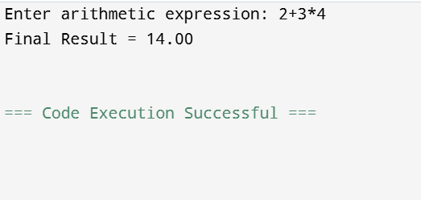
2.
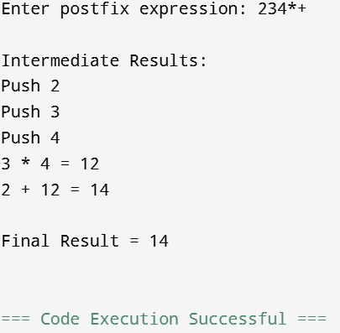
#include <stdio.h>
#include <ctype.h>

int stack[100];
int top = -1;

void push(int value)
{
stack[++top] = value;
}

int pop()
{
return stack[top--];
}

int main()
{
char postfix[100];
int i, a, b, result;

printf("Enter postfix expression: ");
scanf("%s", postfix);

printf("\nIntermediate Results:\n");

for (i = 0; postfix[i] != '\0'; i++)
{
if (isdigit(postfix[i]))
{
push(postfix[i] - '0');
printf("Push %d\n", postfix[i] - '0');
}
else
{
b = pop();
a = pop();

switch (postfix[i])
{
case '+':
result = a + b;
break;

case '-':
result = a - b;
break;

case '*':
result = a * b;
break;

case '/':
result = a / b;
break;

default:
printf("Invalid operator\n");
return 1;
}

printf("%d %c %d = %d\n", a, postfix[i], b, result);
push(result);
}
}

printf("\nFinal Result = %d\n", pop());

return 0;
}
3.
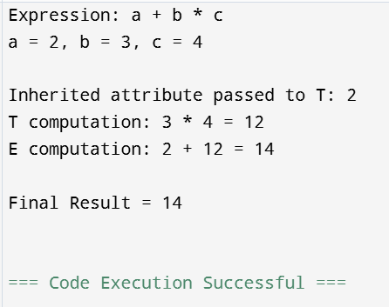
#include <stdio.h>

int E(int inherited)
{
int Tvalue;
int result;

printf("E receives inherited value = %d\n", inherited);

Tvalue = 2; // value of a
result = inherited + Tvalue;

return result;
}

int T(int inherited)
{
int F1, F2;
int result;

printf("T receives inherited value = %d\n", inherited);

F1 = 3; // b
F2 = 4; // c

result = F1 * F2;

return result;
}

int main()
{
int a = 2;
int b = 3;
int c = 4;

int multiplication;
int finalResult;

printf("Expression: a + b * c\n");
printf("a = %d, b = %d, c = %d\n\n", a, b, c);

/* T evaluates b * c */
multiplication = b * c;

printf("Inherited attribute passed to T: %d\n", a);
printf("T computation: %d * %d = %d\n", b, c, multiplication);

/* E combines a and T */
finalResult = a + multiplication;

printf("E computation: %d + %d = %d\n", a, multiplication,
finalResult);

printf("\nFinal Result = %d\n", finalResult);

return 0;
}
4.
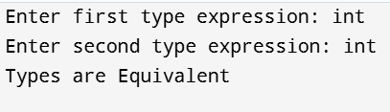
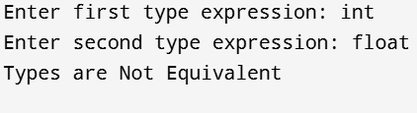

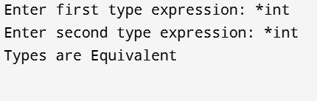

#include <stdio.h>
#include <string.h>

int typeEquivalent(char type1[], char type2[])
{
char base1[20], base2[20];
int ptr1 = 0, ptr2 = 0;

/* Check pointer type */
if (type1[0] == '*')
{
ptr1 = 1;
strcpy(base1, type1 + 1);
}
else
{
strcpy(base1, type1);
}

if (type2[0] == '*')
{
ptr2 = 1;
strcpy(base2, type2 + 1);
}
else
{
strcpy(base2, type2);
}

if (ptr1 == ptr2 && strcmp(base1, base2) == 0)
return 1;

return 0;
}

int main()
{
char type1[20], type2[20];

printf("Enter first type expression: ");
scanf("%s", type1);

printf("Enter second type expression: ");
scanf("%s", type2);

if (typeEquivalent(type1, type2))
printf("Types are Equivalent\n");
else
printf("Types are Not Equivalent\n");

return 0;
}
5.
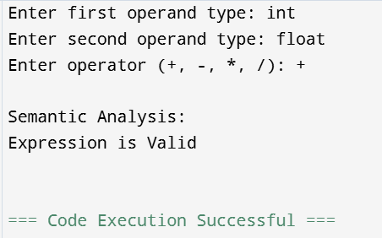

#include <stdio.h>
#include <string.h>

int validType(char type[])
{
if (strcmp(type, "int") == 0 ||
strcmp(type, "float") == 0 ||
strcmp(type, "double") == 0)
return 1;

return 0;
}

int main()
{
char type1[20], type2[20], op;

printf("Enter first operand type: ");
scanf("%s", type1);

printf("Enter second operand type: ");
scanf("%s", type2);

printf("Enter operator (+, -, *, /): ");
scanf(" %c", &op);

printf("\nSemantic Analysis:\n");

if (!validType(type1) || !validType(type2))
{
printf("Type Error: Invalid operand type\n");
return 0;
}

if (op == '+' || op == '-' || op == '*' || op == '/')
{
if (op == '/' &&
strcmp(type2, "int") == 0)
{
printf("Expression is Valid\n");
}
else
{
printf("Expression is Valid\n");
}
}
else
{
printf("Type Error: Invalid operator\n");
}

return 0;
}

RUBRICS FOR CALCULATION

Criteria | Weightage | Level 4 – Exemplary | Level 3 – Proficient | Level 2 – Developing | Level 1 – Beginning
Understanding of Concepts | 25 | Demonstrates thorough understanding and effectively integrates multiple concepts/technologies | Good understanding with proper integration of most concepts | Basic understanding; limited or partial integration | Poor understanding; unable to integrate concepts
Experimental Design | 30 | Well-planned, systematic implementation with optimal solution | Correct implementation with minor issues | Basic implementation with errors or inefficiencies | Incorrect or incomplete implementation
Use of Tools | 20 | Effective and advanced use of tools/technologies with proper configuration | Appropriate use of tools with correct execution | Limited or inconsistent use of tools | Incorrect or minimal use of tools
Analysis of Results | 15 | Insightful analysis with accurate interpretation and validation of results | Good analysis with reasonable interpretation | Basic analysis with limited insights | Poor or incorrect analysis of results
Documentation | 10 | Clear, well-structured documentation with diagrams, code, and results | Organized documentation with necessary details | Basic documentation with missing details | Poor or incomplete documentation

