SIMATS ENGINEERING (SAVEETHA SCHOOL OF ENGINEERING) Department of Computer Science and Engineering
ASSESSMENT TOOL 1 – EXPERIMENTS
Course Code: | CSA06 | Course Title: | Design and Analysis of Algorithms
CO Assessed: | CO3: Articulation  (BL4, BL5) | Assessment: | Assessment Tool 1 – Experiments
Weightage: | 40% of CIA | Total Marks: | 100
CO3 Statement: | Design Divide and Conquer algorithms for Merge Sort, Quick Sort, Binary Search and Matrix Multiplication
Student Name: | R.NANDHINI | Reg. No.: | 192524355
Section / Batch: | 2025 | Date:
Instructions to Students
• Answer the following question. Total Marks: 100.
• Write the algorithm and execute the code for the given experiment.
• Follow a well-structured, systematic approach to design and implement an optimal solution. • Provide insightful analysis with accurate validation, supported by clear documentation including diagrams, code, and results.

Question Type | Focus Area | Questions
Experiments | Design and Code for Divide and Conquer Algorithms: Merge Sort, Quick Sort, Binary Search, and Matrix Multiplication | Q1

ANSWER:
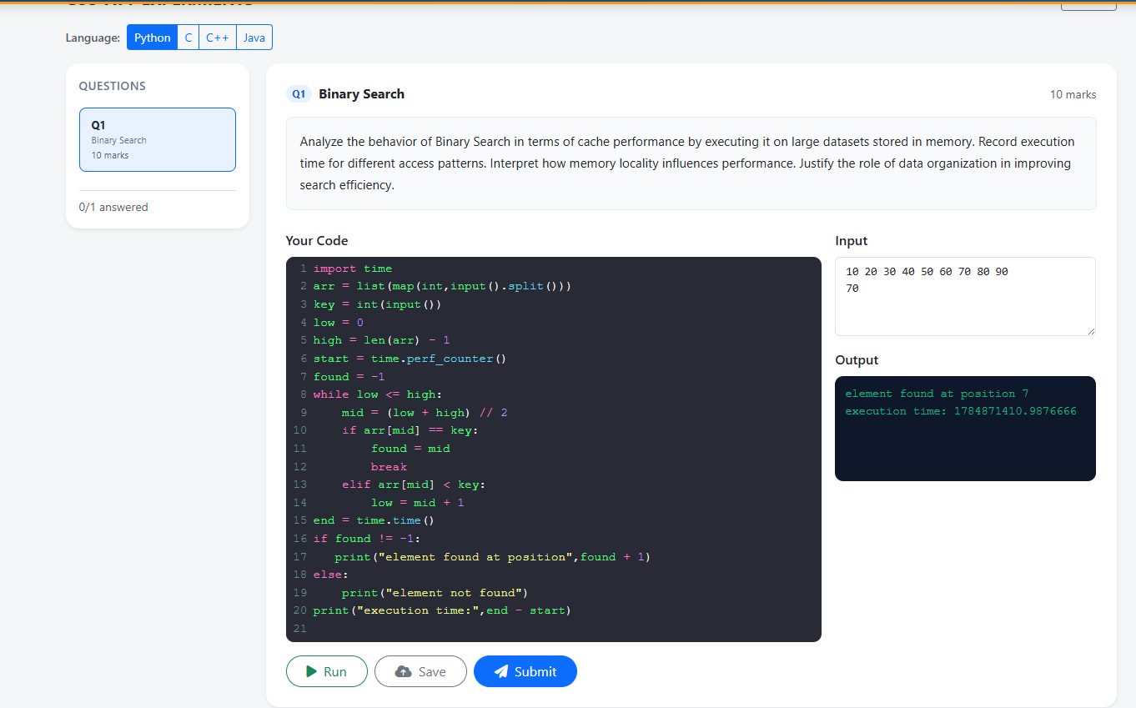

SECTION A – Experiments
Code of Conduct
I __________________________ (Name / Reg No) certify that this submission is my original work and that I have adhered to the guidelines specified for this assessment. I understand that any violation of academic integrity rules will result in disciplinary action.
Signature of the Student: _________________________

RUBRICS FOR CALCULATION
Experiments
Criteria | Weightage | Level 4 –  Exemplary | Level 3 –  Proficient | Level 2 –  Developing | Level 1 –  Beginning
Understa  nding of  Concepts | 25% | Demonstrates thorough understanding and  effectively integrates  multiple  concepts/technologies | Good  understanding  with proper  integration of  most concepts | Basic  understanding;  limited or partial  integration | Poor  understanding  ; unable to  integrate  concepts
Experime  ntal  Design | 30% | Well-planned,  systematic  implementation with  optimal solution | Correct  implementatio  n with minor  issues | Basic  implementation  with errors or  inefficiencies | Incorrect or  incomplete  implementatio  n
Use of  Tools | 20% | Effective and advanced use of  tools/technologies with proper configuration | Appropriate  use of tools  with correct  execution | Limited or  inconsistent use  of tools | Incorrect or  minimal use  of tools
Analysis  of  Results | 15% | Insightful analysis with accurate interpretation and validation of results | Good analysis  with  reasonable  interpretation | Basic analysis  with limited  insights | Poor or incorrect analysis of results
Documen  tation | 10% | Clear, well-structured  documentation with  diagrams, code, and  results | Organized  documentation  with necessary  details | Basic  documentation  with missing  details | Poor or  incomplete  documentatio  n

Marks Evaluation:
Criteria | Wt. | Level 4 –  Exemplary | Level 3 –  Proficient | Level 2 –  Developing | Level 1 –  Beginning
Understanding of Concepts | 25%
Experimental Design | 30%
Use of Tools | 20%
Analysis of Results | 15%
Documentation | 10%
Total Marks (100):

Faculty In-charge | Course Coordinator | Head of Department
Name: | Name: | Name:
Signature: _______________ | Signature: _______________ | Signature: _______________
Date: ___________________ | Date: ___________________ | Date: ___________________

